| **Team name** | Luna R |
| --- | --- |
| **Team members** | Xinghai Nian, Bingzhen Chen, Xiaoqian Yang(current leader) |
| **Project title** | Flashcards to learn a foreign language |
| **Description** | Users can learn different kinds of languages using flashcards. Users are required to log in or sign up for new accounts, then they can choose between study mode and quiz mode. And in quiz mode, users’ scores and quiz time will be recorded, which is visible to all users on the scoreboard. |
| **Job assignments:** | **Xinghai Nian:** study mode design, quiz mode quiz question design,  **Bingzhen Chen:** flashcards design, scoreboard design  **Xiaoqian Yang:** home page, sign in/up, log out, study mode/quiz mode choices page/ user accounts, create a database, connect database to the website  Everyone will do a little bit of everything, we will function as a team. |
| **Technology tools** | Frontend: HTML, CSS, JavaScript  Backend: Flask/Jinja, Python, SQLite for Database |

|  | Description | Date |
| --- | --- | --- |
| Milestone 1 | * Setup Github repo & work environment * Research on tech skills to learn * Website structure design | * week 2: 02/09/2023 |
| Milestone 2 | * Frontend/backend development (home page, register, login) | * week 4: 02/23/2023 |
| Milestone 3 | * Frontend/backend development (study mode design, language/mode choice page design) | week 6: 03/09/2023 |
| Milestone 4 | * Frontend/backend development (quiz mode design) | week 8: 03/23/2023 |
| Milestone 5 | * Frontend/backend development (scoreboard design) * Test website, possibly deploy the website. | week 10: 4/15/2023 |

**The activity/progress/update shown in GitHub repository since last week.**

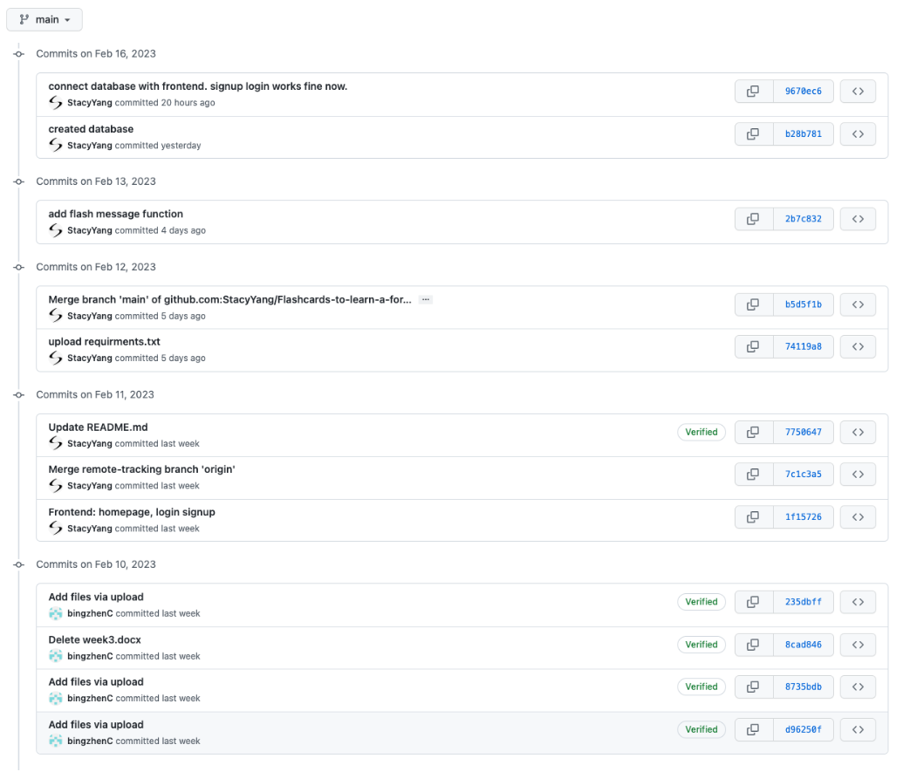

**List the milestones that have been accomplished as a team.**

Milestones 1 & 2 are accomplished.

And we did login/signup page Mockup as a team.

**The next task to do (or current task to be continued).**

Frontend/backend development (study mode design, language/mode choice page design)

**Minor changes:**

In milestone:

We add a new webpage (language/mode choice page) design for milestone 3.

In our flowchart

Previously we had the selecting language option under the study mode, but now we put it before the user choosing quiz/study mode.

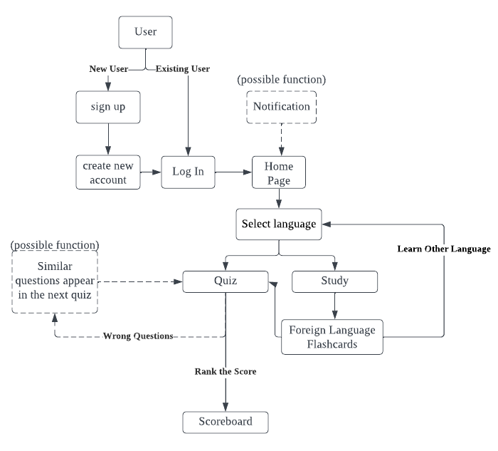

**Conclusion/decisions drawn from your weekly group meeting(s)**

We are able to finish milestone 2 ahead of time, and we continue to work on milestone 3. We'll research how to store study materials/questions&ansers in the database.

Meeting time: 02/17/2023 3:00 pm, over the WeChat platform.