**Team name**: Luna R

**Team members:** Xinghai Nian, Bingzhen Chen(current leader), Xiaoqian Yang

**Project title:** Flashcards to learn a foreign language

**Description:** Users can learn different kinds of languages using flashcards. Users are required to log in or sign up for new accounts, then they can choose between study mode and quiz mode. And in quiz mode, users’ scores and quiz time will be recorded, which is visible to all users on the scoreboard.

**Github:** <https://github.com/StacyYang/Flashcards-to-learn-a-foreign-language>

**Job assignments:**

| **Xinghai Nian:** study mode design, quiz mode quiz question design  **Bingzhen Chen:** study mode design, flashcards design, scoreboard design  **Xiaoqian Yang:** home page, sign in/up, log out, study mode/quiz mode choices page/ user accounts, create a database, connect database to the website  Everyone will do a little bit of everything, we will function as a team. |
| --- |

**Milestones:**

| Milestone 1 | * Setup GitHub repo & work environment * Research tech skills to learn * Website structure design | week 2: 02/09/2023 |
| --- | --- | --- |
| Milestone 2 | * Frontend/backend development (home page, register, login) | week 4: 02/23/2023 |
| Milestone 3 | * Frontend/backend development (study mode design) | week 6: 03/09/2023 |
| Milestone 4 | * Frontend/backend development (quiz mode design) | week 8: 03/23/2023 |
| Milestone 5 | * Frontend/backend development (scoreboard design) | week 10: 4/06/2023 |
| Milestone 6 | * Test the website, and possibly deploy the website. | week 12: 4/20/2023 |

**Technologies involved:**

Frontend: HTML, CSS, JavaScript

Backend: Flask/Jinja, Python, SQLite for Database

The activity/progress/update shown in GitHub repository since last week:

**List the milestones that have been accomplished as a team.**

Milestone 1, 2, 3, 4 are accomplished.

And we did login/signup page Mockup as a team.

Populate quiz questions into database for Quiz mode.

A transaction page after user login to allow users choose language and mode.

Quiz mode (take quiz) frontend & backend design.

**New Update**

Study mode (Flashcards and note) frontend & backend design.

Completed Quiz Result, score and correct answer will be displayed after the user answers

Modified github's README

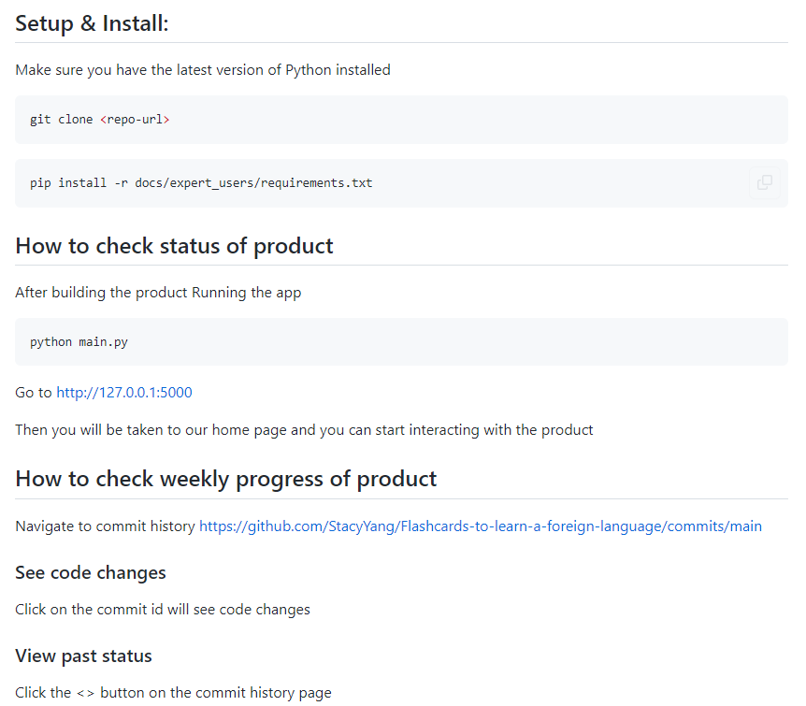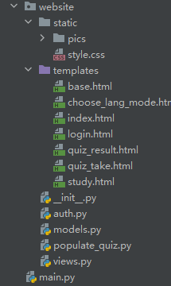

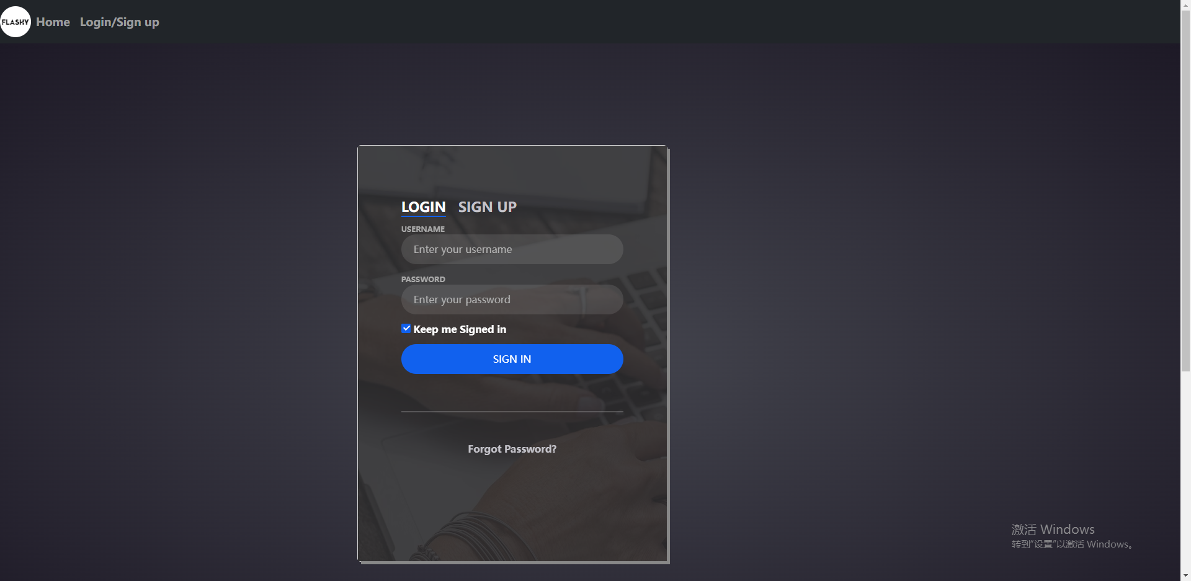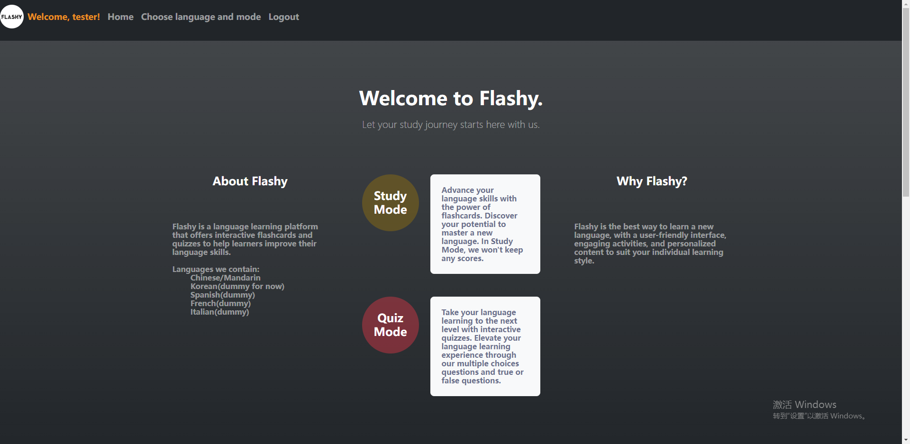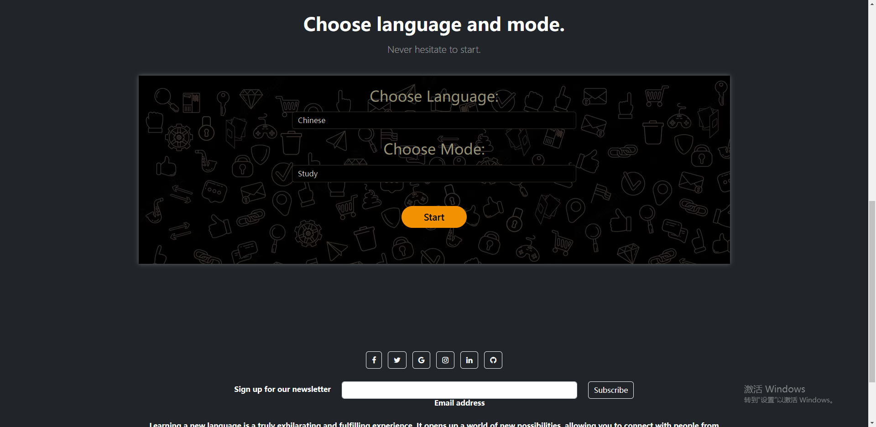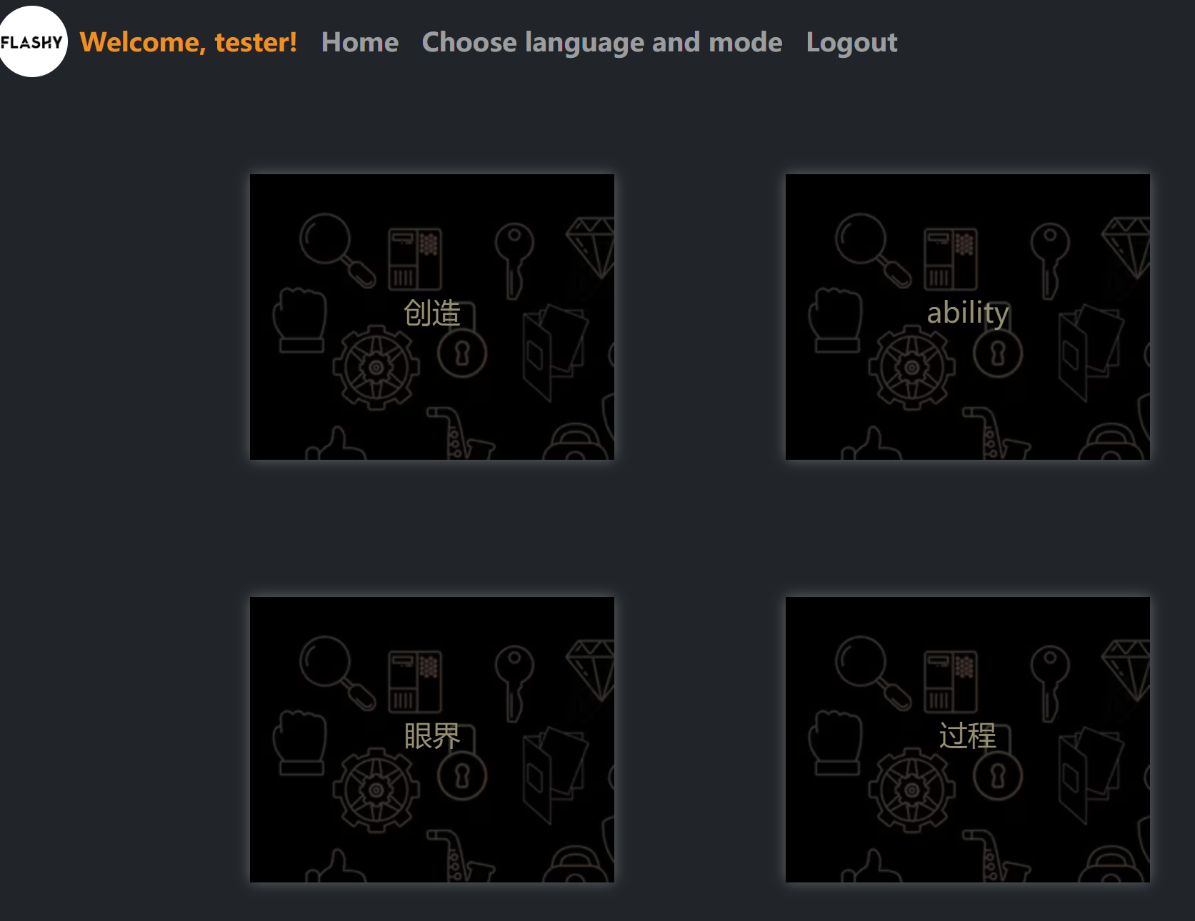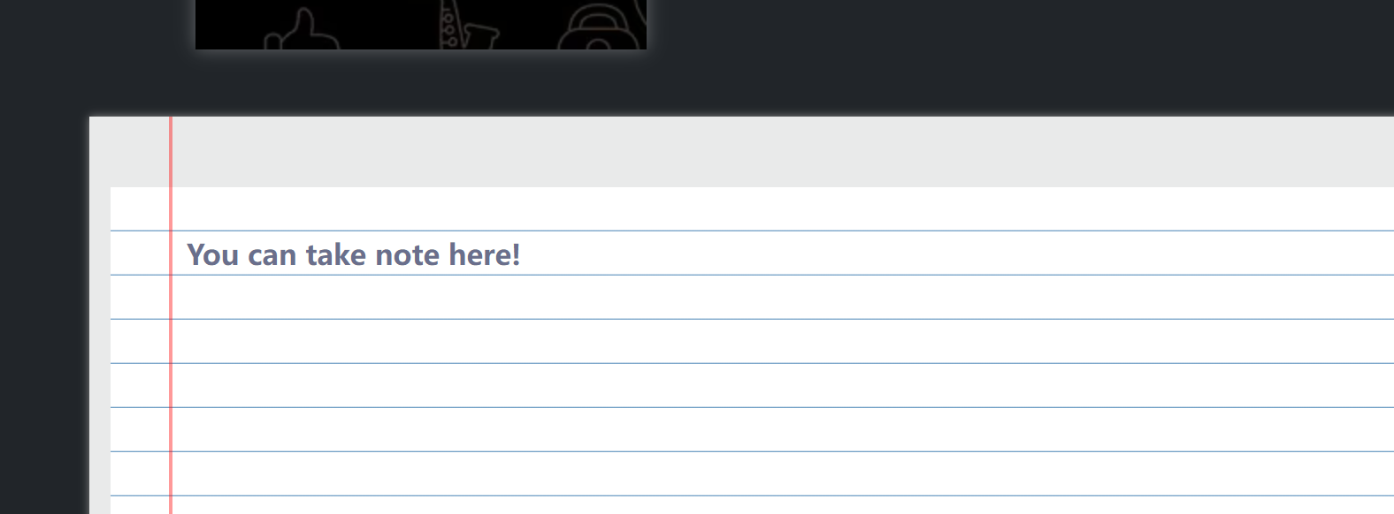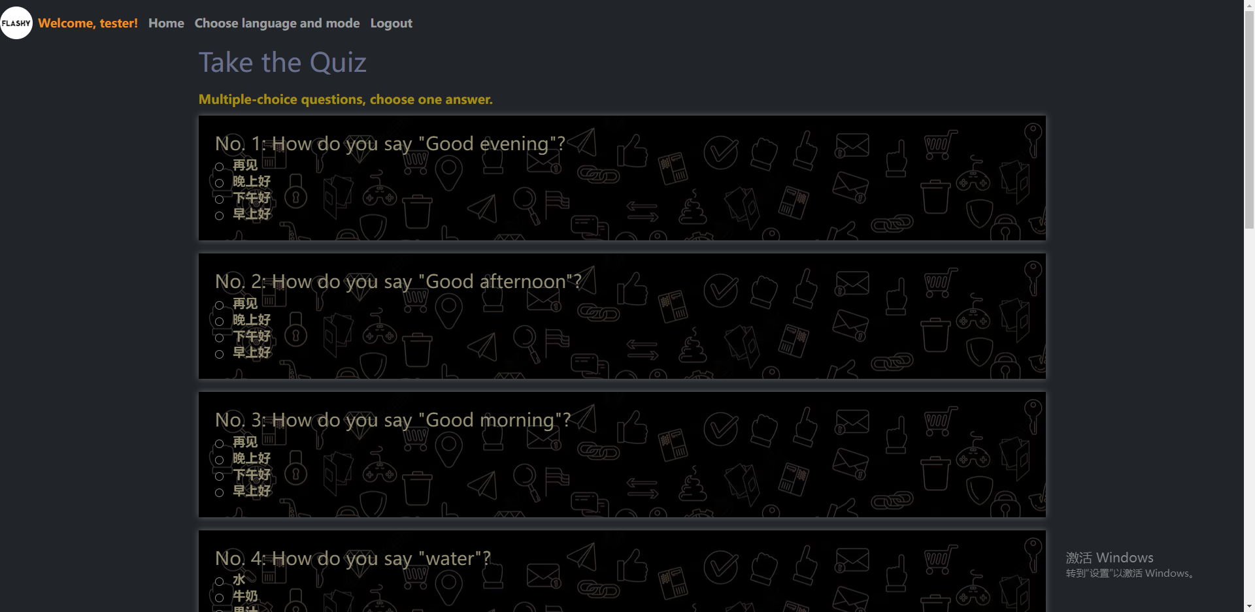

**The next task to do (or current task to be continued).**

Frontend/backend development (Scoreboard design)

Frontend & backend design for Scoreboard

Improve the UI design of study mode