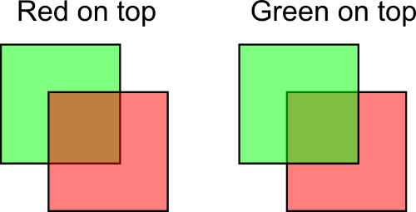

Beware of mat4 vertex attributes needing more location offsets!

