Stop Memorizing Formulas! In Just a Few Minutes, Grasp the "Geometric Soul" of Linear Algebra

The Essence of Linear Algebra

Matrices and Linear Transformations:
First transform the basis vectors i and j, and then apply the result to x and y. Matrix operations go from right to left, which is consistent with the notation g(f(x)).
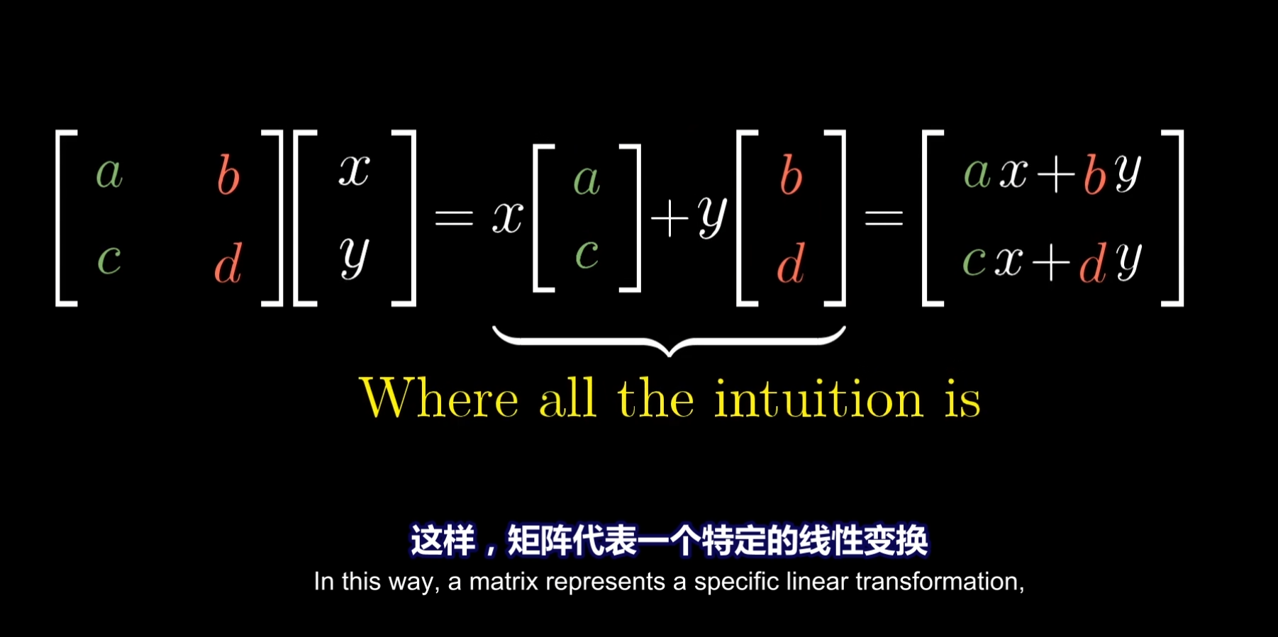
How should we understand ax + by and cx + dy? After the transformation, X2 = ax + by and Y2 = cx + dy. In other words, the transformed X2 is the sum of the influences from the transformed basis vectors i2 and j2, namely the effects produced by a and b, while a and b themselves come from transforming the original i1 and j1. The same applies to Y2: just understand it as the total influence brought to the y-axis after the basis vectors are transformed. Matrix multiplication is similar as well; you just analyze the effect on the corresponding basis vectors in order.
A matrix can be viewed as describing what the space looks like after transforming the basis vectors i and j; the grid in the space remains parallel and evenly spaced.

There is absolutely no need to prove it, because in every case you first apply C, then B, then A. Even if you combine them into a single transformation, the meaning is still the same, because the order of application never changes.

Determinant:
The geometric meaning of the determinant det(A) is this: the area of the grid cell spanned by the original basis vectors i and j in the corresponding space is, for example, 1 * 1 = 1. After a matrix transformation, the space is stretched, and the area of that original unit grid cell changes along with the stretching. The ratio between the area of the transformed unit grid cell and the area of the original unit grid cell is the value of the determinant. Even for an irregular area, we can decompose it into infinitely many sufficiently small grid cells, and the areas of those cells also change under the transformation. So even for an irregular area, after the transformation the determinant still represents the ratio of the area occupied by that region before and after the transformation.


Inverse Matrices, Column Space, Rank, and Null Space:
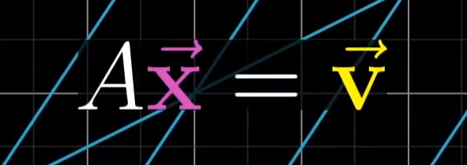
When the determinant is not 0, it means the space has not been compressed into a lower dimension. Geometrically, after a vector x is transformed, there is one and only one vector v that coincides with it.
We can solve for x by multiplying both sides by the inverse transformation of A. In other words, v becomes x after applying the inverse transformation.
When the determinant is 0, it means the space has been compressed into a lower dimension, such as a plane or a line. Then v must lie exactly on that plane or line; otherwise the solution does not exist, because that space is exactly the space where the output vector v lies, that is, all possible output vectors v.

Rank represents the dimension of the transformed space.
The column space is the space spanned by the columns of the matrix (the basis vectors). This space is the space where the output vector v lies, that is, all possible output vectors v.

Null Space:
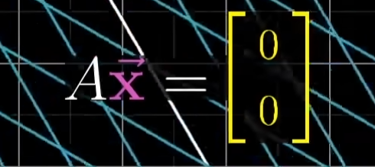
For a system of linear equations, when the vector v happens to equal the zero vector, the null space gives all possible solutions to that vector equation.
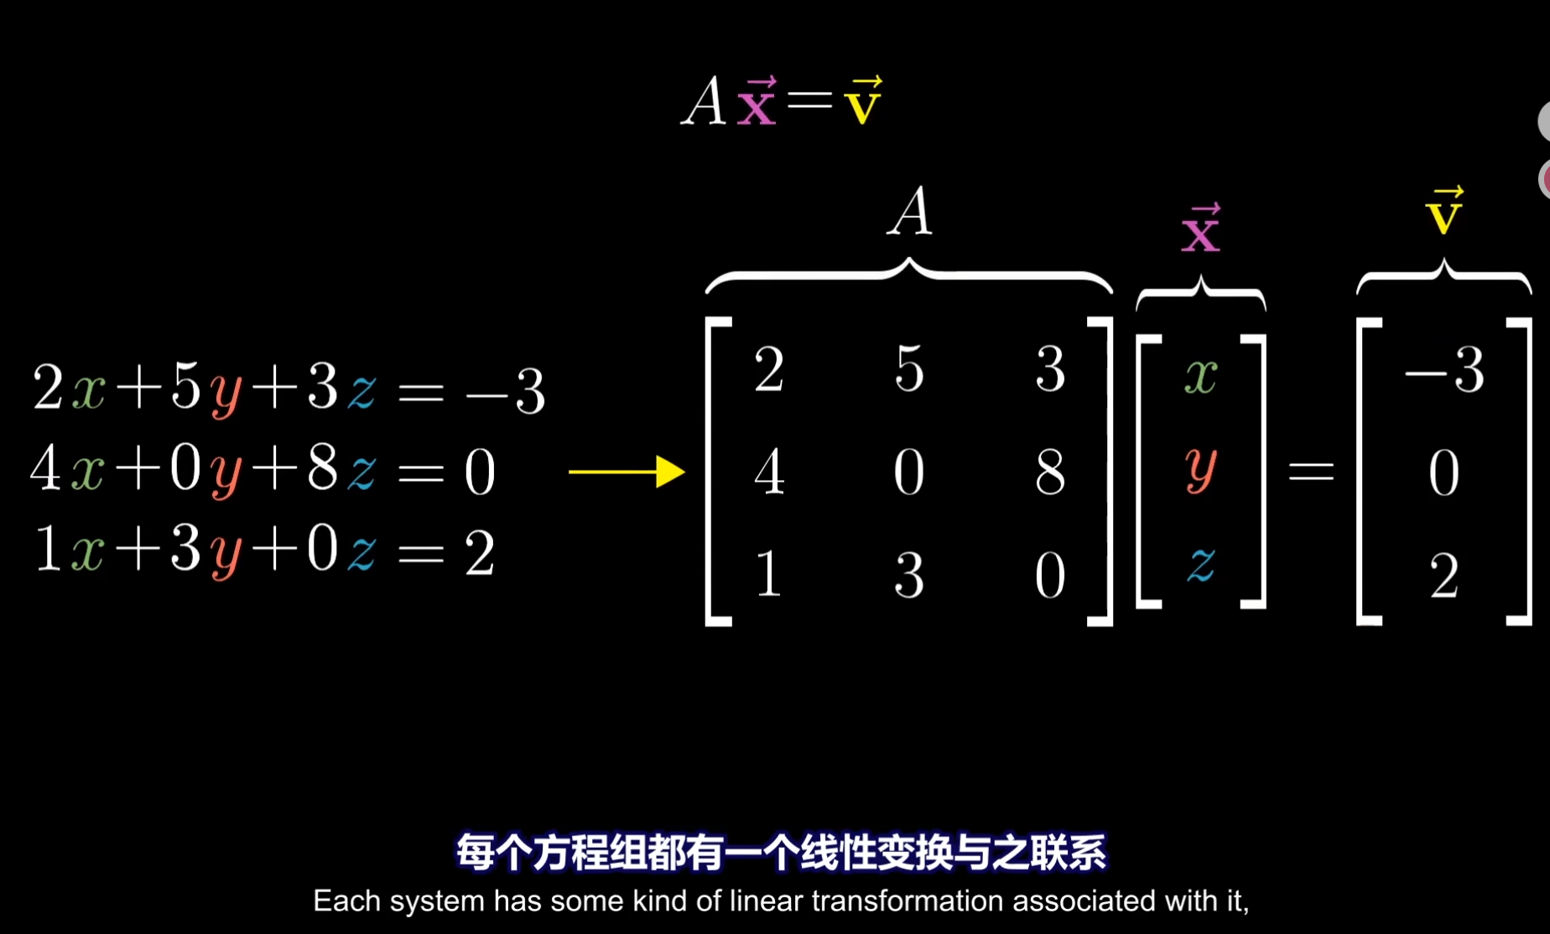
When the inverse transformation exists, we can multiply both sides by the inverse transformation to solve the system and obtain all solutions.

Dot Product and Duality:
$$\overset{→}{v}⋅\overset{→}{w}=∥\overset{→}{v}∥∥\overset{→}{w}∥cos⁡(θ)$$
Imagine converting a 2D space into a 1D space in the direction of v. After the original basis vectors i and j are transformed, they correspond to two values, ux and uy, on the number line in the direction of v.
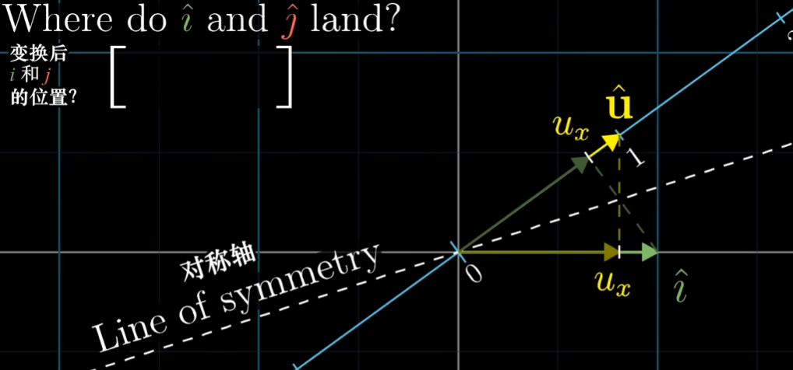
Then the value corresponding to the original vector w after it is transformed into the 1D space is the sum of ux times its x and uy times its y. That is the length of the projection, or the value represented by vector w on the 1D number line. The value of v on the number line is also ux times its x plus uy times its y. So from the perspective of ux and uy, the dot product of these two vectors is w's x times v's x plus w's y times v's y.
The computation is independent of the order of v and w, because geometrically they are symmetric about some axis, and swapping the positions in the multiplication does not change the result.
The dot product is commonly used to judge the relative direction between two directions.

Change of Basis
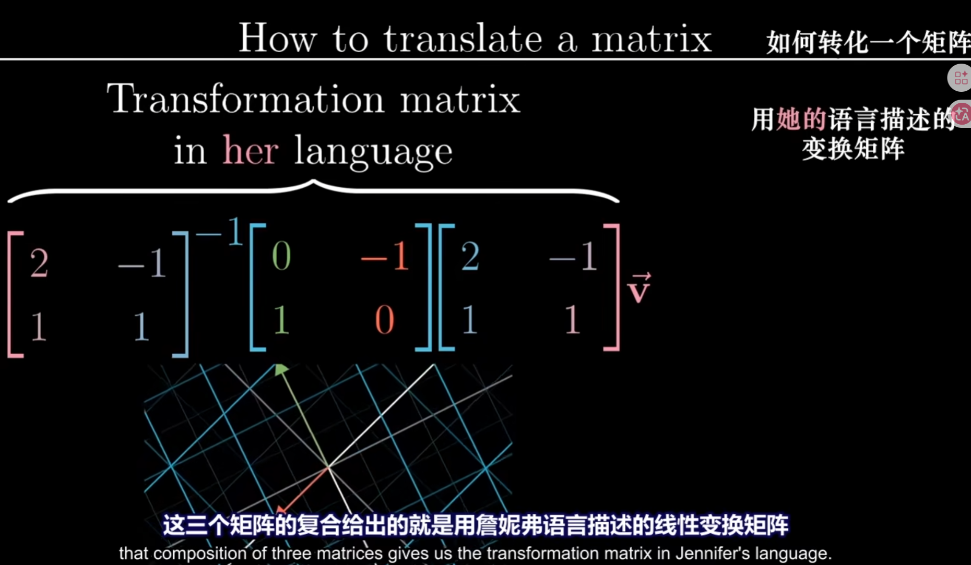

Eigenvectors and Eigenvalues
A Coordinate System with Eigenvectors as the Basis
Eigenvectors satisfy Av=$λ$v, that is: there exists a vector v in the coordinate system such that after undergoing the transformation A, v still spans its original direction. is its eigenvalue, and geometrically it represents the scaling factor after the transformation.$λ$

Av=$λ$v
Av=$λ$Iv
(A-I)$λ$v = 0
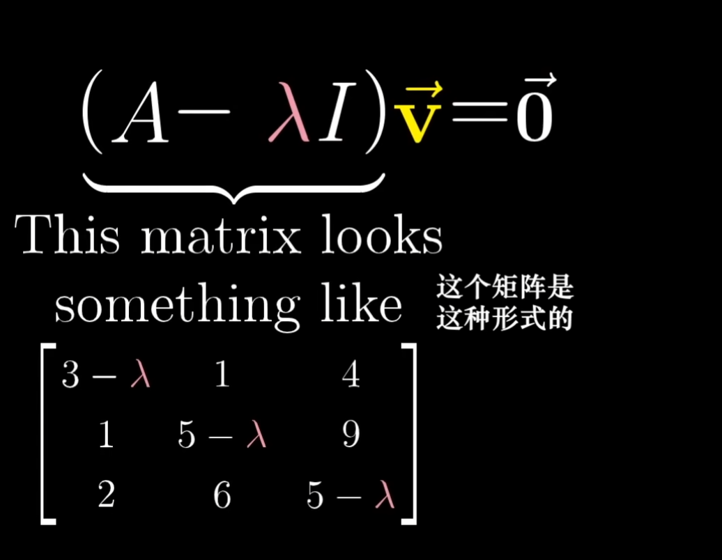
Assume the eigenvector is not the zero vector. Then for the product to equal the zero vector, det(A-I) must equal 0. This means the transformation A-I compresses the space into a lower dimension, causing the eigenvector to become the zero vector.$λ$$λ$
In this expression, only $λ$ is unknown, so solving it gives the value.$λ$
Substitute $λ$ into the original (A-I)$λ$v = 0, and then you can solve for the eigenvector v.

If we want to apply the transformation repeatedly
We can first find the eigenvectors of the transformation, and then use those eigenvectors as the basis vectors. The originally complicated transformation A then becomes an extremely simple diagonal matrix D, whose diagonal entries are the eigenvalues. Why? This is related to the definition of eigenvectors, because in the space that uses eigenvectors as its basis, after applying A, the basis vectors of the coordinate system are only scaled according to the eigenvalues. That is why the values on the diagonal of D are precisely the eigenvalues. The only target being considered here is the original transformation A.

First convert the coordinate system into one that uses the eigenvectors as the new coordinate axes. For example, if the basis vector of the coordinate system with eigenvectors as its basis is 3 times the basis vector of the original coordinate system, then the basis vector of the original coordinate system must be scaled down by a factor of 3 to be represented in the coordinate system with eigenvectors as the basis. So represents translating the original coordinate system into the coordinate system with eigenvectors as the basis.$P^{-1}$$P^{-1}$
In this coordinate system, the transformation A is translated into a diagonal matrix, meaning that only the diagonal entries are nonzero (and those values are the eigenvalues corresponding to the eigenvectors). We apply this transformation, , which represents A in the coordinate system that uses eigenvectors as the basis. If this transformation needs to be applied many times, that is , because it is a diagonal matrix, the result is simply each diagonal entry raised to the n-th power, which is very easy to compute. After obtaining the result, we only need to multiply by to translate it back to the original coordinate system. In this way, the transformation represented by A is equivalent to the transformation represented by $P^{-1}$.$P$$P$$P^{-1}$

Abstract Vector Spaces

Anything that satisfies the following abstract concepts can use linear algebra, such as functions, vectors, and arrays.
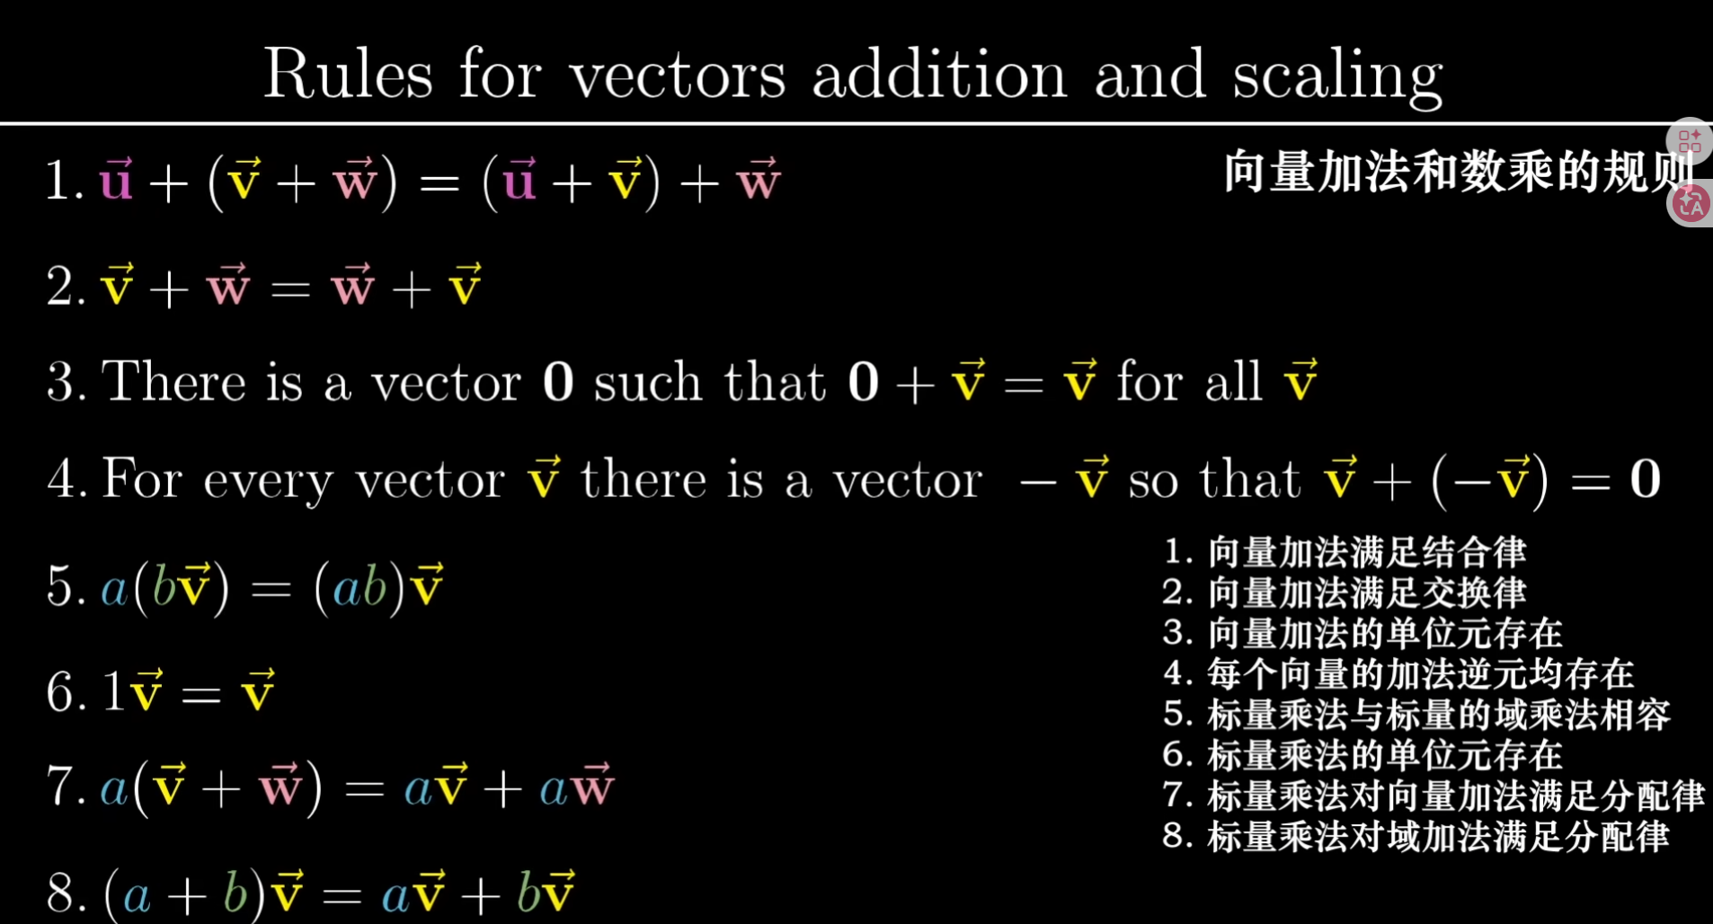

Cramer's Rule:
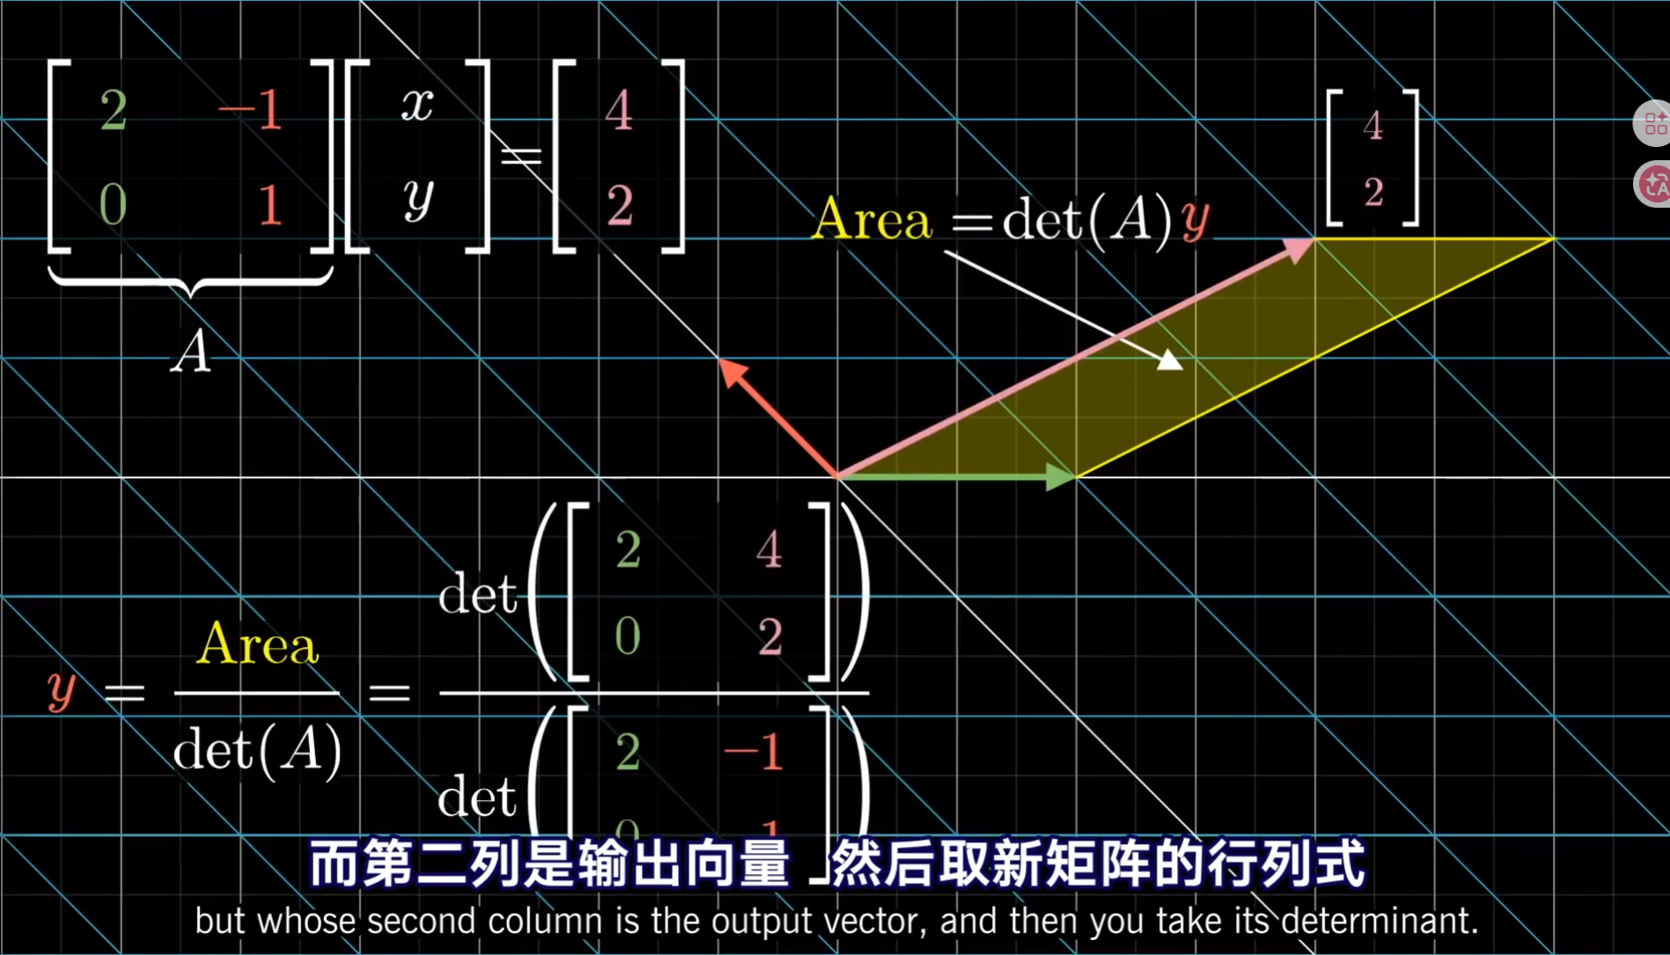
To solve for y:
The area of the parallelogram formed by the original vector (x, y) and the basis vector x is det(y, 1), whose value is y. After the transformation, the area is represented by the area formed by the transformed basis vector i2 and the transformed (x', y'), namely det(i2, y'). This area can be computed, and the ratio by which the area changes can also be computed, namely det(A). From the meaning of the determinant, we know that the ratio before and after transformation is the same for areas of any shape.
So we know that the previous area is the unknown y, the later area is det(i2, y'), and the ratio of change is det(A).
y = det(y, 1) = det(i2, y') / det(A)
In this way, we solve for y.

The same logic applies to solving for x.

