The future of SPIG-GMAB today
SAiGE | SPIG-GMAB Artificial Intelligence GATE Engineering

1. Executive Summary

SAiGE: one shared system. One GATE for every project.
SAiGE is the shared system for all SPIG-GMAB companies worldwide. It combines Artificial Intelligence with the Group’s technical know-how to manage every customer request through to order, using three agents and a human review after each stage. Every project is a GATE, connecting information, calculations, quotations, revisions and approvals.
The first agent reads emails received by Group companies and opens the GATE. The second uses calculation software, 3D design tools and SAP costs to compare configurations and propose the most advantageous solution. The third turns the approved results into a complete quotation, reviewed by people before it is sent.
At the heart of the model is an optimization cycle capable of comparing thousands of combinations. The objective is to improve the expected margin while keeping cost and price separate and meeting customer requirements, quality, safety and feasibility constraints. Customer dialogue drives technical and commercial revisions through to the final order, within the same GATE.

Expected value
- Faster responses and fewer manual activities.
- More efficient solutions through comparison of alternatives.
- Complete quotations aligned with the approved configuration.
- Improved expected margin, taking costs and risks into account.
- Revision traceability and approval control.
The corporate infrastructure is already available. The work focuses on automating requests, connecting calculation, design and costing, and preparing the quotation. SAiGE makes this model available across companies while retaining accountability with the relevant people.
SAiGE is the system. GATE is the individual project. Agents process and propose; people verify, decide and authorize.

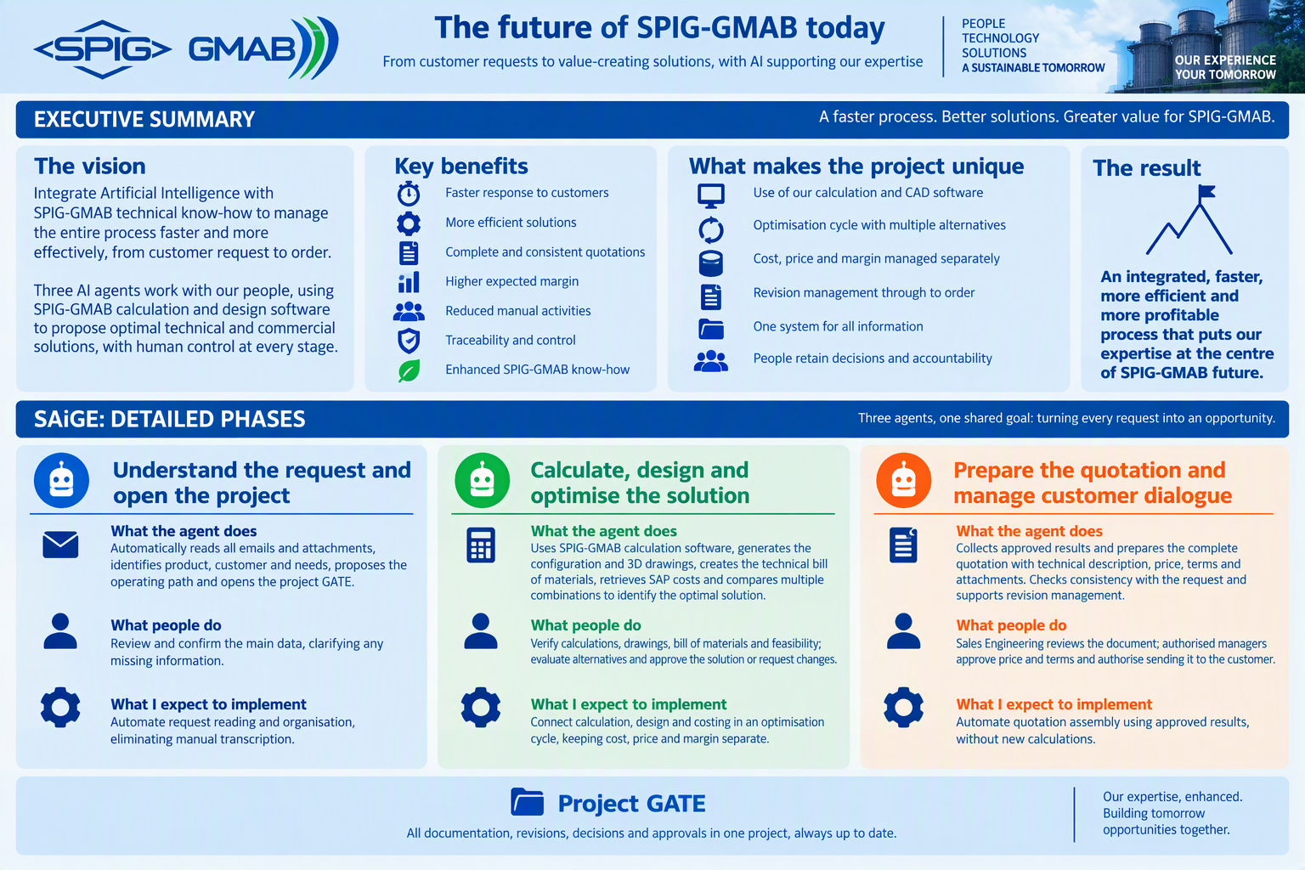

2. Detailed description of the operating model

Stage 1 | From email to opening the GATE

What the agent does
The agent automatically reads authorized corporate emails and attachments from SPIG-GMAB companies worldwide. It identifies the customer, product and stated needs, determines the company concerned and selects the relevant area: NEW SPIG, Service SPIG or GMAB. It converts the communication into a structured request while retaining the link to the original email and documents. The request becomes the starting point of the GATE.
It opens the GATE in SAiGE, collects the available documentation and proposes the operating path: what the customer is requesting and which activities SPIG-GMAB must perform. It highlights missing or ambiguous information without replacing it with assumptions. This stage prepares the next steps but does not start calculations or design before the required review.

What people do
People review the email used to open the GATE and the summary prepared by the agent. They confirm the interpretation of the request, the product, the company concerned, the relevant area and the key data. The review focuses on the meaning of the request and the proposed path, not on transcribing information already collected automatically.
When information is unclear, the individual responsible adds the data available internally or asks the customer for clarification. This review distinguishes confirmed information from points still requiring clarification, preventing an incorrect interpretation from being passed into the technical work.

What I expect to implement
Automate the reading, opening and organization of the GATE, eliminating manual transcription of the request and attachments. The agent prepares the GATE and the proposed path; the person focuses on reviewing and confirming the content. This does not add an administrative step; it immediately creates a common working basis in SAiGE.
Outcome: an open GATE with a verified request, documentation and path, ready for the technical stage. Subsequent communications update the same GATE without opening a new project for every customer exchange.

Stage 2 | Calculate, design and optimize

What the agent does
It reads the verified requirements in the GATE and uses SPIG-GMAB software to perform the calculations. It connects the results to 3D CAD tools to automatically generate the configuration, drawings and technical bill of materials. It retrieves costs from SAP and coordinates the optimization cycle.
Configuration → calculation → design → constraint checking → costing → comparison → new configuration, if required.
The cycle can explore thousands of combinations to identify the most advantageous technically acceptable solution. Cost, price and margin remain separate: manufacturing cost, price proposed to the customer and expected financial return.
Safety, quality, performance and feasibility are mandatory constraints, not factors to be sacrificed to increase margin.

What people do
People verify inputs, calculations, drawings, the technical bill of materials, feasibility and financial assessment. They evaluate the alternatives and approve the configuration or request further work. Customer dialogue may already take place at this stage for clarifications, alternatives and additional checks.

What I expect to implement
- Make calculation software automatically usable through defined inputs and outputs.
- Connect 3D CAD design to the requirements and calculation results.
- Integrate the costs available in SAP.
- Combine calculation, design and costing in a controlled optimization cycle.
Outcome: an approved technical and commercial solution, with drawings, bill of materials and the rationale for the selected option. Technical changes reactivate the affected work and require a new review.

Stage 3 | From the approved solution to the quotation

What the agent does
Only after human approval of the solution does the agent collect the technical bill of materials, calculations, drawings and financial assessments from the GATE and turn them into a complete draft quotation. It uses the validated results to describe the solution, scope of supply and performance, linking them to the proposed price, options, commercial terms and attachments.
It organizes assumptions and exclusions and checks that the document is consistent with the approved configuration. It highlights open points, missing content or inconsistencies for Sales Engineering review. It does not independently modify the technical solution or introduce new calculations; it makes the work completed in previous stages clear and usable for the customer.

What people do
Sales Engineering reviews the draft, verifies that it correctly represents the solution and completes the aspects requiring technical and commercial experience. The review covers both document completeness and alignment between what the customer requested, what was approved and what is actually being offered.
Authorized managers confirm the price and terms in accordance with the required approvals. The quotation is sent to the customer only after these checks. Accountability for content and decisions remains with people: the agent prepares the document and supports the review but does not replace approval.

What I expect to implement
Automate quotation assembly using documents and results already produced and approved in the GATE, avoiding manual reconstruction of information. No new calculation engines are introduced at this stage. The work consists of collecting validated content and turning it into a complete, consistent customer document ready for human review.
Outcome: a verified and approved quotation linked to the GATE and its relevant revision. Commercial or document changes with no technical impact remain in this stage; if they affect configuration, performance or costing, the process returns to Stage 2 before the quotation is updated.

Revisions, customer dialogue and order
The process does not end with the first quotation. Customer dialogue may introduce clarifications, new requests, alternatives, additional checks or changes to the proposed terms. Every communication updates the existing GATE and is linked to the relevant solution and quotation. Stage 1 is not repeated for every revision; work continues in the same GATE.
The process returns to the stage affected by the change. If requirements, configuration or technical checks change, it returns to Stage 2; if the change concerns only commercial or document content, it returns to Stage 3. This distinction avoids repeating unaffected activities while preventing reuse of results that are no longer valid.
- New requirements, technical changes, alternatives or additional checks: return to Stage 2, new review and subsequent quotation update.
- Commercial or document changes with no technical impact: return to Stage 3 and new approval.
- Unsuccessful internal review: correction in the affected stage before proceeding.
- Order received: human verification of alignment with the latest quotation and approved configuration.

One GATE for every project, SAiGE for every company
The GATE brings together correspondence, requirements, configurations, calculations, drawings, bills of materials, costs, quotations and approvals. It is not merely a collection of documents: it maintains the connection between what the customer requests, what is developed and what is offered. SAiGE manages the GATE projects of SPIG-GMAB companies worldwide while preserving the context and responsibilities of each project.
Each revision retains the previous version and identifies the elements to be updated. Changes must clearly distinguish results that remain valid from those requiring rework; affected approvals must be renewed before proceeding. Customer dialogue remains traceable even when it passes through multiple technical and commercial cycles.
When the order is received, the GATE makes it possible to verify that the customer’s confirmation matches the approved quotation and configuration. The result is a continuous path from the initial request to the final order, with automation, expertise and accountability clearly connected.

3. Workflow of a GATE in SAiGE

