# 简易销售库存系统项目报告

Chapter 1

A company has N (N<=20) salespersons (number : E001-E00N, including at least some basic information of salespersons, such as name, gender, education, etc.), who are responsible for selling M (M<=30) products (number: P001-P00M, including at least some basic information of products, such as name, unit price, inventory, etc.). Every salesperson will record the sales information (at least including date, number of the sale, number of the salesperson, number of the product, quantity of the product, etc.) when selling products.

Please design a simple storage-selling management system, which can provide the following functions: 1、 the system works in menu mode; 2、 record the sales information (saved in a file)——input; 3、 collect the sales information: (1) collect total sales value of every salesperson and total sales value of every product, and output the results; (2) sort the salespersons in an ascending order according to the total sales value, and output the results; (3) sort the products in a descending order according to the total sales value, and output the results; (Tips: There should be at least three files to save the data. One is used to save the information of the products, one is used to save the information of the salespersons, the other is used to save the sales information.

Chapter 2

Chapter 3

主菜单

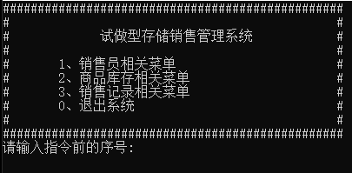

销售人员菜单

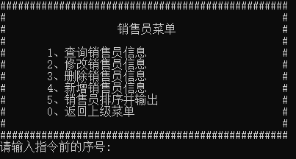

查询信息

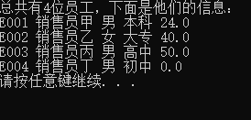

修改信息

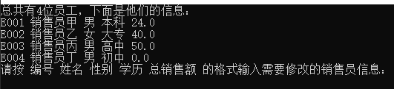

修改信息错误

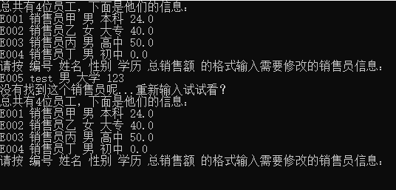

修改信息成功

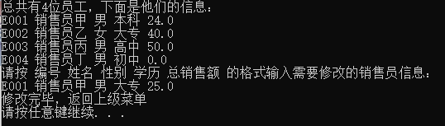

删除销售员信息

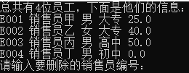

输入错误

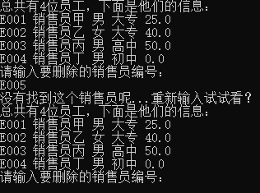

删除成功

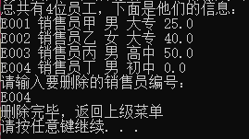

新增销售员信息



输入错误



输入正确

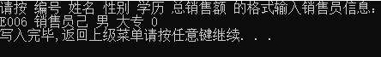

按总销售额对销售员进行排序

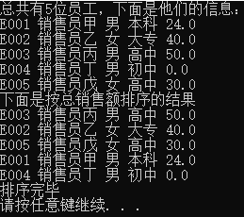

商品菜单

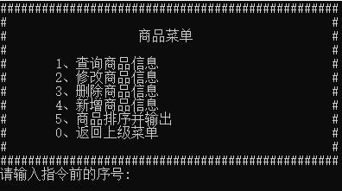

查询信息

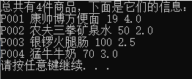

修改信息

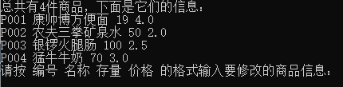

输入错误

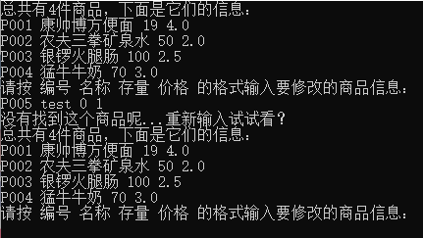

输入正确

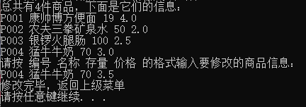

删除商品信息

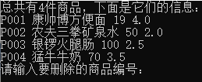

输入错误

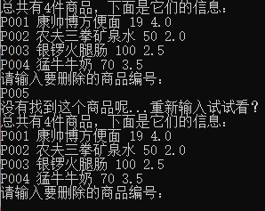

输入正确

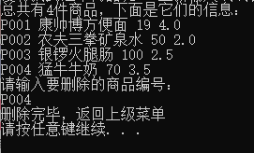

新增商品信息



输入错误



输入正确

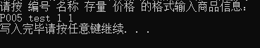

按总销售额降序排序

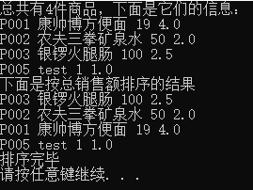

销售记录菜单

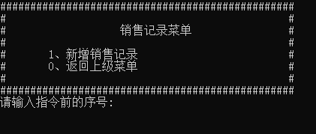

新增销售记录

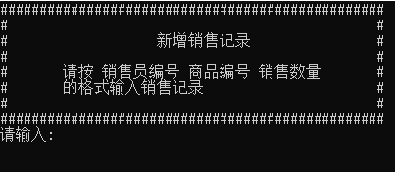

销售员编号错误

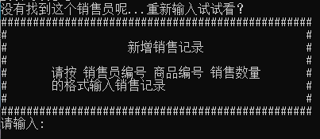

商品编号错误

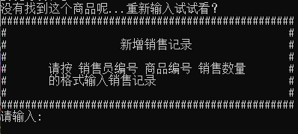

商品存量不足

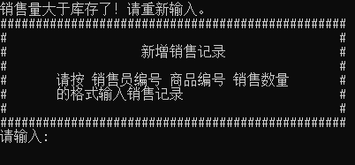

输入正确

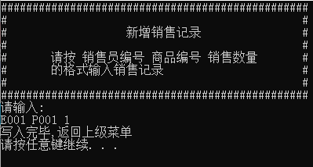

Chapter 4

这次作业大概花费了我总共十个小时左右的时间，中间遭遇了各种因为自己考虑不周而产生的bug，虽然最终还是完成了，但是迫于时间因素很多设想的功能还是没有实现（比如检测库存余量提醒补货等），有些遗憾。尽管UI还是有些让我不满意，不过最终还是完成了一个能够实现基本功能的成品。

Chapter 5

源码请参见附件同文件夹中的<Project.cpp>