StakingLab Coin Masternode Guide

1. Hot Wallet Setup

First step is the desktop wallet setup. This is the wallet you can run on your local PC once your masternode is setup and activated on this wallet you can close it without worrying about your rewards.

Firstly, we must create a **private key** and a **transaction** for each masternode, please fallow these necessary steps for the configuration.

1. Open Console: Tools → Debug Console

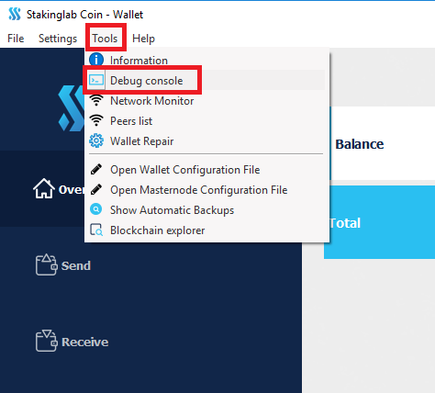

1. Type 🡪 getaccountaddress Masternode1 (Masternode1 you can replace with any text it will represent address label) and press Enter. Now you have collateral address that are located in Receiving addresses, where you will have to send your coins for this masternode.

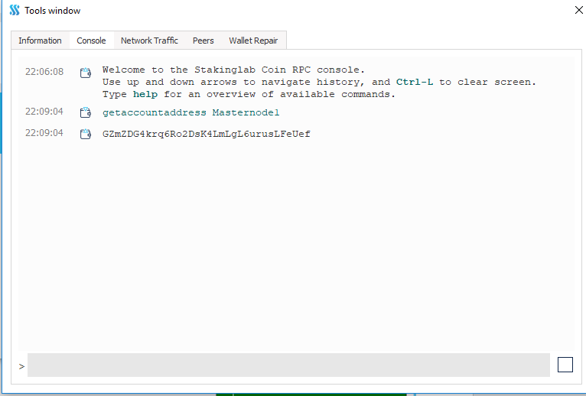

1. Send exactly 1000 LABX coins to your newly generated adress. To do this please refer to picture and fallow numbers for your steps. 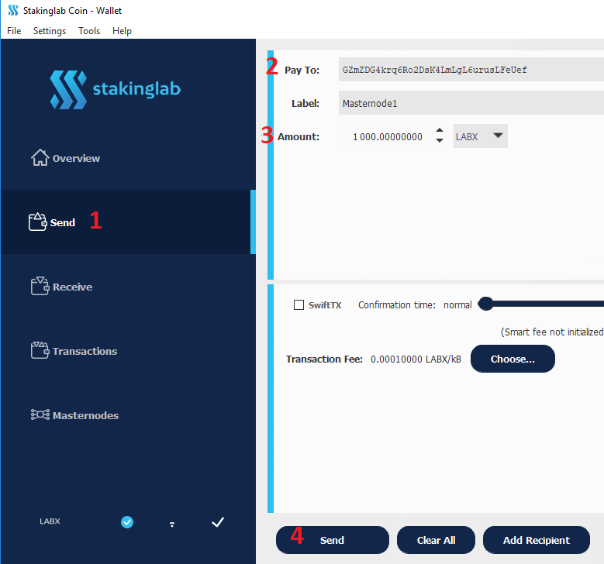
2. Setup MNs in config: Tools → Open Masternode Configuration File . This is required so your wallet would have all necessary information so you would be able to activate your masternode



* 1. Firsly we need mn Lable that was mentioned in step 2. In our case this is Masternode1
  2. Secondly it is fallowed by the IP adress where your MN is installed. (this step will come a bit later, we will host VPS on VULTR) IP will be fallowed by coin port Example 1.1.1.1:
  3. Third part is Private key. This is most sensitive part of this tutorial make shure no one has your private key, and keep it on a safe place. For this step We have to go back to Debug window (Tools → Debug Console) . There you will execute fallowing command : **masternode genkey** 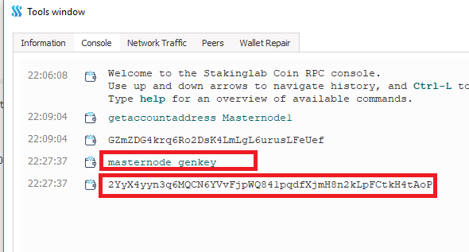
  4. Next step is to get txhash for the transaction that was made in step 3. In Debug Console trype fallowing command **masternode** **outputs** and you will get 1. txhash and 2. outputindex

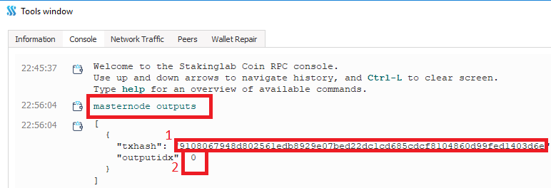

* 1. On the end you will have a line looking like this :

Masternode1 1.1.1.1:53384 2YraHYLhSX3ZWwyKQ6Q7kiAuSLu36KcBdPZBQQty1qt6bAZpqDL 9108067948d802561edb8929e07bed22dc1cd685cdcf8104860d99fed1403d6e 0



* 1. Save and restart the wallet.

1. VPS Setup

To rent a server please [**Click Here**](https://www.vultr.com/?ref=7411270) **or https://www.vultr.com/?ref=7411270**

1. Register on VULTR, or login. Click on Servers and then on + button. There you will be taken to a screen to select VPS configuration.

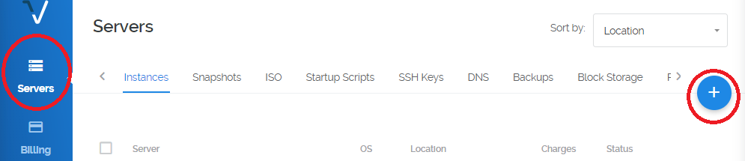

1. Select your VPS Server Location

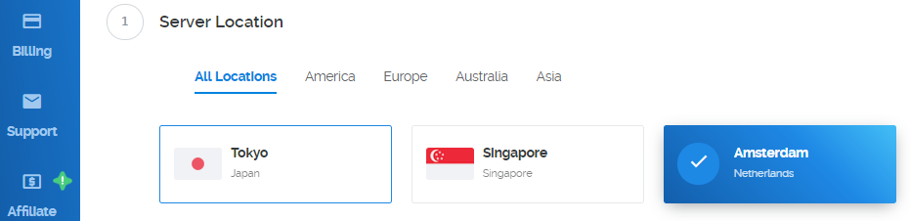

1. **Select server type**. 64 bit OS 🡪 UBUNTU 16.04 x64

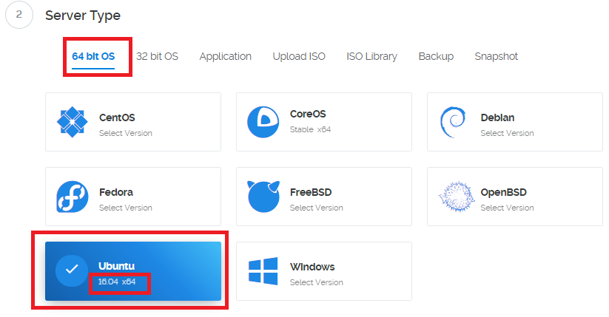

1. **Select SERVER Size**. We recommend 5$ version that would give you best hardware resources.

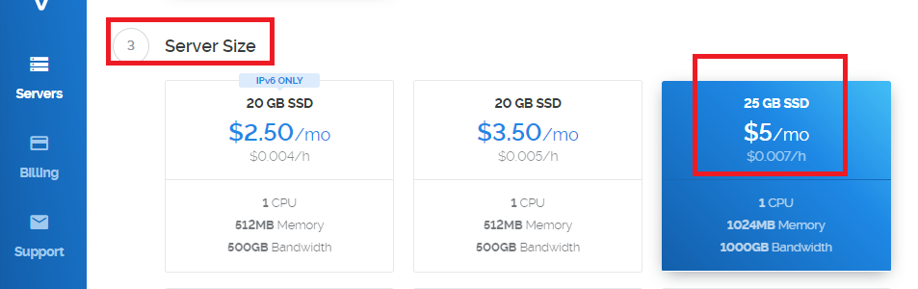

1. **Server HOSTNAME and LABEL**. Here you can select your VPS hostname and Label that would designate it on our vultr account.

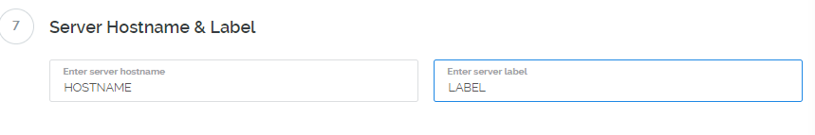

1. Finaly click on **Deploy Now** !
2. MN Install
3. Download Putty Here
4. Read Guide how to use putty Here
5. In you vultr account you will now find your VPS that you previously ordered. In there you will find your VPS ip and Password

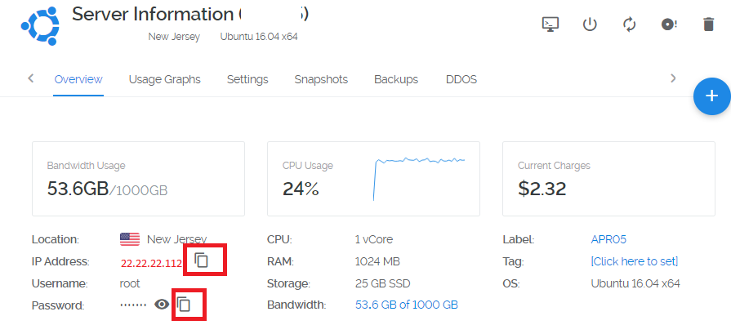

1. Open Putty put your VPS IP and click Open.
2. In fallowing window put user root and password that you got in your vultr account in step 1.

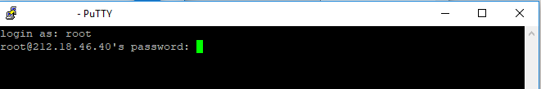

1. Now you will copy fallowing command and execute it.

apt-get install git && git clone https://github.com/StakingLabio/InstallScryptLABX && cd InstallScryptLABX && bash LABX-install-script-2.sh

1. Prepare your private key and Label name to input when asked by install scrypt.
2. You are ready to activate your masternode from your wallet
3. Activate your MN
4. After your succesful install you should now go back to your wallet and in masternode section you will see your masternode with missing status. Select it and click on START ALIAS.

Congratulations you are ready to stake 😊