**Report: Start Assembly Programming**

**Group 10**

**Member : Night、Paul**

**Student ID : 108502572、108502570**

1. **Program execution flow**

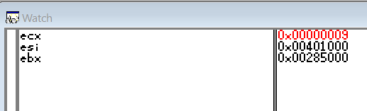 **Description:**

The first line of code I use register “ecx” as the count of loop, which is “9”.

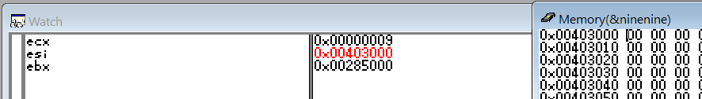

In the second line, I assign register “esi” to store the address of memory “ninenine”. So what it stored looks as same as ninenine[0] in language C’s way.

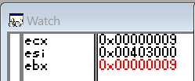Register “ebx” is a variable outside the loop to remember the number we want to give to “[esi]”.

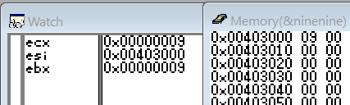 The next line of code we move the number stored in “ebx” to address “0x00403000”, which is 9.

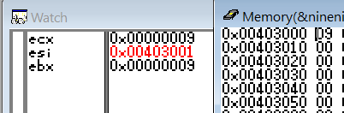 This step we move “esi” to the next address of “ninenine”.

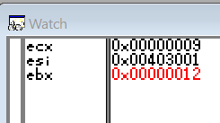 Add “9” to “ebx” in order to give the number to the next address in the next loop.

Loop pictures:

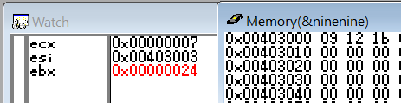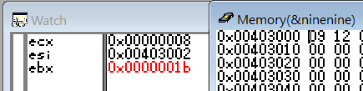

Loop 2 Loop 3

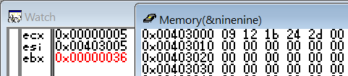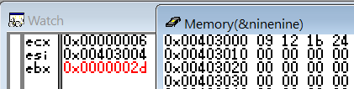

Loop 4 Loop 5

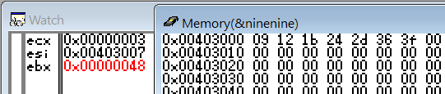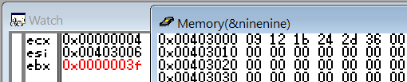

Loop 6 Loop 7

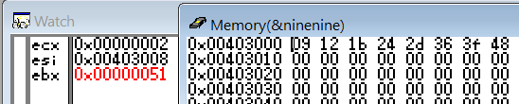

Loop 8

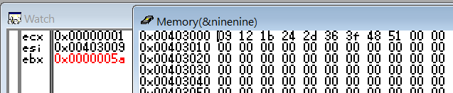

Loop 9

1. **Reviews**

Today we’ve learned about how to loop a scope of codes. We learn how to make a loop and also know that the register with “c” is going to using in loops. What’s an amazing! Also I’m thankful of both Tas that when I come and ask you guys about I can’t move my answer to memory, you are so patient and wait me for finish it though it consumes a long time. Finally, I get the problem is that address should be access by “[“ and “]”. Thank you for being so patient and teach us carefully.