**Report: Start Assembly Programming**

**Group 10**

**Member : Night、Paul**

**Student ID : 108502572、108502571**

1. **Program execution flow**

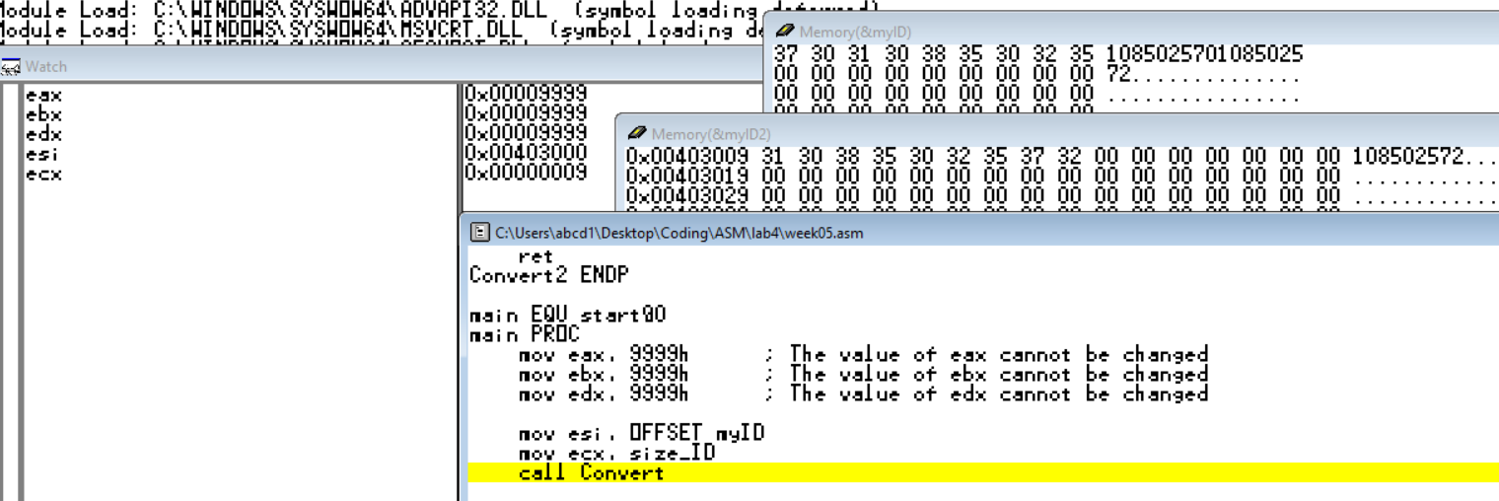 **Description:**

This is a condition before we get into “Convert”, and I use al as a register to change “[esi]” like 0-A, so I write “USES eax” in the code.

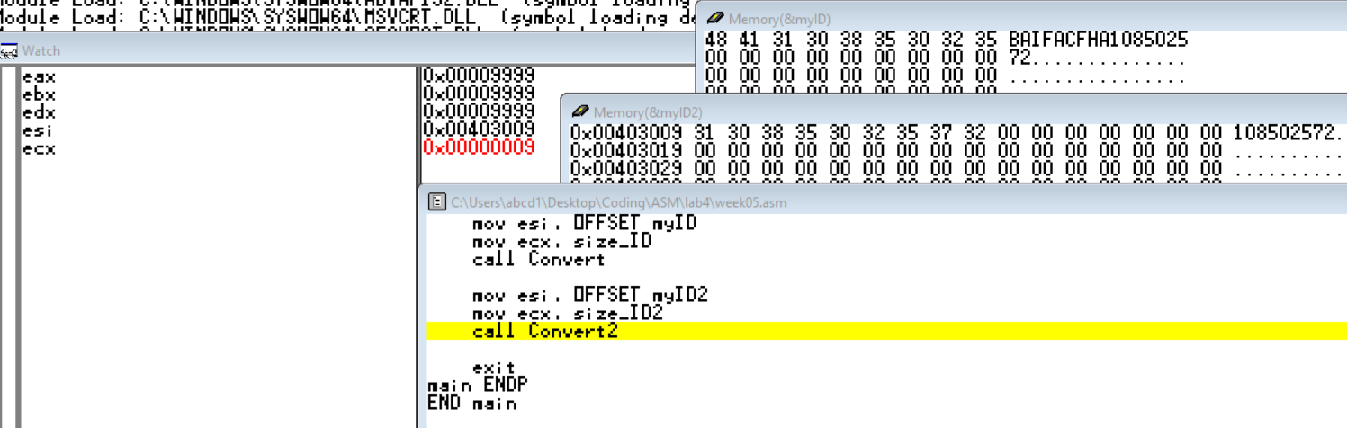The next condition is between “Convert” and “Convert2”, we could see “eax” has back to the initial number and “myID” has changed all its numbers to English elements.

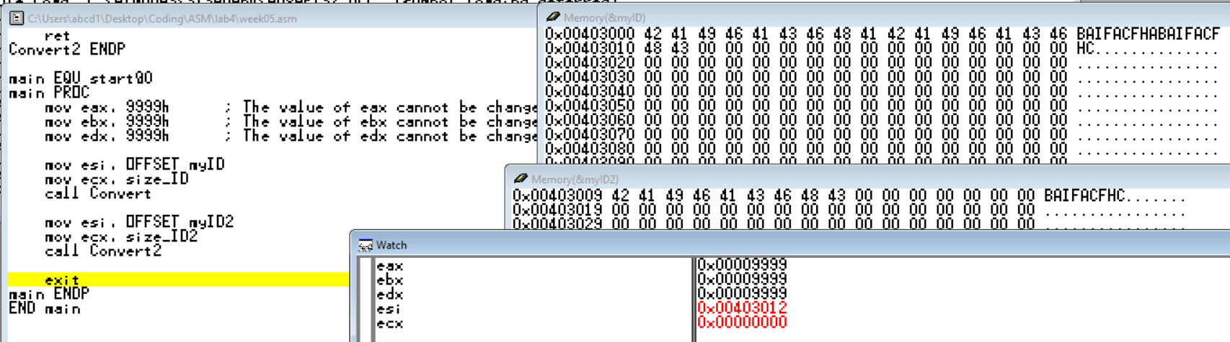The last condition of this program is that all the numbers have turned into English Elements and “eax”, “ebx”, “edx” are all “9999h” in the end.

1. **Reviews**

At the beginning, I consumed a lot of time to understand what the function doing with positions in register and what the difference between no “USES” and the use of “USES”. In the end, I just write a program and test what the change with “eax” that I finally know what it is and this is the answer why I didn’t hand in on time. After this accident, I think of a thing that I should ask someone instantly if I have any questions. Not trying that self could find out why it is or how it does, this is impossible for someone is tired enough and feels very annoying about the code. I hope so I can remember it next time. Thank for your lecturing.

1. **Others**

I sorry for one thing that our second partner’s studentID is wrong in the former reports, and this should be changed from “108502570” to “108502571”. I am sorry for increasing your amount of tasks.