Report: HW1#ARITHMETIC

CSIE Grade.2B 108502571 Paul

* Code Flows：

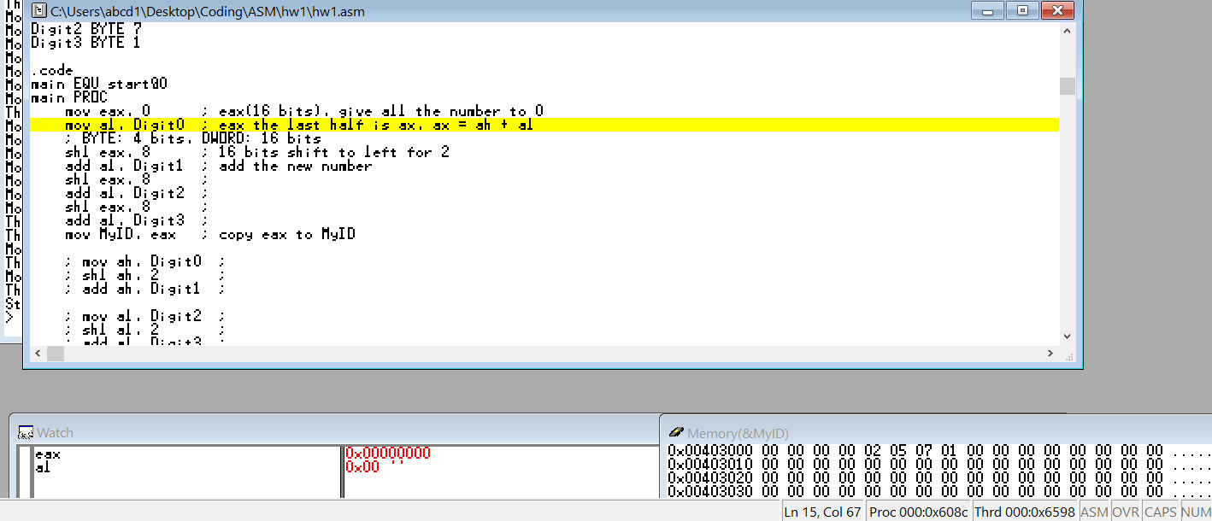

(1) Set register eax to 0

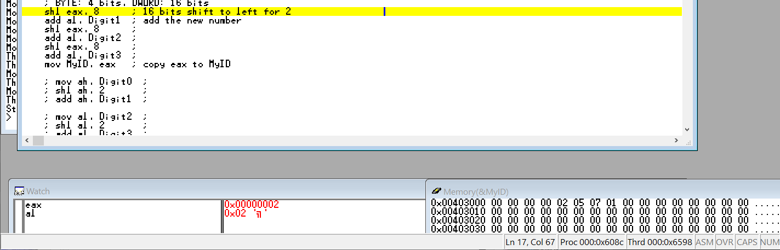

(2) Give Digit0 to register al

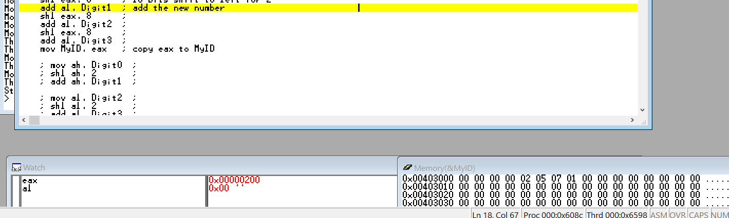

(3) Shift register eax left 8 bits

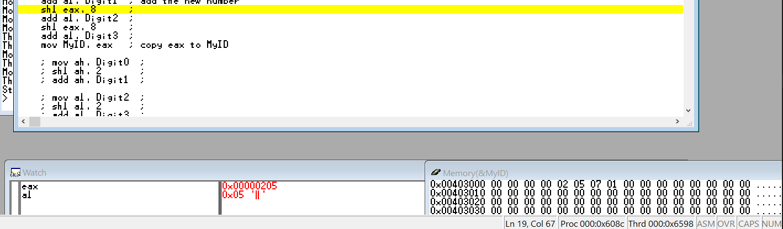

(4) Give Digit1 to register al (is equivalent to eax + Digit1)

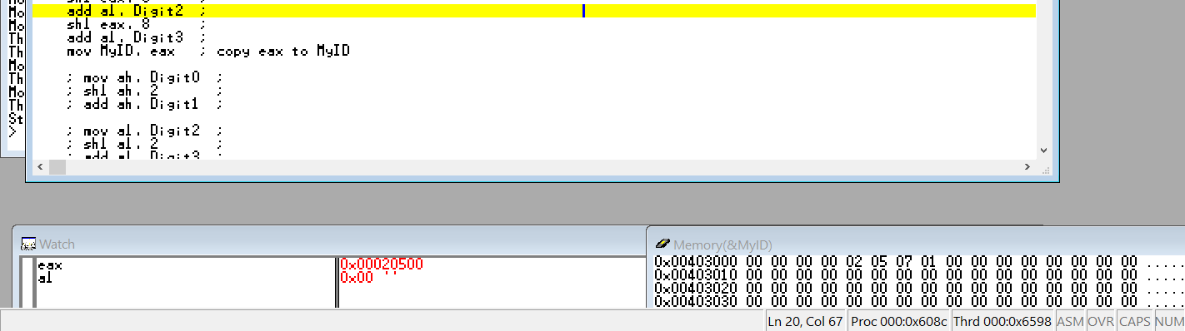

(5) Shift register eax left 8 bits

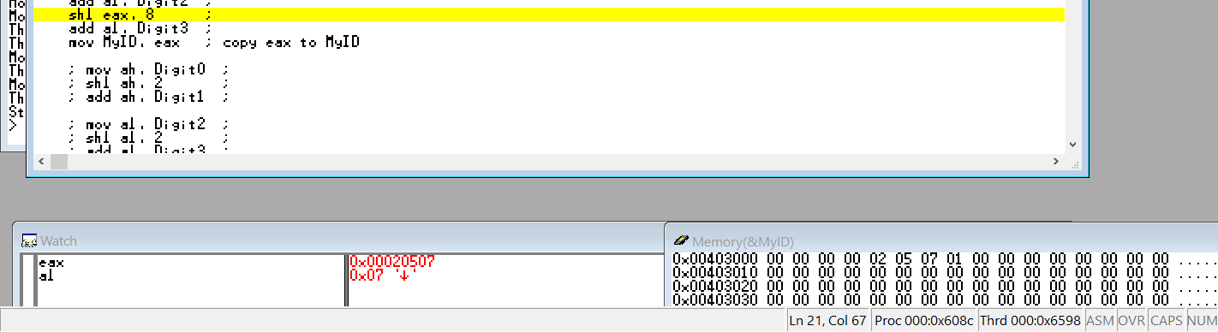

(6) Give Digit2 to al

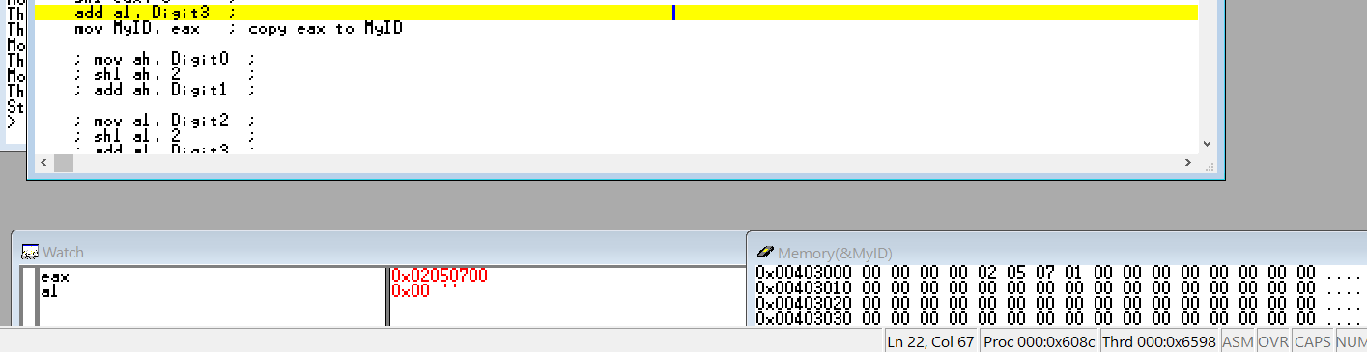

(7) Shift register eax left 8 bits

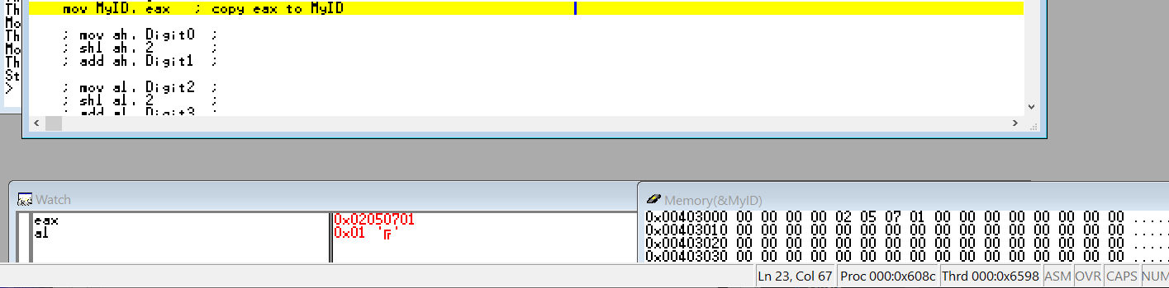

(8) Give Digit3 to register al

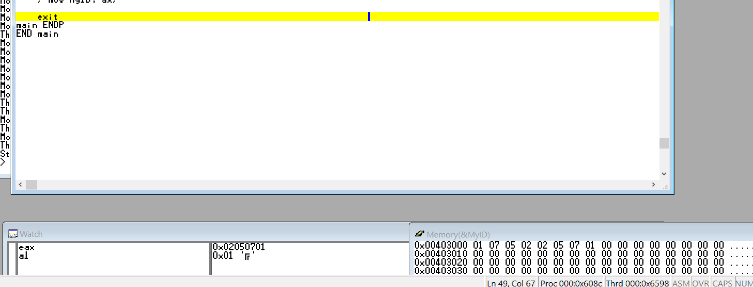

(9) Give register eax to MyID

* Finished～～：

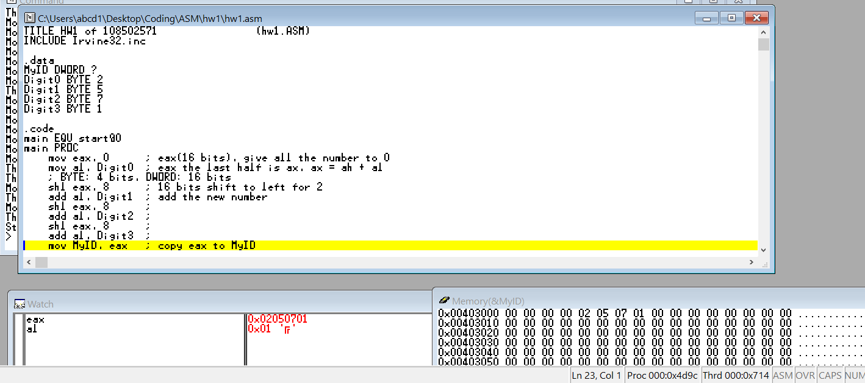

* Review：

This project is kind of difficulty and take me many efforts to understand it. Though this, it is a chance to learn more about assembly. I know more about the size of type and the way to let a register move to all 0s.