Report: HW2#PROCEDURE

CSIE Grade.2B 108502571 Paul

* ***Code Flows***

1. Do loops 8 times and **call change** in each loop. I use register esi to store the position of each ChStrs.

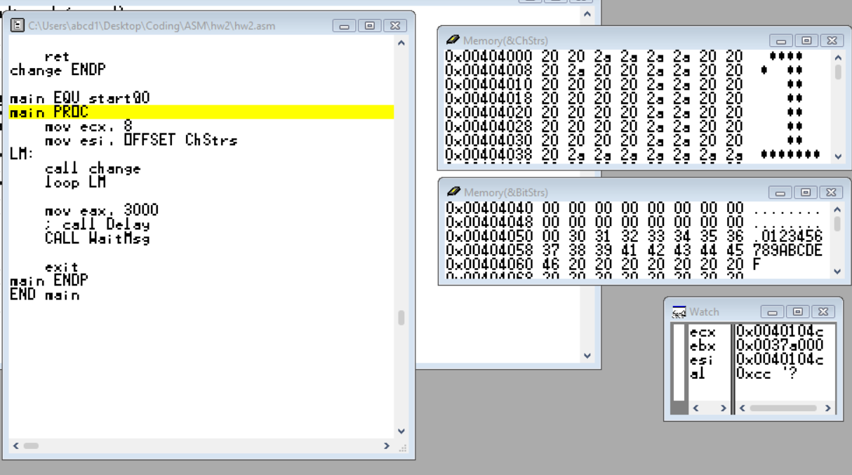

1. In **change PROC**, I push register ecx at first by using **USES**, and it would be pop out automatically. With 8 times loop following, this make each time the **8 bits information** (store in register al) could be **cmp** with ‘ ‘, which make decisions whether ‘1’ or ‘0’ to be stored in each BitStrs’ position (register ebx remember 0-7 the position in BitStrs)

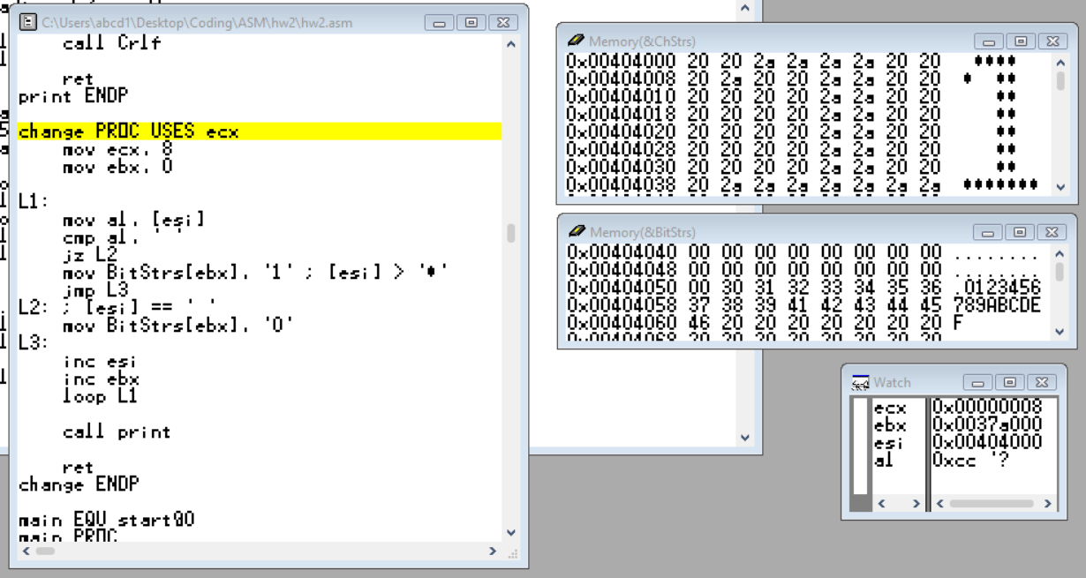

1. After **change PROC**’s loops, ‘0’ and ‘1’ in ASCII are put in BitStrs. I call **print PROC** to print out the elements in BitStrs in **char** style (**WriteChar**).

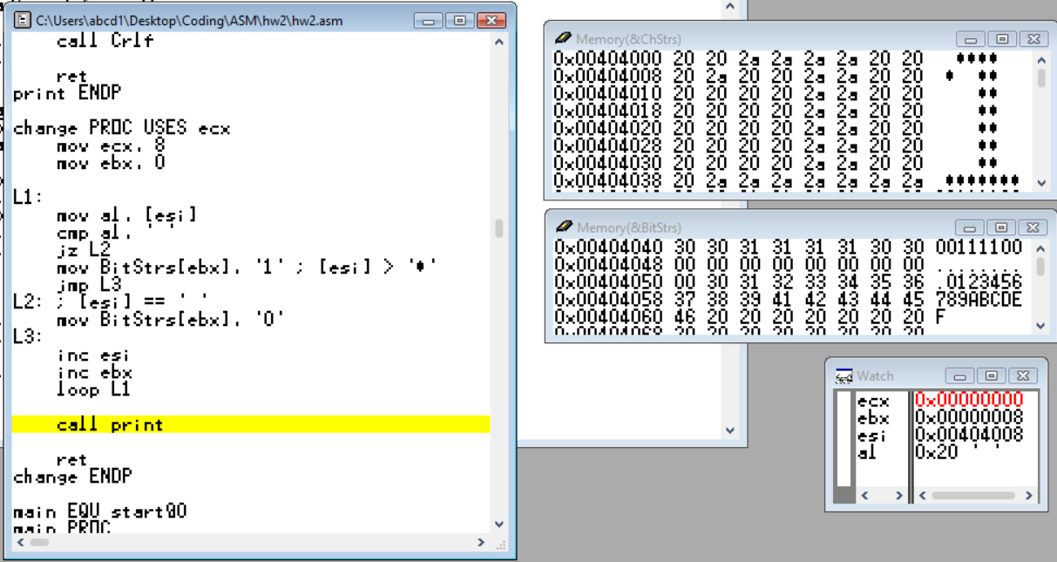

1. In **print Proc**, **USES** push register esi, ecx, and eax which were used in **change PROC** to get different position to use them. Register esi **OFFSET**s BitStrs, and Register ecx take **LENGTHOF** BitStrs which is 8. This process loops for 8 times to print out every element in BitStrs (**WriteChar**). After the loops, I move to the next line (**Crlf**).

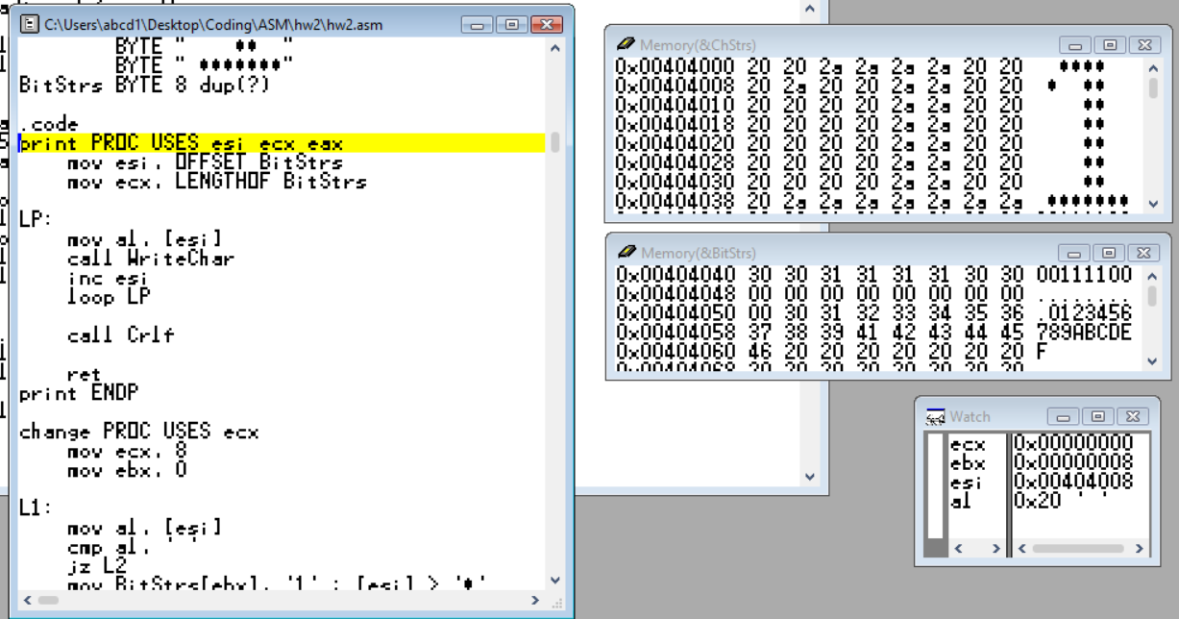

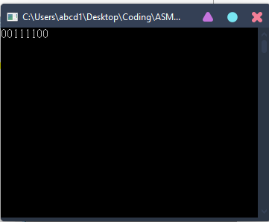

1. I call **WaitMsg** before the console close.

* ***Finished～～***

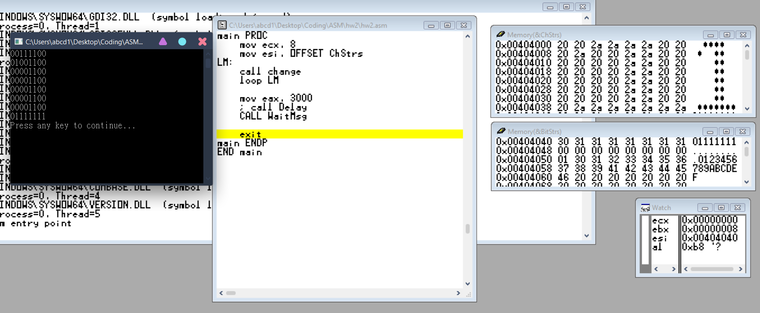

* ***Review***

I like this homework because it makes me use the things learned in the class before. By the way, I always forget the register size, and this cause very big problems whenever I want to accomplish a thinking to solve the homework. “Practice is hard, so we need to practice”, I always learn this from every lab or homework. Hoping I can practice this concept one day, XD. Thanks for your teaching.