**Report: A Simple Assembly Program**

**Group 10**

**Member : Night、Paul**

**Student ID : 108502572、108502570**

1. 一張含有 螢幕擷取畫面 的圖片

   描述是以非常高的可信度產生**Program execution flow**

一張含有 螢幕擷取畫面 的圖片

描述是以非常高的可信度產生 **Description:**

The first line of code means assign 72(my number) to the register call “al”, and then we check the register showing “0x48” whose 48 means 72 presented in hexadecimal.

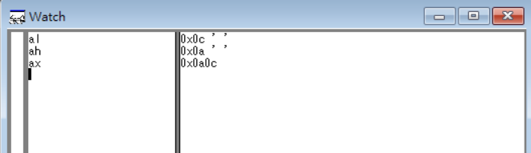 Just like above, assign 70 to “ah”, and then it shows “0x46” whose 46 means 70 in hexadecimal.

Because al is the lower 8-bits register, ah is bits 8 through 15 register, and ax is the lower 16-bits register. So, when we assign “0a0c” to ax, al and ah will change the value at the same time. See the following form:

|  |  |  |  |  |
| --- | --- | --- | --- | --- |
| ax | 0000 | 1010 | 0000 | 1100 |
| al |  |  | ~~0100~~ 0000 | ~~1000~~ 1100 |
| ah | ~~0100~~ 0000 | ~~0110~~ 1010 |  |  |

一張含有 螢幕擷取畫面 的圖片

描述是以非常高的可信度產生

We assign “eeea” to dx, so it shows “eeea”.

一張含有 螢幕擷取畫面 的圖片

描述是以非常高的可信度產生

At the last line of code, we write “sub dx, ax”

which means dx=dx-ax. Therefore, dx=eeea, ax=a0c, and then eeea-a0c=e4de same as the screenshot.

1. **Reviews**

Today we’ve learned about the basic architecture of assembly language, such as the ways to declare variable, and how to assign values to register. What’s more, today we got a new tool called Windbg. Although it was kind of complicated to set up, we were still able to finish it and compile our program. There was a question I forgot to ask, that is, why when check the register al and ah, there were “H” and “F” at the end of line? I hope TA can explain it next class. Both of two TA were very nice, and it’s not difficult to understand what you said.