

**NMAM INSTITUTE OF TECHNOLOGY**

(A unit of Nitte Education Trust)

Nitte - 574 110, Karkala taluk, Udupi Dist., Karnataka

**Department of Computer Science and Engineering**

**RDBMS PROJECT REPORT ON**

**BLOOD BANK MANAGEMENT SYSTEM**

**PROJECT ASSOCIATES**

**Stalin Christopher Dsouza Sujay S Shenoy**

**4NM17CS187 4NM17CS188**

**V Sem, Sec 'D' V Sem, Sec 'D'**

**Dept of C.S.E Dept of C.S.E**

**PROJECT GUIDE**

**Ms. Anusha Anchan**

**Dept of C.S.E.**

**NMAMIT**

**ABSTRACT**

Blood donation is a voluntary practice that helps those in need of blood transfusion due to some accident or illness. The most essential body fluid, excessive blood loss can cause an untimely death if the need is not fulfilled immediately. Hence, blood donation is a life-saving procedure.

There may be different reasons behind the blood requirement of an ill person. Maybe he has met with an accident, has undergone an operation or is suffering from an illness like anemia. Your donated blood goes on to help this affected person in overcoming his/her critical situation and regain new life. It symbolizes a helpful and responsible gesture not only to the person in need, but also towards society at large.

Blood can neither be artificially produced nor can it be stored beyond a definite time. Amidst the three components of blood, plasma can be preserved for years, red blood cells can be stored for 42 days and platelets can be kept only for 5 days. Consequently, the rush for blood is always on the high in hospitals and the only way to meet this requirement is through donation.

Blood donation is our human duty. Our body does not get affected if we donate blood. The body can repair the loss within a few days. So we must come forward to donate blood as it can make sure the return of a dying man again into the light of life.

**CERTIFICATE**

Certified that the project work carried out by Stalin Christopher Dsouza(4NM17CS187) and Sujay S Shenoy (4NM17CS188) bonafide students of NMAM Institute of Technology, Nitte in fulfilment for the Relational Database Management System lab in Computer Science and Engineering during the academic year 2019-2020.

Signature of the Examiners:

Signature of the Guide:

1.

2.

**ACKNOWLEDGEMENT**

The satisfactions that accompany the successful completion of any task would be incomplete without the mention of the people who made it possible. So we acknowledge all those whose guidance and encouragement served as a beacon of light and crowned our efforts with success.

We are thankful to our project guide, Ms. Anusha A, Dept. of CSE for her valuable guidance and advice. Her willingness to motivate us contributed tremendously to our project.

We would also like to thank Mr.Ranjan Kumar HS and Mr.Pawan Hegde for their guidance.

We would like to place on record our deep sense of gratitude to Dr. K. R. Udaya Kumar Reddy, HOD-Dept. of Computer Science and Engineering, NMAMIT, Nitte for his generous guidance, help and useful suggestions. We also acknowledge and express our sincere thanks to our beloved Dr. Niranjan. N. Chiplunkar, Principal, NMAMIT, Nitte who is a source of inspiration to us.

We thank all the Teaching and Non-Teaching staff members of the department of CSE for providing resources for the completion of the project. A special thanks goes to our parents and friends for supporting and encouraging us in all ways thus making our project successful. Finally, we thank all those who have contributed directly or indirectly in making this project a grand success.

Stalin Christopher Dsouza

(4NM17CS187)

Sujay S Shenoy

(4NM17CS188)

**TABLE OF CONTENTS**

**Chapter Page no.**

1. **INTRODUCTION 1**
2. **SYSTEM REQUIREMENTS 4**
3. **DESIGN 6**
4. **IMPLEMENTATION 8**
5. **SCREENSHOTS 9**

**CONCLUSION**

**REFERENCE**

**CHAPTER 1**

**INTRODUCTION**

Blood donation is one of the most significant contribution that a person can make towards the society. It is not harmful for an adult person to donate blood. The body of the donor can regenerate the blood within few days. It poses no threat to the metabolism of the body.

The "Blood Bank Management System" has been developed to override the problems prevailing in the practicing manual system. This software is supported to eliminate and in some cases reduce the hardships faced by this existing system.

**REQUIREMENTS FOR BLOOD DONATION:**

For a person to donate the blood there are several requirements that has to be met before donating the blood to the blood bank.

**PARAMETERS THAT DETERMINE THE ELIGIBILITY TO DONATE BLOOD:**

* Overall health- The donor must be fit and healthy, and should not be suffering from transmittable diseases.
* Age and weight- The donor must be 18–65 years old and should weigh a minimum of 50 kg.
* Pulse rate- Between 50 and 100 without irregularities.
* Hemoglobin level- A minimum of 12.5 g/dL.
* Blood pressure- Diastolic: 50–100 mm Hg, Systolic: 100–180 mm Hg.
* Body temperature- Should be normal, with an oral temperature not exceeding 37.5 °C.
* The time period between successive blood donations should be more than 3 months.

**You will not be eligible to donate blood if you are:**

* A person who has been tested HIV positive.
* Individuals suffering from ailments like cardiac arrest, hypertension, blood pressure, cancer, epilepsy, kidney ailments and diabetes.
* A person who has undergone ear/body piercing or tattoo in the past 6 months.
* Individuals who have undergone immunization in the past 1 month.
* Individuals treated for rabies or received Hepatitis B vaccine in the past 6 months.
* A person who has consumed alcohol in the past 24 hours.
* Women who are pregnant or breastfeeding.
* Individuals who have undergone major dental procedures or general surgeries in the past 1 month.
* Women who have had miscarriage in the past 6 months.
* Individuals who have had fits, tuberculosis, asthma and allergic disorders in the past.

**PROBLEM STATEMENT**

At present, the public can only know about the blood donation events through conventional media means such as radio, newspaper or television advertisements. There is no information regarding the blood donation programs available on any of the portal. The current system that is used by the blood bank is manual system. With the manual system, there are problems in managing the donors' records. The records of the donor might not be kept safely and there might be missing of donor's records due to human error or disasters.

Besides that, errors might occur when the staff keeps more than one record for the same donor. There is no centralized database of volunteer donors. So, it becomes really tedious for a person to search blood in case of emergency. The only option is to manually search and match donors and then make phone calls to every donor. There is also no centralized database used to keep the donors' records.

Each bank is having their own records of donors. If a donor makes donation in different hospital, no previous records can be traced except if the donor brings along the donation certificate. Hence, the donor is considered to be a first-timer if they make blood donation in a new place.

Without an automated management system, there are also problems in keeping track of the actual amount of each and every blood type in the blood bank. In addition, there is also no alert available when the blood quantity is below its par level or when the blood in the bank has expired.

**OBJECTIVES OF THE PROJECT**

The main objective of the Project on Blood Bank Management System is to manage the details of Blood Bank, Blood Group, Donor, Blood Stock and Transactions. It manages all the information about Blood Bank, Record, Donor details. The project is built at administrative end and thus admin is the main authority who can do addition, deletion, and modification if required. The registered user on the other end can only view the donations, update the profile and change the password.

**FEATURES OF THE BLOOD BANK MANAGEMENT SYSTEM**

* Manage the information of Donor
* Shows the information and description of the Blood, Blood Group
* All the fields such as Blood, Blood Group are validated and does not take invalid values
* It deals with monitoring the information and transactions of Blood Bank
* Editing, adding and updating of Records is improved which results in proper resource management of Blood data
* Donor can update the profile and change the password.
* Donor can view the total amount of blood donated to the blood bank

**CHAPTER 2**

**SOFTWARE REQUIREMENTS**

**FRONTEND TECHNOLOGY:**

**1. Hyper Text Markup Language(HTML)**

Hypertext Markup Language is the standard markup language for creating web pages and web applications.

**2. Cascading Style Sheets(CSS)**

Cascading Style Sheets is a style sheet language used for describing the presentation of a document written in a markup language like HTML

**3. JavaScript**

JavaScript, often abbreviated as JS, is a high-level, interpreted programming language. It is a language which is also characterized as dynamic, weakly typed, prototype-based and multi-paradigm.

**BACKEND TECHNOLOGY:**

**1.PHP**

Hypertext Preprocessor is a server-side scripting language designed for Web development, and also used as a general-purpose programming language. It was originally created by Rasmus Lerdorf in 1994, the PHP reference implementation is now produced by The PHP Group.

**2.Laravel**

Laravel is a free, open-source PHP web framework, created by Taylor Otwell and intended for the development of web applications following the model–view–controller (MVC) architectural pattern and based on Symfony. Some of the features of Laravel are a modular packaging system with a dedicated dependency manager, different ways for accessing relational databases, utilities that aid in application deployment and maintenance, and its orientation toward syntactic sugar.

**Database:**

**MySQL:**

MySQL is an open-source relational database management system. Its name is a combination of "My", the name of co-founder Michael Widenius's daughter, and "SQL", the abbreviation for Structured Query Language.

**CHAPTER 3**

**DESIGN**

**ER-Diagram**

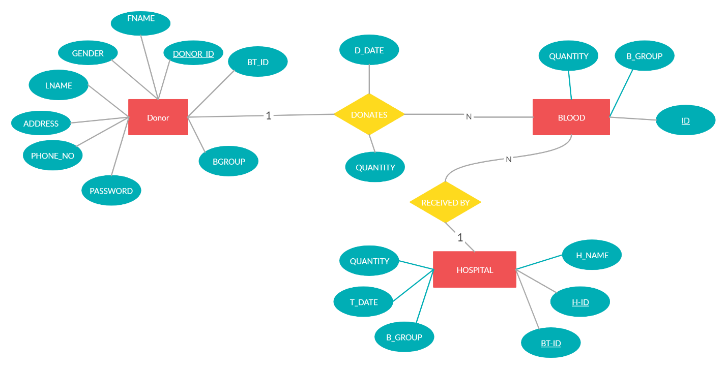

This ERD summarizes the entire database of the blood bank management system where the data is organized into different relations.

**SCHEMA**

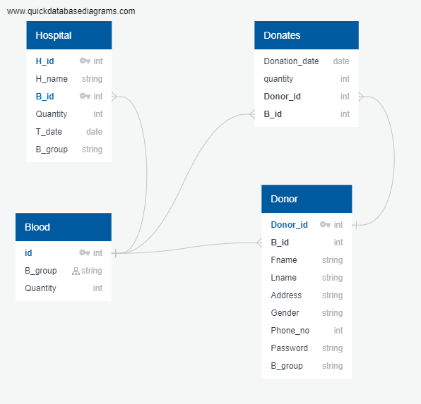

This relation schema gives the detailed information of the above ER diagram and also gives a proper explanation of the different relations used in the database.

**CHAPTER 4**

**IMPLEMENTATION**

The project is built at administrative end and thus admin is the main authority who can do addition, deletion, and modification if required. The registered user on the other end can only view the donations, update the profile and change the password.

**ADMIN LOGIN:**

* Admin has to login to the website with the correct password
* Once the admin has logged in to the website he/she can add the details of a new donation into the blood bank which will be stored into the database
* Admin can also view all the donations made by the donors
* Admin can also manage the donors in the database where admin can delete the donors registered to the blood bank
* Admin can view the total blood available in the blood bank
* Admin can add a new hospital transaction when a hospital request for blood from the blood bank
* Admin can also view details of all the transactions taken place in the blood bank

**DONOR LOGIN:**

* Donor has to first register into the website by filling the registration form given in the homepage of the website
* Once the donor has registered he/she has to login into the website using correct password
* Donor can view the donation rules that has to be followed before donating blood
* Donor can view the details of the past donations made by him/her (i.e. donation date and quantity of blood donated)
* Donor can also update the basic information such as address and phone number
* Donor can view the profile where the basic information will be displayed inside a card
* Donor can also update the password if required

**CHAPTER 5**

**SCREENSHOTS**

**HOME PAGE:**

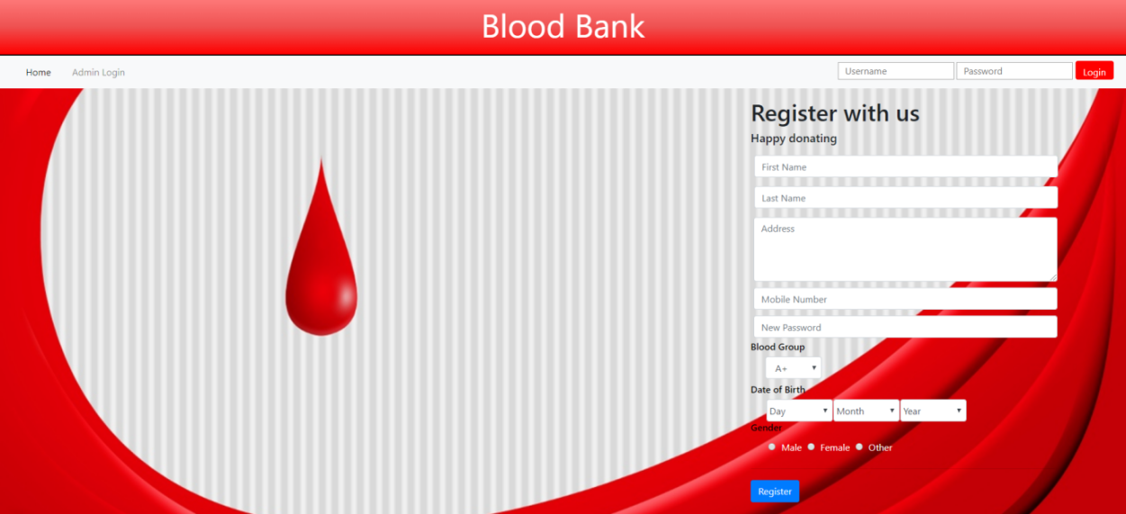

This is the homepage of the blood bank management system where the admin/donor can login and a new donor can register to the blood bank.

**ADMIN LOGIN:**

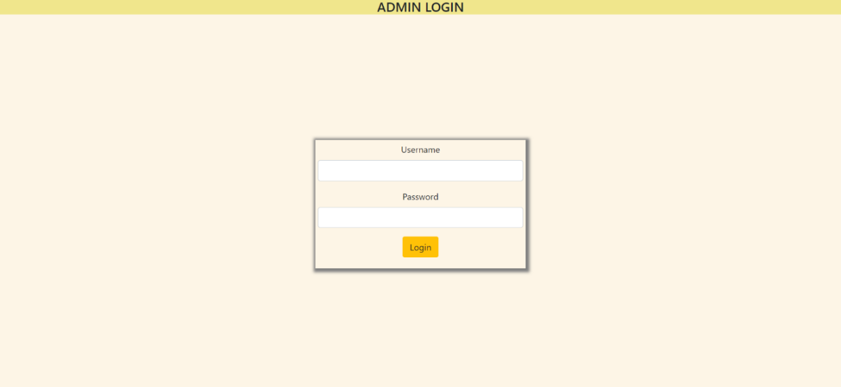

This is the admin login screen where the admin can log into the website. Only after logging into the website the admin can access the features of the blood bank management system.

**ADMIN HOME:**

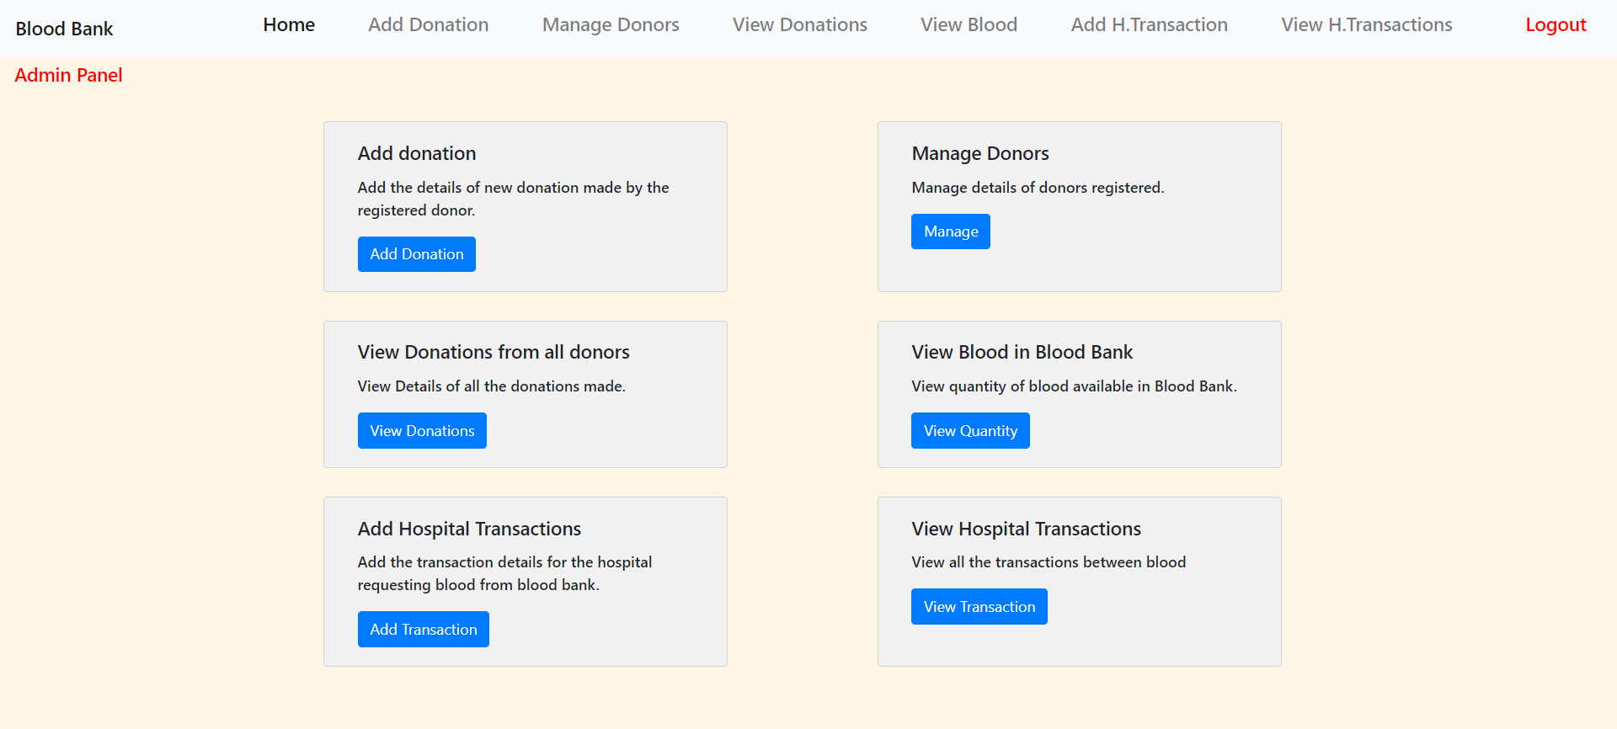

This is the admin home where the admin can access the different functions available in the website

**ADD DONATION:**

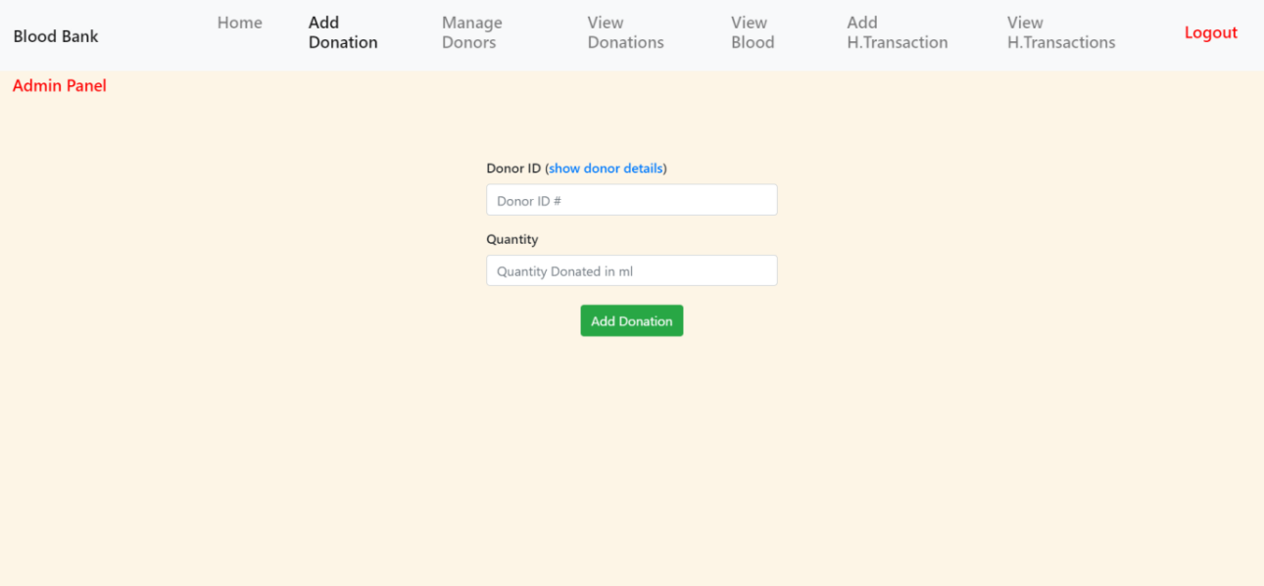

Here the admin can add the details of the new donation made by the registered donor. The admin has to add the id of the donor and the amount of blood donated by the donor.

**ADD HOSPITAL TRANSACTION:**

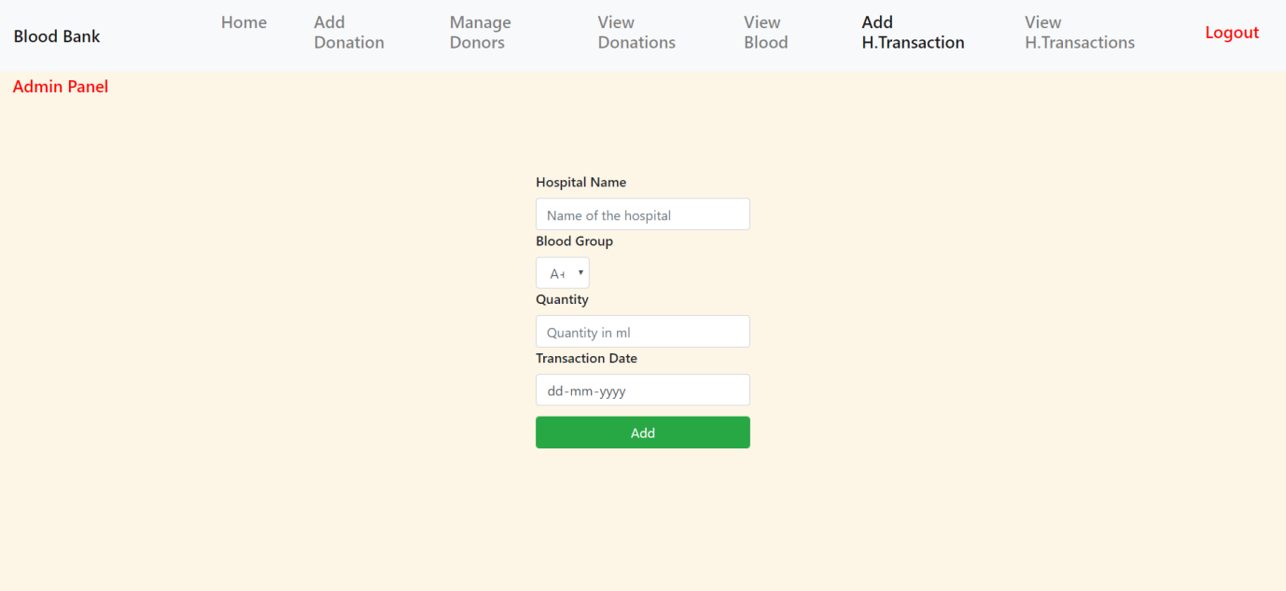

Add the details of the hospital that requires the blood. Here the admin can add the details of the new transaction where the hospital name, the blood group name, the quantity of blood required and the transaction date has to be entered.

**MANAGE THE DONORS:**

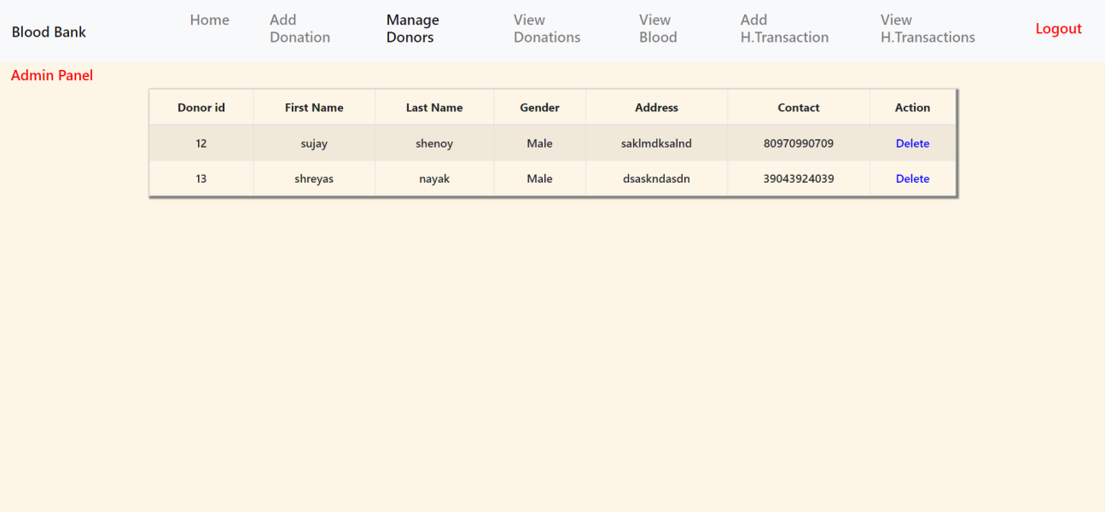

Here view the details of the donors registered in the blood bank and also delete the details of the donor if needed.

**VIEW THE DONATIONS MADE BY THE DONORS:**

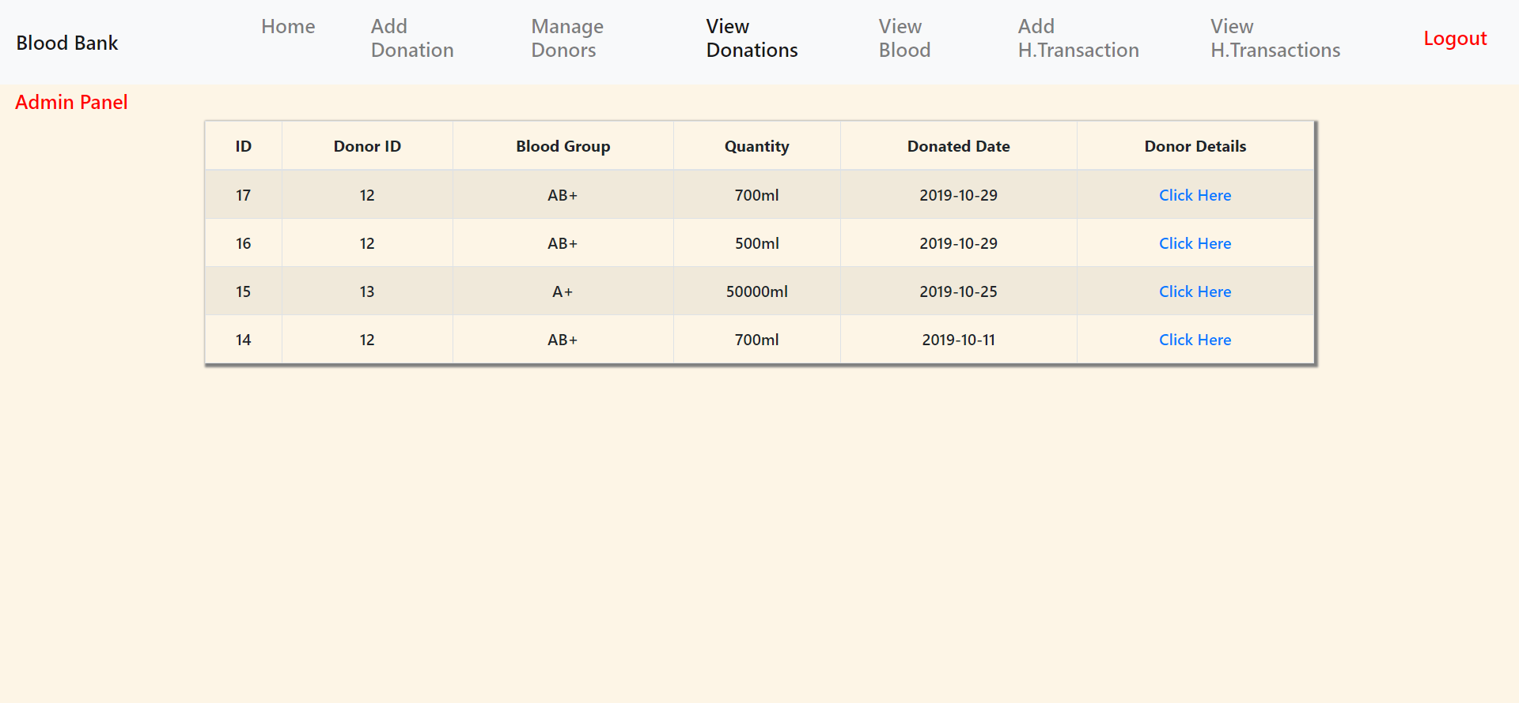

Here view all the donations made by the different donors. Here the admin can view the different donations made by the different donor which is displayed according the donor id.

**VIEW THE TOTAL BLOOD AVAILABLE IN THE BLOOD BANK:**

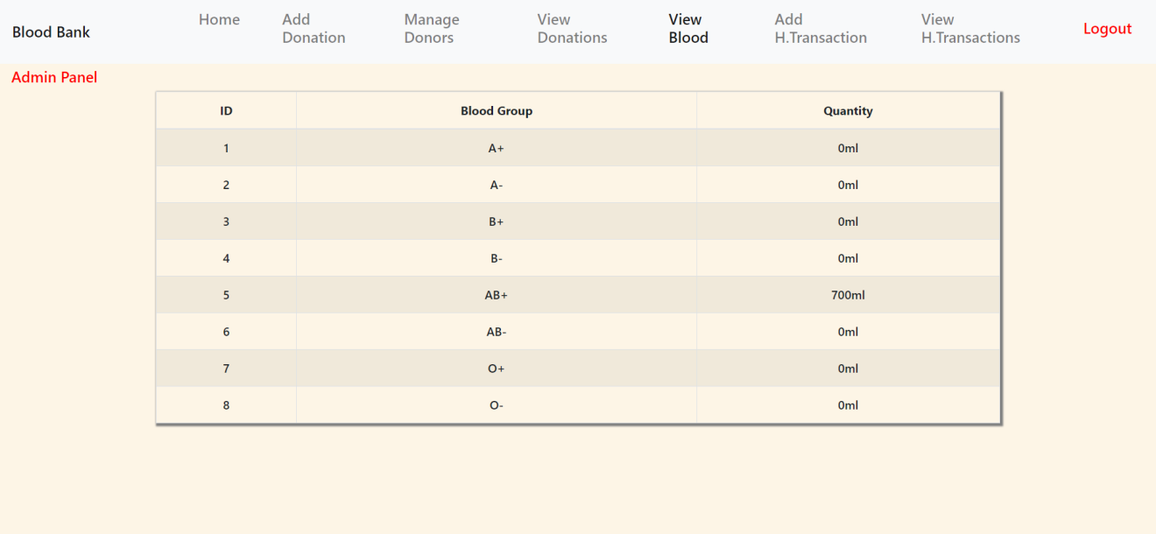

Here the admin can view the total blood of different blood groups available in the blood bank.

**VIEW HOSPITAL TRANSACTIONS:**

Here view all the transaction details of different hospitals that borrowed the blood from the blood bank. Here the transaction date, quantity of blood, order id, hospital name will be displayed in a table.

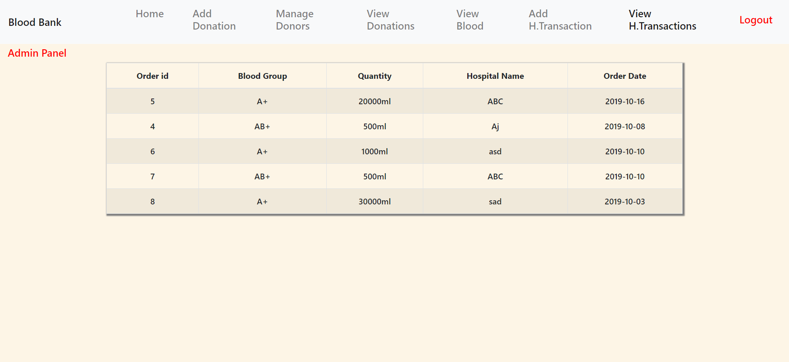

**DONOR REGISTRATION SUCCESSFULL:**

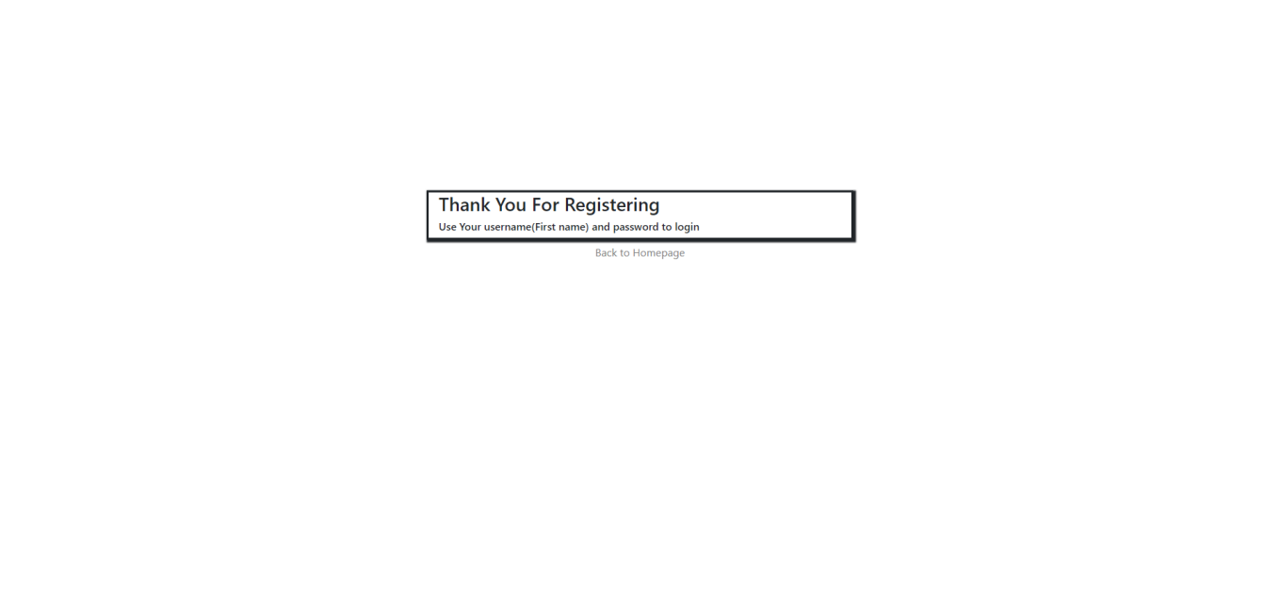

This wil be displayed once the donor registers to the blood bank.

**DONOR HOME:**

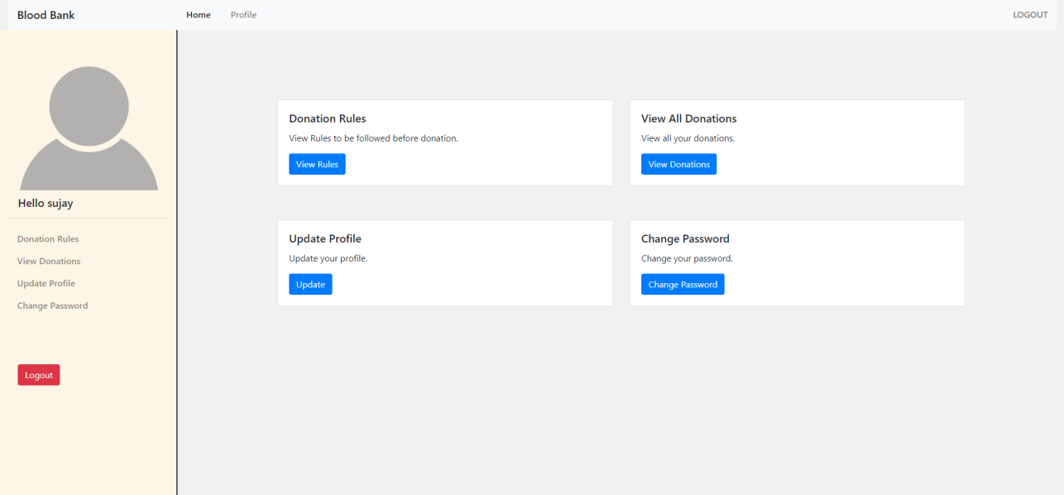

This is the homepage of the donor that logs into the website. The donor has to login in to the website with the correct password. Only after logging in the website the donor can access the different functions available to the donor.

**RULES FOR DONATION:**

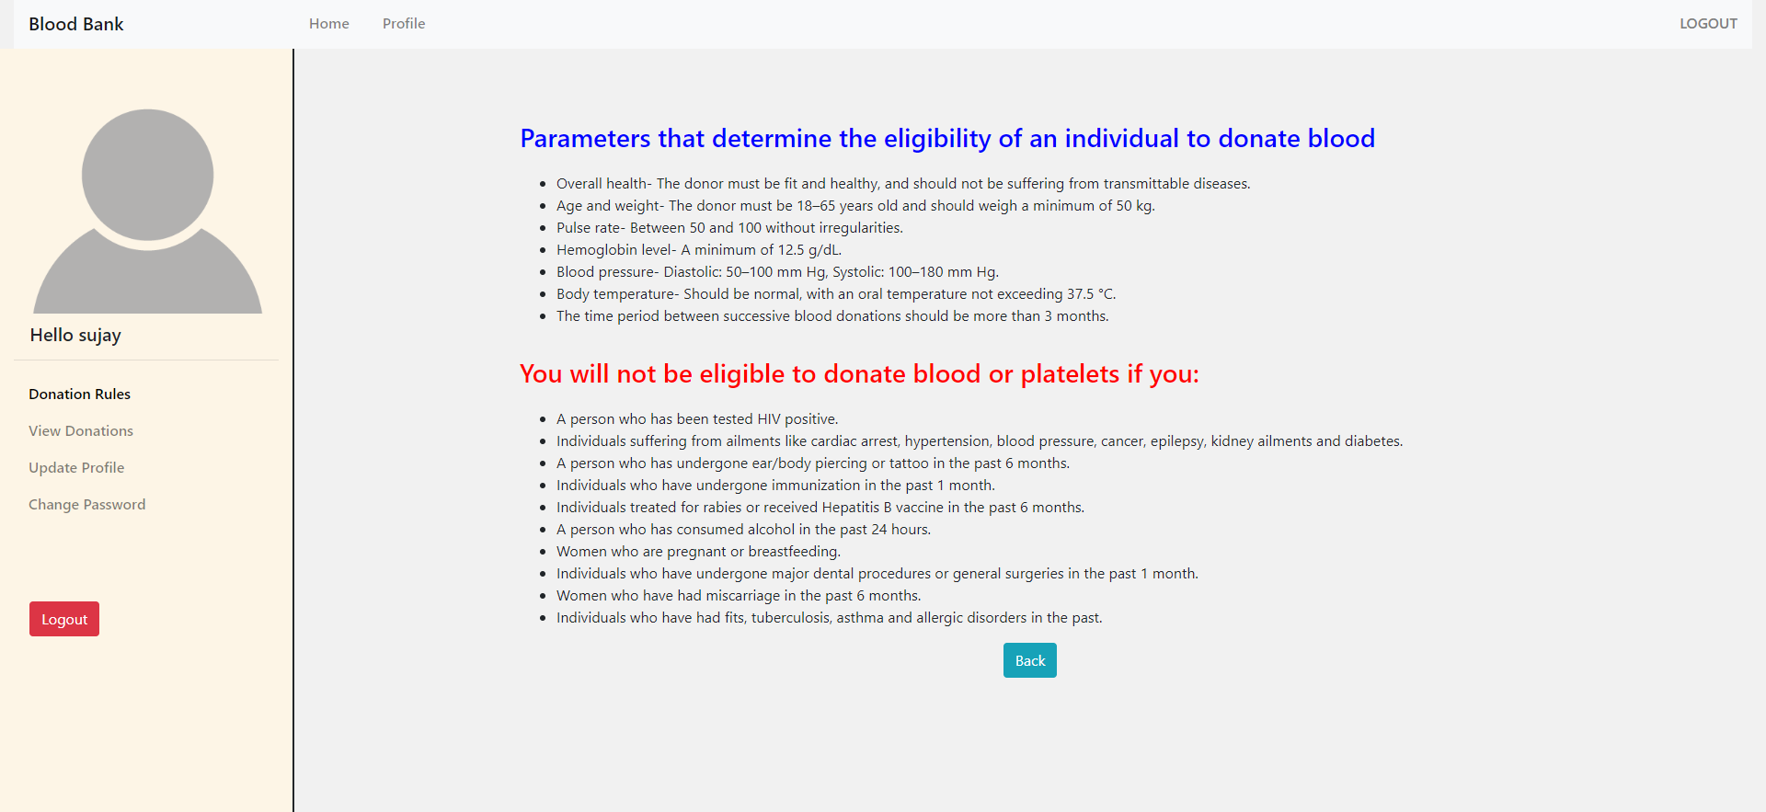

Here donor can view the rules for the donation. Here the different requirements for blood donation are specified.

**VIEW DONATIONS(DONOR):**

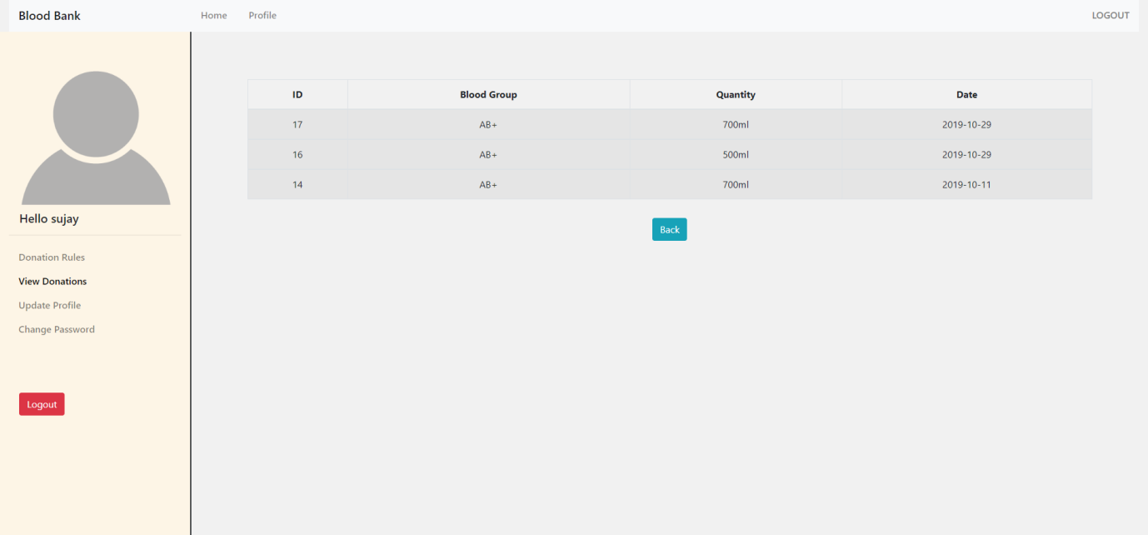

Here the logged in donor can view the details of past donations made by him/her. The donation date, quantity of blood donated, blood id and the blood group will be displayed.

**UPDATE DONOR PROFILE:**

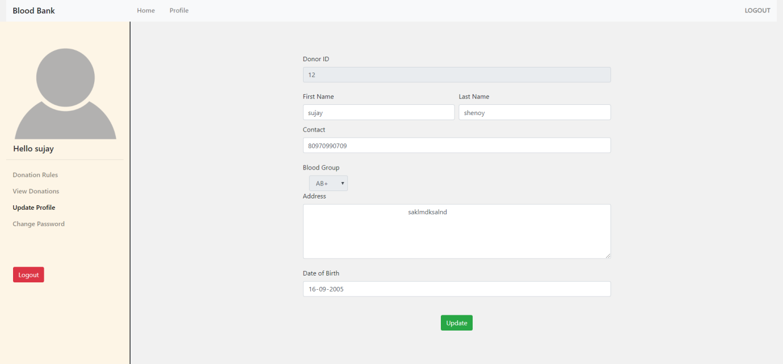

Here the donor can update the basic information like phone number, address and so on. This feature is really helpful to the donor if in case his/her phone number or the address has been changed.

**CHANGE PASSWORD:**

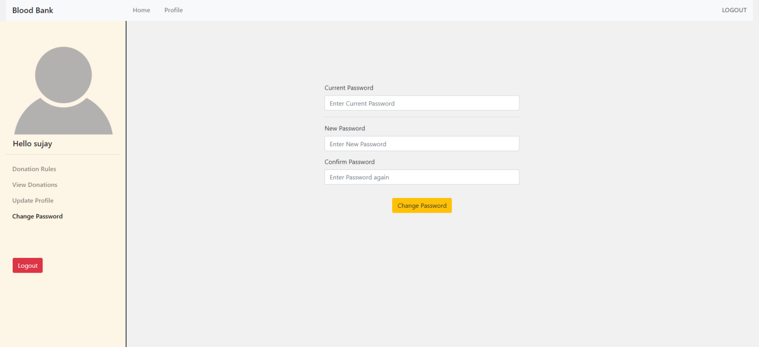

Here the donor can update the password. The registered donor can change the password whenever required.

**VIEW PROFILE:**

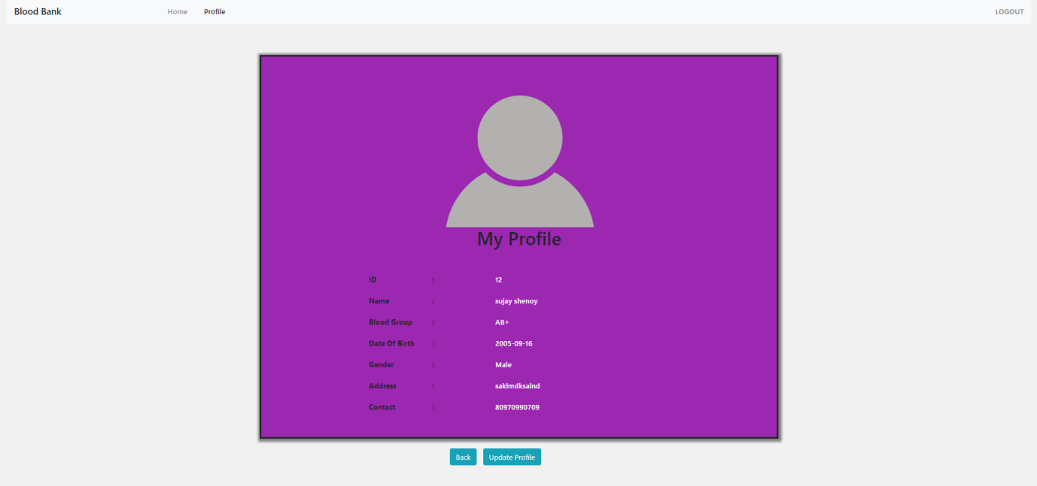

Here the donor can view his/her profile. A card will be displayed in which all the basic information like id, name, blood group, address, phone number and so on will be displayed.

**CONCLUSION**

The **blood bank management system** is successfully designed and developed to fulfil the necessary requirements of the blood bank and the donor. This web based system allows the blood bank employees to easily access the donor's information, manage the donor list, check the available blood for donation and also keeps track of the various transaction that takes place between the different hospitals. The donor on the other hand can register to the blood bank and obtain the information regarding all the donations and also update the profile or change the password when required.

The system is strong enough to withstand operations under conditions where the database is maintained. The implementation of the system in the organization will considerably reduce data entry and time.

**REFERENCES**

1. **[www.stackoverflow.com](http://www.stackoverflow.com)**
2. **[www.youtube.com](http://www.youtube.com)**
3. **[www.w3schools.com](http://www.w3schools.com)**
4. **[www.laravel.com](http://www.laravel.com)**
5. **[www.bootstrap.com](http://www.bootstrap.com)**
6. **www.wikipedia.com**