Astana IT University

IT-2101

Group: Arman Karimov, Beybaryssultan Aitbayev

Web technologies 2

Final exam

Project documentation

Outlook

* Project goal
* Project structure
* Request example
* Database structure
* Group responsibilities

Project goal

The purpose of the project is to create a website similar to an online store with the functionality of adding products to the cart, taking into account the stock of these products. Achieve this using MongoDB data structure, RESTful API.

Project structure

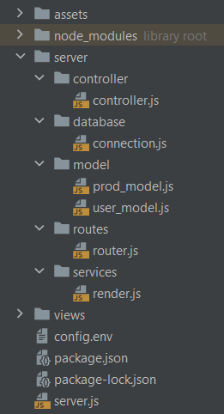Assets – css, js scripts

Server – server modules

Controller – module, performs API requests

Database – module, connects to database

Model – models for collections

Routes – module, maintains routes between client and server sides

Render – module, callbacks client requests

Views – contains frontend views

Config.env – configuration values

Server.js – starting point of server, refers to all modules

Request example

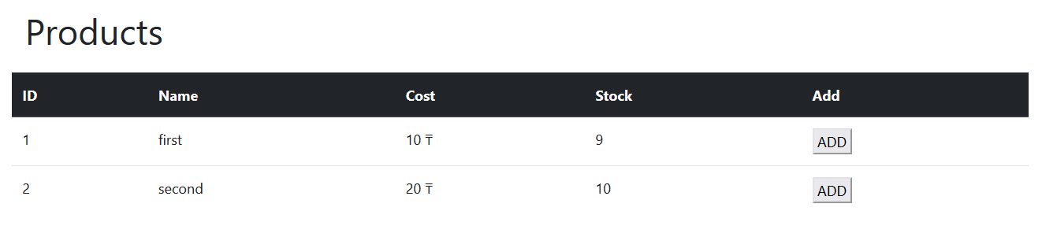

When you press ADD button, it creates a POST request with user and product id’s in its query to /main/add_cart

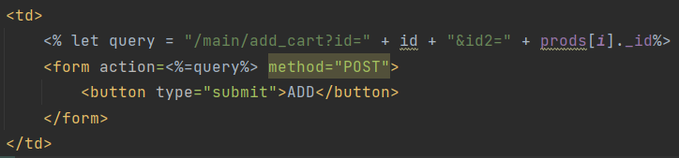

Router accepts that request, referring to renders add_cart function



On it’s turn, it creates axios GET request to API with both id’s in query

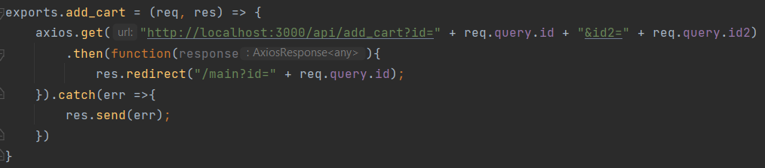

Controller accepts id’s, searching for user with product in cart. If such user doesn’t exist, it means that such product wasn’t in user’s cart before. Therefore, it pushes a new element (product’s id) in cart array. If such user does exist, it just increments count field in product’s cart array.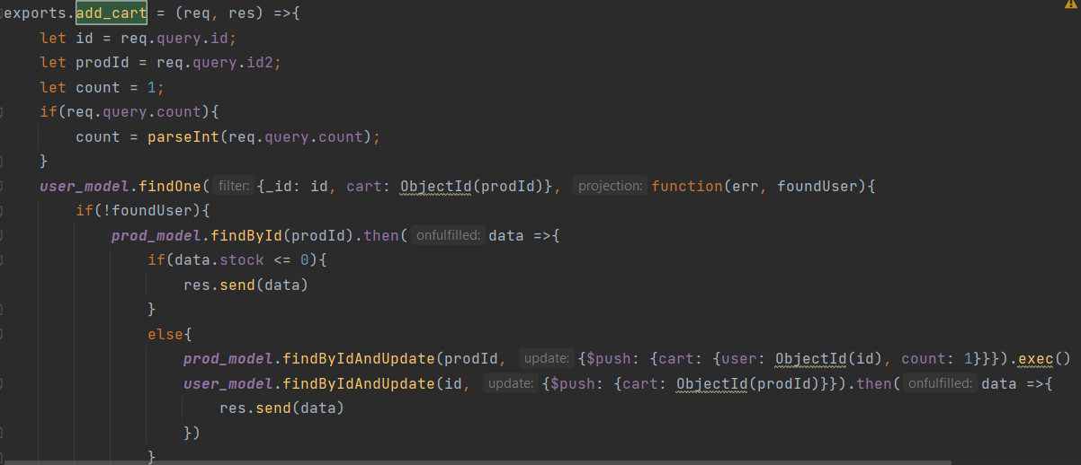

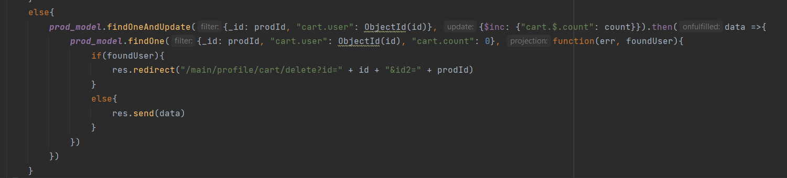

Database structure

usersproducts

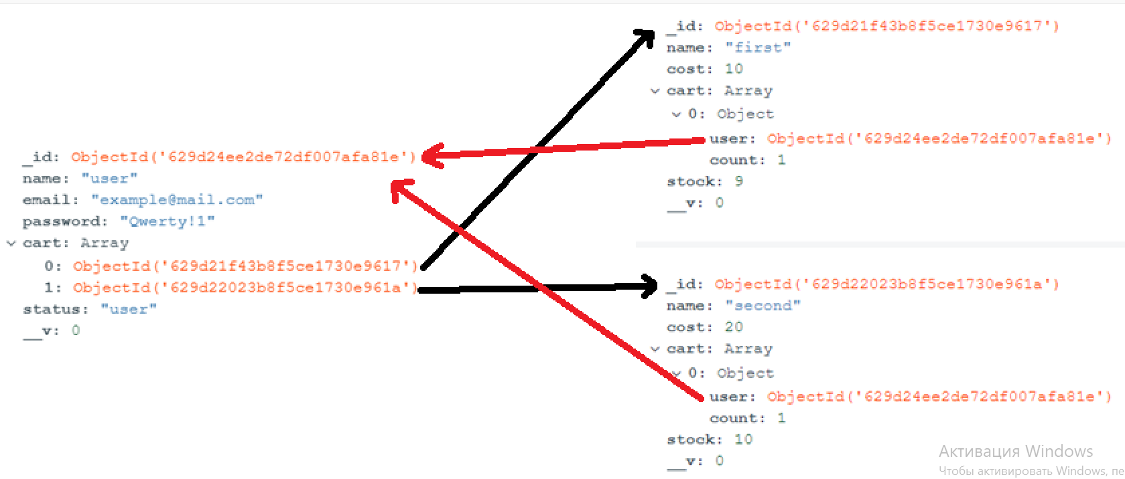

Database consists of two collections: users and products. Cart in each collection refers to another collection, making many-to-many type of reference. It is used because it allows to keep track of product’s count for each user, without document overload.

REST

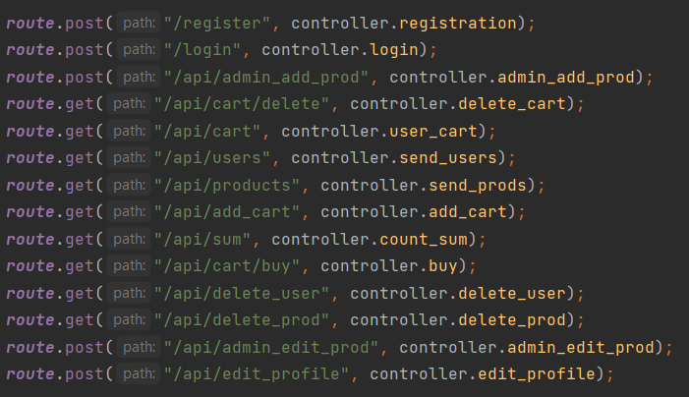

Group responsibilities

|  |  |
| --- | --- |
| Arman | Sultan |
| Routing | Login/registration |
| REST API | Frontend |
| MongoDB manipulation | Admin page |