Final Project

CS-499

John Stallard

4/21/19

These artifacts that I have submitted, I believe fit well in to my portfolio as they demonstrate the elements that the project was looking for, it shows that I have the ability to write code and for the program to read it correctly, if I am honest this is not my strongest talent, but this is something that I have improved in considering using pymongo and mongodb is something that I had never used prior to that class. The databases shows that I have the ability to read the graphs and interpret the data, once I have read the data I can adequately show how and where the company is being successful within their online store, and offer suggestions as to how the company may improve or attempt to gain more customers in purchasing particular products. The Data structures shows that I am able to adequately define the software cycle in a way that makes sense to the reader so that they are able to follow along. It shows how the user is able to log in and go through the cycle of obtaining class and course records through to the success of registering for a class.

The coursework through this computer science class has been very interesting to say the least, it allowed me to go back through some of the work that had been completed some time ago, it has allowed me to see where some of my strengths and weaknesses lie within the computer science field, it also has helped me to understand where I may want to enter in terms of what field in IT I would like to do.

This is the first time that I have done anything with MongoDB and Pymongo, this certainly wasn’t an easy field for me, it took some time for me to understand it, but I feel like I have gotten better but still need to continue working with it to improve some more. I have included in Github a good portion of the work that I have done, this includes Updating, reading information, removing information using the .remove function, and the code that I inputted. Collaborating in a team environment with algorithms is certainly essentially, this allows people to work as a team, and perform a code review on each other’s work, this is an important aspect to the success of the people doing the work, but also it is essential for the company to ensure that all deadlines are met and there are no delays costing the company value time and resources.

Looking at the databases, I feel like I have got a good grasp on graphs and how to read them to ensure that the most vital information is taken to help a company understand how well their sales are doing, where the most sales are coming from and ideas on how it can improve, whether it is in a brick and mortar store or online. Communicating this information to the stakeholders of a company is going to allow them to evaluate how well their company is operating, where their downfalls are, and whether or not they need to revaluate what they are selling and where, for instance if a store is doing well in a certain product that only 20-30 year olds are buying, then maybe they can add more stock to that business, or try and entice older customers that they may want to buy these items by marketing them in such a way or offering deals.

Doing an SIS communication diagram shows my understanding of how software programs work, by revisiting this work which was done early in 2018 it allowed me to review it and make improvements where I felt it was necessary, and to show how much of my understanding of this particular part of the program has improved. The diagram shows someone logging in to the system and trying to register for a class. The way that I did the SIS diagram allows for the reader to see systematically how the process works, and how it cycles around with the deviation back to the start due to errors or rejection of application.

What is code review?

Code review is the process of auditing the source code, this is to verify that the proper security is present within in the code, and that it is not going to be vulnerable or susceptible to attacks. Code review also allows to review application developers to show that they are following all the proper protocols and techniques that have been set in place.

Important practices for computer science professionals

Code review is certainly important for computer science professionals, this allows the person to be consistent with their code designs and the way they implement them. It allows the computer science professional to identify any bugs or coding errors more effectively. Sharing new techniques will help hone other people’s skills and to learn a new and effective way to code.

When and how

Code reviews should happen after all of the automated checks have been completed successfully, if the code is going to integrated into the repository then it certainly should happen before this stage.

Best practices

Some of the best practices for code reviewing; the person shouldn’t review too much at one time, they should review less than 400 lines at one time to allow them to focus and not rush through all of the code less chance of missing something this way. Authors should have annotation for their code, this way the reviewer will understand the purpose of the code and what they should be looking for. Reviewers should use a checklist method to ensure they cover everything.

Software Design

Class records returned

Class Records



Class records returned, select course

Not qualified for class

Select Class

  

Course Records

Class and course records approved



Registration verified; registration accepted

Class registration

This artifact is from a previous class that I did and is called a SIS communication diagram, this is a diagram that depicts someone logging into a computer and accessing the school website, they are trying to get registered for a class.

I feel this artifact is justified in being included as it shows my understanding of how software programs can work, as in the diagram it shows someone selecting and showing their class records, from there the records can either be sent back to them or sent directly to course records to show that they are qualified to take the desired course, once both of those records have been approved they can then been registered for the class and the registration is then verified and sent back to the user, if not a message will be sent to the user denying their request.

Redoing this communication diagram made me think more logically, and how it could work better than what I had originally done. It is certainly a challenge when you think something that you have done works, but I think when you look at it after a while you can see that there is always something that you can do that will work a little better, or works more logically.

This artifact was done in a previous class of mine, it shows some of the work that I had done using MongoDB, Pymongo on Codio. Everything that I did was done by coding into the program which is seen at the bottom, using the code and using a series of different methods I was able to produce various results, such as; using the update and $set method to update businesses state to NY. I was able to delete a business from the database.

I feel that this artifact is justified in being included as it does show that I do have an understanding of how coding works, and how it works with different methods to reach the desired result and works within the database.

Algorithm

All businesses with the zip code “11242” updated to include the state of “NY” using the .update and $set method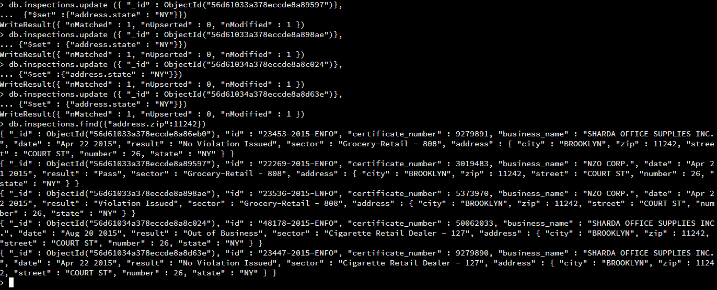

ACME explosives was updated to include the new name of “New ACME Explosives which went from a business that was padlocked to a business that was re-opened and the comment added that it was under new management using the .update function.

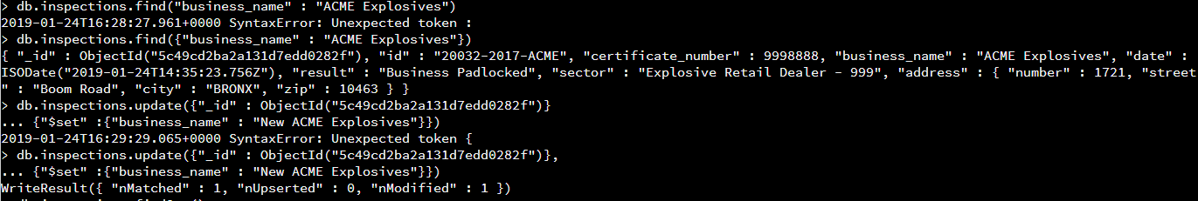

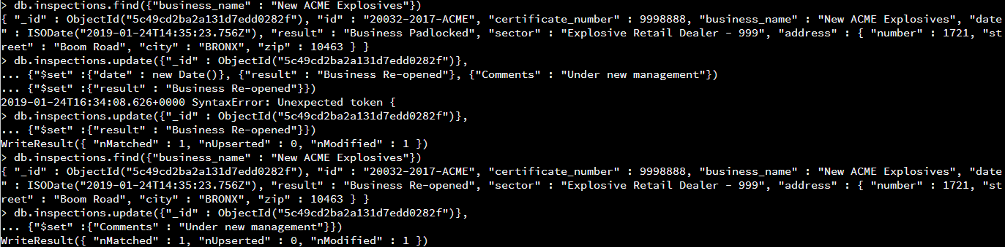



The first document on record was the “LD BUSINESS SOLUTIONS” this business was deleted using the .remove function.





Index was created using the key “business_name” using the .ensureIndex function, this was then found by using the .find function along with the .explain() function which shows the index and explains the usage.

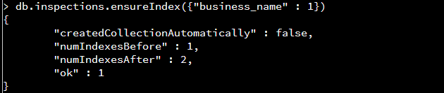

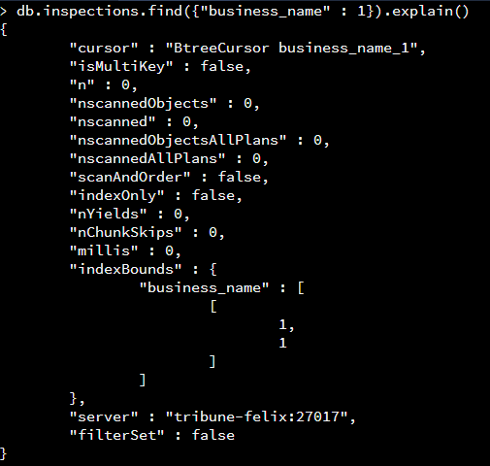

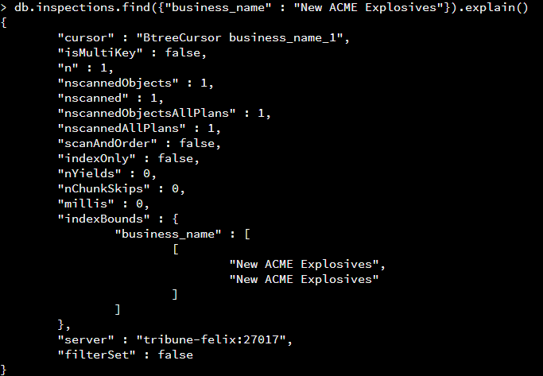

Compound index was created to show the business name with the result of a violation that had been issued.

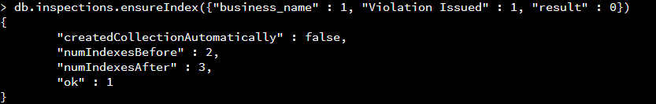

Index was created to help improve the performance of finding a business by the companies city location.

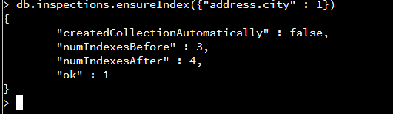

import json

from bson import json_util

from pymongo import MongoClient

from bottle import abort

import pymongo

connection = MongoClient('localhost', 27017)

db = connection['City']

collection = db['inspections']

def insert_document(document):

try:

result=collection.save(document)

except ValidationError as ve:

abort(400, str(ve))

return result

def get_document(document, name):

try:

query = {document: name}

result=collection.find_one(query)

except Exception as ve:

return False

return result

def update_document(document, business, updateData):

try:

result = collection.update({"id":"inspections"},{ '$set': updateData }, upsert=False, multi=False)

except Exception:

abort(400, str(ve))

return result

def main():

myDocument = {"id" : "inspections", "business_name" : "InspectionsRus", "date" : "February 8 2019", "result" : "New Business", "sector" : "City Inspectors", "address" : {"city" : "Richmond", "zip":22235, "street" : "First Ave", "state" : "Virginia"}}

print insert_document(myDocument)

print get_document("id", "inspections")

updateData = { "business_name": "VA Inspectors" }

print update_document("id", "inspections", updateData)

main()

#!/usr/bin/python

import json

from bson import json_util

import bottle

from bottle import route, run, request, abort

import milestone

import pymongo

# myclient = pymongo.MongoClient("mongodb://localhost:8080/")

# mydb = myclient["mydatabase"]

# mycol = mydb["customers"]

mydict = {"id" : "10011-2017-TEST","certificate_number" : 9278833,"business_name" : "ACME TEST INC.","date" : "Feb 20 2017","result" : "No Violation Issued","sector" : "Test Retail Dealer - 101"}

# set up URI paths for REST service

@route('/currentTime', method='GET')

def get_currentTime():

dateString=datetime.datetime.now().strftime("%Y-%m-%d")

timeString=datetime.datetime.now().strftime("%H:%M:%S")

string="{\"date\":"+dateString+",\"time\":"+timeString+"}"

return json.loads(json.dumps(string, indent=4, default=json_util.default))

@route('/create', method='POST')

def put_document():

data = request.json

if not data:

abort(400, 'No data received')

#entity = json.loads(data)

if not data.has_key('id'):

abort(400, 'No id specified')

try:

milestone.insert_document(data)

except NameError:

abort(404, 'No parameter for id %s' % id)

if not string:

abort(404, 'No id %s' % id)

return "True"

@route('/read', method='GET')

def get_document():

b_name = request.query.business_name

result = milestone.get_document("business_name", b_name)

return json.dumps(result, indent=4, default=json_util.default)

return "true"

@route('/update', method='GET')

def update_document():

id = request.query.id

result = milestone.update_document("result", id, updateData)

return json.dumps(result, indent=4, default=json_util.default)

if __name__ == '__main__':

#app.run(debug=True)

run(host='localhost', port=8080)

#from bottle import route, run

Database

This artifact was created in a previous class that I have taken within my computer science degree, the artifact was based upon a company called bubba gump, it was to show their sales.

This artifact incorporates databases, it shows a list of people along with multiple other data such as income, age, webspend, visits etc. this artifact allows me to show how I am able to obtain information, create them into graphs and show how these graphs can be a benefit for a company such as bubba gump.

The one thing that I did to improve on my previous class was to improve the range of graphs, this allows me and the company to see how they may be likely to improve their web store and the likely hood that they may need to adjust prices, products to suit the age demographic that is visiting their website.

This class has taught me how to think more analytical, think about what information could be valuable to a company that may enhance them sales wise, without this information the company could continue as they are without really progressing.

It can certainly be challenging to think about what information is going to be useful, it is easy to create graphs with information, but without really understanding the information nothing is going to progress.