All businesses with the zip code “11242” updated to include the state of “NY” using the .update and $set method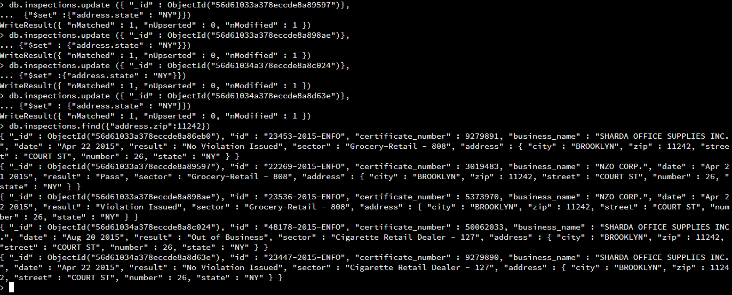

ACME explosives was updated to include the new name of “New ACME Explosives which went from a business that was padlocked to a business that was re-opened and the comment added that it was under new management using the .update function.

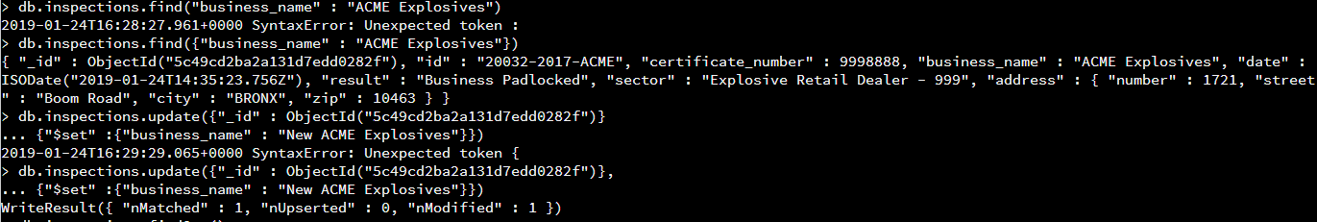

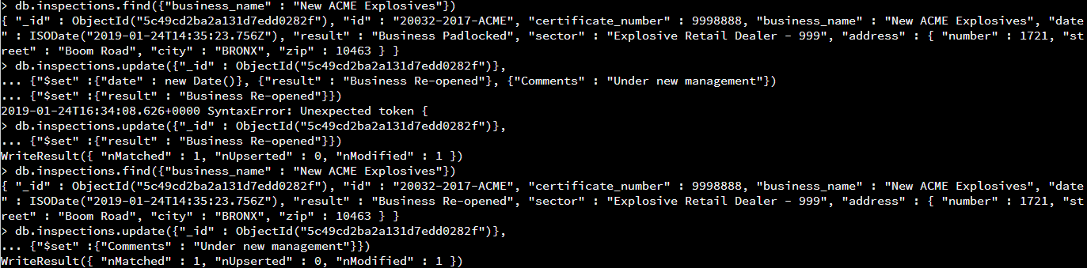



The first document on record was the “LD BUSINESS SOLUTIONS” this business was deleted using the .remove function.





Index was created using the key “business_name” using the .ensureIndex function, this was then found by using the .find function along with the .explain() function which shows the index and explains the usage.

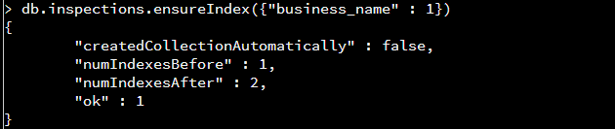

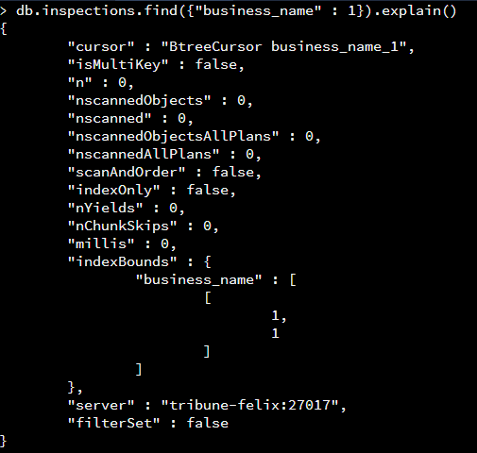

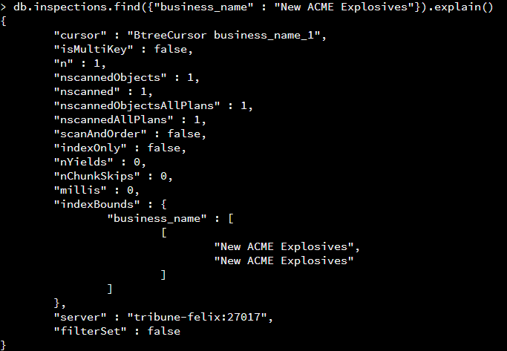

Compound index was created to show the business name with the result of a violation that had been issued.

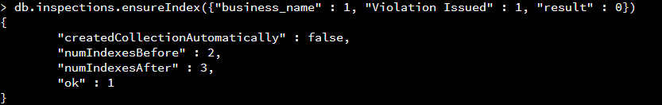

Index was created to help improve the performance of finding a business by the companies city location.

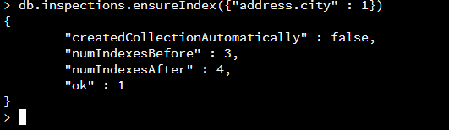

import json

from bson import json_util

from pymongo import MongoClient

from bottle import abort

import pymongo

connection = MongoClient('localhost', 27017)

db = connection['City']

collection = db['inspections']

def insert_document(document):

try:

result=collection.save(document)

except ValidationError as ve:

abort(400, str(ve))

return result

def get_document(document, name):

try:

query = {document: name}

result=collection.find_one(query)

except Exception as ve:

return False

return result

def update_document(document, business, updateData):

try:

result = collection.update({"id":"inspections"},{ '$set': updateData }, upsert=False, multi=False)

except Exception:

abort(400, str(ve))

return result

def main():

myDocument = {"id" : "inspections", "business_name" : "InspectionsRus", "date" : "February 8 2019", "result" : "New Business", "sector" : "City Inspectors", "address" : {"city" : "Richmond", "zip":22235, "street" : "First Ave", "state" : "Virginia"}}

print insert_document(myDocument)

print get_document("id", "inspections")

updateData = { "business_name": "VA Inspectors" }

print update_document("id", "inspections", updateData)

main()

#!/usr/bin/python

import json

from bson import json_util

import bottle

from bottle import route, run, request, abort

import milestone

import pymongo

# myclient = pymongo.MongoClient("mongodb://localhost:8080/")

# mydb = myclient["mydatabase"]

# mycol = mydb["customers"]

mydict = {"id" : "10011-2017-TEST","certificate_number" : 9278833,"business_name" : "ACME TEST INC.","date" : "Feb 20 2017","result" : "No Violation Issued","sector" : "Test Retail Dealer - 101"}

# set up URI paths for REST service

@route('/currentTime', method='GET')

def get_currentTime():

dateString=datetime.datetime.now().strftime("%Y-%m-%d")

timeString=datetime.datetime.now().strftime("%H:%M:%S")

string="{\"date\":"+dateString+",\"time\":"+timeString+"}"

return json.loads(json.dumps(string, indent=4, default=json_util.default))

@route('/create', method='POST')

def put_document():

data = request.json

if not data:

abort(400, 'No data received')

#entity = json.loads(data)

if not data.has_key('id'):

abort(400, 'No id specified')

try:

milestone.insert_document(data)

except NameError:

abort(404, 'No parameter for id %s' % id)

if not string:

abort(404, 'No id %s' % id)

return "True"

@route('/read', method='GET')

def get_document():

b_name = request.query.business_name

result = milestone.get_document("business_name", b_name)

return json.dumps(result, indent=4, default=json_util.default)

return "true"

@route('/update', method='GET')

def update_document():

id = request.query.id

result = milestone.update_document("result", id, updateData)

return json.dumps(result, indent=4, default=json_util.default)

if __name__ == '__main__':

#app.run(debug=True)

run(host='localhost', port=8080)

#from bottle import route, run