**“COVID 19 WEBSITE USING CHATBOT”**

A PROJECT REPORT

*Submitted by*

**NAME OF THE CANDIDATE(S)**

|  |  |  |
| --- | --- | --- |
| **Name** | **Registration Number** | **Roll Number** |
| Anay Sarkar | 17013000384 | 17010301017 |
| Sourit Paul | 17013000539 | 17010301171 |
| Sanchary Chanda | 17013000501 | 17010301134 |
| Rai Banik | 17013000476 | 17010301109 |
| Rupak Dey | 17013000494 | 17010301127 |

*in partial fulfillment for the award of the degree*

*of*

**Bachelor of Computer Application**



**Department of Computational Science**

**BRAINWARE UNIVERSITY**

**398, Ramkrishnapur Road, Barasat, North 24 Parganas, Kolkata - 700 125**

June, 2020

**“COVID 19 WEBSITE USING CHATBOT”**

*Submitted by*

**NAME OF THE CANDIDATE(S)**

|  |  |  |
| --- | --- | --- |
| **Name** | **Registration Number** | **Roll Number** |
| Anay Sarkar | 17013000384 | 17010301017 |
| Sourit Paul | 17013000539 | 17010301171 |
| Sanchary Chanda | 17013000501 | 17010301134 |
| Rai Banik | 17013000476 | 17010301109 |
| Rupak Dey | 17013000494 | 17010301127 |

*in partial fulfillment for the award of the degree*

*of*

**Bachelor of Computer Application**

***in***

**Computational Science**



**BRAINWARE UNIVERSITY**

*398, Ramkrishnapur Road, Barasat, North 24 Parganas, Kolkata - 700 125*



**BRAINWARE UNIVERSITY**

*398, Ramkrishnapur Road, Barasat, North 24 Parganas, Kolkata - 700 125*

**COMPUTATIONAL SCIENCE**

**BONAFIDE CERTIFICATE**

Certified that this project report “**COVID 19 WEBSITE USING CHATBOT**” is the bonafide work of “**SOURIT PAUL , SANCHARY CHANDA , RUPAK DEY , RAI BANIK , ANAY SARKAR**” who carried out the project work under my supervision.

**SIGNATURE SIGNATURE**

Dr. Sandip Roy Mr. Milan Pradhan

**HEAD OF THE DEPARTMENT SUPERVISOR**

**Computational Science Assistant Professor**

*398, Ramkrishnapur Road,* **Computational Science**

*Barasat,*

*North 24 Parganas,*

*Kolkata - 700 125.*

**ABSTRACT**

Coronaviruses of human origin have emerged as probable important etiologic agents of acute upper respiratory tract illnesses in adults; their role in the etiology of respiratory illnesses of childhood is less certain. The first coronavirus of human origin, B814, was described in 1965 and since that time only 31 additional strains have been recovered. Ten of these were originally recovered in human embryonic tracheal organ cultures only, and the remainder in monolayer cell cultures. All of the latter group were antigenically related to a prototype strain designated 229e. As a result of the fastidious growth requirements of these agents, most of the knowledge concerning the clinical syndromes associated with them has come from challenge studies in volunteers and neuroepidemiology investigations. Coronaviruses have been shown to be associated with a substantial number of adult respiratory illnesses especially during certain periods when rhinovirus infections are infrequent. Progress in propagating coronaviruses and in detecting coronavirus infections has been achieved recently: viruses similar to 229E were successfully recovered in human embryonic intestine cell cultures from patients with upper respiratory tract illnesses; 30C strains (B814, LP and EVS) were recovered in L132 cell cultures from infectious nasal washings; OC43(and OC38) viruses which were originally recovered in OC and later adapted to grow in suckling mice were not only shown to directly hemagglutinate various erythrocytes but were also adapted to grow in MK cell cultures; OC43 virus was also found to induce hemadsorption of rat and mouse erythrocytes in certain cell cultures; and a coronavirus strain was detected by immune electron microscopy. Coronaviruses are also associated with certain diseases in animals. As the greatest pandemic have already arrived and it’s trying for the extinction of human life so we have contributed something to help the society to fight against COVID-19. The government is also trying hard to get rid of this virus and everyone should have the responsibility to help them because together we can make the change. If we can contribute something to the society to fights against the pandemic then we can be a part of the greatest battle. COVID-19 Website using chatbot is a website which mainly makes the people aware about the pandemic so that they shouldn’t take wrong actions. We have introduced some features to make the people aware of it. We think that a small contribution can give a greater impact.

**TABLE OF CONTENTS**

|  |  |  |
| --- | --- | --- |
| **Chapter** | **Topic** | **Page Number** |
| **0** | **INTRODUCTION**   * ***Reason for the project*** * ***Problem Statement*** * ***Aims and objective of the project*** * ***Scope*** | **1** |
| **1** | ABOUT COVID-19 Website using Chatbot ***1.1* *How COVID-19 Website using Chatbot work***  ***1.2 Benefits of COVID-19 Website using Chatbot*** | **2** |
| **2** | COVID-19 Website using Chatbot REQUIREMENTS ***2.1 Information Requirement***  ***2.2 Software Used***  ***2.3 Requirement (Hardware & Software)*** | **3** |
| **3** | **SOFTWARE REQUIREMENT SPECIFICATION (SRS)**  **3.1 Introduction**  **3.2 Purpose**  **3.3 Scope of Project**  **3.4 Overview of Document**  **3.5 Overall Description**  **3.5.1 Product Perspective**  **3.5.2 Operational Environment**  **3.5.3 Python packages used for making real time count**  **3.5.4 Python packages used for making detector**  **3.5.5 Python packages used for making chatbot**  **3.6 System Environments**  **3.6.1 Home**  **3.6.2 Services**  **4.6.2.1 Input for Registration**  **4.6.2.2 Output**  **3.6.3 F.A.Q** | **4** |
| **Chapter** | Topic | **Page Number** |
| **5** | **DIAGRAMS**  **5.1 Data Flow Diagram**  ***5.1.1 Coronavirus Probability Detector***  ***5.1.2 Real Time Data Fetching***  ***5.1.3 Chatbot.*** | **12** |
| **6** | **SNAPSHOTS** | **14** |
| **7** | **CONCLUSION** | **17** |
| **8** | **REFERENCE** | **18** |

**Introduction**

COVID-19 Website using chatbot is a client server website which is created on Python, Machine Learning and Bootstrap. The main function of this website is to make aware of the greatest pandemic of all time i.e.; Coronavirus. Coronavirus is creating disaster all over the world and we are just trying to contribute to the society that will help all of us. We have introduced some special features in our website so that it makes easier for all the people to know about COViD-19 and so that they can make serious steps to prevent it.

#### Reason for the project

We have tried to overcome a live problem by creating this project i.e.; in government hospitals daily thousands of patients arrived to check whether they are COVID-19 positive or not but among those thousand people a few percentages of the people are found positive and for this checking lots of testing kits are used and wasted. So, we have tried to found a solution that will reduce the wastage of the kits and can also saves the time of the doctors so that they can fruitfully use the time for the recovery of the patients.

#### Problem Statement

A Website which will help the people to be aware about the COVID=19 pandemic and to check themselves whether they are COVID-19 positive or not.

#### Aims and Objective of the project

COVID-19 Website using chatbot is one type of contribution from our group to the society. The aim of the project is to give the knowledge about the pandemic named COVID-19 to the normal people. As most of the people are connected to the internet and internet serves as a greatest sharing of knowledge to all over the world so we have shared the knowledge in the form of a website. The objective is that we don’t want any people to take any wrong step towards prevention of COVID-19.

#### Scope

The scope of the project is mainly for those people who want to know about the pandemic and want to test themselves whether they are having any chance of having corona in their body or not, by giving their symptoms. We have provided a lot of information about the pandemic so that when a client visiting

our website and at the time of leaving we expect that the client has much information to prevent himself from COVID-19.

## 1: About COVID-19 Website using chatbot

## 1.1 Working Of COVID-19 PROJECT

* Client will be provided with the introduction of COVID-19 in the home page.
* After that they have to surf through various columns in order to know more.
* In our services column there is a COVID-19 probability detector which can predict whether the patient is COVID-19 positive or not after inputting the client symptoms.
* In the FAQ column we have introduced one chatbot to communicate with the client about COVID-19.
* Finally, in our contact section the client can contact us anytime and they can clear their doubts if any.

#### 1.2 Benefits of COVID-19 PROJECT

* Website that can make the people aware about coronavirus.
* It is user friendly
* Time Saving.
* Run on any operating system.
* It reduces the effort of client to collect information from various resources.

## 2: COVID-19 Website using chatbot Requirements

## 2.1 Information Requirement:

###### In order to create the project, we need the information about: -

* Machine Learning.
* Python and its libraries.
* Bootstrap.
* Natural Language Processing.

#### 

#### 2.2 Software Used:

* **For Developing: -**

###### **Python 3.7**

Python 3.7 is an application where we can run our python programs very easily and it is user friendly. Python 3.7 provides all the libraries related to machine learning and there is various king of functions which reduces our time complexity. And python itself is a very interesting language and coding in python saves a lot of time and most of the machine learning developers or data scientist uses Python or sometimes R for coding.

###### **ENVIORNMENTS**

* Android
* IOS
* Windows
* Linux

#### 

#### For User Purpose: -

For user purposes we need only internet connection and Android/IOS/Windows/Linux Device.

#### 2.3 Requirement (Hardware & Software)

* Any Processor after Intel Pentium.
* 2GB RAM minimum required.
* Android/IOS/Windows/Linux
* Python 3.7

## 3: Software Requirement Specification (SRS)

## 3.1. Introduction

COVID-19 Project is a client server website which is created on Python, Machine Learning and Bootstrap. The main function of this website is to make aware of the greatest pandemic of all time i.e. Coronavirus. Coronavirus is creating disaster all over the world and we are just trying to contribute to the society that will help all of us. We have introduced some special features in our website so that it makes easier for all the people to know about COViD-19 and so that they can make serious steps to prevent it.

## 3.2 Purpose

COVID-19 Project is one type of contribution from our group to the society. The aim of the project is to give the knowledge about the pandemic named COVID-19 to the normal people. As most of the people are connected to the internet and internet serves as a greatest sharing of knowledge to all over the world so we have shared the knowledge in the form of a website. The objective is that we don’t want any people to take any wrong step towards prevention of COVID-19. For developing any project, we need SRS and it is an important part for all of the project and without SRS we cannot describe the requirements that is needed by our project to execute in a proper manner.

#### 3.3 Scope of Project

The scope of the project is mainly for those people who want to know about the pandemic and want to test themselves whether they are having any chance of having corona in their body or not, by giving their symptoms. We have provided a lot of information about the pandemic so that when a client is visiting our website and at the time of leaving we expect that the client have much information to prevent himself from COVID-19.

#### 3.4 Overview of Document

The documents consist of the detailed description of our project. We have given the aim, scope, objective of the project and we have provided with the software requirement of the project. After that we have given all specification which was used to build the project and described each of the software

that we have used. We have described every section of our project. We have given various diagrams related to the project and snippets of the code are also given in the last part. We have mentioned the references from where we have taken help to develop this project a better one.

## 3.5 Overall Description

#### 3.5.1 Product Perspective

COVID-19 Project is a client server website which is created on Python, Machine Learning and Bootstrap. The main function of this website is to make aware of the greatest pandemic of all time i.e.; Coronavirus. Coronavirus is creating disaster all over the world and we are just trying to contribute to the society that will help all of us. We have introduced some special features in our website so that it makes easier for all the people to know about COViD-19 and so that they can make serious steps to prevent it.

#### 3.5.2 Operational Environment

* The COVID-19 PROJECT website can be operated with Android/IOS/Windows/Linux.
* It can be operated using internet or without using internet.

**3.5.3 Python Packages used for making the real time patients count.**

* **flask =** It is a lightweight web frame of Python. It provides the user with libraries, modules and tools to help build Web-Applications such as a blog or wiki. The flask package is installed by writing this command in the command prompt which is “pip install flask” or” python -m pip install flask”. This can be imported by writing this import statement which is “from flask import Flask”.
* **render_template =** The result is a full HTML page sent to the client. The process is called rendering the template. Because rendering a template results in what the viewer sees on their screens, templates are often called views. This can be imported by writing this import statement which is “from flask import render_template”.
  + - **Request =** Flask Request Object. In the client-server architecture, the request object contains all the data that is sent from the client to the server. ... It is the dictionary object containing cookie names and the values. It is saved at

the client-side to track the user session. This can be imported by writing this import statement which is “from flask import request”.

* **bs4 = It** is a Python package for parsing HTML and XML documents (including having malformed markup, i.e. non-closed tags, so named after tag soup). It creates a parse tree for parsed pages that can be **used** to extract data from HTML, which is useful for web scraping. The bs4 package is installed by writing this command in the command prompt which “pip install bs4” or “python -m pip install bs4”.
  + - **BeautifulSoup =** Beautiful Soup is a **Python** library for pulling data out of HTML and XML files. It works with your favorite parser to provide idiomatic ways of navigating, searching, and modifying the parse tree. It commonly saves programmers hours or days of work. This can be imported by writing this import statement which is “from bs4 import BeautifulSoup”.

**3.5.4 Python Packages used for making the Coronavirus Detector**

* + **Pandas =** It is a popular Python-based data analysis toolkit which can be imported using import pandas as pd. It presents a diverse range of utilities, ranging from parsing multiple file formats to converting an entire data table into a [NumPy](https://www.educative.io/edpresso/how-to-create-an-array-in-numpy) matrix array. This makes pandas a trusted ally in data science and machine learning. The installation of this package is by writing this command in the command prompt which is “pip install pandas” or “python -m pip install pandas”. This can be imported by writing this import statement which is “import pandas as pd”.
  + **Numpy =** It is a python library used for working with arrays. It also has functions for working in domain of linear algebra, fourier transform, and matrices. NumPy was created in 2005 by Travis Oliphant. It is an open source project and you can use it freely. The installation of this package is by writing this command in the command prompt which is “pip install numpy” or “python -m pip install numpy”. This can be imported by writing this import statement which is “import numpy as np”.
  + **Scikit-learn =** It is a free machine learning library for Python. It features various algorithms like support vector machine, random forests, and k-neighbors, and it also supports Python numerical and scientific libraries like NumPy and SciPy. The installation of this package is by writing this command in the command prompt which is “pip install scikit-learn”.
    - **Logistic Regression =** Logistic regression is a supervised learning classification algorithm used to predict the probability of a target variable. The nature of target or dependent variable is dichotomous, which means there would be only two possible classes. This can be imported by writing this import statement which is “from scikit-learn import LogisticRegression”.
* **Flask =** Flask is a lightweight [WSGI](https://wsgi.readthedocs.io) web application framework. It is designed to make getting started quick and easy, with the ability to scale up to complex applications. It began as a simple wrapper around [Werkzeug](https://www.palletsprojects.com/p/werkzeug/) and [Jinja](https://www.palletsprojects.com/p/jinja/) and has become one of the most popular Python web application frameworks. Flask offers suggestions, but doesn’t enforce any dependencies or project layout. It is up to the developer to choose the tools and libraries they want to use. There are many extensions provided by the community that make adding new functionality easy. The installation of flask is pretty simple “pip install flask”.
  + 1. **Python Packages used for making the Chatbot**
* **ChatterBot =** Chatterbot is a machine learning, conversational dialog engine. Chatterbot is a machine-learning based conversational dialog engine build in Python which makes it possible to generate responses based on collections of known conversations. The language independent design of Chatterbot allows it to be trained to speak any language, An untrained instance of ChatterBot starts off with no knowledge of how to communicate. Each time a user enters a statement, the library saves the text that they entered and the text that the statement was in response to. As ChatterBot receives more input the number of responses that it can reply and the accuracy of each response in relation to the input statement increase. The program selects the closest matching response by searching for the closest matching known statement that matches the input, it then returns the most likely response to that statement based on how frequently each response is issued by the people the bot communicates with. This can be imported by writing this import statement “from chatterbot import ChatBot”
* **ChatterBot.Trainers**
* **Training data =** ChatterBot comes with a data utility module that can be used to train chat bots. At the moment there is training data for over a dozen languages in this module. Contributions of additional training data or training data in other languages would be greatly appreciated.
* **SQL Storage Adapter =** Storage adapters provide an interface that allows ChatterBot to connect to different storage technologies. The SQLStorageAdapter allows ChatterBot to store conversation data in any database supported by the SQL Alchemy ORM.The storage adapter that your bot uses can be specified by setting the storage_adapter parameter to the import path of the storage adapter you want to use.

**chatbot=ChatBot(**"MyChatterBot",) **storage_adapter=**"chatterbot.storage.SQLStorageAdapter")

* **Logical Adapters =** Logic adapters determine the logic for how ChatterBot selects a response to a given input statement. The logic adapter that your bot uses can be specified by setting the logic_adapters parameter to the import path of the logic adapter you want to use.

**chatbot = ChatBot**("My ChatterBot",

**logic_adapters=**["chatterbot.logic.BestMatch"]

)

* **Chatterbot-corpus =** A machine readable multilingual dialog corpus. These modules are used to quickly train ChatterBot to respond to various inputs in different languages. Although much of ChatterBot is designed to be language independent, it is still useful to have these training sets available to prime a fresh database and make the variety ofresponses that a bot can yield much more diverse. All training data contained within this corpus is user contributed. The following module can be installed by simply running the following command in the virtual environment “pip install chatterbot-corpus”
* **Flask =** Flask is a lightweight [WSGI](https://wsgi.readthedocs.io) web application framework. It is designed to make getting started quick and easy, with the ability to scale up to complex applications. It began

as a simple wrapper around [Werkzeug](https://www.palletsprojects.com/p/werkzeug/) and [Jinja](https://www.palletsprojects.com/p/jinja/) and has become one of the most popular Python web application frameworks. Flask offers suggestions, but doesn’t enforce any dependencies or project layout. It is up to the developer to choose the tools and libraries they want to use. There are many extensions provided by the community that make adding new functionality easy. The installation of flask is pretty simple “pip install flask”.

## 3.6 System Environments

#### 3.6.1 Home

Viewer can visit the COVID-19 project webpage. They can access the webpage and look for the information whatever they want to know about the virus. There is a Realtime data fetch where we can see the affected, recovered, death cases and locations.

#### 3.6.2 Services

In services part there is a probability detector which will detect the probability of having COVID-19. The symptoms are mentioned in that detector. If the symptoms are detected positive then he/she will have to visit to the doctor or else not.

#### 3.6.2.1 Input for services

###### **User Information**

|  |
| --- |
| Fever |
| Age |
| Body pain |
| Runny nose |
| Breathing difficulty |

All fields are required for the detector otherwise there will be a warning message if any field is left vacant. Then after filling up the field is done they have to submit.

#### 3.6.2.2 Output

If the detector detects positive then: patient probability of infection is x%. More the percentage will be 100% he/she have the chance of having virus in her body.

#### 

#### 3.6.3 Conversation with Chatbot

In the FAQ section we have introduced chatbot to communicate with the users for better understanding of users. A person may have different problems and we cannot showcase all of the solutions in our website so we have designed a chatbot and we have trained our chatbot in a very efficient way so that it can give all the possible that a user can ask. Interaction is the most important way of sharing crucial information so we have tried to make their selves comfortable by interacting with the chat bot. Though in our chatbot there are few developments which needs to be done which we have decided to do it in the future. We have tried to train our chatbot with the maximum questions possible. Basically, if the people are aware of the pandemic and they know exactly what to do in this critical situation then I think it will be easier to defend. And we have chosen knowledge and information our weapon to fight against the pandemic. And as we know India has the greatest percentage of illiteracy and we can also see in the television that what wrong steps that the villagers as well as the people who lives in the slums are taking to defend the pandemic. As every people is using mobile phone and internet connection nowadays is there in every people’s phone so an website form our perspective will be a best medium for sharing.

**4: Planning of Project**

#### 4.1 Team Structure

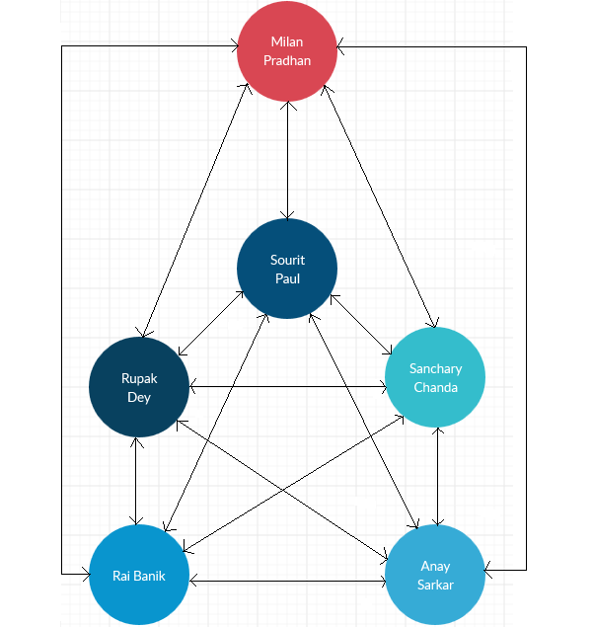

**4.2 Gnatt Chart**

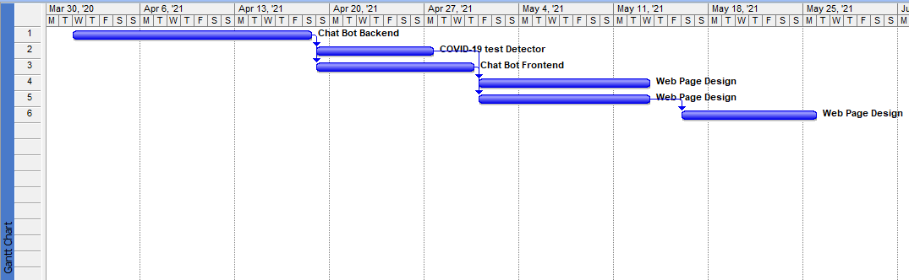

**4.3 Report**

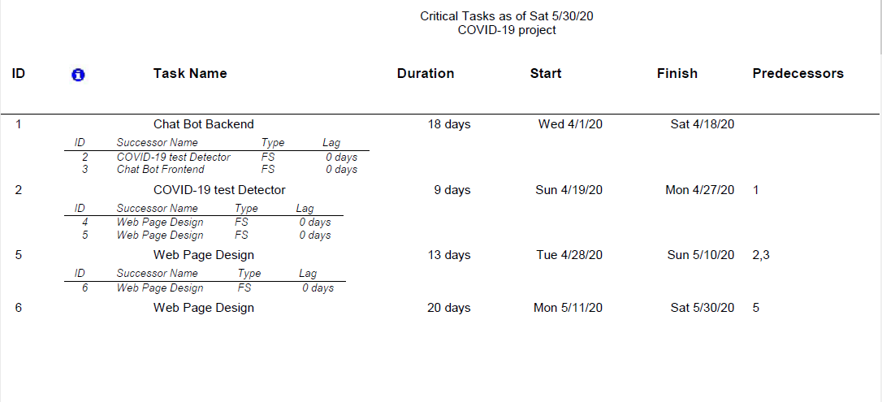

**4.4 Network Diagram**

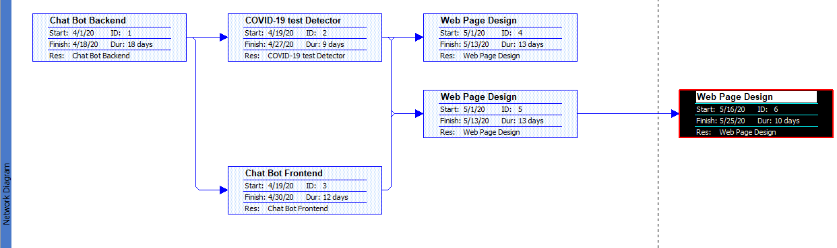

**4.5 Minimum Time Complexity**

The time taken by the project to be done is 60 days.

**5: Diagrams**

**5.1 Data Flow Diagram**

**5.1.1 Coronavirus Probability Detector: -**

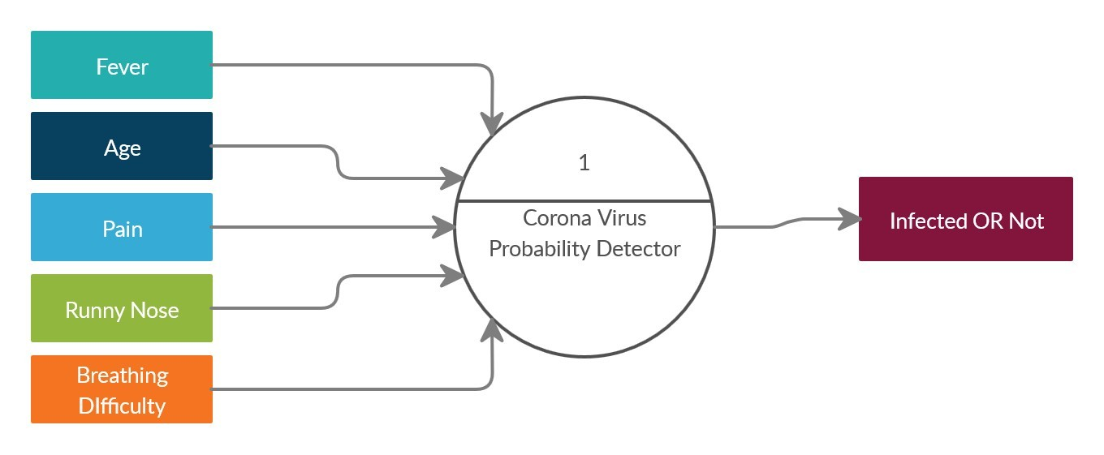

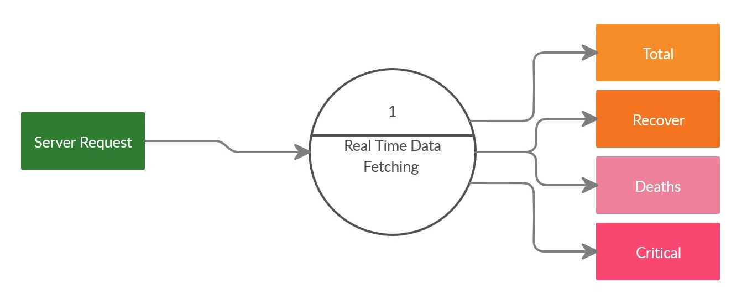 **5.1.2 Real Time Data Fetching and calculating total affected, death, recovered: -**

#### 

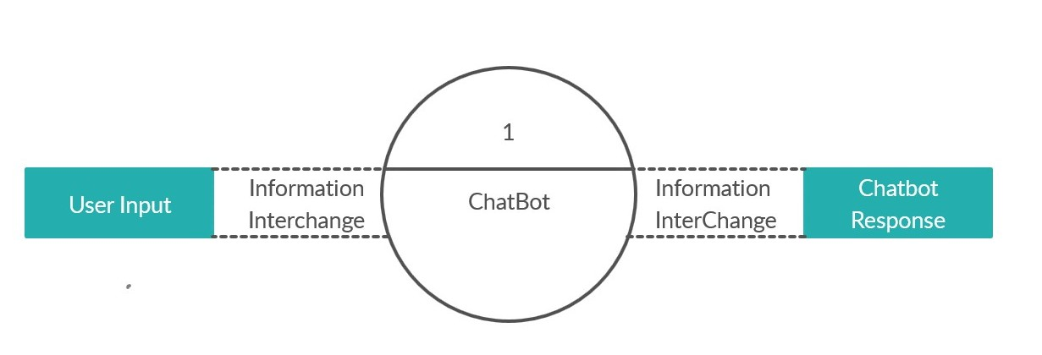 **5.1.3 Chatbot: -**

**6: Snapshots**

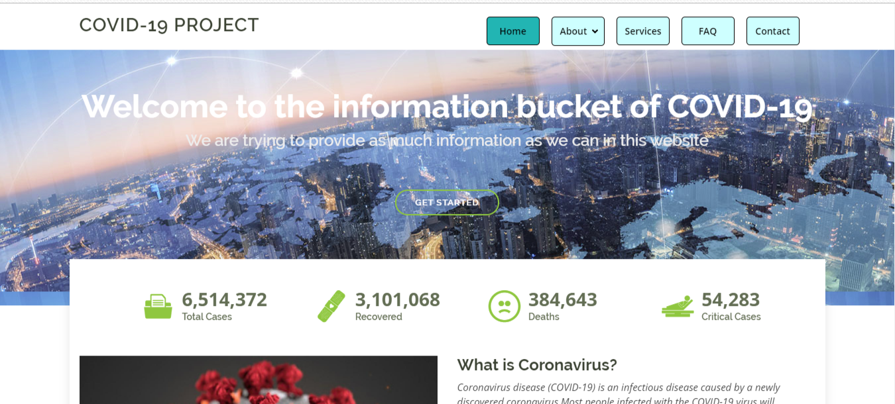**6.1 Home Page**

**6.2 About Page**

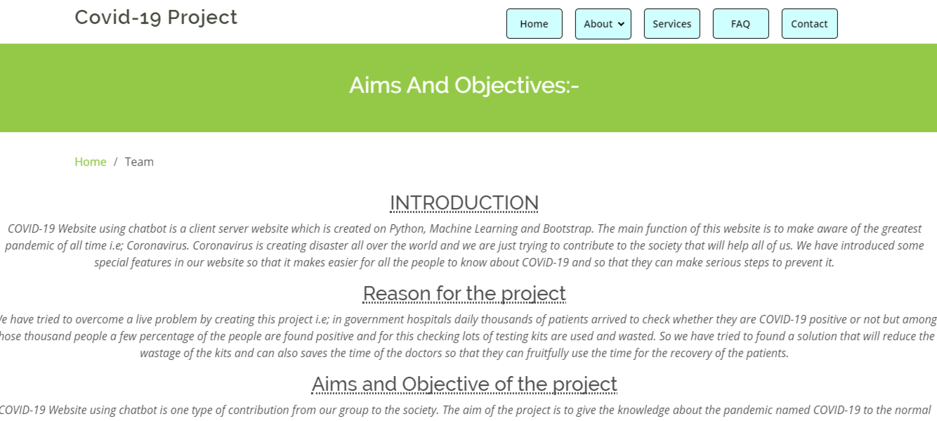

**6.3 Services Page**

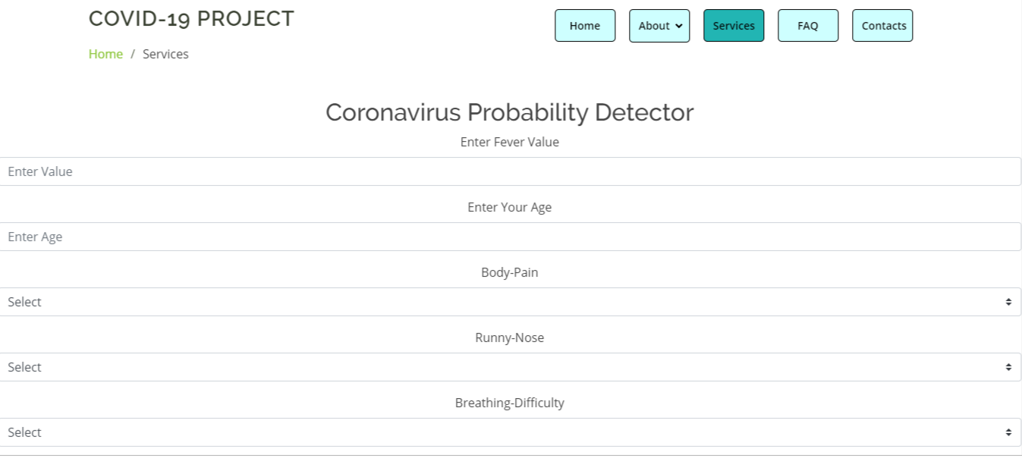

**6.4 F.A.Q Page**

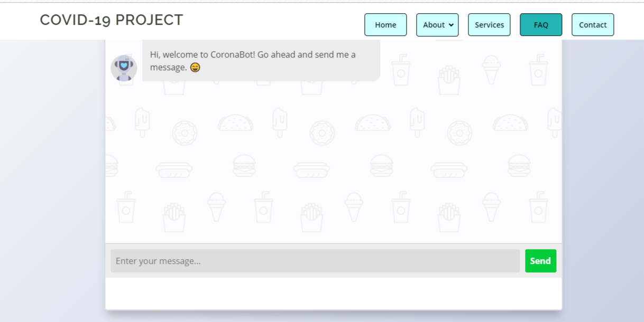

**6.5 Contact Page**

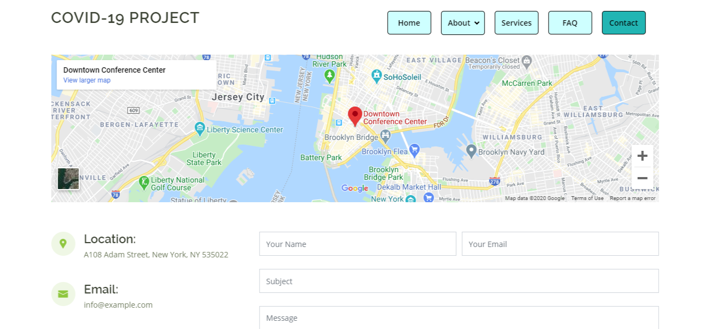

**7: Conclusion**

The world is suffering from the greatest pandemic ever experienced. The human population is badly affected by this. The doctors are trying their best to find the antidote of this pandemic. But only the doctors will not be enough to fight against this pandemic we the human beings all have the responsibility to stand against this pandemic and help the others in various possible ways. Our small contribution when it reaches can save many lives and resources for further aid. We have contributed this project to the society to help others and as it is in a prototype state so if we can get good resources in the future, then this project can be efficient for doctors. Considering the trending technologies like python and machine learning we have tried to execute on this as because in 2020 machine learning and python are the most trending in terms of development and prediction. Through this project, I want to request each and every people to help the other in their most possible ways because together we can succeed and one day we will definitely overcome this pandemic and world will be again an amazing place to live on. In the further aspect of our Chabot we would like to use the module off stop words for making the user search more versatile and understandable by the chatbot, which would result making the chatbot search result more accurate and more user friendly. We would also try to implement the concept of synonyms in the user search, which would versatility on the user end, and the Chat bot would be able to give output regardless of any synonyms used.

**8: References**

* **Book Name = ‘Data Science from Scratch’**

Writer = Joel Grus.

Publishing Year = 2015.

Publisher Name=O’Rielly.

* **Book Name = ‘Learning Python’**

Writer = David Ascher and Mark Lutz

Publishing Year = 1999,

Publisher Name=O’Rielly.

* **Book Name = ‘HTML & CSS: Design and Build Web Sites’**

Writer = Jon Ducket.

Publishing Year = 2011.