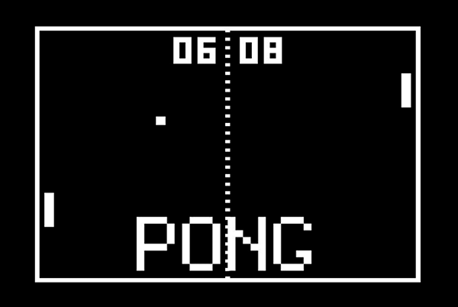

1. create the screen - done
2. create and move a paddle - done
3. create another paddle - done
4. create the ball and make it move - done
5. detect collision with wall and bounce - done
6. detect collision with paddle - done
7. detect when paddle misses - done
8. keep score - done

ball

1. create the ball
2. place the ball in the middle
3. ball moving to random position
4. ball interacts with players

players

1. create keybinds
2. create player 1 and 2
3. position players
4. move players up and down
5. interact with the ball

scoreboard

1. create the score
2. position the score
3. count score
4. score interact with the ball

middle thing

1. create middle thing
2. just place it in the middle