Emmanouil Stamatakis

23 years old programmer entrepreneur athlete.

D.O.B: 05/02/1997 | Spercheiou 78, Athens, Greece | PC: 12137

Email: EmmanouelStamatakes@gmail.com | +30 6976667762

Skype: live:themagicsport

I’m studying Informatics at University of Piraeus, Greece. I chose the Software Engineering and Intelligent Systems direction to continue my studies. I would like to create projects that could be useful to public and save as much time as possible from them. I am very excited to learn new things about programming and my aim is to create and develop projects that resolve real world problems.

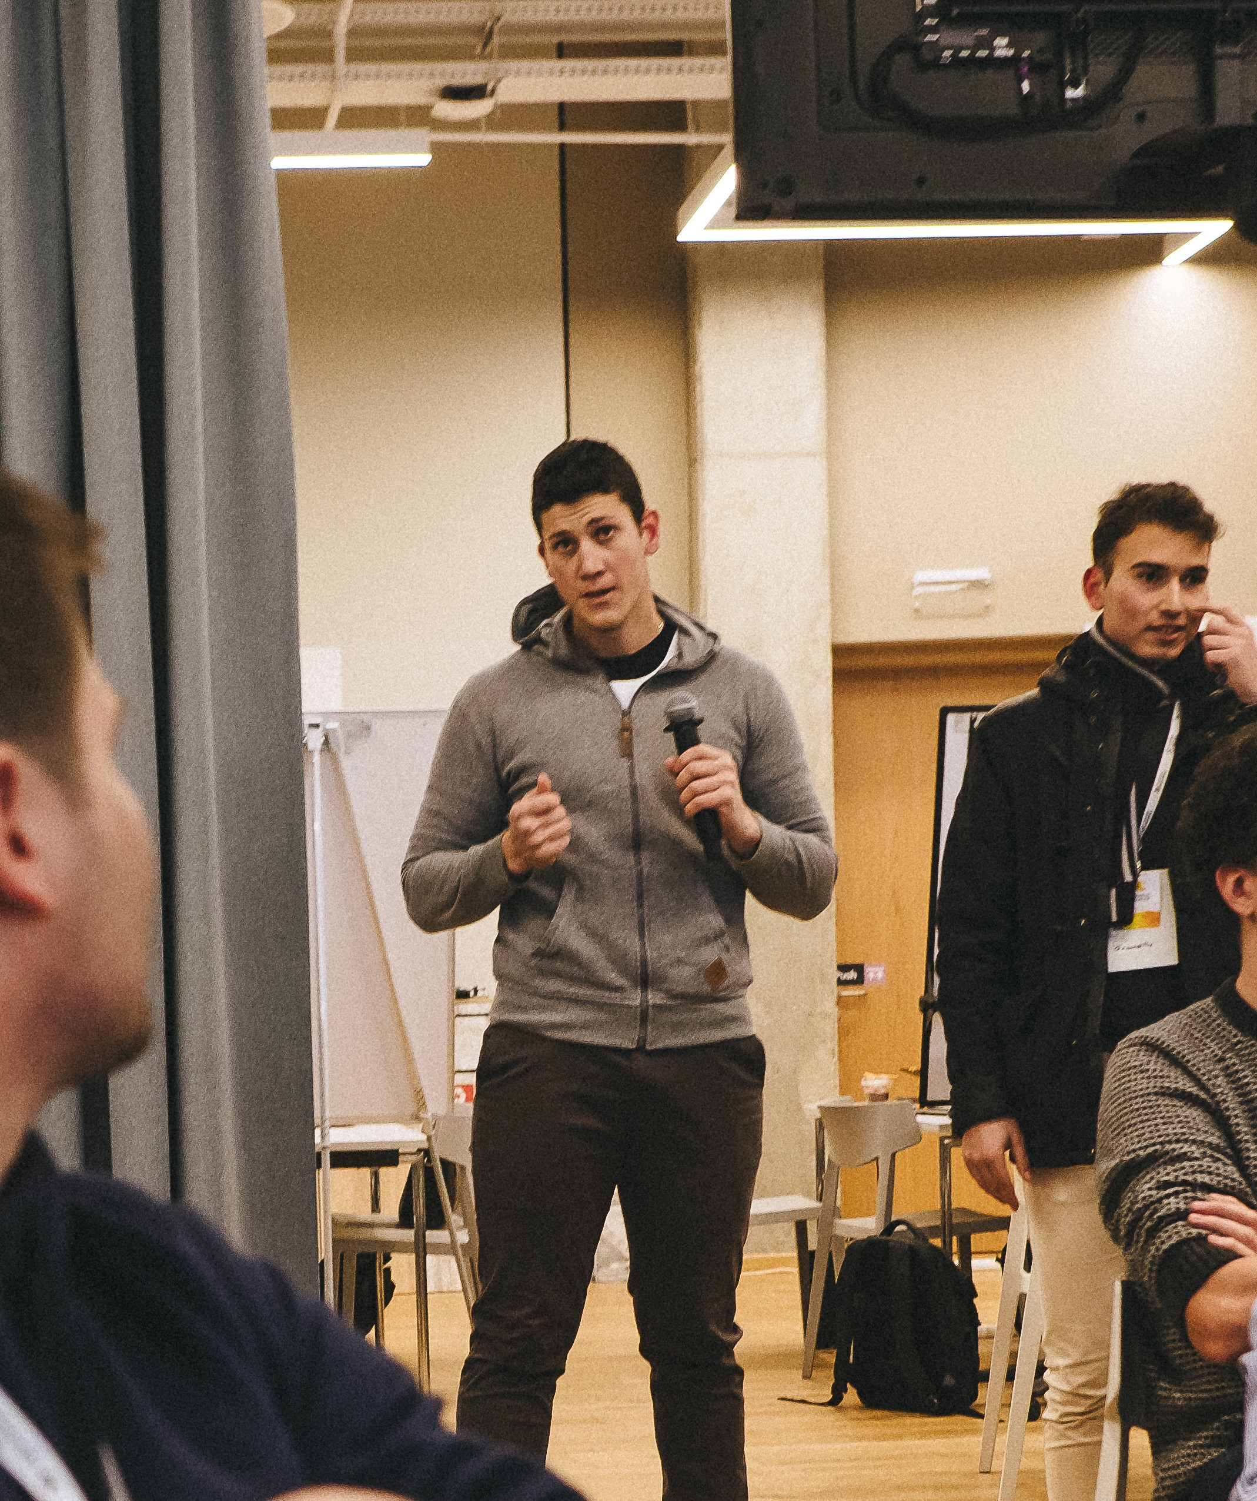 | Working Experience |  |  | Doing |  | Working With
 | September 2017 – February 2018 |  |  | Android Development |  | Android Studio(Java)
 |  |  |  | (Groundifly) |  | Visual Studio(Xamarin, C#)
 | November 2017 - January 2018 |  |  | Integration Testing |  | Visual Studio (C#, SQLite, .NET)
 | Siemens, Furth Germany |  |  | Data analysis |  | Integration testing
 | May 2018 – December 2018 |  |  | Developer |  | Visual Studio (C# using MVC
 | Dataverse Ltd |  |  |  |  | framework)
Programming Knowledge |  | Job-related skills |  |  | Technical skills
• | C# (advanced) | • Good at researching data bases, skills |  |  | • Good computing skills
• | Javascript (very good) | developed while undertaking various |  |  | • Problem solving skills
• | Python (good) | courses at the University |  |  | • Good at optimizing problems
• | Java (basic) | • Capable of high quality, independent |  |  | • Committed to the task
 |  | and team work alike |  |  | • Increased analytical abilities
 |  | • Great at meeting deadlines |  |  | • Extremely organizational
 |  | • Multitasking |  |  | • Very Good use of Frameworks like
 |  | • Hard working |  |  | Angular and MVC.


As an entrepreneur (team achievements)

- Ennovation Contest - 3rd phase (SEP 2017)

- Entrepreneurship Bootcamp Contest - achieved incubation (JUL 2017)

- Cosmote Hackathon - Finals (MAY 2017)

- Google Startup Launchpad Warsaw, Poland (Top 10 in Europe) (OCT 2017)

As an athlete

- 22nd place at sailing, in the International Youth Championship 2012, Finland.

- 3rd place at Discus throw in the Youth(U20) National Championship 2016, Greece

- 3rd place at Discus throw in the U23 National Championship 2017, Greece

- 3rd place at Discus throw in the Winter National Championship 2018, Greece

Other awards

- 3rd place at Mathematical Olympics “Archimedes” 2015, Greece

- 2nd place at National Microsoft Excel contest, 2014, Greece

- Microsoft Specialist (Office 2007) since I was 15 years old.

- 3rd in NASA space apps challenge 2019 in Athens.

Personality

- Adventurous • Obedient • Competitive • Self-sufficient

- Positive • Optimistic • Sincere • Spontaneous


GitHub: https://github.com/ManosTheMaster

LinkedIn: https://www.linkedin.com/in/manolisstamatakis/

