Reminders App
A modern, responsive PWA for managing reminders, routines, and habit workflows with reliable multi-channel notifications and a precomputed queue architecture.
At a Glance
■ User features: reminders, routines, calendar, repeat rules, snooze/completion.
■ System features: denormalized notification_queue, delta sync, cron runner dispatch.
■ Platforms: Desktop web + iPhone PWA (Home Screen) with iOS 16.4+ push support.

Table of Contents
Right-click and update field to generate TOC.

1. App Purpose & Target Users
The Reminders App is a Progressive Web App (PWA) designed to help users manage tasks, routines, and habits. It combines a calendar interface with dynamic scheduling logic and supports push, SMS, and email notifications.

2. Core Features

2.1 User Features
• Reminders with due dates/times/timezones; notes attached and gracefully truncated in push payloads.
• Completion and Snooze: marking done halts future queued notifications; snooze reschedules and updates the queue.
• Calendar views (grid/list) using robust date boundary handling.
• Repeat rules: presets (daily/weekly/monthly) plus custom repeatRule cloning behavior.
• Routines: sequential steps generated into standalone reminders for a rolling 24-hour window.

2.2 System Features
• Multi-channel notifications: Web Push (VAPID + Service Worker), SMS (Twilio), Email (SMTP/Nodemailer).
• Denormalized notification_queue per user: avoids scanning reminders every minute.
• Delta sync: edits to a reminder/routine rebuild only its affected queue items.
• Theme system: next-themes with multiple palettes; UI micro-animations via framer-motion.
• Multi-device push subscriptions stored in push_subscriptions.

3. Platform Support
Capability | Desktop Web | iPhone PWA (Home Screen)
Install | No install required | Must use Add to Home Screen
Push notifications | Standard Web Push API | iOS 16.4+ Web Push via Service Worker
Offline behavior | Firestore offline support (client) | Firestore offline support (client)
Multi-device push | Supported via push_subscriptions | Supported via push_subscriptions
Best UX path | Settings → Enable Push | Install PWA → Settings → Enable Push

4. Operational Behavior

How Notifications Work (High Level)
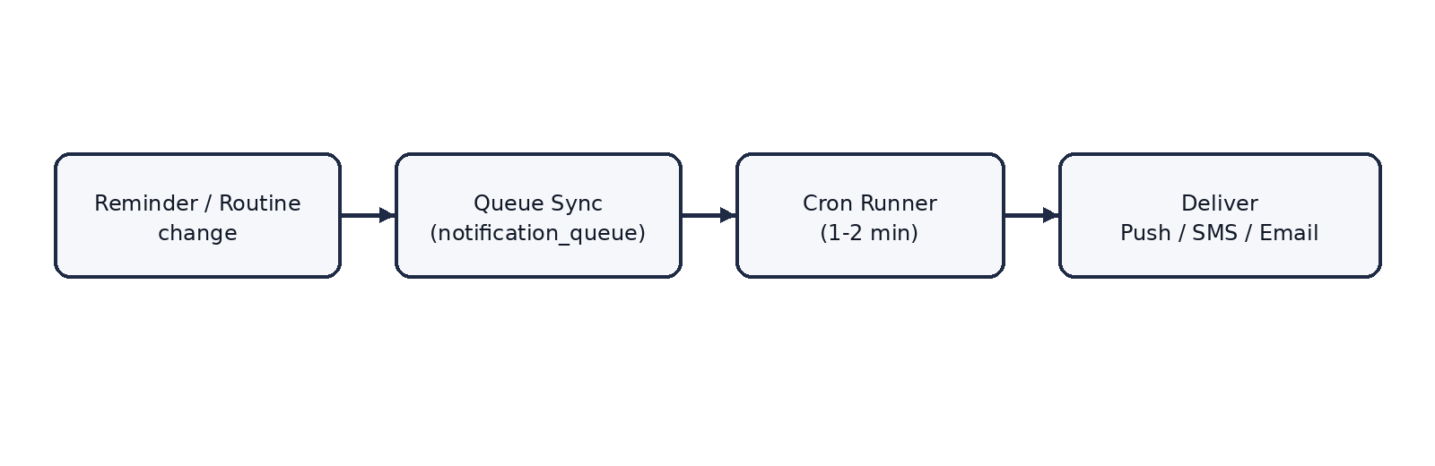
Figure: boxed flow diagram

Cron schedule calls
• Minute-runner pinged externally every 1–2 minutes to app/api/cron/run/route.ts (Bearer secret protected).
• Queries notification_queue for unsent items bounded strictly in a [now-2m, now] window to account for drift.

Daily 12am generation & rebuild
• On the first minute-runner ping of a new day, the system triggers routine generation and rebuilds the queue horizon (24h).

5. Known Limitations & Assumptions
⚠ Warning: Missing client clock sync
• Due times are treated as absolute instances based on provided timezone or user fallback timezone.

⚠ Warning: SMS rate limits
• If many SMS reminders are scheduled for the exact same minute, Twilio may throttle unless configured for high throughput.

⚠ Warning: Offline completion gap
• If a reminder is marked done offline, the cloud queue may still fire before the client reconnects and syncs.

