System Map
At a Glance
■ High-level architecture: client, API routes, Firebase Auth, Firestore, cron runner, and delivery channels.
■ Routing map for the main app surfaces.
■ Critical paths: Reminder → Queue → Cron → Push and Routine → Generation → Queue.

Table of Contents
Right-click and update field to generate TOC.

1. High-Level Architecture Diagram
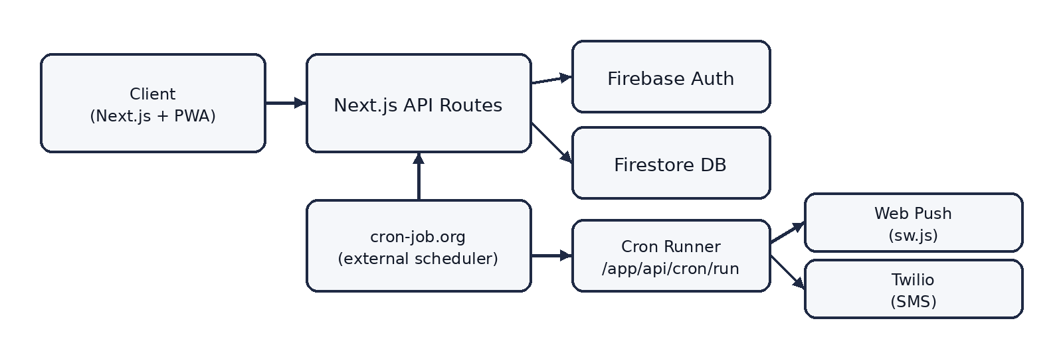
Figure: boxed flow diagram

2. Routing Map
Route | Purpose | Key Components
/login, /signup | Authentication flow | app/(auth)/* + Firebase Auth
/ | Primary dashboard | ReminderList + calendar components
/calendar | Expanded grid view | components/calendar
/routines | Manage step-based routines | components/routines + enable toggle
/settings | Preferences + notification setup | Theme toggles + push enable

3. Data Flow Map

3.1 Reminder CRUD → Queue Sync → Cron Dispatch → Push
→ Create/Edit (lib/reminders.ts): ReminderForm saves to Firestore reminders subcollection.
→ Delta sync (lib/queueSync.ts): syncReminderQueue wipes/rebuilds queue items for that reminder.
→ Cron runner (app/api/cron/run/route.ts): queries notification_queue where sent=false in [now-2m, now].
→ Delivery: fetch push_subscriptions, build payload (title + truncated notes), send via Web Push; mark sent=true.

3.2 Routine Enable/Disable → Generation/Removal → Queue
→ Enable (app/api/routines/[id]/run): catch-up generation for the next 24h, inserting step reminders.
→ Deterministic IDs: SHA-256 hash of routineId:stepId:dateStr ensures idempotency.
→ Disable/Delete (lib/routines.ts): cascades to removeRoutineQueue() and deletes future routine-generated reminders.

4. Critical Paths
💡 Key Insight: Reminder → Queue → Cron → Push
• Reminder edit triggers delta queue rebuild (fast, scoped).
• Cron reads only precomputed queue items (cheap, predictable).
• Dispatch path fans out per channel (push/SMS/email).

💡 Key Insight: Routine → Generation → Queue
• Routines generate concrete reminder docs for the next 24h window.
• Queue is built from these generated reminders the same way as normal reminders.

