Backend Guide
Backend at a Glance
■ Firestore-first model with per-user subcollections (reminders, routines, notification_queue, push_subscriptions).
■ Cron runner reads denormalized queue to dispatch push/SMS/email efficiently.
■ Routine generation uses deterministic IDs for idempotency and duplicate prevention.

Table of Contents
Right-click and update field to generate TOC.

1. Firestore Data Model

1.1 users/{uid} (metadata)
Field | Type | Description | Example
timezone | string | User default timezone | America/New_York
email | string | User email | user@example.com
smsOptIn | boolean | SMS enabled flag | true
phoneNumber | string | E.164 phone number | +15555550123

1.2 users/{uid}/reminders
Field | Type | Description | Example
title | string | Reminder title | Take vitamins
notes | string | Optional notes (truncated in push payload) | With food
due_at | timestamp | Due time | 2026-02-20T09:00Z
status | enum | pending|done|snoozed | pending
timezone | string | Timezone at creation | Europe/London
repeatRule | object|null | Repeat logic for cloning | {type:'weekly'}
notifications[] | array | Channel + offsetMinutes + sent flag | [{type:'push', offsetMinutes:0}]
routineId | string? | Link to routine if generated | routine_abc
rootId | string? | Link to original reminder for repeats | rem_123

1.3 users/{uid}/routines
Field | Type | Description | Example
title | string | Routine name | Morning routine
active | boolean | Enabled/disabled | true
schedule | object | Type + days | {type:'weekly', days:[1,2,3]}
steps[] | array | Ordered steps with HH:MM and notifications | [{id:'1', time:'07:00'}]
timezone | string | Routine timezone abstraction | America/New_York
lastRun | timestamp | Last generation time | 2026-02-20T00:00Z

1.4 users/{uid}/notification_queue
Field | Type | Description | Example
reminderId | string | Parent reminder doc id | rem_123
channel | enum | push|sms|email | push
notificationId | string | Notification entry id | notif_1
scheduledAt | timestamp | dueAt - offsetMinutes | 2026-02-20T08:55Z
dueAt | timestamp | Original due time | 2026-02-20T09:00Z
sent | boolean | Dispatch status | false
timezone | string | Timezone context | Europe/London

1.5 users/{uid}/push_subscriptions
Field | Type | Description | Example
endpoint | string | Push endpoint URL | https://...
keys.auth | string | Web Push auth key | base64...
keys.p256dh | string | Web Push p256dh key | base64...
created_at | timestamp | Registration time | 2026-02-20T10:00Z

2. API Routes
Endpoint | Method | Auth | Purpose | Notes
/app/api/cron/run | GET | CRON_SECRET (Bearer or ?key=) | Minute-runner dispatch core | Queries queue window [now-2m, now]
/app/api/routines/[id]/run | POST | Firebase Auth token | Manual catch-up for routine enable | Generates next 24h block if missing
/app/api/push/subscribe | POST | Firebase Auth token | Register push subscription | Writes to push_subscriptions
/app/api/push/unsubscribe | POST | Firebase Auth token | Remove push subscription | Deletes device endpoint entry

3. Cron/Queue Logic

Cron Dispatch Flow
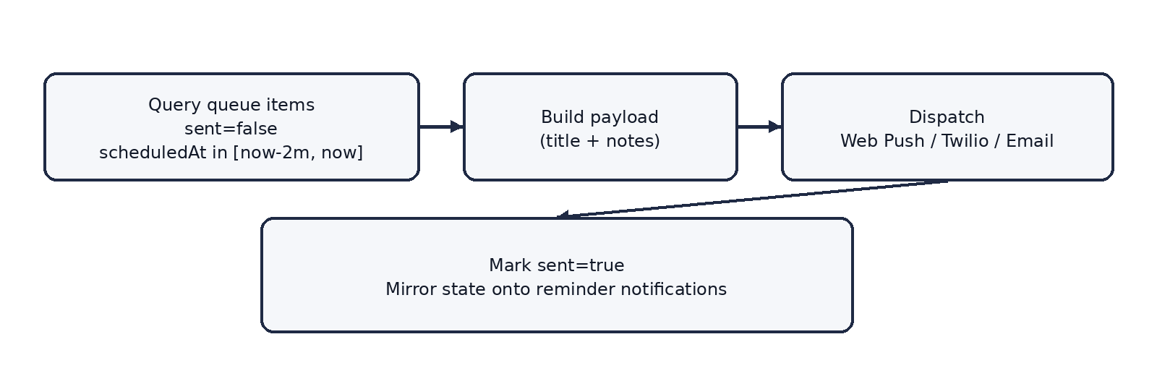
Figure: boxed flow diagram

4. Routine Generation Logic
• Rolling 24h deterministic generation: evaluates localNow to localNow + 1 day and maps HH:MM steps into reminder docs.
• Daily 12am run tracked via users/{uid}/meta/routineGenState.lastGenDate (yyyy-MM-dd) to prevent overlap.
• Idempotency: deterministic hash routineId:stepId:dateStr used as document id; set(merge=True) prevents duplicates.
• Disable/delete cascades: removeRoutineQueue() purges future queue footprint and deletes generated reminders tied to routineId.

5. Indexes
Index | Query it supports | Needed because
reminders: status ASC, due_at ASC | Pull pending reminders efficiently | Avoids expensive full scans
notification_queue: sent ASC, scheduledAt ASC | Cron retrieves unsent items ordered by scheduledAt | Core path for minute runner
routines: created_at DESC | Client list ordering | Stable ordering without extra reads

6. Security Rules (Summary)
✓ Best Practice: Tenant isolation
• Use match /users/{uid}/{collection=**} with request.auth.uid == uid to prevent cross-tenant reads/writes.

