**Members**

* 吕家伟 1822441005
* 邹睿泓 1822441012
* 刘心雨 1822441017
* 王楷淇 1822441038

**Heroku Application**

**Heroku Link**: <https://gamerverse2.herokuapp.com/>

**(Hint: When registering an account, the detection of mobile phone number is strict. You can try the following numbers: 0431234567,0731234567)**

**Project Management**

|  |  |  |  |  |
| --- | --- | --- | --- | --- |
| Timeline | 6-26 | 6-27 | 6-28 | 6-29 |
| Landing Page | Designed the appearance of the home page | The home page has been optimized | Fixed the bug on the home page | Added some small features |
| Registration | The login interface is designed with the framework | Added login function | Be able to fill the registration information into the database | Some tests were carried out |
| Create item | Designed the general appearance | Design out the appearance of static web page | Be able to read the goods uploaded by users | The ability to store data in a database |
| Database mode | The general appearance of the database is designed | The table was created in the database | Be able to connect the front end with the database | Fixed a bug in the database |
| Reviews | The appearance of the comment interface is designed | The function of comment is added in flask | Ability to store comments in a database | Removed comments from sellers |
| Error Handling | The display of the home page is misplaced | Unable to distinguish between buyer and seller when logging in | Unable to store user information | Sellers can also comment under the item, which is not allowed |

**Test Script**

The landing page of the application will be accessed. The ‘search-by-category’ feature that allows a user to view items by category will be tested.

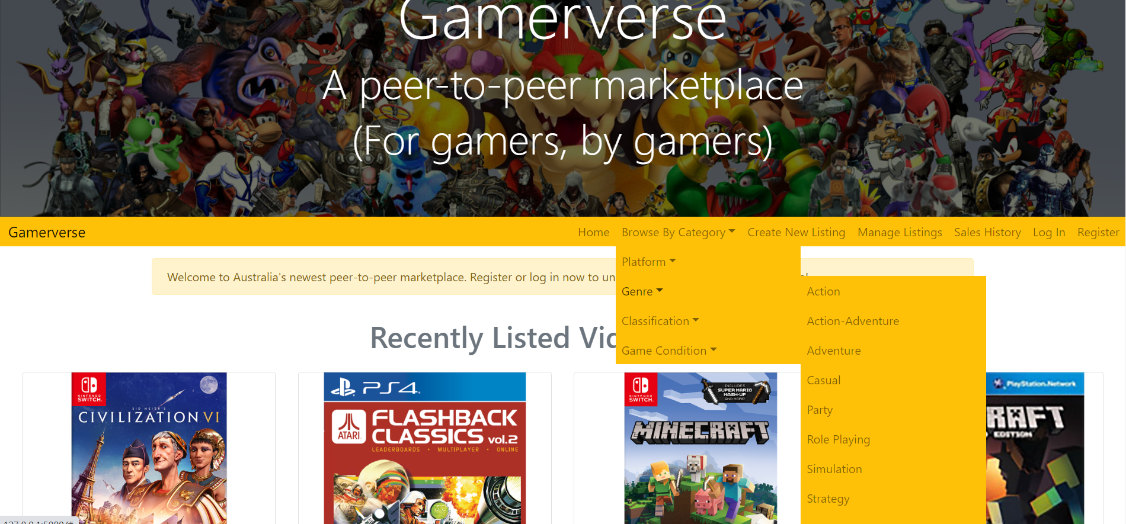

The details of one of the items on the landing page will be assessed. The user should be able to see the comments posted on the item

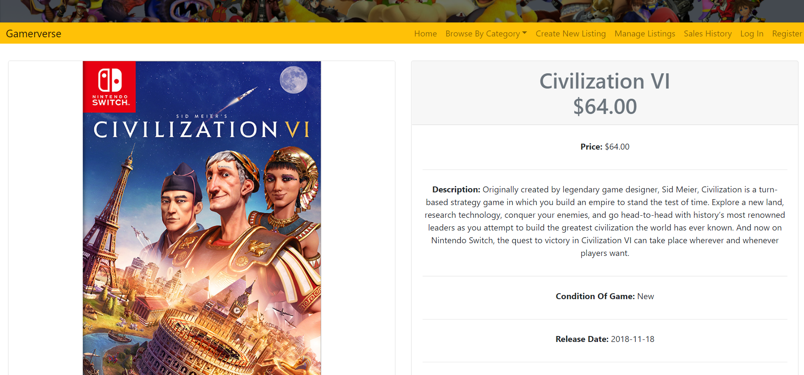

On trying to create item, the user should be prompted to a login page.

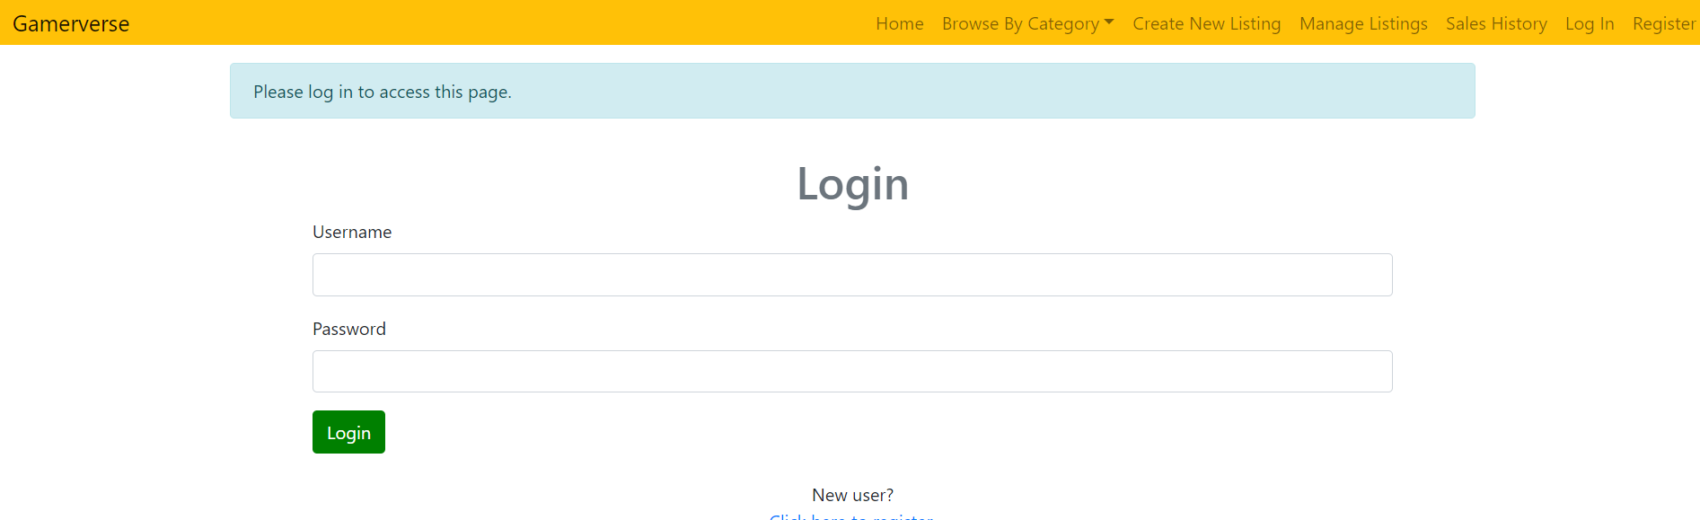

A new user will be registered as a seller and details of the registration page will be tested.

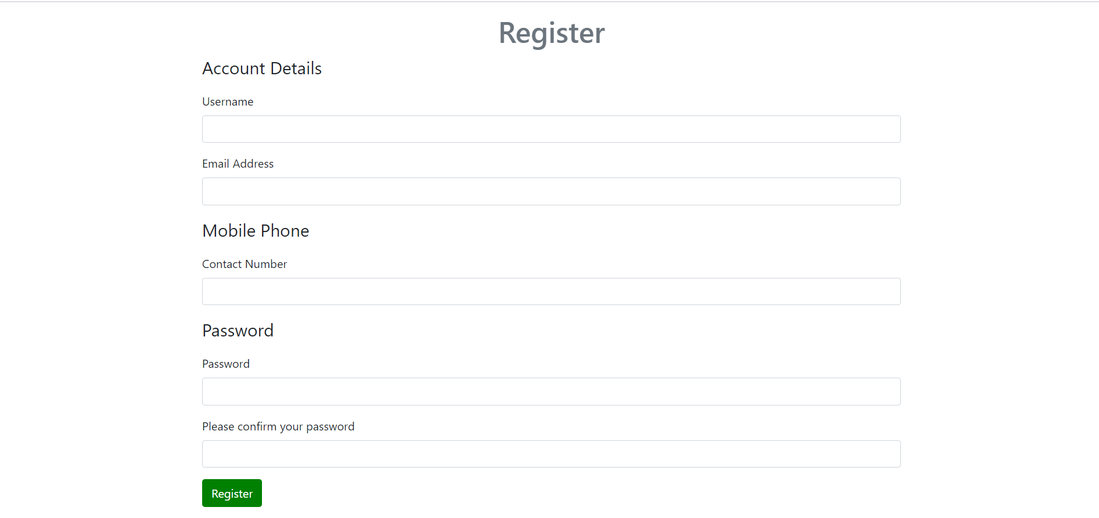

The seller will login to the application



The seller will create two items. The item creation will be tested

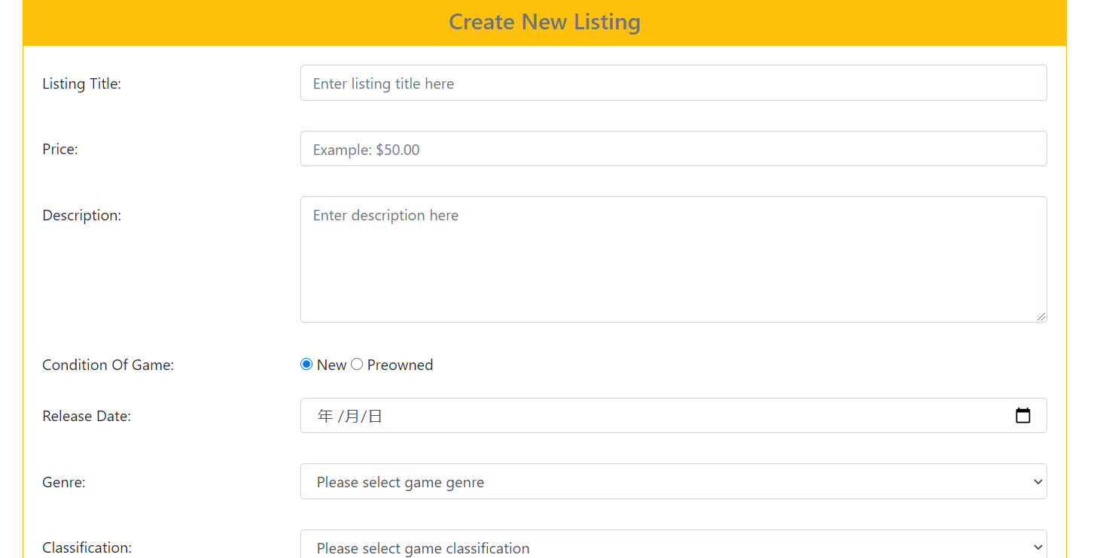

The seller will logout of the application. Logout functionality will be tested.



The ‘buy an item’ functionality will be tested. A user should be taken to the login page if a user is not logged-in



The buyer will enter a lower quantity of items. The buyer should be able to order the item by entering relevant details for ordering an item. An order-id will be provided to the buyer.

