**Description:**

This website provides dozens of categories, tens of thousands of books for users to choose. Users can choose to register as a buyer or seller. Buyers can view the details of the book, such as the author, author profile, content introduction, etc. buyers can also see some comments from other buyers. As a seller, you can upload the books you want to sell, you need to upload the basic information such as the pictures of the books, and you need to set the inventory of the goods.

**User stories:**

**Title: Register as a buyer**

As a user, I want to register as a buyer so that I can buy my favorite books on the website.

**acceptance criteria:**

1. A buyer cannot be a seller.
2. They need to have distinct user registrations. The buyer provides details of the name, email-id, password and contact number.

**Title: Register as a seller**

As a user, I want to register as a seller so that I can sell my books.

**acceptance criteria:**

1. A buyer cannot be a seller.
2. To register, a seller is required to provide details such as name, email-id, password, contact number, bank account details for credit of sales.

**Title: Leave a comment**

As a buyer, I would like to comment after the purchase.

**acceptance criteria:**

1. The buyer must have purchased the goods he wants to comment on, and the buyer must have confirmed the goods received.
2. The buyer's comments can be accompanied by pictures, and the text content shall comply with the regulations. Advertising and other malicious attacks are prohibited.

**Title: View comments**

As a buyer, I would like to see the comments of other buyers before I buy the goods.

**acceptance criteria:**

1. Need to be able to see the model purchased by the evaluator, the time of purchase and the time of comment.
2. Be able to leave comments and reply with commentators.

**Conceptual Model:**

As an unregistered user, I want to register as a seller so that I can sell my books.

As an unregistered user, I want to register as a buyer so that I can buy books.

As a logged in buyer, I want to check the book category and profile because I need to make sure I want to buy it.

As a registered seller, I need to upload the books I need to sell and indicate the details of the books.

As a buyer, I want to check the progress of express delivery.

As an existing buyer, I would like to post a review on the book I bought.

As a buyer, I'd like to see reviews from other buyers.

As a seller, I want to modify the information of my products, such as inventory.

**Class Responsibilities**

register as a seller 🡪 User: register as a seller

register as a buyer 🡪 User: register as a buyer

upload books 🡪 Upload: upload books

buy books 🡪 Order: buy books

Post a review 🡪 Review: post review

See reviews 🡪 Book: see reviews

**UML model：**

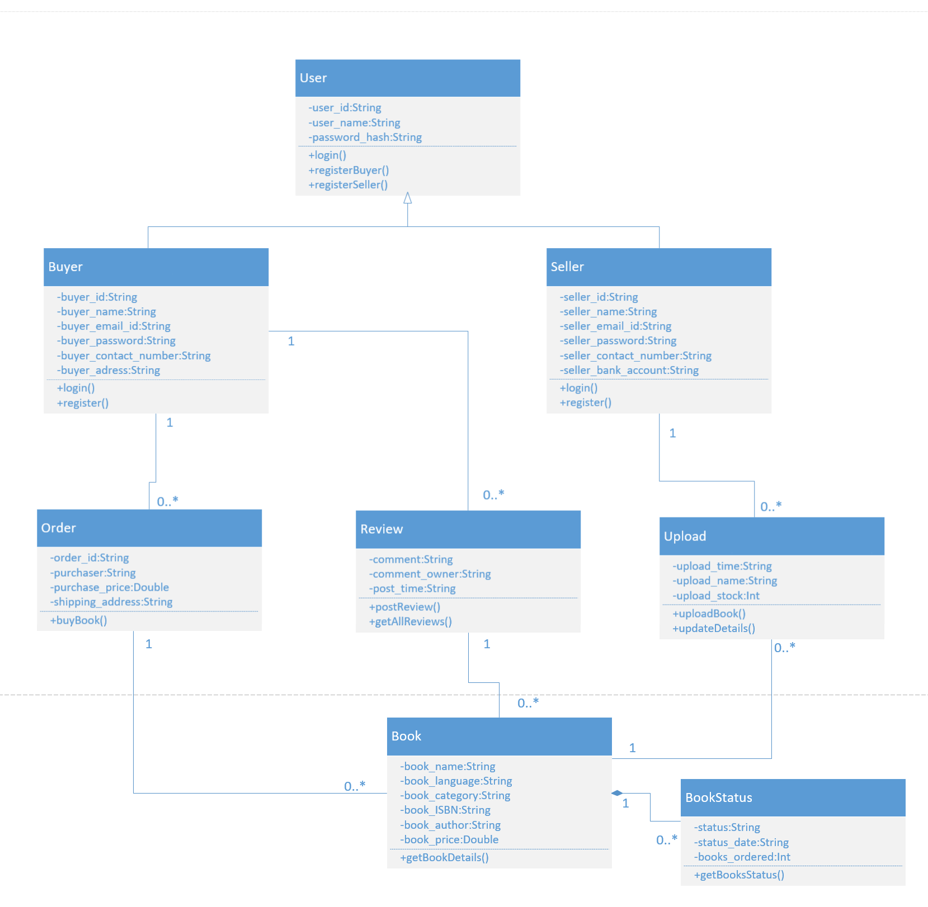

**Database Design:**

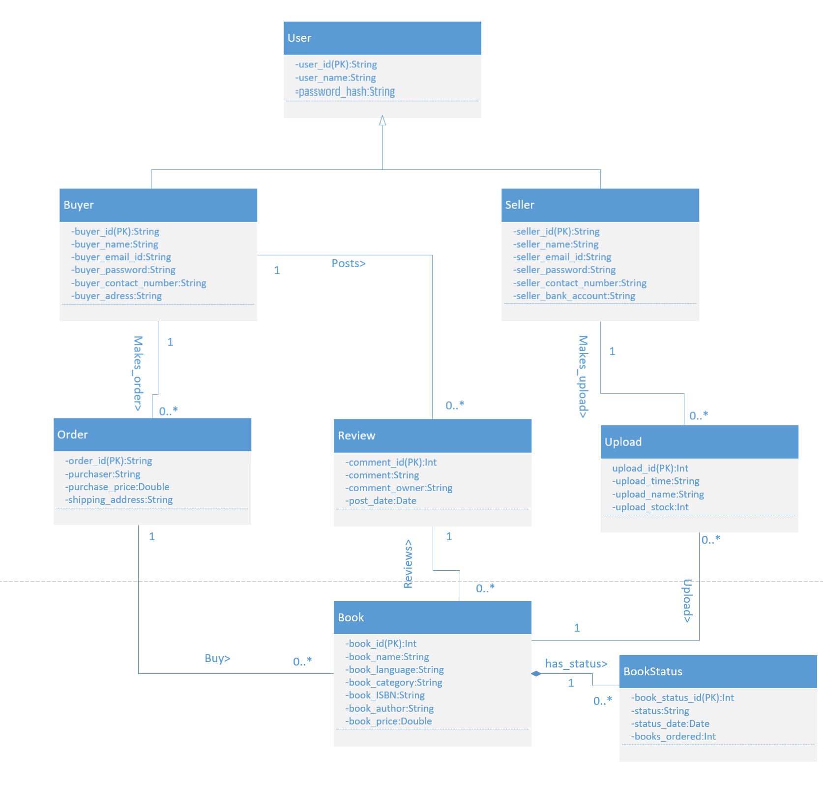

**Wireframes:**

1.      Landing/index page of the marketplace



2.      A page that allows the seller to create a product/service



1. Page providing the details of the product/service.



1. The page that allows a buyer to buy the items

