**Introduction**

Outdoor Grill is a product development project, developed with 2 peers from scratch as part of our Computer-Aided Design CAD exam. The project was designed and validated using CATIA v5.

The inspiration for this project came from a simple personal need: a barbecue grill with an adjustable distance between the grill surface and the heat source (fire/charcoal).

Hierarchically, the project is structured in 3 main assembly:

* The roller chain assembly
* The scissor lift assembly
* The supporting frame assembly

We adopted a Top-Down design approach for the 3D model. This involved creating a skeleton for each assembly containing all the necessary geometrical references, controlled by a set of parameters. This method provided significant control over the project, allowing for a high degree of flexibility when changing parameters without requiring extensive manual adjustments.

**The Scissor Lift Mechanism**

My primary contribution to the project was the design of the **scissor lift assembly**: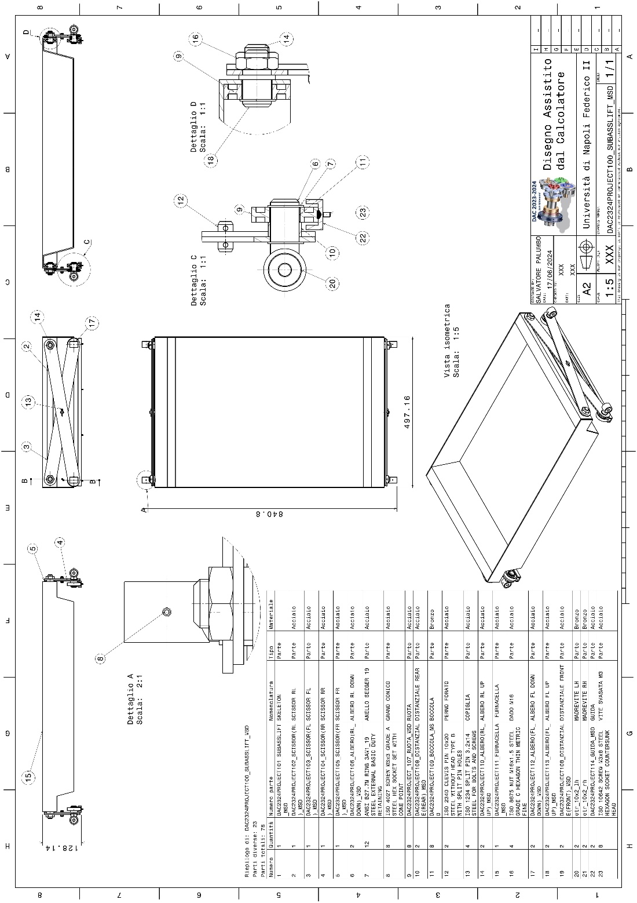

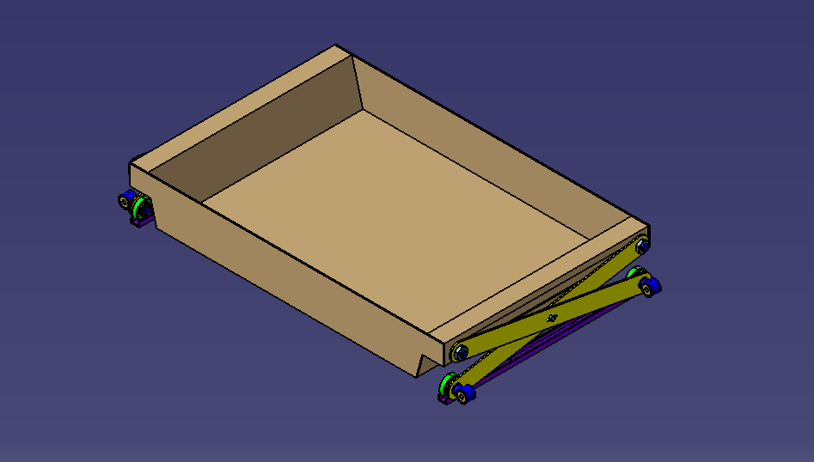

Unlike standard scissor lifts, where one side remains fixed while the other moves due to lead screw rotations (as demonstrated in an initial handmade prototype), our design required the center of gravity of the charcoal basket to remain in the middle of the basket due to safety reason.

To achieve this, I implemented a double trapezoidal lead screw system. This system uses one right-hand screw and one left-hand screw of the same pitch, connected by a mechanical sleeve.

Each lead screw is paired with a corresponding lead screw nut (one right-hand and one left-hand) attached to the two arms of the scissor mechanism.

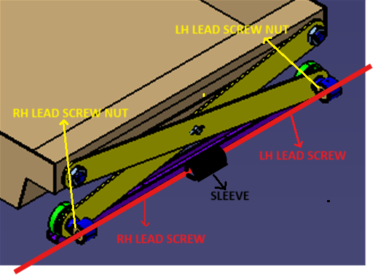

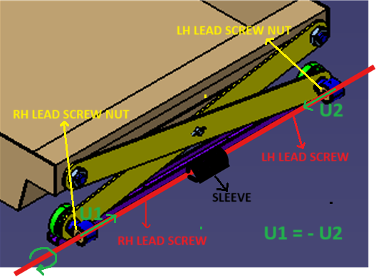This system ensures that for every rotation of the lead screws, the two lead screw nuts experience displacements of equal magnitude but in opposite directions. This synchronized movement maintains the central position of the charcoal basket.

Furthermore, the translation mechanism was designed for smooth operation. For this reason, I decided to implement a system which converts the linear displacement of lead screw nut in the rotation of a wheel over a guide.

**Simulations**

Kinematic simulations were performed specifically on the roller chain assembly. While structurally was simulated on the frame:

Unfortunately, due to the fact that it was not required, and due to time limitations we have not been able to have a physical prototype of the entire system.