Università degli Studi di Napoli Federico II
Scuola Politecnica e delle Scienze di Base
Dipartimento di Ingegneria Industriale
Corso di Laurea in Ingegneria Meccanica
Classe di laurea L 09



Elaborato di laurea in
Tecnologia meccanica
Superalloys and casting process
for ultra-high temperature gas turbines

Relatore:
Ch.mo Prof. Ing. Antonio Formisano
Candidato:
Salvatore Palumbo
N47/7322

ANNO ACCADEMICO 2023/2024

Alla mia famiglia

Contents

Abstract 4
Chapter 1: Achieving ultra-high temperature gas turbines 5
1.1 Introduction 5
1.1.1 Why increasing Turbine inlet temperature (TIT)? 5
1.1.2 Mitsubishi Heavy Industries (MHI) project for 1700℃ Class Ultra High Temperature Gas Turbine 7
Chapter 2: Evolution of Ni-SXs 10
2.1 Introduction to Ni-SXs 10
2.2 Two phase microstructure and lattice misfit 11
2.2.1 Two phase microstructures: key factor of the Ni-SXs creep strength 11
2.2.2 Lattice misfit: a parameter to manage the γ/γ' interfacial coherency 13
2.3 Creep because of dislocations in Ni-SXs 15
2.3.1 Dislocation Motion in the γ Phase 15
2.3.2 Dislocation Motion in the γ' Phase 16
2.4 Composition Evolution in Ni-SXs 17
2.4.1 Addition of the γ' Phase Elements 17
2.4.2 Addition of the γ Phase Elements 19
Chapter 3: Simulation techniques for investment casting process of MGA1700 by MHI 22
3.1 Introduction to MGA1700 22
3.2 Design of MGA1700 through the MHI flow chart 23
3.3 Casting furnace and solidification simulations to predict the casting defect generation and the grain orientation 25
3.3.2 Freckle Generation 25
3.3.2 Stray Grain 26
3.3.3 Re-crystallization 28
Chapter 4: Conclusion 29
Bibliography 30

Abstract
Combined cycle power plants are leaders in modern power generation due to their superior efficiency compared to other cycles. This advantage lies in the clever marriage of a gas turbine cycle with a Rankine steam cycle. But the key to unlocking even greater efficiency lies in supercharging the Rankine cycle with exhaust at the highest temperature and this is possible if we push the inlet temperature to the limit. Consequently, pushing the boundaries of this limit is crucial for achieving even greater efficiency in combined cycle plants.
This thesis takes the 1700℃ Class Ultra High Temperature Gas Turbine developed by Mitsubishi Heavy Industries (MHI) as a starting point. Through a technical review, are showed the key technologies that have led to MHI success. The focus is on two crucial areas: the novel Ni-based superalloy they developed and the techniques they employ to predict defects during the casting process.
Obviously, the superalloy they developed is currently under patent and for this reason it has been decided to take a general look on the evolution of the Ni-based superalloys by introducing the basic knowledge about the microstructure, dislocation mechanism and common alloying elements. While it explores the development flow that led to MHI superalloy creation.
Finally, by examining a specific defect, it is possible to gain valuable insight into the organization of the casting process. This analysis will also showcase a solution employed to achieve the single crystal structure of the superalloy.

Chapter 1: Achieving ultra-high temperature gas turbines

1.1 Introduction
This thesis investigates two critical technologies enabling the development of ultra-high efficiency gas turbines: superalloy design and manufacturing processes.
Superalloys, particularly nickel-based compositions, are essential for gas turbine operation due to their exceptional strength and resistance to high temperatures. This research will explore first the evolution and the design of this of single crystal nickel-based superalloys (Ni-SXs), considered the pinnacle of this technology due to their superior performance.
The performance of superalloys is inextricably linked to their manufacturing processes. Simulation techniques are crucial to predict defects like freckle, stray grain and re-crystallization.

1.1.1 Why increasing Turbine inlet temperature (TIT)?
By focusing on these areas, this thesis aims to elucidate the vital role of superalloys and manufacturing in the development of next-generation, high-efficiency gas turbines.
The research topic arose from a Google Scholar search combining keywords like "High Inlet temperature turbines,” "blade creep," "casting process," and "Ni-based superalloys." This combination led to the technical review “Key Technologies for 1700℃ Class Ultra High Temperature Gas Turbine” released by Mitsubishi Heavy Industries on the key technologies required to develop 1700°C-class gas turbines for ultra-high efficiency power generation.
Having a high TIT in a gas turbine simple cycle is crucial for improving the output power. Gas turbine should be imagined like a heat engine – the higher the temperature difference between the incoming hot gas and the outgoing exhaust, the more work it can be extracted. By increasing the TIT, the heat entering the turbine is at a higher temperature, allowing more energy to be converted into usable work and boosting overall efficiency as it can be observed in Fig.1.1. This translates to a power plant that generates more electricity while using less fuel but meanwhile NOx emissions straightly increase. In fact, for gas turbine plant the optimum TIT is around 1325K-1350K [Kazemiani‑Najafabadi, 2021].
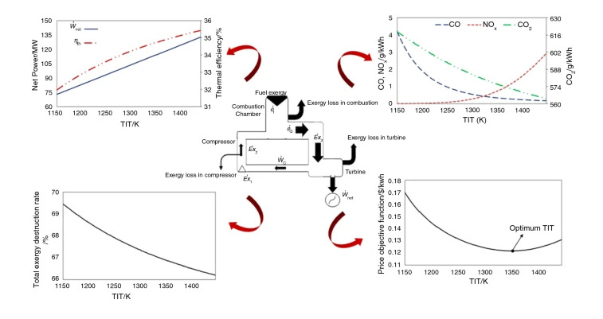
On the other hand, increasing TIT is particularly relevant in combined-cycle power plants, where a higher TIT implies a higher exhaust temperature from the gas turbine enhancing the efficiency of the Rankine cycle downstream, leading to a significant improvement in overall plant efficiency [Ishizaka, 2017].
Figure 1.1 Effects of TIT on Gas Turbine Cycle
One of the significant challenges associated with increasing TIT in gas turbines is blade creep. At these extreme temperatures, even the most advanced superalloys used in turbine blades begin to slowly deform plastically over time. This phenomenon, known as creep, can have severe consequences. As the blades creep, their shape elongates as shown in Fig.1.2, and their internal passages narrow. This can reduce aerodynamic efficiency by causing flow disturbances and restricting cooling air within the blades. Furthermore, excessive creep can lead to warped or cracked blades, potentially causing catastrophic failure and significant downtime for repairs or replacements. These risks necessitate a delicate balancing act – maximizing TIT for efficiency gains while keeping it low enough to prevent detrimental blade creep and ensure safe, reliable turbine operation.
Therefore, developing stronger materials with superior creep resistance and implementing advanced cooling technologies are crucial for pushing the boundaries of TIT in gas turbines.

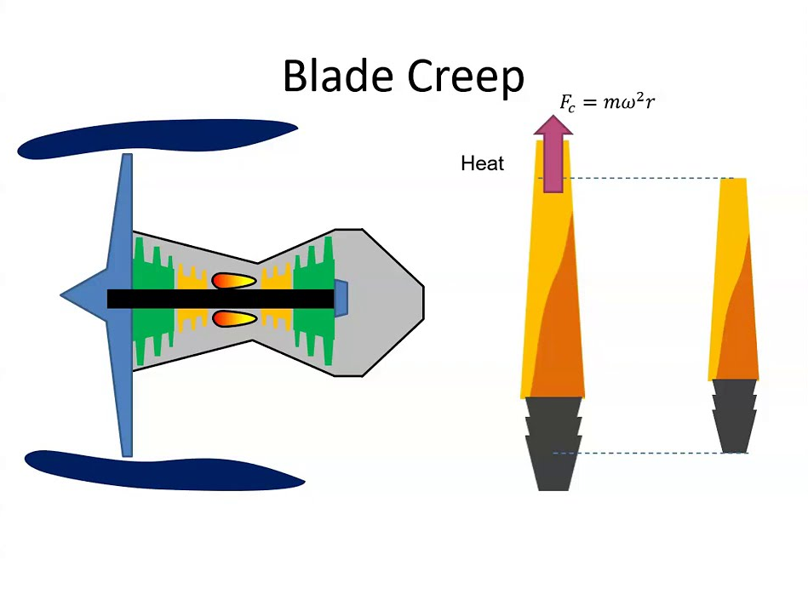
1.1.2 Mitsubishi Heavy Industries (MHI) project for 1700℃ Class Ultra High Temperature Gas Turbine
Figure 1.2 Blade Creep
The MHI project is divided into phases. Phase I (2004-2007) focused on developing six key technologies for 1700°C turbines (Fig. 1.3): barrier coatings, cooling systems, combustors, turbines, compressors, and heat-resistant materials. Phase II and III (2008-2015) aimed at commercializing these technologies. Achievements from this phase have already been implemented in the development of the world's first 1600°C-class J-series gas turbine and next-generation high-efficiency gas turbines [Ishizaka, 2017].
Phase IV is underway with an expanded focus on 13 key technologies. This phase aims to develop, manufacture, and test an actual 1700°C-class gas turbine unit.
These technologies include [Ishizaka, 2017]:
- High-performance compressors with improved boundary layer control to increase pressure ratio and efficiency.
- Lean premix combustors with reduced NOx emissions achieved through improved flame position evaluation using optical measurement and large-scale unsteady numerical simulation.
- High-performance turbines with optimized exhaust diffusers to improve efficiency by reducing turbine blade exit velocity.
- Advanced thermal barrier coatings (TBC) for high-temperature components with improved thermal conductivity and high-temperature stability.
- Welding repair technology for single-crystal turbine blades using Laser Metal Deposition (LMD).
- Additive manufacturing for complex cooling structures in hot parts to reduce cooling air volume.
- Super heat-resistant materials for turbine blades with excellent creep strength and dwell thermo-mechanical fatigue strength.
- Casting process simulations for directionally solidified and single crystal blades to predict casting defects and optimize casting processes.
- Wireless power supply technology for high-speed blade vibration measurement eliminating the need for battery changes.
- Blade internal surface defect detection technology using a matrix array UT probe for improved inspection of cooling passages.
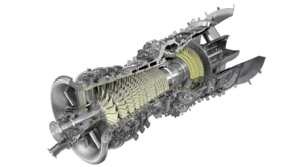
As already stated, this thesis focuses only on the underlined key technologies.
Figure 1.3 Mitsubishi 1700°C Class Ultra High Temperature Gas Turbine
In collaboration with the National Institute for Materials Science (NIMS), Mitsubishi developed a super heat-resistant material for single crystal blades, the new Ni-SX MGA1700. MGA1700 exhibits exceptional creep strength and dwell thermo-mechanical fatigue strength, some results are shown in Fig. 1.4. Notably, it achieves these superior mechanical properties without relying on the expensive element rhenium [Ishizaka, 2017].
However, due to the current patent status of MGA1700, this thesis focuses on the broader development of Ni-SXs for ultra-high efficiency gas turbines. It will delve into the evolution of superalloys design principles and explore various strengthening mechanisms employed in these materials.

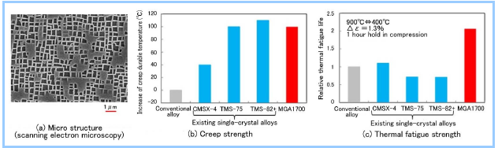
The casting process is a delicate part of the manufacturing process, because Ni-SXs are very sensitive to form defects if not able to control the solidification direction. This thesis will discuss the models created by MHI to predict the main casting defects: freckle, stray grain and re-crystallization. Some results are shown in Fig. 1.5 [Ishizaka, 2017].
Figure 1.4 MGA 1700 single crystal alloy
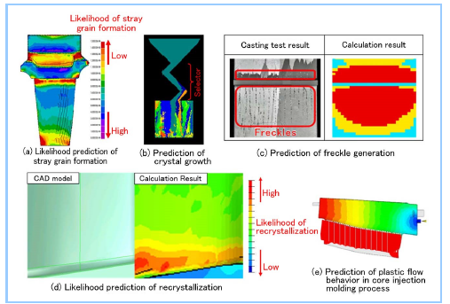
Figure 1.5 Simulation results for each casting process

Chapter 2: Evolution of Ni-SXs

2.1 Introduction to Ni-SXs
This chapter explores the Ni-SXs design evolution as discussed in [Xia, 2020].
In modern aerospace and industrial gas turbine engines, components are subjected to extremely severe operating conditions characterized by high temperatures, high stresses, and aggressive oxidizing and corrosive environments. These challenging conditions necessitate the use of advanced materials that can maintain their mechanical integrity and performance over prolonged periods. Among these materials, Ni-SXs have emerged as critical for their exceptional high-temperature properties, particularly in turbine blade applications.
Ni-SXs are extensively employed in turbine blades due to their superior thermo-mechanical performance. One of the most significant attributes of Ni-SXs is their high-temperature creep resistance. Creep, defined as the time-dependent deformation of materials under constant stress, is a primary failure mechanism in high-temperature environments. The enhanced creep properties of Ni-SXs are paramount for the longevity and reliability of turbine engines.
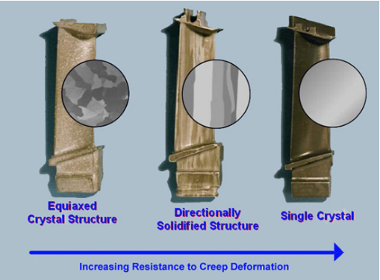
The superior creep resistance of Ni-SXs compared to traditional equiaxed superalloys is primarily due to the elimination of grain boundaries. In conventional alloys, grain boundaries act as weak points that facilitate the nucleation and propagation of creep cracks, leading to premature failure. Ni-SXs, by being single crystals, eliminate these grain boundaries, thereby significantly improving creep resistance and overall mechanical performance as shown in Fig. 2.1.
Figure 2.1 Creep Resistance

2.2 Two phase microstructure and lattice misfit

2.2.1 Two phase microstructures: key factor of the Ni-SXs creep strength
A key factor contributing to the remarkable creep strength of Ni-SXs is their intrinsic two-phase microstructure. This microstructure consists of a continuous matrix phase (γ phase) and a precipitated phase (γ' phase). The γ phase, which has a face-centered cubic (FCC) crystal structure similar to pure nickel, forms a continuous matrix that accommodates other phases. The primary strengthening phase within this matrix is the γ' phase, which plays a crucial role in enhancing the alloy's strength.
The γ' phase typically constitutes a significant volume fraction of the alloy and is characterized by an ordered L12 crystal structure. This phase forms coherent interfaces with the γ matrix, as shown in the HAADF-STEM microscopy of Fig. 2.2(a) where cuboidal γ' particles (dark) are separated by narrow γ channels (bright). Such a highly ordered structure significantly boosts the strength and creep resistance of the alloy, as the dislocation movements are primarily confined to the γ channels, making it challenging for dislocations to penetrate the rigid γ' cuboids.
The compositional aspects of Ni-SXs also play a vital role in their high-temperature performance. These alloys generally contain a high percentage of nickel, along with various alloying elements such as chromium (Cr), cobalt (Co), molybdenum (Mo), tungsten (W), titanium (Ti), tantalum (Ta), rhenium (Re), ruthenium (Ru), aluminium (Al), titanium (Ti), and tantalum (Ta). These elements are strategically added to either the γ or γ' phases to optimize the microstructure and enhance the mechanical properties of the alloy. The distribution of these elements between the phases is critical for achieving the desired balance of properties, including creep resistance, thermal stability, and strength.
According to their roles in strengthening the alloy, these elements are categorized into two groups: γ phase elements and γ' phase elements. The γ phase elements are those that primarily distribute within the γ phase and form solid solutions. These include elements such as Co, Cr, Mo, W, Re, and Ru, as shown in the EDX maps of Fig. 2.2(b). Adding these elements to the γ phase significantly increases the solidus temperature, which enhances thermal stability, and decreases the stacking fault energy (SFE), which improves creep properties. Additionally, the microstructures of alloys are expected to be optimized by designing the composition of the γ phase to enhance creep properties.
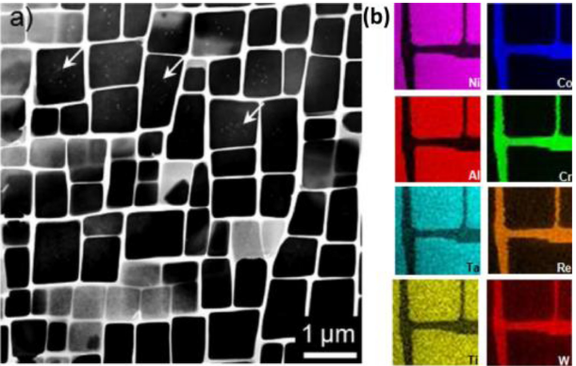
As can be seen from the same EDX maps, the γ' phase alloying elements primarily include Al, Ti, and Ta. During the formation of microstructures with these elements, the construction of Ni-X bonds (where X represents Al, Ti, or Ta) is promoted over Ni-Ni or X-X bonds. These bonds exhibit a strong degree of chemical order, leading to the formation of the ordered γ' phase, which is different from the disordered γ phase with an FCC structure.
Figure 2.2 Standard γ/γ' microstructure and elemental partitioning behaviour of Ni-SXs. (a) HAADF-STEM microscopy of a Ni-SX; (b) Series of EDX maps showing alloying elements.
The addition of γ' phase elements needs to be considered in two aspects. First, to adjust the volume fraction of the γ' phase, the total content of γ' phase elements needs to be changed. Second, some alloying elements like Ta and Ti are used to replace Al, which improves the intrinsic strength of the γ' phase.
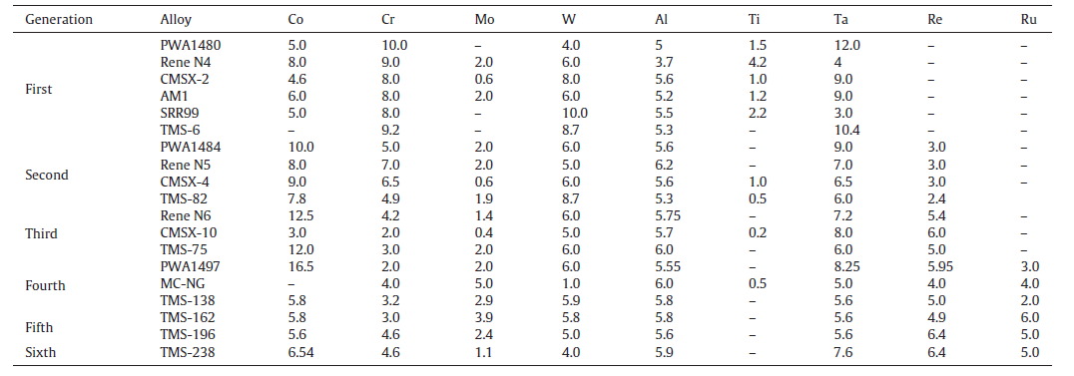
Table 2.1, instead, shows the evolution of the composition of Ni-SXs
Table 2.1 Compositions of some representative Ni-SXs(wt%).

2.2.2 Lattice misfit: a parameter to manage the γ/γ' interfacial coherency
The creep properties of the alloy are closely related to the interfacial coherency, which is typically described by the lattice misfit, denoted as δ. The lattice misfit is defined by the equation:
$$δ=\frac{\left(a_{γ^{'}}-a_{γ}\right)}{\left(a_{γ^{'}}+a_{γ}\right)}$$
Here, $a_{γ^{'}}$ and $a_{γ}$ represent the lattice constants of the γ' phase and γ phase, respectively. Since the lattice constants are significantly influenced by the partitioning of alloying elements in the γ' and γ phases, the lattice misfit can be either positive or negative depending on the values of the lattice constants of the two phases.
The lattice constants in Ni-SXs are greatly influenced by the partitioning of alloying elements between the γ and γ' phases, leading to either positive or negative lattice misfit depending on the values of these constants. Elements like Ta and Ti, which tend to partition to the γ' phase, have larger atomic sizes compared to elements like Co and Cr in the γ phase. The incorporation of these larger atoms in the γ' phase can replace some of the atomic sites in the Ni-Al structure, effectively increasing the lattice constant of the γ' phase. Although the γ phase elements also have larger atomic sizes than pure nickel and can increase the lattice constant of the γ phase, the increase is generally less significant than in the γ' phase.
As a result, most Ni-SXs exhibit positive lattice misfits at room temperature. However, these positive lattice misfits typically turn negative at high temperatures due to the much larger thermal expansion coefficient of the γ phase. The changing lattice misfit leads to significant variations in the γ/γ' microstructure because of the altered interfacial coherency stress, which is a main driving force for the coarsening of γ' precipitates.
A reduced lattice misfit decreases coherency strains and coarsening kinetics. Near-zero lattice misfit can produce nearly spherical γ' precipitates (Fig. 2.3) to minimize surface energy. As the lattice misfit increases, the interfacial energy also increases to minimize enhanced elastic strain energy and large lattice distortion energy, leading to the cuboidal shape of γ' precipitates.
If the lattice misfit is not too large, the γ/γ' interface maintains its coherency with low interfacial energy, stabilizing the interface. A cuboidal shape of γ' precipitates, as can be observed from the same figure, is beneficial to the alloy's creep properties because it minimizes the elastic moduli of both phases along the <100> direction. In alloy design, elements such as W and Mo are generally added to enhance the lattice misfit and optimize the shape of γ' precipitates due to their much larger atomic size compared to Ni. A moderate lattice misfit is expected to be advantageous to creep properties, with an absolute value around 0.4 being favourable for many Ni-SXs.
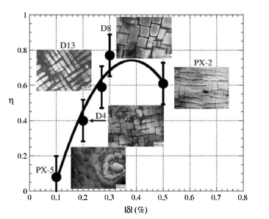
However, an excessively large lattice misfit can lead to irregular coarsening of γ' particles, destabilizing the microstructure and adversely affecting the alloy's creep properties. Therefore, the additions of W and Mo are typically limited to minor contents in most Ni-SXs.
Figure 2.3 Effects of lattice misfit on shape of γ' phase

2.3 Creep because of dislocations in Ni-SXs
Creep is a crucial failure mechanism for materials exposed to high temperatures and stresses over prolonged periods. Ni-SXs exhibit outstanding creep resistance due to their unique microstructural characteristics and the intricate interactions between dislocations and phases within the alloy.

2.3.1 Dislocation Motion in the γ Phase
In Ni-SXs, the γ phase, which possesses a FCC structure, is initially almost free of dislocations due to thorough heat treatment processes.
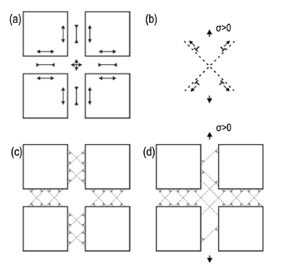
As the external stress is applied, dislocations start to move within the γ phase as showed in Fig. 2.4(b). These dislocations primarily travel through the narrow channels of the γ phase, encountering significant resistance from the γ' precipitates. The γ' phase precipitates form coherent interfaces with the γ matrix, creating obstacles that the dislocations must bypass. The interaction between dislocations and these γ/γ' interfaces leads to the formation of dislocation networks around the γ' precipitates (Fig. 2.4(c)).
Figure 2.4 Schematic illustrations of dislocation movements in the γ channels. (a) Stress components associated with misfit; (b) Effect of an external tensile stress on two dislocation dipoles; (c) Misfit dislocations. (d) Interface dislocations after creep
The movement of dislocations in the γ phase necessitates the diffusion of atoms and vacancies, which significantly contributes to the overall creep deformation. The γ phase elements, including Co, Cr, Mo, W, Re, and Ru, play a vital role in this process by influencing the diffusion rates and the stability of the dislocation structures.
Dislocations within the γ phase begin to multiply and interact under applied stress, leading to the formation of complex dislocation structures. These interactions result in the creation of dislocation networks that are anchored around the γ' precipitates. The stability of these networks is influenced by the lattice misfit between the γ and γ' phases as well as the internal coherency stresses.
The behaviour of dislocations within the γ phase directly impacts the creep properties of Ni-SXs. The formation of stable dislocation networks helps to restrict further dislocation movement, thereby enhancing the creep resistance of the alloy. The coherency and stability of the γ/γ' interface are crucial in maintaining these networks and ensuring the alloy's mechanical integrity under high-temperature conditions.

2.3.2 Dislocation Motion in the γ' Phase
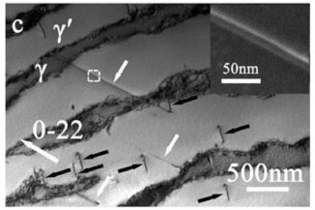
Dislocations in the γ' phase typically travel in pairs as can be observed in Fig. 2.5. The formation of anti-phase boundaries (APBs), which occur when two L12 crystals combine, plays a crucial role in this process. Dislocations in the γ matrix need to convert Ni-X bonds into Ni-Ni and X-X bonds to pass through the γ' phase, which requires significant energy known as APB energy. This energy is considerably higher than the SFE of the γ matrix, making dislocation movement more challenging.
Figure 2.5 Dislocations in γ matrix travel in pairs across the γ' phase. (with forming of APBs)
When a dislocation pair enters the γ' phase, the first dislocation creates an APB by locally disrupting the ordered bonds. The second dislocation then restores the ordered structure by eliminating the APB. This process requires substantial energy, which is a key factor in strengthening the alloy.
The need for APB energy makes it difficult for dislocations to move through the γ' phase, significantly contributing to the strengthening of the alloy. The ability of dislocations to travel through the γ' phase depends heavily on the composition of the alloy and the APB energy. Higher APB energy corresponds to greater resistance to dislocation movement, enhancing the creep properties of the superalloy.

2.4 Composition Evolution in Ni-SXs
The evolution of the composition in Ni-SXs is a critical aspect of their development, influencing their microstructural characteristics and, consequently, their mechanical properties. The design and optimization of these alloys involve careful selection and balance of alloying elements to achieve the desired high-temperature performance.

2.4.1 Addition of the γ' Phase Elements
Al, Ti, and Ta are much larger than Ni and promote the formation of the ordered γ' phase. The ordered γ' phase is essential for enhancing the creep resistance of the alloy. By increasing the volume fraction of the γ' phase to an appropriate level, the creep resistance is improved. The γ' phase exhibits an ordered structure that is harder and more resistant to dislocations compared to the disordered γ phase.
A significant volume fraction of the γ' phase helps to impede dislocation movements, contributing to substantial precipitating strength. However, increasing the γ' phase volume fraction inevitably reduces the γ contents, which results in a reduction of the total area of γ/γ' interfaces and the width of γ channels. Since these interfaces play a crucial role in impeding dislocation movements and the γ channels provide the main plasticity of Ni-SXs, the creep strength will significantly degrade if the total area of γ/γ' interfaces and the width of γ channels are reduced beyond a certain level. Therefore, the volume fraction of γ' precipitates needs to be controlled within an appropriate range, generally 60%-75% for most Ni-SXs. Excessive additions of γ' phase elements can lead to a rapid degradation of the high-temperature strength of the alloy.
In a ternary Ni-Al-X system, the substitution behaviour depends on the atomic size of the replaced atoms. Al is replaced by larger solutes such as Ti and Ta. The addition of Ti and Ta promotes the formation of Ti-Ni and Ta-Ni bonds, which are much stronger than Al-Al bonds. This enhances the APB energy, which in turn increases the resistance to dislocation motion in the γ' phase, enhancing the creep resistance. Nano-indentation analysis shows that the hardness of the γ' phase increases with the addition of Ta and Ti, while the hardness of the γ channels remains nearly constant.
Ti strongly partitions to the γ' phase, changing its hardness due to atomic substitutions. As shown in Fig. 2.6(a), the APB energy increased monotonically with the increase of Ti/Al ratio. The increase of APB energy results in the enhanced resistance of dislocation motion in γ' phase referring to the enhanced creep resistance However, excessive addition of Ti can damage high-temperature creep resistance. In a Ti-Ni-Al system, Al is replaced by Ti, increasing the lattice parameter of the γ' phase and enhancing the lattice misfit, leading to γ' phase coarsening and degradation of creep resistance. Additionally, Ti eutectic structures, which are hard to dissolve, can form during the casting process and destabilize the microstructure. A high Ti/Ni ratio can promote the precipitation of the η-Ni3Ti phase, providing sites for crack nucleation and propagation. Consequently, Ti has been gradually abandoned from the third generation of Ni-SXs.
In contrast to Ti, Ta is still extensively used in single crystal alloys to enhance creep strength and resistance to oxidation and corrosion. The effects of Ta on APB energy in a Ta-Ni-Al ternary system differ significantly. The APB energy increases greatly with a small Ta-Al ratio but decreases drastically with a continuous increase in the Ta-Al ratio, becoming negative after a ratio of 5, as can be observed in Fig. 2.6(b). A peak APB energy value occurs at a low ratio of around 0.2, representing optimal properties. Compared to Ti, Ta performs better in strengthening alloys and plays a crucial role in stabilizing γ' precipitates. The addition of Ta makes the enthalpy of forming the γ' phase more negative, suggesting increased stability of the γ' precipitates. High Ta content can inhibit the γ' phase from coalescing and growing during prolonged high-temperature exposure, restraining γ' phase coarsening.
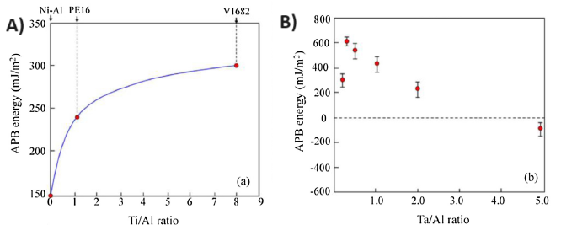
Modulating the Ta/Al ratio is an important aspect of alloy design. Enhanced contents of Ta and Al can promote the formation of eutectic phases. At elevated temperatures, large amounts of eutectic phases can deteriorate structural stability and increase the nucleation of topologically close-packed (TCP) phases, greatly damaging the creep strength of the alloys.
Figure 2.6 Effects of Ti and Ta on APB energy of Ni-SXs. (a) The effects of Ti/Al ratios on APB energy; (b) The effects of Ta/Al ratios on APB energy.

2.4.2 Addition of the γ Phase Elements
The second class of elements includes Co, Cr, Mo, W, Re, and Ru. These elements form solid solutions in the γ matrix and derive their creep-strengthening effects from their low mobility in a Ni solvent, which impedes the diffusion of dislocations.
The diffusion rates of these alloying elements in Ni are crucial. Elements exhibit varying diffusion rates with increasing temperature, ordered in Fig. 2.7 from fastest to slowest as Al, Ti, Cr, Co, Mo, W, and Re. Notably, larger atoms generally diffuse slower due to higher binding energy. Despite being larger, elements like Re diffuse several orders of magnitude slower than other 5d transition metals. This low diffusivity is due to the atomic radii of Re being only slightly larger than Ni, combined with the electronic structure of solute atoms affecting d-states occupancy.
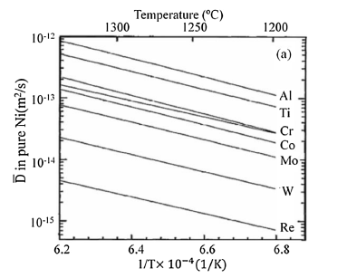
Re's slow diffusion in Ni leads to optimal creep performance when added to alloys. The coarsening of the γ' phase is hindered by the segregation of Re at γ/γ' interfaces due to its low diffusion rate. This segregation enhances creep resistance. Evaluations show that higher Re content significantly improves the high-temperature performance of superalloys. For instance, increasing Re from 0% in CMSX-2 to 6% in CMSX-10 improves the creep time and temperature endurance by significant margins.
Figure 2.7 Diffusion coefficients of some strengthening elements in Ni
The high-temperature performance of superalloys is often evaluated by their ability to maintain stability under specific conditions, such as 137 MPa pressure for 1000 hours. The addition of Re and its evolution in alloy compositions has shown substantial improvements in temperature endurance. The introduction of Ru in higher generations of Ni-SXs further enhances temperature endurance due to its beneficial effects on stabilizing microstructures and restraining TCP phases.
The content of Ru in Ni-SXs has increased from 0% in third-generation alloys to 5-6% in fifth and sixth generations. Ru helps in stabilizing the γ/γ' microstructures and restraining TCP phases, contributing to improved high-temperature stability. However, increasing Re and Ru contents in new Ni-SXs decreases the proportion of other γ phase elements to maintain appropriate volume fractions of the γ' phase.
The proportions of Co and Cr have decreased in newer generations of superalloys. High Co levels, although beneficial for reducing the SFE of the γ phase, can decrease the solvus temperature of the γ' phase and increase TCP-forming element partitioning, leading to TCP phase formation. High Cr contents, while providing structural stability at high temperatures, can negatively impact creep properties and hot workability due to the formation of Cr-rich phases with poor plasticity.
These elements are extensively used in superalloys for their contributions to enhance solvus temperature, creep strength, and microstructural stability at high temperatures. Re, has been shown to be more effective than W or Mo in strengthening the matrix, attributing to its strong creep-strengthening effect due to its slower diffusion in Ni.
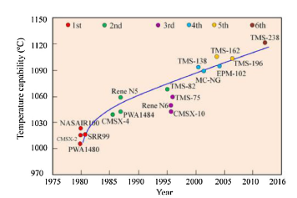
In summary, the composition evolution in Ni-SXs is a complex process that involves balancing various alloying elements to optimize the microstructural characteristics and mechanical properties. Understanding the roles and interactions of these elements has been essential for developing advanced superalloys with superior high-temperature performance and creep resistance, as can be observed in the evolution summary of Figure 2.8.
Figure 2.8 High temperature capabilities of some typical Ni-SXs.

Chapter 3: Simulation techniques for investment casting process of MGA1700 by MHI

3.1 Introduction to MGA1700
As explained in the Chapter 1, the development of the Ni-SX superalloy MGA1700 (TMS-1700) was achieved through a joint research effort between the NIMS and MHI. This new alloy, intended for use in high-efficiency gas turbine blades, boasts outstanding creep strength and thermo-mechanical fatigue strength. MGA1700 does not contain costly elements such as Re. However, the mechanical properties and manufacturing yield of Ni-SX blades are highly sensitive to the casting process conditions. To address this, the study established simulation analysis techniques for various stages of the investment casting process, including solidification and mold manufacturing. These techniques can also be applied to other components, such as directionally solidified (DS) rotating blades and conventionally cast (CC) rotating blades and stationary vanes [Fujiwara, 2019].
Developing Ni-SXs that possess both excellent creep strength and thermo-mechanical fatigue strength is generally challenging. However, the new MGA1700, developed collaboratively by NIMS and MHI, successfully combines these properties. Additionally, MGA1700 does not include expensive elements like Re, as it is based on second-generation Ni-SXs [Fujiwara, 2019].
Simulation analysis is critical for the investment casting process of Ni-SX blades because the mechanical properties and manufacturing yield are highly sensitive to casting defects and crystal orientation. These defects typically arise during the solidification of molten metal, but the mold manufacturing process can also contribute to defects and low yields. For instance, improper injection molding conditions of wax patterns can lead to core cracking or incomplete filling (short shot). Therefore, the study conducted by NIMS and MHI has established simulation analysis techniques for various stages of the investment casting process, including both the solidification and mold manufacturing steps [Fujiwara, 2019].

3.2 Design of MGA1700 through the MHI flow chart
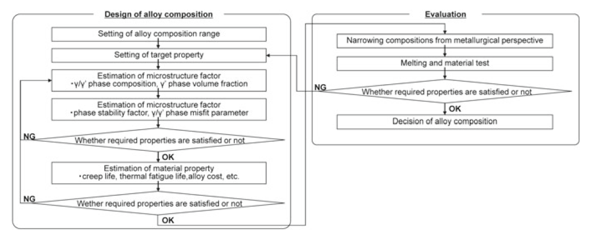
The composition of the experimental alloys was determined based on this concept, using a materials design flow chart (Fig. 3.1). NIMS extensive experience in superalloy development led to create an alloy design program utilizing a database of material properties. This program can estimate metallurgical factors, such as γ/γ' phase composition, γ' phase volume fraction, phase stability factor, and γ/γ' phase misfit parameter. By applying multiple regression analysis to these factors, the creep strength and thermo-mechanical fatigue strength can be accurately predicted. The creep strength estimates are particularly accurate due to the large amount of available data from NIMS. However, due to insufficient data, the initial estimates for thermo-mechanical fatigue strength were less accurate. Therefore, the estimation program for thermo-mechanical fatigue strength was improved by incorporating tested results from MHI study [Fujiwara, 2019].
Figure 3.1 Alloy design flow of a new superalloy
According to the flow chart, to test the target properties of the alloy obtained through the NIMS design program, specimens must be manufactured. In fact, in that study dozens of superalloys were designed, and size of 200 mm x 200 mm x 20 mm cast plates were manufactured using ceramic molds. After the heat treatment, round bar and plate shape specimens were machined for mechanical properties measurements. Figure 3.2 shows the microstructures of a plate specimen of the developed alloy MGA1700, which contains no Rhenium. The microstructure was homogenized and no eutectic γ/γ' phase was observed [Fujiwara, 2019].
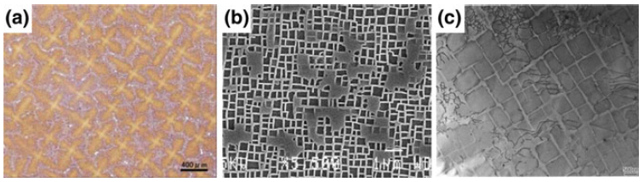
Following the steps of the flow chart, once estimated material properties like creep life, thermal fatigue life, etc., they should be tested. The creep test was conducted at temperatures ranging from 900 to 1100°C. The results, shown in Figure 3.3, indicate that the creep strength of MGA1700 (TMS-1700) is superior to that of CMSX-4 and comparable to TMS-82+ and TMS-75. This confirms the excellent creep strength of MGA1700 [Fujiwara, 2019].
Figure 3.2 a) Optical micrograph, b) SEM image, and c) TEM image of MGA1700 (TMS-1700)
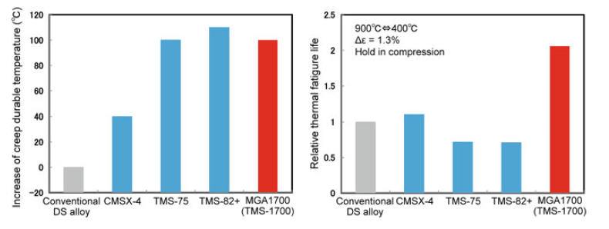
To simulate actual operating conditions of turbine blades, a thermo-mechanical fatigue test was also performed. The temperature and strain were controlled under out-of-phase conditions, with the temperature cycling between 400 and 900°C, and the specimens held at 900°C under compressive stress for an hour. Due to the variability in fatigue test results, multiple tests were conducted under the same conditions. As shown in the results, the MGA1700 exhibited excellent fatigue strength, meeting the development goals. Additionally, the absence of expensive elements makes MGA1700 a viable material for practical applications [Fujiwara, 2019].
Figure 3.3 Increase of creep durable temperature and relative thermal fatigue life

3.3 Casting furnace and solidification simulations to predict the casting defect generation and the grain orientation
The typical defects in Ni-SX are, as shown in Fig. 3.4:
- Freckle
- Stray grain
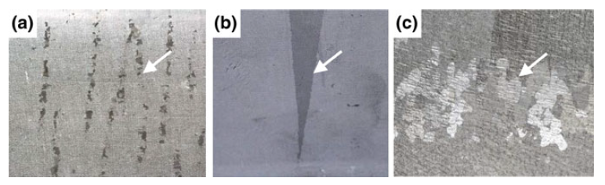
- Re-crystallization
Figure 3.4 Typical casting defects in the SC superalloy a freckle, b stray grain, and c re-crystallization

3.3.2 Freckle Generation
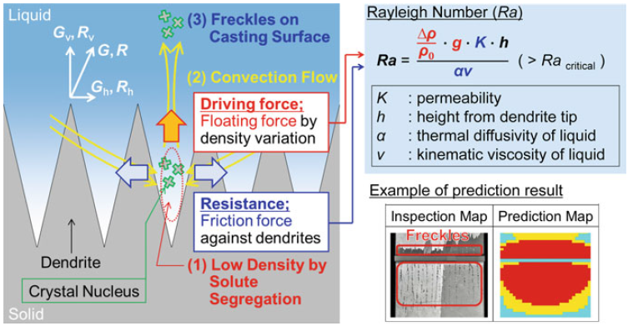
Freckle generation occurs there where dendrites form. The dendrites are the result of the segregation mechanism in which due to different melting temperature of the alloying elements the resulting composition of the solid is different from that of the liquid that has not solidified, yet. This mechanism drive to the formation of “bumps” that when they are limited to the boundaries of the grains (in this case of the single crystal) are called dendrites [Gabrielli, 2008]. Driving force for freckle generation in MGA1700 is segregation of compositional elements. High-density elements (such as W, Re) tend to segregate the solid and concentrate in the dendrite core while low-density elements (such as Ti or Al) tend to segregate to the liquid and these segregations make the liquid lighter in the vicinity of liquid/solid interface and promote convection flow of molten metal. The convection flow, promoted by segregation, causes the freckle generation, as shown in Fig. 3.5. On the other hand, the friction force between the liquid and dendrite arms acts as a resistance force of the freckle formation. For this reason, to predict the freckle formation, the Rayleigh number has been used. The Rayleigh number is the ratio between driving force (liquid density variation) and resistance force (permeability of dendrites or liquid properties) [Fujiwara, 2019]. The result of experiment and simulation was compared and showed good match between the results.
Figure 3.5 Basic mechanism and an example of prediction result of freckle generation

3.3.2 Stray Grain
To understand this type of defect it should be briefly introduced how the casting process works (see schematic furnace in Figure 3.6). To achieve the desired off-axis orientation in single-crystal components, a specially prepared SX seed labelled A in the Figure 3.7(a) is used. This seed is partially melted during the mold's soak period. Molten alloy is then introduced into the mold cavity, crossing the interface where the seed has melted back. This interface is labelled B in the image. Subsequently, the mold is withdrawn from the furnace [Yang, 2005].
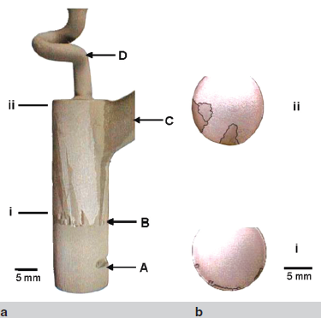
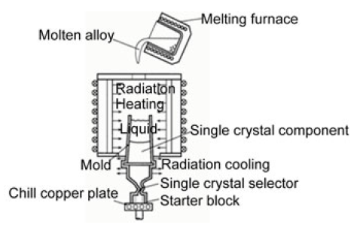
During the initial phase of orientation transfer between the semi-solid seed and the molten alloy, highly misoriented stray grains can nucleate relative to the SX axis. These stray grains may grow instead of the desired orientation if they have a more favourable growth direction than the off-axis seed. As shown in Figure 3.7(b), many stray grains (boundaries are highlighted) appear just above the melt-back interface (cross section i, 2.5 mm above B), with some preferentially oriented stray grains growing at the expense of the seed grain just before entering the selector (cross section ii, 29.5 mm above B). The likelihood of these stray grains surviving increases with the seed's crystallographic misorientation. The use of a helical selector (labelled D) prevents these stray grains from entering the blade cavity [Yang, 2005].
Figure 3.7 (a) The seed and helical selector section of a turbine blade casting macro etched to highlight the stray grains; (b) optical micrographs of transverse sections showing the nucleation and growth of stray grains.
Figure 3.6 Schematic diagram of furnace and casting mold
The stray grain is a crystal grain grows irregularly on the way of continuous crystal growth from the bottom side of the mold to top. The stray grain generation is mainly caused by an imbalance between two solidification parameters, called solidification speed and thermal gradient. Therefore, the stray grain can be predicted using these parameters obtained from the solidification simulation results (Fig.3.8(a)) [Fujiwara, 2019].

3.3.3 Re-crystallization
In this case the nucleation of new grains during the heat treatment process is a result of the residual strain generated during the casting process. To predict the re-crystallization, the temperature variation results of solidification simulation were transferred to FEM code, and then the residual strain generated during the solidification and the post solidification was calculated [Fujiwara, 2019].
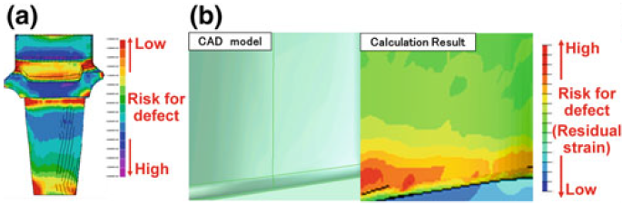
The predicted place of casting defect generation by simulation was in good agreement with the place of casting defect generation on the real blade, as shown in Figure 3.8(b). The angle difference between crystal orientation and withdrawing direction in casting process should be minimized to obtain sufficient material strength [Fujiwara, 2019].
Figure 3.8 Predicted results of a) stray grain, b) re-crystallization

Chapter 4: Conclusion
Driven by a curiosity about combined cycle power plants, this thesis first explores the critical role of raising turbine inlet temperature in enhancing cycle efficiency. It then investigates, using as an example the Mitsubishi Heavy Industries (MHI) 1700℃ Class Ultra High Temperature Gas Turbine project, the key technologies for manufacturing turbine blades resistant to creep and thermo-mechanical fatigue.
Ni-based single crystal superalloys (Ni-SXs) represent a pinnacle of materials engineering, combining advanced compositional strategies with intricate microstructural design to achieve exceptional high-temperature performance. The development of Ni-SXs has been driven by the need for materials capable of withstanding extreme operating conditions. The intricate balance of alloying elements, the unique microstructural characteristics, and the advanced understanding of creep mechanisms have collectively contributed to the success of these superalloys.
While the casting process retains elements of traditional techniques, it has been significantly optimized through the implementation of advanced simulation techniques. The simulation analysis technique for various steps of investment casting process was established to find adequate casting conditions. The established technique was very helpful to predict the casting defects and the crystal orientation.
Thus, it can be concluded that the evolution of these superalloys has relied on a multidisciplinary approach, integrating insights from materials science, metallurgy, computer science, statistics and engineering. And this exact approach will guide future progresses in this field with the aim of making this technology more affordable and accessible for widespread use.

Bibliography
Fujiwara K., Oguma H., Taneike M., Okada I., Kawagishi K., Yokokawa T., Harada H. (2019) Simulation Analysis Techniques for Investment Casting Process of Ni-Base Superalloy Components. In: Tiryakioğlu, M., Griffiths, W., Jolly, M. (eds) Shape Casting. The Minerals, Metals & Materials Series. Springer, Cham, 253-262
Gabrielli F., Ippolito R., Micari F. (2008) Analisi e tecnologia delle lavorazioni meccaniche, The McGraw-Hill Companies, Milano (IT), 1-465 (in Italian)
Ishizaka K., Ito E., Masada J., Saitoh K., Yuri M. (2017) Key Technologies for 1700℃ Class Ultra High Temperature Gas Turbine, Mitsubishi Heavy Industries Technical Review, 54(3): 23-32
Kazemiani‑Najafabadi P., Amiri Rad E. (2021) Introducing an optimum gas turbine inlet temperature (TIT) based on a 4E analysis: a case study of northeastern Iran, Journal of Thermal Analysis and Calorimetry, 146: 403–413
Xia W., Zhao X., Yue L., Zhang Z. (2020) A review of composition evolution in Ni-based single crystal superalloys, Journal of Materials Science & Technology, 44: 76-95
Yang X.L., Lee P.D., D'Souza N. (2005) Stray grain formation in the seed region of single-crystal turbine blades, JOM, 57: 40-44

