Università degli Studi di Napoli Federico II  Scuola Politecnica e  delle Scienze di Base |  |  |  | Corso di Studi in  Ingegneria Meccanica
(Ingegneria Meccanica – Classe delle lauree in Ingegneria Industriale – Classe n. L-9)

Elaborato di Laurea
Superalloys and casting process for ultra-high temperature gas turbines
Relatore:  Ch.mo Prof. Ing. Antonio Formisano  Dip. di Ingegneria chimica, dei materiali e della produzione industriale |  |  | Candidato:  Salvatore Palumbo  matr. N47/7322
ABSTRACT
Combined cycle power plants are leaders in modern power generation due to their superior efficiency compared to other cycles. This advantage lies in the clever marriage of a gas turbine cycle. But the key to unlocking even greater efficiency lies in supercharging the Rankine steam cycle with exhaust at the highest temperature and this is possible if we push the inlet temperature to the limit. Consequently, pushing the boundaries of this limit is crucial for achieving even greater efficiency in combined cycle plants. This thesis takes the 1700℃ Class Ultra High Temperature Gas Turbine developed by Mitsubishi Heavy Industries (MHI) as a starting point. Through a technical review, I show the key technologies that have led to MHI success. My focus is on two crucial areas: the novel Ni-based superalloy they developed and the techniques they employ to predict defects during the casting process. Obviously, the superalloy they developed is currently under patent and for this reason I decided to take a general look on the evolution of the Ni-base superalloys by introducing the basic knowledge about the microstructure, dislocation mechanism and common alloying elements. While it explores the development flow that led to MHI superalloy creation. Finally, by examining a specific defect, it is possible to gain valuable insight into the organization of the casting process. This analysis will also showcase a solution employed to achieve the single crystal structure of the superalloy.
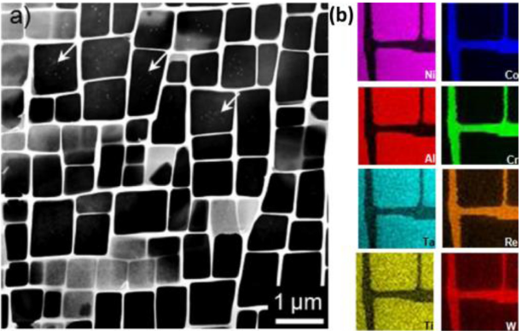  Figure 1 Standard γ/γ' microstructure and elemental partitioning behaviour of Ni-SXs. (source: Xia W., Zhao X., Yue L., Zhang Z. (2020) A review of composition evolution in Ni-based single crystal superalloys, Journal of Materials Science & Technology, 44: 76-95) |  | 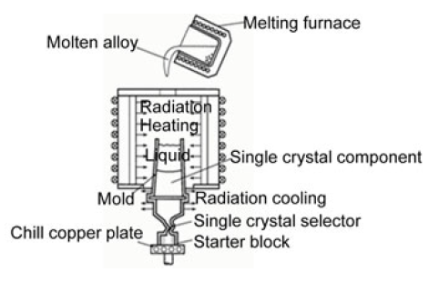  Figure 2 Schematic diagram of furnace and casting mold (source: Fujiwara K., Oguma H., Taneike M., Okada I., Kawagishi K., Yokokawa T., Harada H. (2019) Simulation Analysis Techniques for Investment Casting Process of Ni-Base Superalloy Components. In: Tiryakioğlu, M., Griffiths, W., Jolly, M. (eds) Shape Casting. The Minerals, Metals & Materials Series. Springer, Cham, 253-262)
Anno Accademico 2023/2024

