**HOMEWORK FOR NETWORKING**

**Exercise 1 – Basic network stuff.**

**Use the arp command and paste the output from the arp table on your system:**

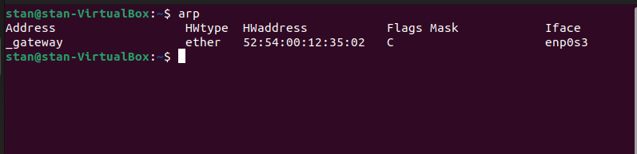

**Use the route command and paste the output from the routing table on your system:**

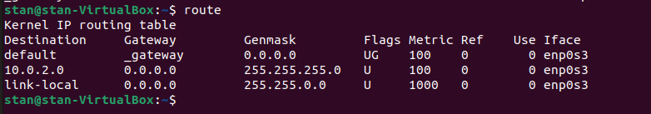

**Use the traceroute command on your system and observe the hops to Google’s DNS, 8.8.8.8.**

**The traceroute command is used to trace the path that packets take from your system to a destination IP address.**

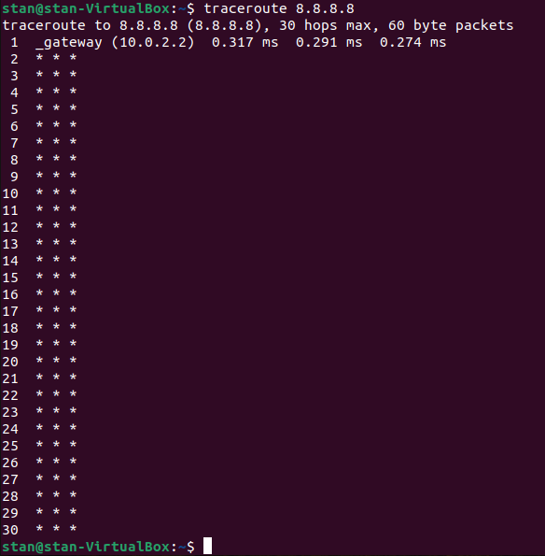**Paste the full output from the command bellow showing all the hops from your system to 8.8.8.8.**

**Why would you need to use the ping command? Answer:**

The ping command is used to test connectivity between your system and another device on the network. It sends packets to the specified device and measures the time it takes to receive a response. The ping command is useful for troubleshooting network connectivity issues and verifying that a device is reachable on the network.

**Write down the TCP/UDP ports of the most commonly used services bellow in the form of TCP[PORT] or UDP[PORT].**

* HTTP - TCP80
* SNMP - UDP161
* HTTPS - TCP443
* DNS client - UDP53
* DNS zone transfer - TCP53
* SMTP - TCP25
* SSH - TCP22
* FTP - TCP21
* Telnet - TCP23
* MSSQL - TCP1433
* MySQL - TCP3306
* PostgreSQL - TCP5432
* RDP (Remote Desktop Protocol) - TCP3389
* NTP - UDP123
* NFS - TCP2049 (UDP can also be used for NFS)

**Exercise 2 – TCP/IP Basics.**

For each of the packet locations shown, 1 to 4 write down the source and

destination MAC addresses of the packet as it travels across the network interfaces.

**1. The laptop initiates communication with the web server and prepares a packet. What would the**

**package look like at this stage?**

* SRC IP : 100.20.30.10/24
* DST IP : 80.70.60.100/24
* SRC MAC : AA-AA-AA:33:33:33
* DST MAC : BB:BB:BB:11:11:01

**2. RTR1 receives the packet on its IF-LAN interface, prepares it accordingly and forwards it out its IFWAN. What would the packet look like at this stage?**

* SRC IP : 100.20.30.10/24
* DST IP : 80.70.60.100/24
* SRC MAC : BB:BB:BB:11:11:01
* DST MAC : BB:BB:BB:11:11:02

**3. RTR2 receives the packet on its IF-WAN interface, prepares it accordingly and forwards it out via IFLAN. What would the packet look like at this stage?**

* SRC IP : 100.20.30.10/24
* DST IP : 80.70.60.100/24
* SRC MAC : CC:CC:CC:22:22:02
* DST MAC : CC:CC:CC:22:22:01

**4. The web server receives the packet and prepares a response packet back. What would the packet**

**look like at this stage?**

* SRC IP : 80.70.60.100/24
* DST IP : 100.20.30.10/24:
* SRC MAC : DD:DD:DD:77:77:77
* DST MAC : CC:CC:CC:22:22:02

The most probable transport layer protocol to be used is TCP.

Since we are talking about web traffic (www), the most probable transport layer protocol that will be used is TCP.

When the laptop sends the packet, we can expect to see a random high-numbered source port

50000 and destination port 80 (HTTP) or 443(HTTPS).

When the web server sends a response packet back, we can expect to see source port 80 (HTTP) or 443(HTTPS) and a random high-numbered destination port.

There are four broadcast domains in the exhibit shown: one for RTR1's IF-LAN interface and one for RTR2's IF-LAN interface and 2 more.

**Exercise 3 – Traffic analysis and identifying the OSI layers of the network packets.**

**Analyze the TCP’s three-way handshake and using screenshots from the Wireshark**

**window answer the questions bellow:**

**1. What is the source IP (of the initiating host): 192.168.31.38**

**2. What is the destination IP? (target website): 194.141.38.18**

**Identify the Network Interface (Layer 1 & 2) section of the SYN packet and paste a**

**screenshot from it:**

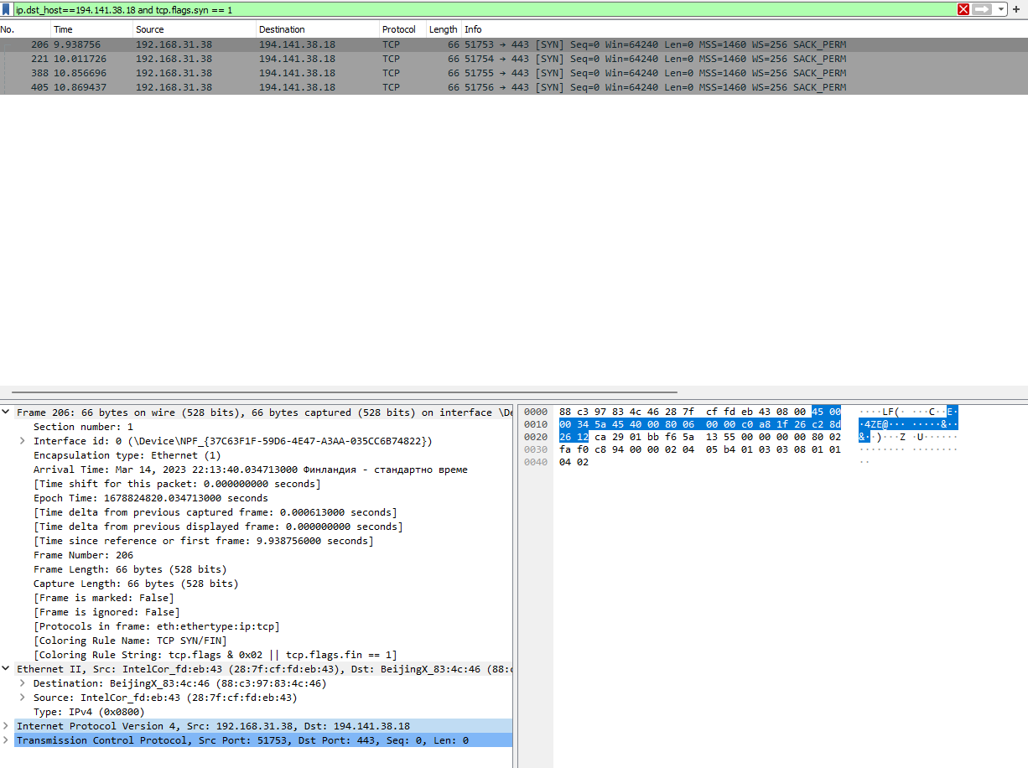

**Identify the Network Layer 3 section of the SYN/ACK packet and paste a screenshot**

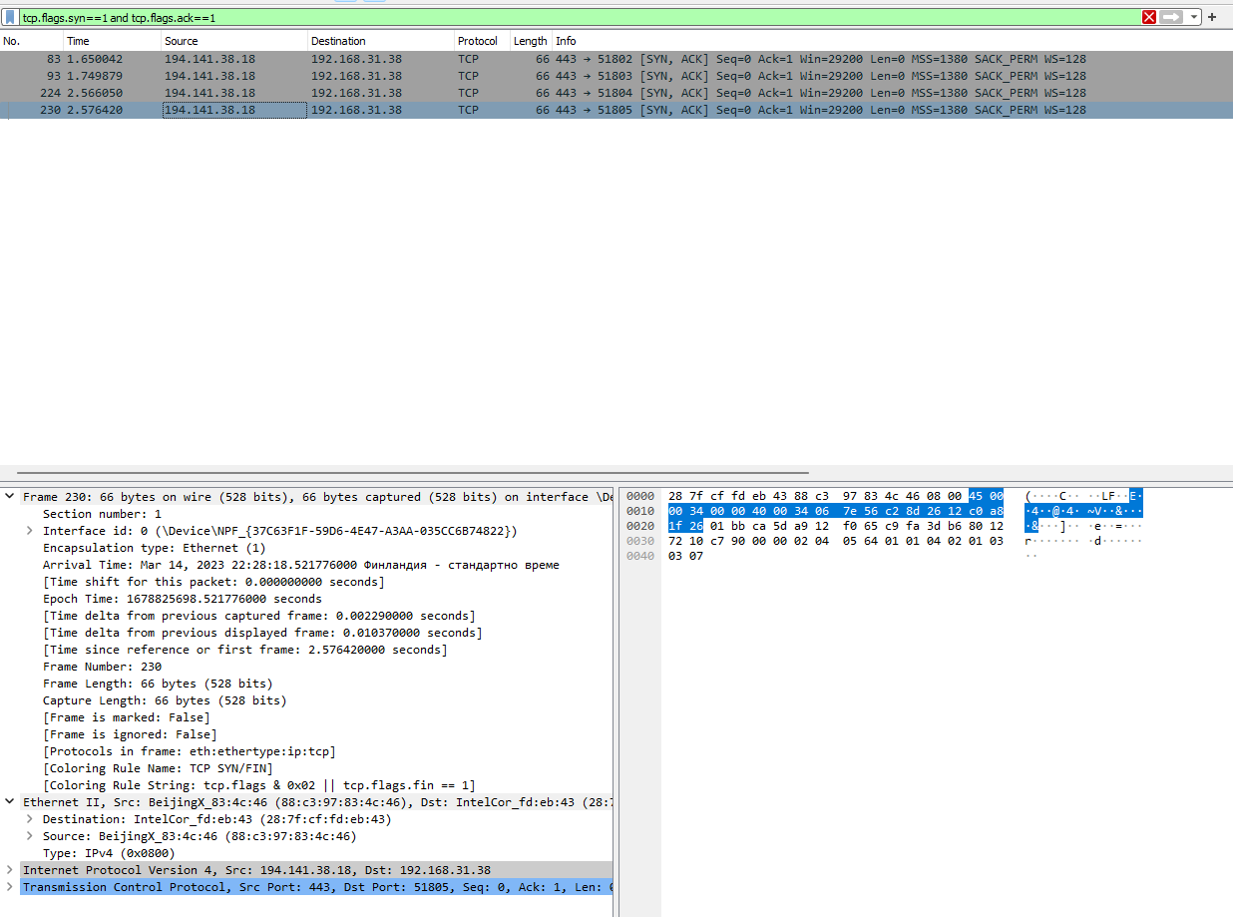 **from it:**

**Identify the Transport Layer 4 section of the ACK packet and paste a screenshot**

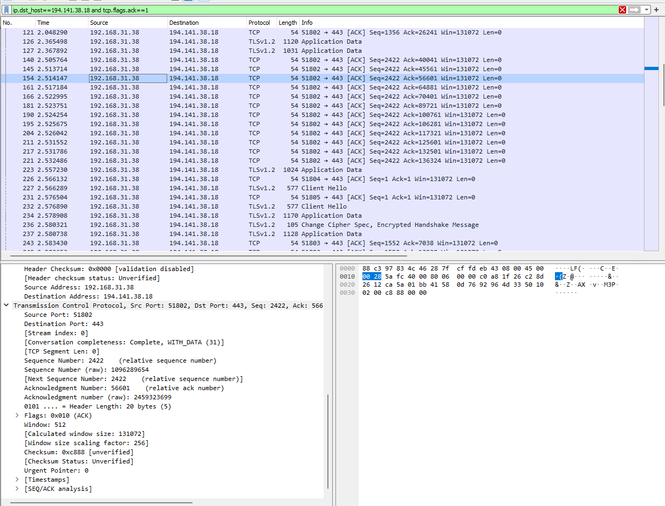 **from it bellow:**

**Look closely at the L2 section of the three-way handshake packet details. Each of them**

**shows the source and destination MAC address of the packets.**

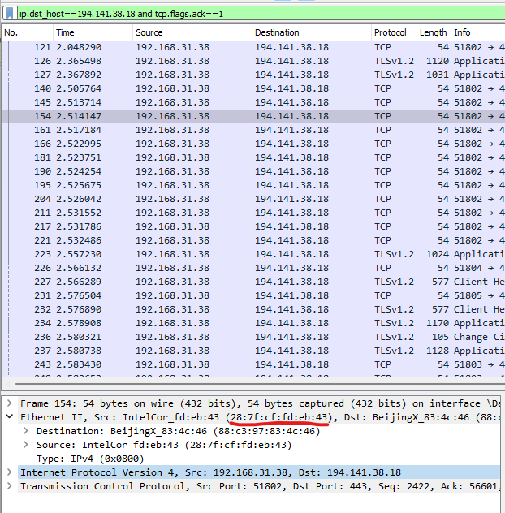

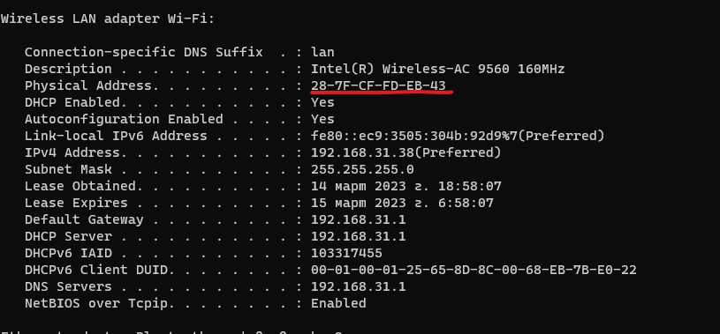 **Who is the owner of the destination MAC address of the SYN packet?**

**Exercise 4 – Hacking mockup (for Bonus points).**

Use Wireshark to capture the packet’s application layer data and discover the implications

of using unencrypted communication over a network.

As a proof of competition for this exercise paste in bellow a screenshot of the application layer data containing visible username and password.

Using TELNET:

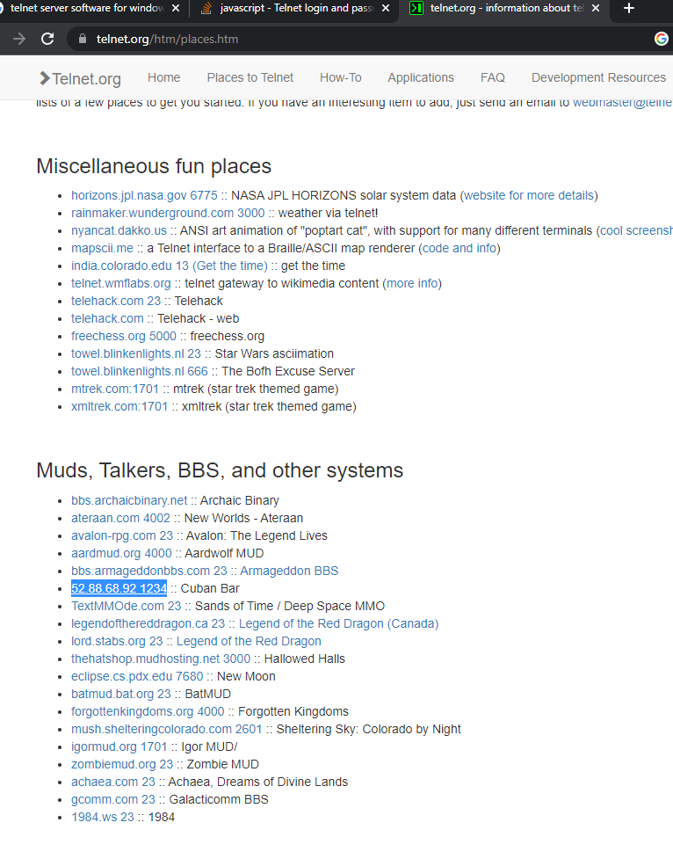

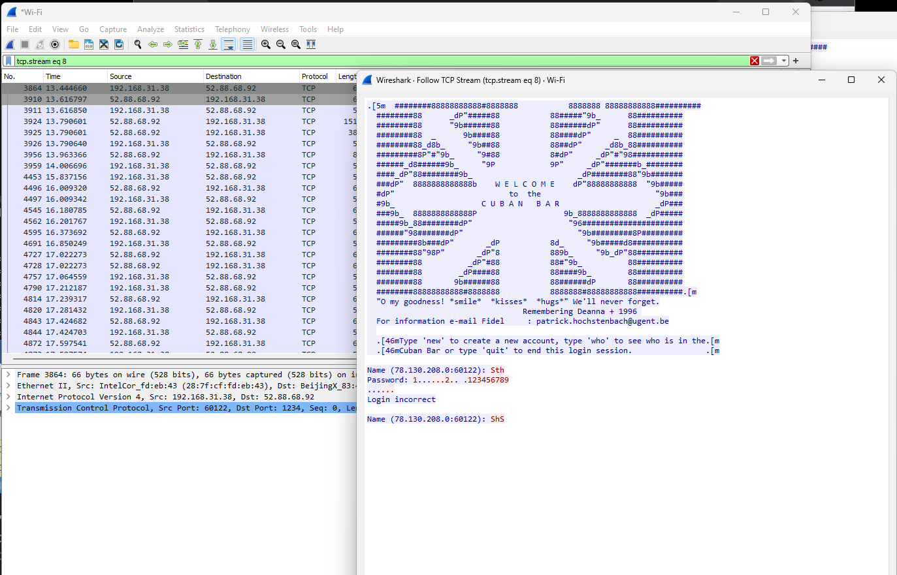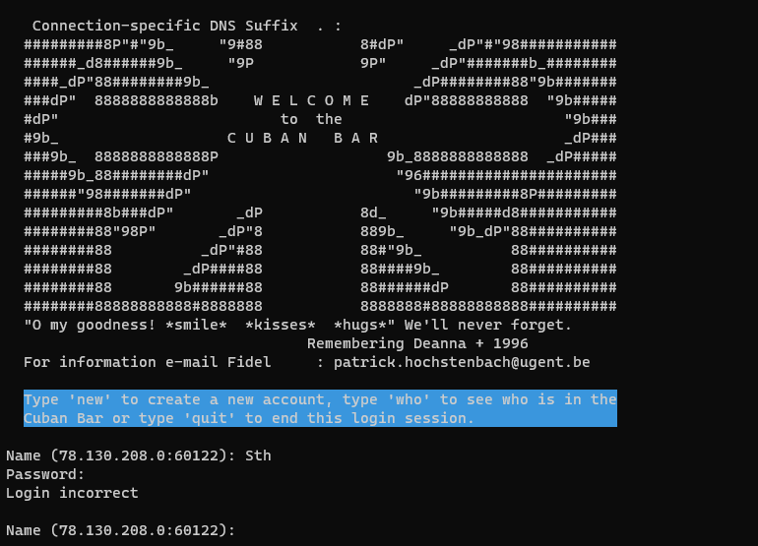

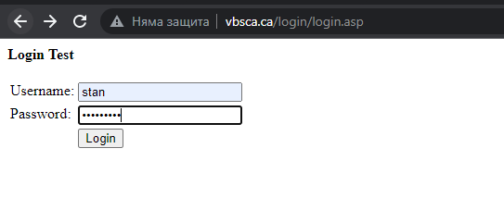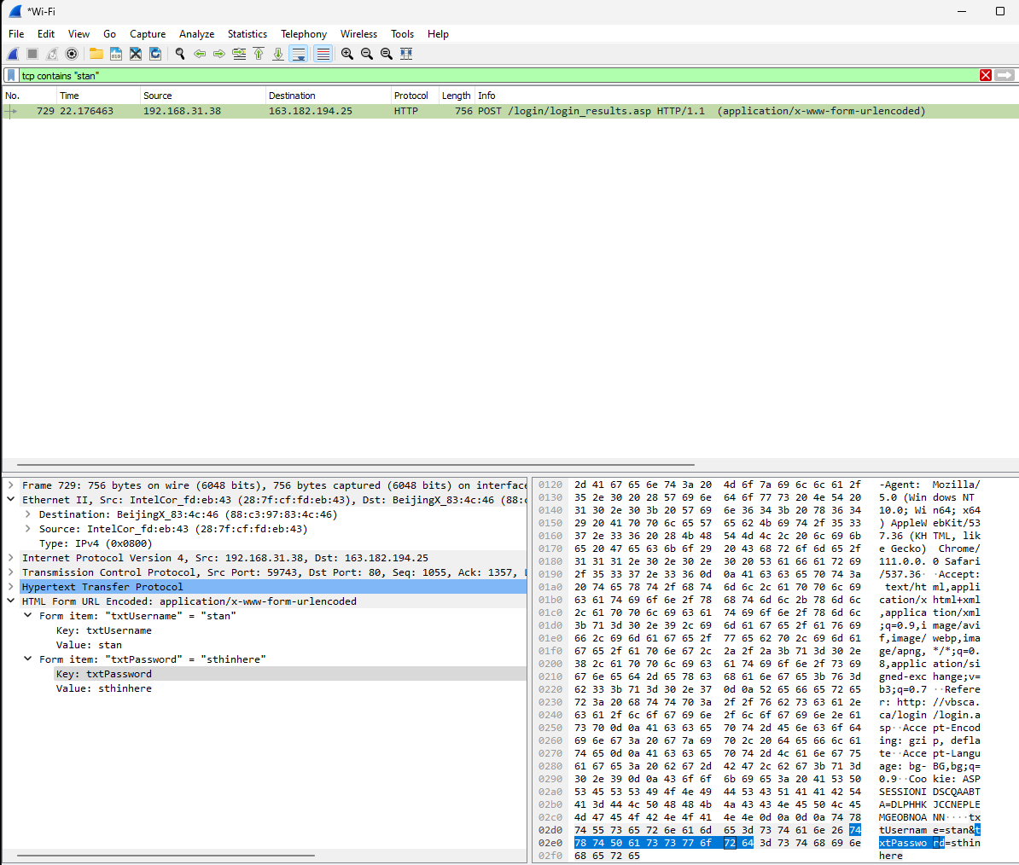**Using HTTP:**