**Mid-Term Task**

**Part I**

1. Host a static website on Blob Storage: build and deploy a static Hello

World website to Azure Storage.

2. Verify that the default web page has the Hello World! page.

3. Provide the steps and results.

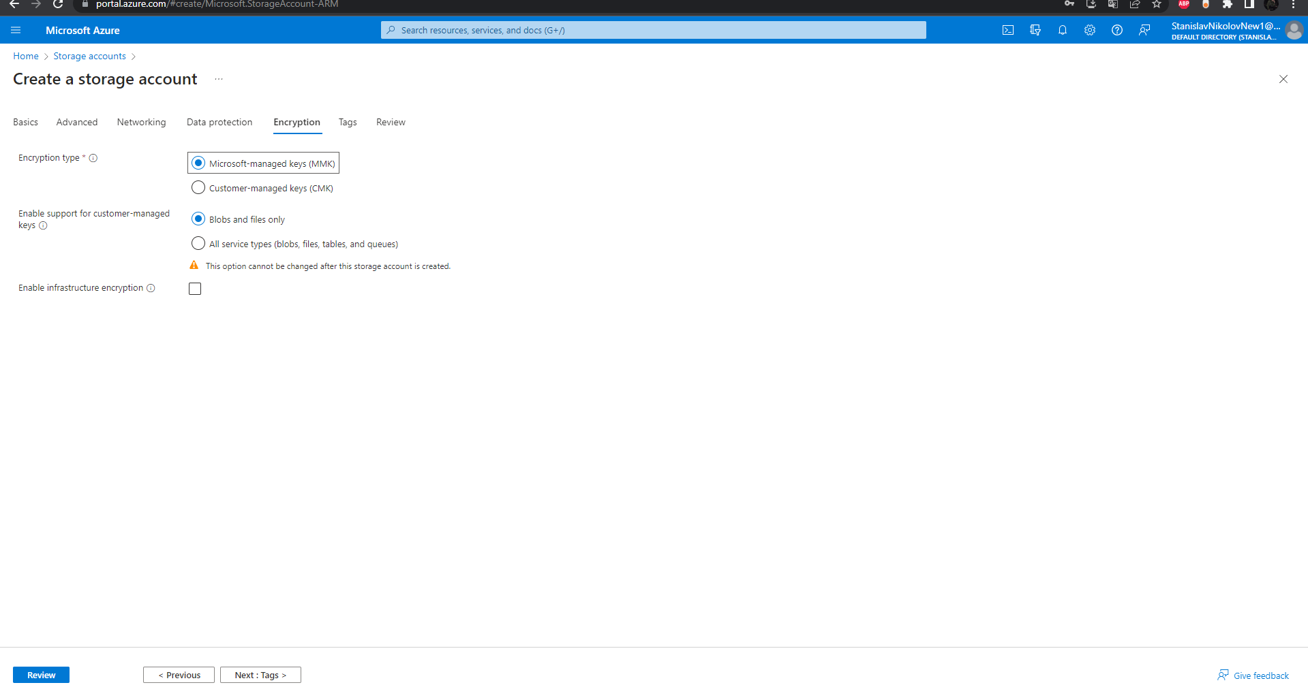

* Creating a storage account.

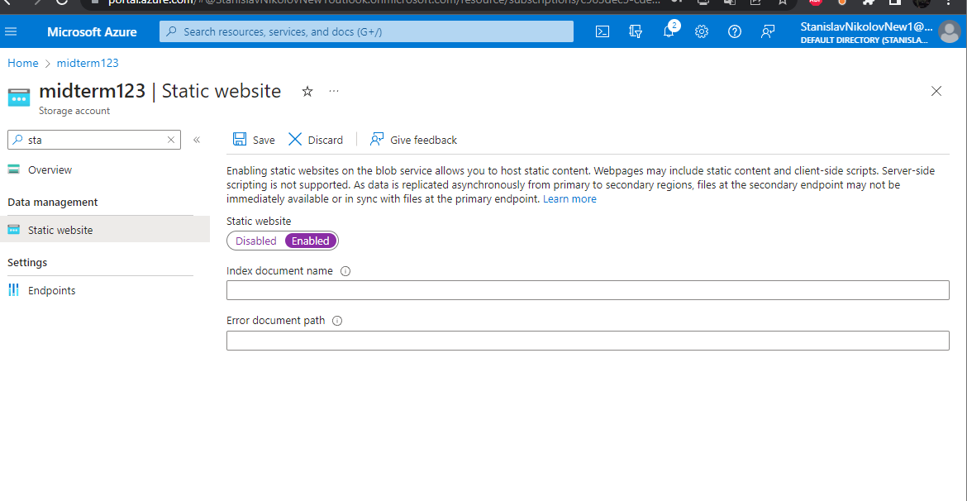

* We now should enable the static website, which is from the left options in the storage menu.

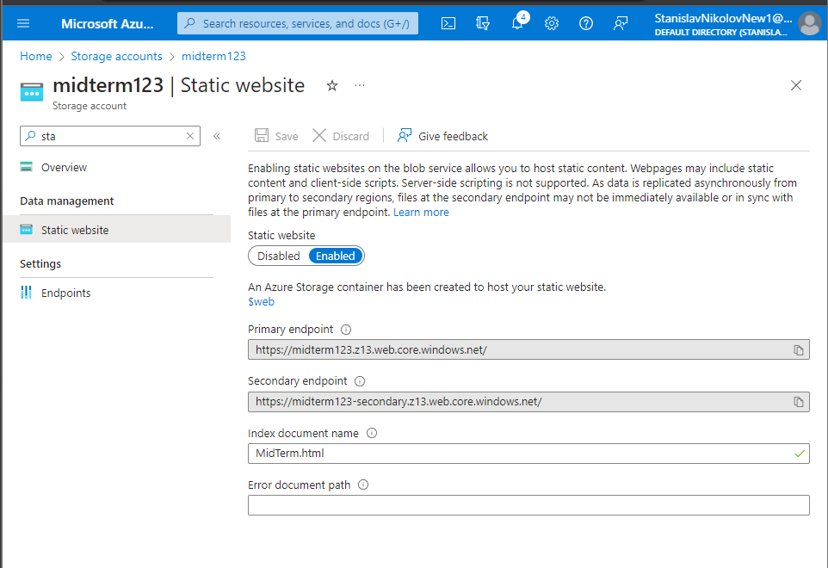

* Giving the index(html document) with the “Hello world!”

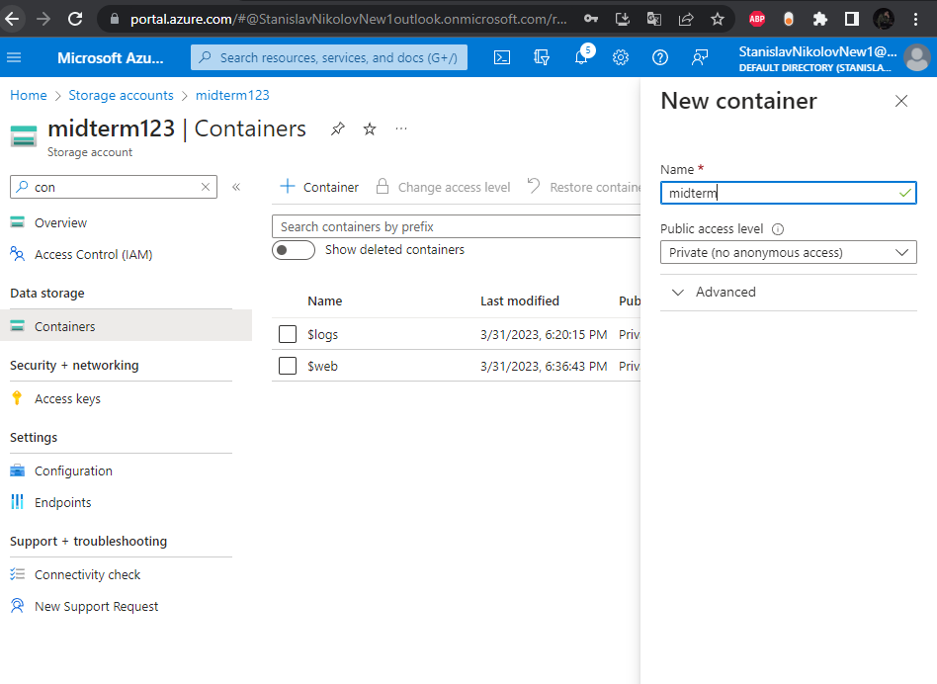

* Here is the creation of the container, which will hold the html file.

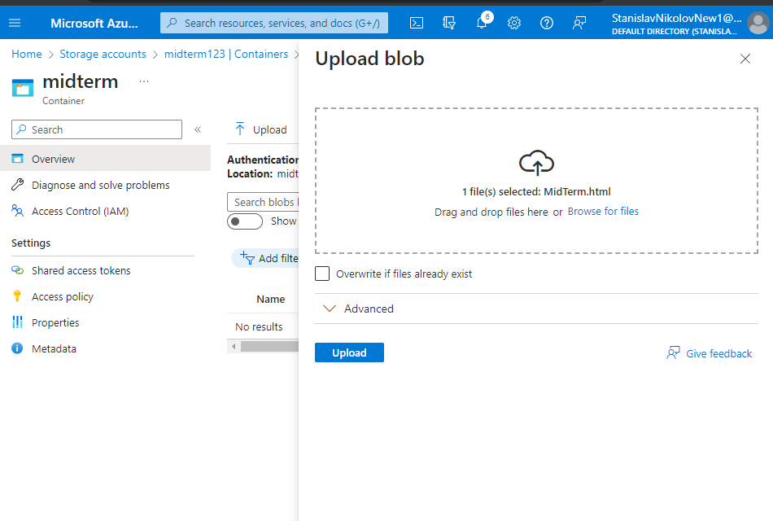

* Providing the midterm html with “hello world” html document, which is in the folder in the GitHub 😊.

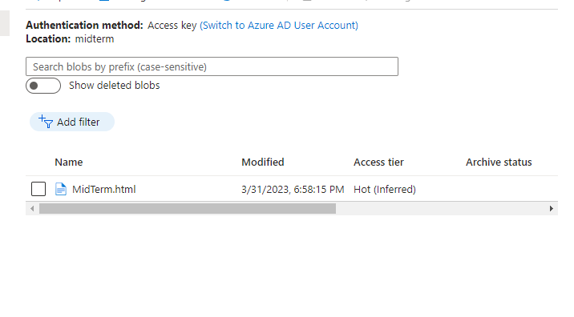

* Here is the uploaded file from my computer.

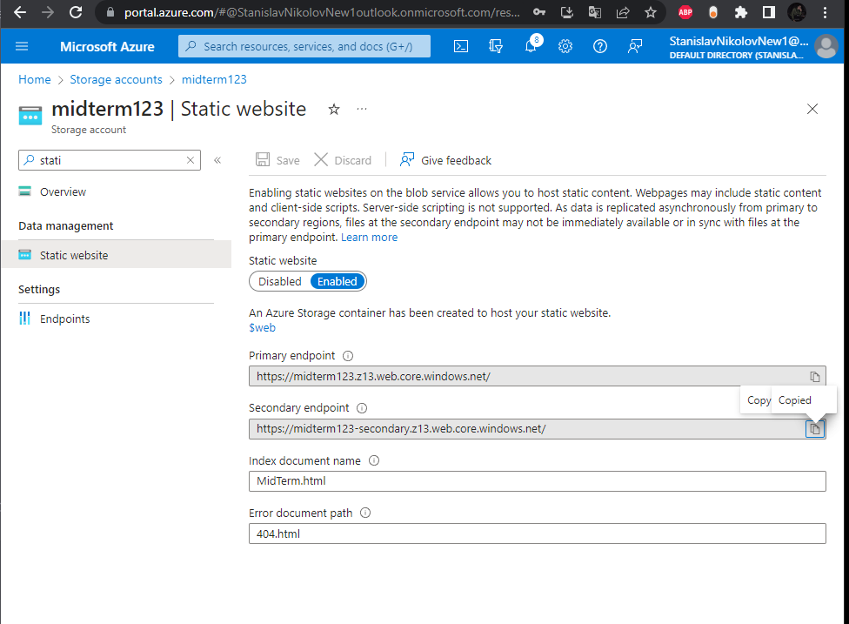

* Copying the static URL.

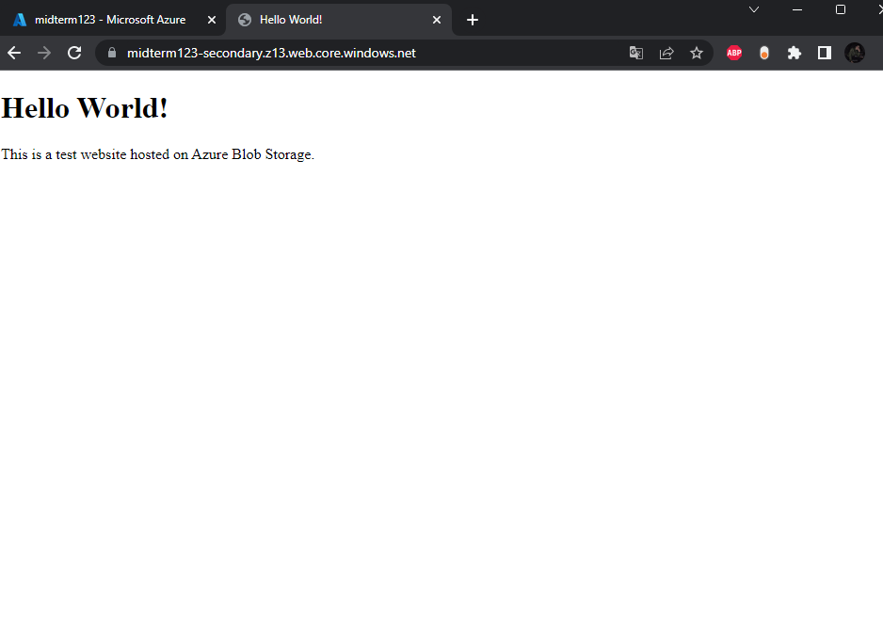

* https://midterm123-secondary.z13.web.core.windows.net/
* “Hello world”, provided from a host a static website on Blob Storage. 😊

**Part II**

* In this exercise we will setup a Linux based web server and will

deploy a web page on it:

1. Create a Virtual Network where you will deploy your Linux Based Web Server.

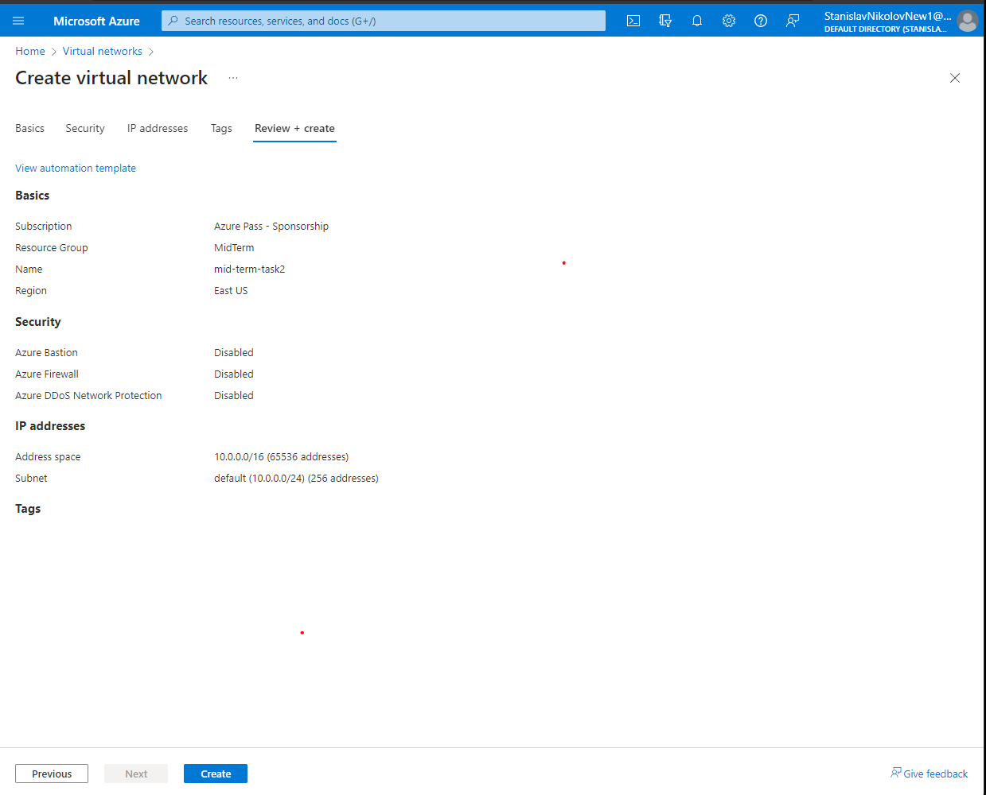

2. Modify the network security group for your virtual machine that will

allow you to remotely manage your machine only from your local

machine and nowhere else.

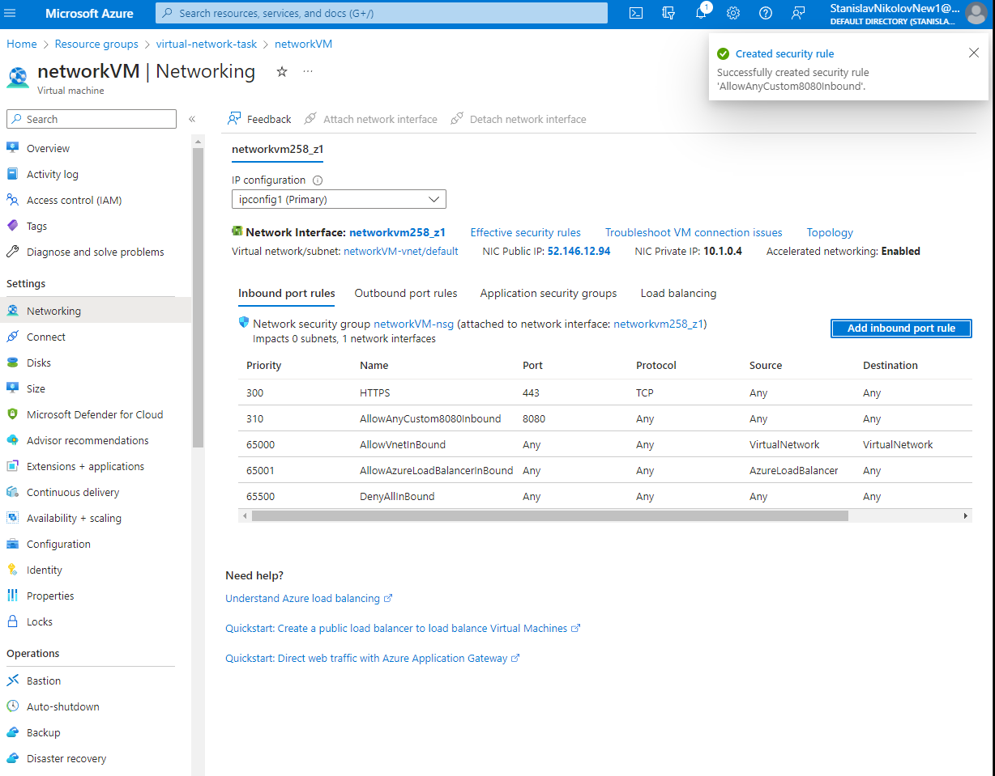



3. Create a Linux Virtual Machine that will be your Web Server which is

publicly available for web publishing (not SSL) only from your

machine and nowhere else.



4. Connect to the VM.

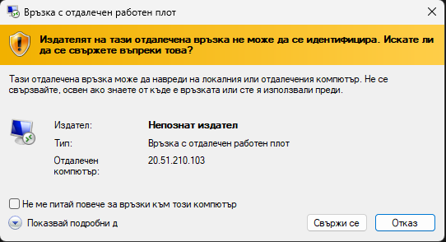

5. Install Apache Web Server.

6. Deploy the “Hello World” web page.