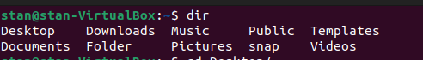

dir
First command is to check the directories in stan(user).

cd Desktop/
Second command is to change the directory to Desktop/

mkdir lab4
With this command we are creating a directory named lab4/

cd lab4/
As I said this is for changing the directories from Desktop/ to lab4/

1. touch friend.txt
Here in the current directory we are creating a file, named “friend” with extension .txt

nano friends.txt
Here with this command we are editing the content of the friends.txt file.
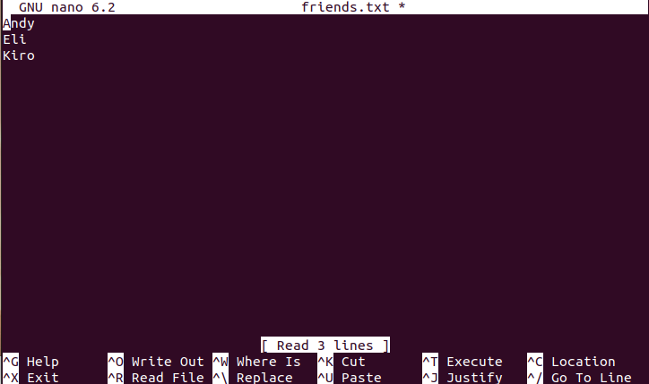
To safe the changes we simply hit ctrl + x + y + enter.
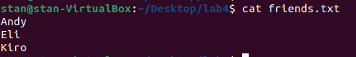

2. cat friends.txt
This command is displaying the content of the txt file.

3. mv friends.txt bestfriends.txt
This mv command is changing the name of the “friends.txt” file to “bestfriends.txt” file.
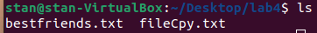

4. cp bestfriends.txt fileCpy.txt
This command is going to copy “bestfriends.txt” in “fileCpy.txt” in the current directory lab4.

5. ls -d b*
This is listing all elements, starting with the letter “b” in the directory.

6. wc --bytes fileCpy.txt
This command is telling us how many bytes are taken by the file. In this case the taken bytes are 14.

7. touch cars.txt
This command, as I mentioned is creating a file. In this example we created “cars.txt”
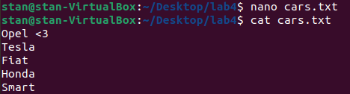

nano cars.txt
cat cars.txt
As I mentioned earlier nano is for file editing and cat is for displaying the content of a file quickly. Here we can see 5 Brands(the first is my favorite :) ).

8. wc --bytes cars.txt
As I mentioned this command will display how many bytes are taken by the file. In this example the taken bytes are 31.
9. cp cars.txt ./tmp/cars.txt
This command as I mentioned is going to copy “cars.txt” in directory tmp/ with the name “cars.txt”.

10. ls -d *.txt
This command will search in the current directory for a file with extension “.txt”.
11. mv ./Desktop/lab4/tmp/cars.txt ./Desktop/lab4/tmp/vehicles.txt
This is changing the name of “cars.txt” to “vahicles.txt”.

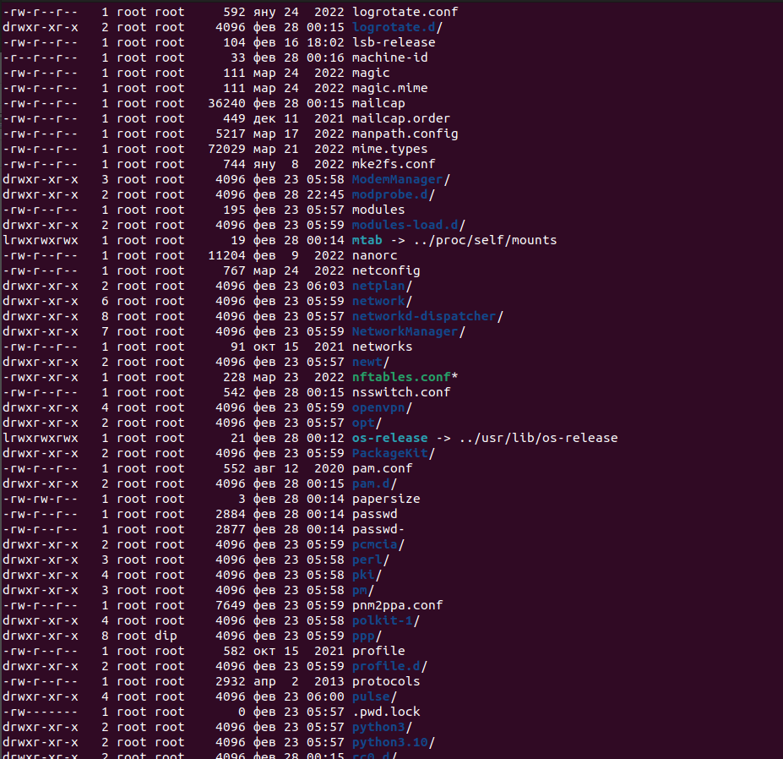

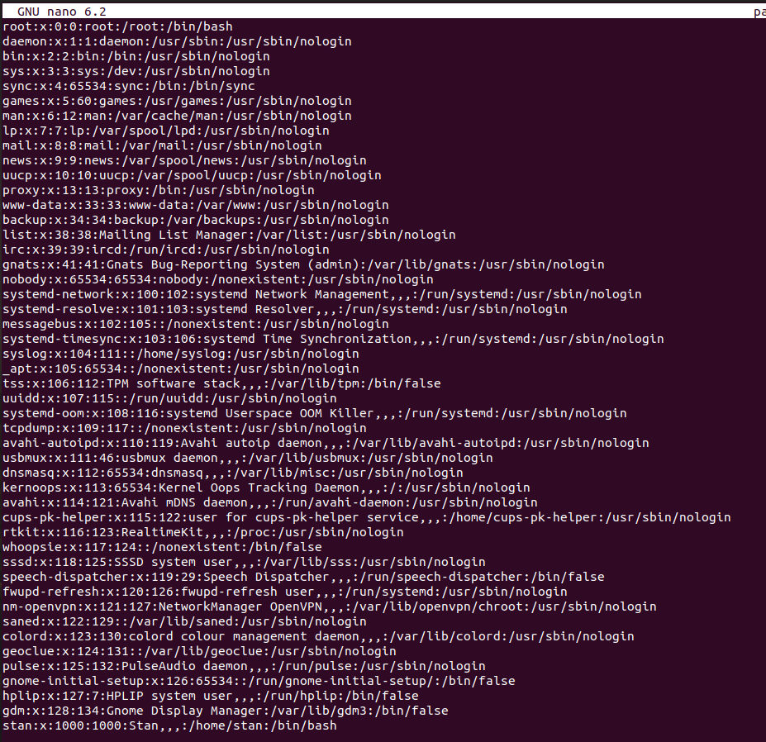
12. cd ..
cd etc
nano passwd
With this we are navigating to root, from there to directory etc/ and from there to passwd file, and to see the content we are editing the file with nano.

