# User Guide

This script will log into Euclid and collect the information from all students signed up to the programmes listed in the programmes excel file. It will collect

|  |  |  |
| --- | --- | --- |
| **Name** | **Type** | **Description** |
| UUN | String specifically in the form SXXXXXXX with the X representing a number | The student’s student number |
| Age | Integer | The students age in years |
| Region | String | The country the students term time address is in |
| Gender | String | The students gender |
| Nationality | String | The students nationality as listed on Euclid |
| Programme | String | The ID of the programme the student is on |
| Year | Integer | The year of the course the student is on |
| Status | Categorical represented as string | The stage of the matriculation process the student is in |
| Route | Categorical represented as string | The type of programme the student is on |
| Year X courses | Comma separated list of strings | a list of the course with ID that a student took in year X, with X being 1,2 or 3 |

## Running the script

1. Ensure you have python: Python can be downloaded in the Microsoft store admin privileges are not required.
2. Install selenium: This can be done by opening the command prompt and entering

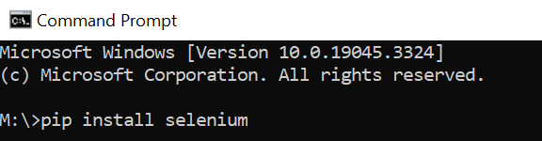“pip install selenium”

1. Navigate to the EuclidScraper directory through the command prompt: ensure you are in the c driver by entering “c:” then enter “cd ” followed by the path to that file. The path will differ depending on where the file is stored
2. Once in the directory enter “python” and then “import scraper.py”
3. From here you can enter your Euclid username, password and letters from your memorable word to log.
4. You may also want to run the script runToStopSleping.py in a separate terminal to stop the PC from going to sleep while this runs.
5. See Errors and Crashes Below

## Errors and crashes

It is likely the program will crash if Euclid becomes too slow. If it does simply run the program again and it will pick up where it left off. You will be able to tell the program was interrupted because there will be a text file called progress in the folder with it. If you would like the scraper to restart from scratch delete this text file. The script deletes this file on its own when it finished the full list.