# User Guide

This script will move across the videos listed in the excel file and add tags as given and/or add the course code to the description

## Running the script

1. Ensure you have python: Python can be downloaded in the Microsoft store admin privileges are not required.
2. Install selenium: This can be done by opening the command prompt and entering

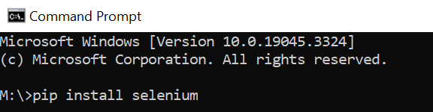“pip install selenium”

1. 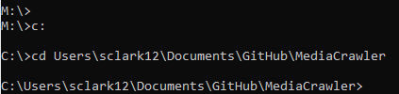Navigate to the MediaCrawler directory through the command prompt: ensure you are in the c driver by entering “c:” then enter “cd ” followed by the path to that file. The path will differ depending on where the file is stored
2. Once in the directory enter “python” and then “import MediaCrawler.py”
3. From here you can enter your Mediahopper username and password and select what tags if any you would like to add and whether or not you would like to add course codes to the description from the parallel list