**Project Alcuin - XML DITA Advanced**

**Contents**

Frontmatter 4

Copyright 4

Patents 4

Trademarks 4

Disclaimer 4

Typographic conventions 4

Documentation reading path 5

Documentation feedback 5

StormSuite overview 6

Hybrid compute environments 6

StormSuite - integrated solutions for a hybrid world 7

StormCloud overview 7

StormCluster overview 8

StormCenter - unified services and APIs 8

StormCenter-Analyzer 9

StormCenter-Backup 10

StormCenter-Balance 11

StormCenter-Report 11

StormCenter-Secure 12

StormCenter-Store 13

StormView 14

StormView-Console 15

StormView-Mobile 16

StormView-REST-API 16

StormSuite - the complete solution 17

Getting Started with StormView 18

StormView views and messages 18

Custom views in StormView 18

Messaging in StormView 18

StormView-Console 19

Parts of the StormView-Console interface 19

Logging on to StormView-Console 20

StormView-Mobile 20

About StormView-Mobile 20

Logging on to StormView-Mobile 21

StormView-Mobile workspace environment 21

StormCenter reports and queries 22

StormCenter system diagnostics 22

StormCenter query filters 22

StormCenter query warning messages 25

StormCenter capacity reports 26

System performance 26

**Troubleshooting cluster reporting problems 27**

## Appendices 27

Frequently Asked Questions 27

System notifications 28

Quick reference: data views 28

Quick reference: system health indicators 29

# Frontmatter

## Copyright

© Copyright 2017 StormSystems Inc.

All rights reserved. No part of this publication may be reproduced, distributed, or transmitted in any form or by any means, including photocopying, recording, or other electronic or mechanical methods, without the prior written permission of the publisher, except in the case of brief quotations embodied in critical reviews and certain other noncommercial uses permitted by copyright law.

## Patents

StormSystems Inc. products and technology are protected under one or more of these issued patents:

* US Patent No. 1,111,111 (12 June 2010)
* US Patent No. 2,222,222 (13 July 2011)
* US Patent No. 3,333,333 (14 July 2012) and other US Patents applied for by StormSystems Inc..

Please contact StormSystems Inc. for information about licensing StormSystems Inc. products or technology.

## Trademarks

The following names are trademarks or registered trademarks of StormSystems Inc.:

StormSystems Inc.™, StormSuite™, StormCluster™, StormCloud™, and StormView™ and trademarks of StormSystems Inc..

## Disclaimer

This document presents the current views of StormSystems Inc. as of the date of publication. Because StormSystems Inc. must respond to changing market and technological conditions the information herein should not be interpreted as a commitment from StormSystems Inc.. It cannot guarantee the accuracy of any information presented. StormSystems Inc. makes no warranties, express or implied, about the content of any part of this document or the content contained in it.

## Typographic conventions

StormSystems Inc. documentation uses the following conventions to assist your reading.

#### General formatting

Monospace font represents a command line syntax, file path, system output, or similar code.

*Italic font* represents a user-defined name or variable.

**Bold font** represents a user interface element, such as a button or tab, with which a user interacts.

#### Command line formatting

StormSystems Inc. documentation uses the following format for StormView-REST-API statements:

command --option *variable*

where

* command is the name of the command and should be typed exactly as shown.
* --option is a command option and should be typed exactly as shown.
* *variable* is an option variable and should be replaced with the required value.

#### Informational Alerts

#### WARNING:

Alerts you to the risk of bodily injury, damage to hardware or software, loss of warranty, or loss of data.

#### Caution:

Alerts you to the risk of data unavailability or possible issues with regard to security, performance, or configuration.

#### NOTE:

Indicates information that is supplemental or that may require additional attention.

#### Tip:

Provides helpful information such as best practices.

## Documentation reading path

The StormSuite documentation set is available for online browsing or for download at http:// stormsystems.com/support/documentation.

#### StormSuite Release 4.3 documentation

Release 4.3 documentation contains the following publications.

* The *StormSuite Release Notes* provide late-breaking information about the pre-requisites, installation, and operation of StormSuite. Read the *StormSuite Release Notes* before all other StormSuite documentation.
* The *StormSuite Installation Guide* provides step-by-step instructions for installing and configuring StormSuite on your Windows or LINUX server.
* The *StormSuite Administration Guide* (this guide) provides an overview of all StormSuite components and detailed procedures for administering those StormSuite components.
* *StormSuite REST API Developers Guide* documents the StormView-REST-API and how you can use it to manage your StormSuite services.

### Documentation feedback

StormSystems Inc. welcomes your feedback. To provide feedback on the StormSuite documentation, send email to

[docfeedback@stormsystems.com.](mailto:docfeedback@stormsystems.com)

# StormSuite overview

This section of the *StormSuite Administration Guide* provides an overview of the major components in StormSuite and how they support the unified deployment and adminstration of both Cloud and Cluster services.



## Hybrid compute environments

As Cloud computing matures into a mission-critical component for IT organizations, the breadth and types of services migrating to the Cloud are increasing. IT organizations are being asked to develop and maintain parallel services

in both Cloud and Cluster environments. Increasingly, IT organizations are doubling their overhead by needing to develop redundant services for both Cloud and Cluster environments. It canot scale.

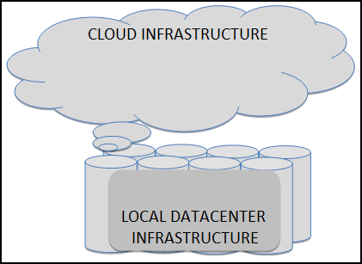

What will differentiate successful hybrid IT organizations will the ability to streamline and consolidate the management of hybrid (parallel) services without compromising security, scalability, or efficiency (cost). If each parallel, hybrid service requires redundant or duplicate management infrastructure, hybrid IT organizations will not be able to support Cloud migration without significant costs and disruption.

## StormSuite - integrated solutions for a hybrid world

StormSuite addresses this primary source of cost and disruption -- the need to maintain both Cloud-specific or Cluster-specific management infrastructure. With StormSuite, you can deploy one management infrastructure (StormCenter) designed to support services that are deployed on the Cloud and on Clusters. StormCloud and StormCluster provide the interface between the shared StormCenter management services and Cloud-specific or Cluster-specific environment.

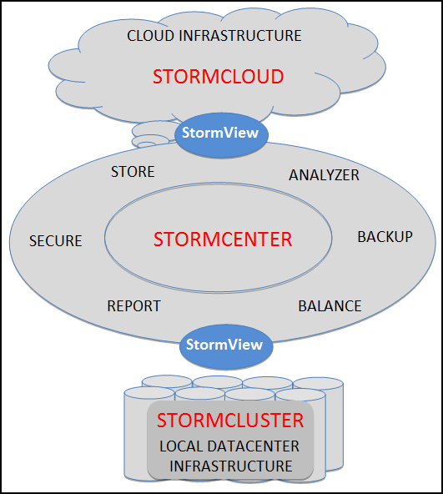

To build out that complex, high-speed data center and hybrid Cloud infrastructure, you do not need to develop a library of specialized tools and applications -- StormCenter provides it all.

### StormCloud overview

StormCloud provides a set of interfaces to the following Cloud-specific services:

* *Cloud client interfaces*: The access and security interfaces required to allow web clients, mobile apps, or dedicated management applications to interact with Cloud services.
* *Cloud storage*: The storage interfaces that allow multiple clients to access stored objects, be they physically residing on a public cloud, private cloud, or hybrid cloud. The cloud storage needs to be agile, flexible, scalable, multi-tenant, and secure.
* *Service-oriented delivery*: The logical interfaces necessary to allow Cloud-based services to become available to multiple clients and tenants – Software as a service (SaaS), Development as a service (DaaS), Platform as a service (PaaS), and Infrastructure as a service (IaaS).

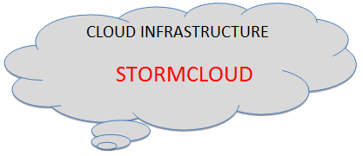

StormSuite administrators interact with StormCloud interfaces via StormCenter.

### StormCluster overview

StormCluster provides a set of interfaces to the following Cluster-specific services:

* Network-attached storage
* Redundancy-aware node configurations
* Failover and disaster-recovery policies

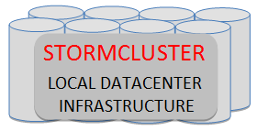

StormSuite administrators interact with StormCloud interfaces via StormCenter.

## StormCenter - unified services and APIs

StormCenter provides a unified suite of services that can deploy, manage, monitor, and balance resources that reside on a Cloud or on a local Cluster.

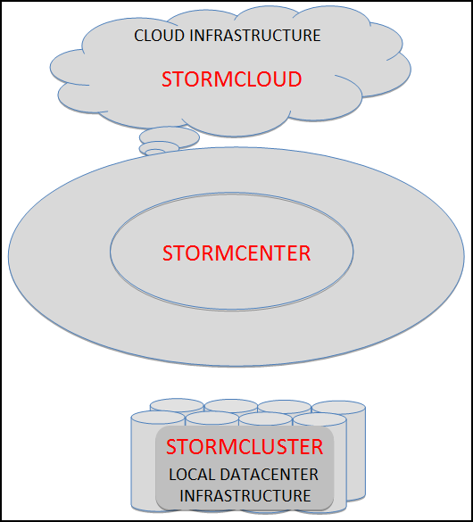

One set of interfaces and services to perform the following management tasks in a hybrid environment:

* *StormCenter-Analyzer*: description.
* *StormCenter-Backup*: description.
* *StormCenter-Balance*: description.
* *StormCenter-Report*: description.
* *StormCenter-Secure*: description.
* *StormCenter-Store*: description.

### StormCenter-Analyzer

StormCenter-Analyzer provides central administration for resources hosted on the Cloud or in your Cluster.

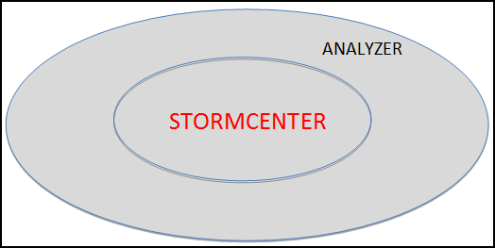

In the larger context of StormSuite, StormCenter-Analyzer does the following:

* Conducts a complete inventory of available compute, network, and storage resources accessible to StormCloud or to StormCluster.
* Provisions a central resource database with inventoried resources.
* Monitors the availability and general health of each resource indentified in its inventory via layered "heartbeat" agents.
* Serves inventory and status information to StormCenter-Report.

### StormCenter-Backup

StormCenter-Backup provides central administration for configuration and data backups for all resources hosted on the Cloud or in your Cluster.

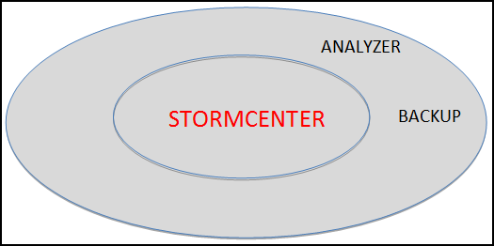

In the larger context of StormSuite, StormCenter-Backup does the following:

* Provides a single Backup Policy Manager for resources available to StormCloud or to StormCluster.
* Provides an easy-to-use web interface (through StormView-Console) to create, update, and manage backup policy definitions and profiles.
* Executes backup policies and reports backup statistics to StormCenter-Report.

### StormCenter-Balance

StormCenter-Balance provides basic resource balancing and capacity management services across resources hosted out of the Cloud or out of the Cluster.

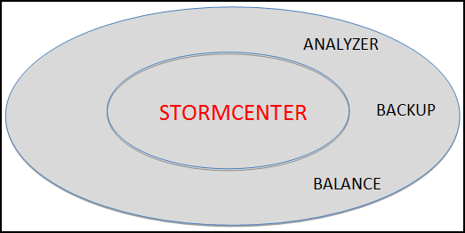

In the larger context of StormSuite, StormCenter-Balance does the following:

* Provides a single Capacity and Performance Manager for resources available to StormCloud or to StormCluster.
* Provides an easy-to-use web interface (through StormView-Console) to create, update, and manage storage capacity or compute performance definitions and profiles.
* Monitors capacity and performance threshholds throughout the system and reports to any of the StormView clients.
* Reports general capacity and performance metrics to StormCenter-Report.

### StormCenter-Report

StormCenter-Report collects metrics from all the StormCenter applications and makes them viewable in all the StormView clients.

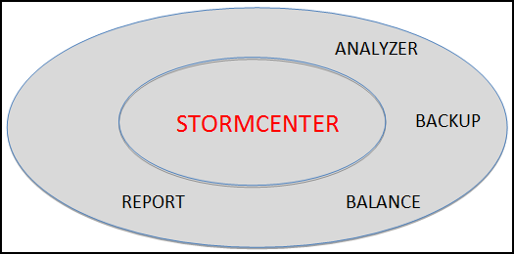

In the larger context of StormSuite, StormCenter-Report does the following:

* Provides a single point of collection for both StormCloud and StormCluster metrics on the following:
  + Capacity utilization
  + Networking performance
  + Application performance
  + System availability

StormView calls StormCenter-Report to obtain the most current data tables and diagrams.

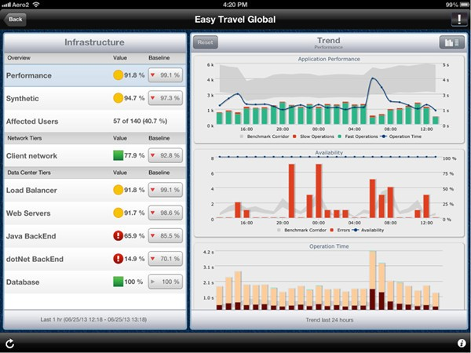

### StormCenter-Secure

StormCenter-Secure provides a combination of account management and network security services for all StormSuite services and applications.

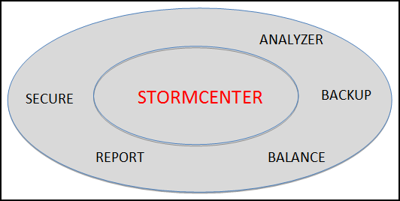

In the larger context of StormSuite, StormCenter-Secure does the following:

* Provides enterprise-class account management.
* Reports general capacity and performance metrics to StormCenter-Report.

StormView calls StormCenter-Report to obtain the most current data on system and user-account security.

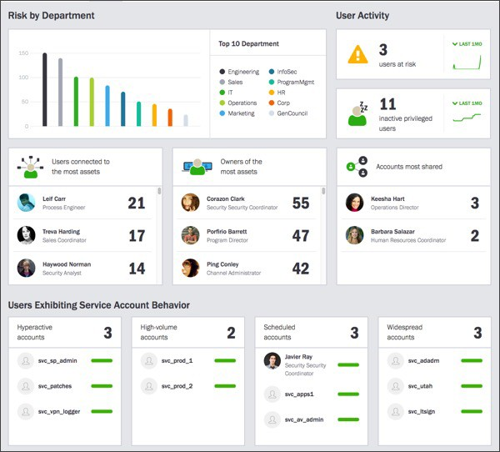

### StormCenter-Store

StormCenter-Store provides a master inventory of storage devices and assets hosted in the Cloud or in a local Cluster. StormCenter-Store does not store objects, but makes its global inventory of stored assets available by proxy to all StormSuite applications and services.

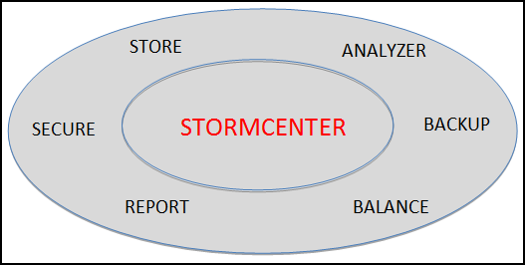

## StormView

StormView provides a single interface for configuring, monitoring, and administering StormSuite assets – be they in the Cloud or in a local Cluster. StormView provides that consistent, complete, and elegant interface for StormSuite adminstrators.



StormView provides three, functionally equivalent interfaces:

* StormView-Console: Desktop graphical console
* StormView-Mobile: Mobile graphical interface
* StormView-REST-API: RESTful application programming interface

### StormView-Console

For administrators working on laptops or workstations, StormView-Console provides full access to all administrative functions supported by StormCenter.

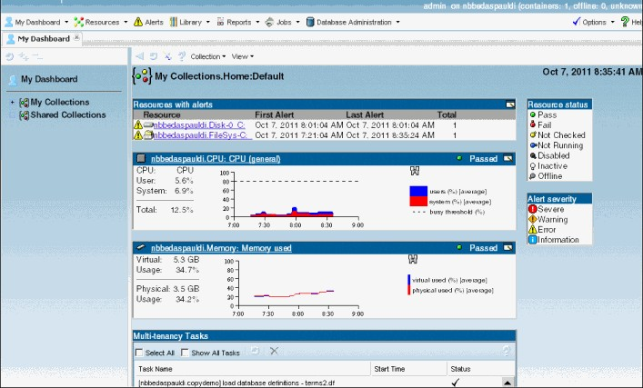

### StormView-Mobile

For administrators working on mobile devices, StormView-Mobile provides full access to all administrative functions supported by StormCenter.

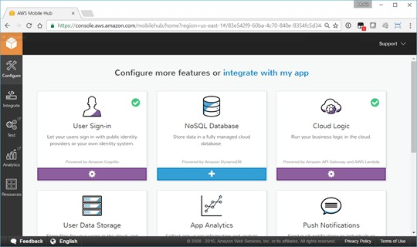

### StormView-REST-API

For application developers and integrators, StormView-REST-API provides full access to all administrative functions supported by StormCenter.

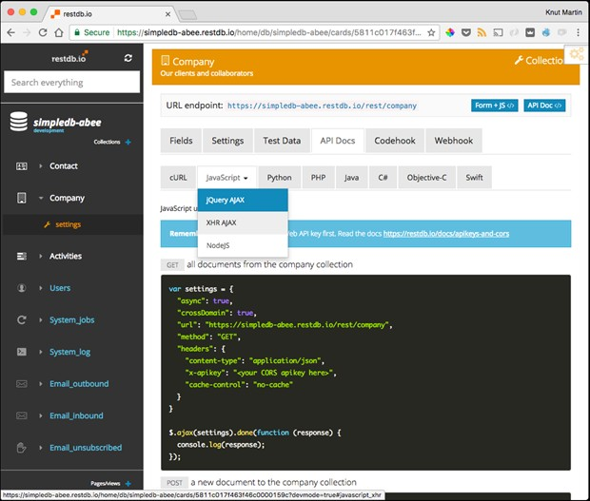

## StormSuite - the complete solution

StormSuite combines powerful cluster management services with a simple-to-use, intuitive front-end application. The combination places control of the full resources of your computing infrastructure into the hands of your team members and it does so in a way the establishes, and sustains, the highest levels of security.

#### Key StormSuite benefits

* Maximum flexibility
* Designed for extensibility
* Ease of management
* Extreme scalability
* Intuitive reports and data visualizations
* Industry-leading support

#### Key StormSuite features

* Easy to use and manage for onsite administrators
* High performing, scalable architecture
* Comprehensive, intelligent scheduling policies
* Complete customization flexibility for integrators
* Heterogeneous platform support
* Continuous live data reporting services
* Robust security services

#### Component architecture delivers maximum scalability and flexibility

StormSuite components become a powerful workload management suite for demanding, distributed high-performance computing environments. Not only is a complete set of workload management capabilities available, but the

reporting benefits of StormCenter-Report work to reduce cycle times and maximize productivity in mission critical environments. Equipped with StormView client interfaces, your system administration team and designated system users can collaborate to coordinate their business priorities so that the overall effect is improved even more.

# Getting Started with StormView

This section introduces StormView and provides an overview of the three StormView interfaces available to you in StormSuite.

## StormView views and messages

This section explains how to use views and messages in StormView.

### Custom views in StormView

In the **Customize Views** page, you can query a range of different entities in order to analyze different aspects of your project and associated cluster activity. You can analyze the tasks, targets, and clusters associated with your project.

This allows you to gain more powerful insights into the status and progress of your project.

There are a variety of existing data analysis tasks available for constructing your queries or you can develop your own. Once you have developed your custom data view, you can save, print, or export the results.

**Analysis Pane** Displays the returned results. The data will be displayed differently and different commands will be available, depending on the type of data analyzed and the types of queries enacted.

Number of Results Displays the number of returned results. A warning is issued when your query returns too many rows. If this happens, adjust your query filters to reduce the number of results.

Data columns Right-click a column heading to determine whether a column is displayed in the report pane.

**Entity Pane** Lists the data analysis tasks and other parameters - including tasks, clusters, users, and hosts

- that are available for analysis.

**Query Pane** Use the **Query Pane** to set up the queries from your analysis.

Query filters Use the filters in the **Query Pane** tab to set up your query. Click on a filter heading to turn it on or off. Invalid filters display as *Warning* or *Error*. Hover your mouse over the filter to view the reason it is invalid.

**Generate** Click the **Generate** to run your data analysis.

**Export** button Click to export your data analysis once it is generated. **Print** button Click to print your data analysis once it is generated. **Save** button Click to save your data analysis as a data view.

### Messaging in StormView

#### Introduction

The message manager in StormView allows you to do the following:

* Send messages.
* Receive messages and notifications.
* Reply to messages.
* Forward messages to others.
* Save messages for later reference.
* Delete unwanted messages.
* Acknowledge notifications.

#### Sending Messages

You can send a message to an individual contact or to a group of contacts in StormSuite. You can compose a message and then add one or more recipients or you can select one or more recipients and then compose your message. All messages are retained within StormSuite.

#### Receiving Messages and Notifications

You can receive messages from other StormSuite users. You can also receive automated notifications regarding alerts or alarms associated with your project.

#### Replying to Messages

You can reply to messages you have received using the **Reply** option. You cannot reply to notifications. See the section, "Acknowledging Notifications", below.

#### Forwarding Messages

Providing it is not marked as Private, you can forward a message to an individual or group of people using the

**Forward** option. When forwarding, you can include your own message.

#### Saving Messages

Saving messages allows you to store messages for reading at a later time. Once you save a message, you can still reply to the sender or, unless the message is marked as Private, send it to other people or groups of people.

#### Deleting Messages

You can delete messages by selecting one or more messages and using the **Delete** option. Deleted messages are not removed from the message archive within StormSuite. These archived messages can be retrieved by a system administrator.

#### Acknowledging Notifications

Each notification you receive will include some text describing the issue, as well as direction towards further information and recommended action. Once the appropriate action has been taken, click the **Acknowledge** button at the bottom of the notification message.

## StormView-Console

This section introduces the StormView-Console.

### Parts of the StormView-Console interface

The StormView-Console interface supports the following elements.

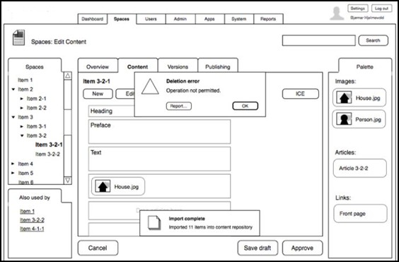

### Logging on to StormView-Console

Make sure that you have your username, password, and the name of the server to which you want to connect. Once you are logged on, you can log off and disconnect from a particular project without closing StormView-

Console. Logging off without closing the application is helpful if you plan to log on again using a different username and password.

**NOTE:** You might automatically be logged off after a period of inactivity. To log on to StormView-Console:

1. To open StormView-Console, click **Start** > **All programs** > . You will see the StormView-Console Login Screen.
2. In the dialog box, do one of the following:
   * Enter your StormSuite username and password.
   * Log on using your Windows user account by selecting the **Windows** selection button.
3. In the directory field, enter the name or IP address of the main StormCenter server.
4. If you are required to log on with supervision, your supervisor must provide a username and password.
5. Click log in button.
6. To log off, click the **Home** tab and then click **Log Off** button.

## StormView-Mobile

This section explains how to use StormView-Mobile, your one-stop solution for managing StormSuite from a mobile device.

### About StormView-Mobile

StormView-Mobile provides a single, mobile interface for monitoring and managing cluster activity within StormCenter.

From the StormView-Mobile app you can oversee cluster operations, monitor system performance, and diagnose problems within StormCenter. You can also create custom views that present metrics specific to your project.

### Logging on to StormView-Mobile

Make sure that you have your username, password, and the name of the server to which you want to connect.

Once you are logged on, you can log off and disconnect from a particular project without closing StormView-Mobile. Logging off without closing the application is helpful if you plan to log on again using a different username and password.

**NOTE:** You might automatically be logged off after a period of inactivity. To log on to StormView-Mobile:

1. To open StormView-Mobile, tap on the StormView-Mobile icon on your mobile device. You will see the StormView-Mobile Login Screen.
2. In the dialog box, do one of the following:
   * Enter your StormSuite username and password.
   * Log on using your mobile device user account by selecting the **Windows** selection button.
3. In the directory field, enter the name or IP address of the main StormCenter server.
4. If you are required to log on with supervision, your supervisor must provide a username and password.
5. Click log in button.
6. To log off, click the **Home** tab and then click **Log Off** button.

### StormView-Mobile workspace environment

The **Workspace Tab** includes four different data views to provide a detailed overview of how your project is using cluster resources. These data views display:

* Cluster response time.
* Cluster requests.
* Active host servers.
* Cluster workload.

Content is automatically updated in these data views when events occur related to the project you are monitoring. This provides you with real-time information that is crucial for monitoring your project's use of cluster resources as effectively and efficiently as possible.

**Account Information** Access and modify account information.

**Task List** Access assigned tasks.

**Notifications** View notifications.

**Contacts** View a list of contacts and interact using messaging.

**Search** Search for documentation, cluster hosts, reports, and other resources.

**Session Details** Displays current session details including date, time, and location.

**Workspace Tab** View reports on cluster operations. The **Workspace** tab includes different data views to provide a detailed overview of how your tasks are using cluster resources.

**Customize Views Tab** Access the **Customize View** tab to reconfigure the:

* + reports are displayed in the **Workspace** tab
  + the layout of reports within the **Workspace** tab
  + the definition of individual reports
  + the design of customer reports

**System Performance** View reports on task progression and cluster activity. These reports provide in depth, real-time analytic information about current jobs and the associated cluster activity.

View reports on job progression. The **System Performance** tab displays your current jobs as they progress towards their targets.You can modify the reports according to the time period and tasks displayed.

**System Support** The **System Support** tab provides access to three important sub-tabs:

* + **Troubleshooting** which provides access to structured diagnostic procedures to be used to isolate and resolve system problems.
  + **Documentation** which can be searched using a combination of full-text queries and filter selections.
  + **Discussion board** where past and ongoing moderated discussions can be accessed and participated in.

**Contact Support** if you have trouble using StormView-Mobile and cannot find the answers you need on the Troubleshooting or Documentation pages.

# StormCenter reports and queries

This section introduces StormCenter reports and queries.

## StormCenter system diagnostics

The **Troubleshooting** sub-tab provides a data view for cluster modules actively engaged with your project tasks. The data views provide details regarding the current status and projected performance of the cluster modules.

The System Diagnostic troubleshooting agent will run a series of interactive tests to identify and isolate problems within the StormCenter grid. A typical interaction would proceed as follows:

* User selects the **Troubleshooting Scenario** that best fits the observed situation.
* A series of tests will run, with results either being captured and displayed automatically or being observed and entered by the user.
* The result from one test may lead to one or more additional tests being run.
* One or more problems will be identified, isolated, and confirmed by the tests.
* One or more resolution measures will be identified.
* Resolution measures will include references to the applicable task documentation.

For each cluster module, a data view presents a graph depicting the clusters progress. Three different health indicators signal the current or future processing status:

If the cluster has stopped processing a task, it is not performing optimally, or it cannot address projected workloads, you will also receive a notification message alerting you to the problem. Visit the **Diagnostics Tab** to see additional information on the issue, select actions to amend the situation, and monitor the impact of your intervention.

## StormCenter query filters

#### Query filter Associated reports Description

**Access rule** • Access rule configuration Select the access rule to investigate.

#### Query filter Associated reports Description

**Acknowledged by** • Alarm report Users who acknowledged the alarm. **Acknowledged on** • Alarm report Alarm acknowledgement time range. **Action taken** • Hits User hit actions (Monitor, Diagnose, Clear).

**Acknowledgement type** • Alarm report Check one of the following acknowledgement type

options:

**Alternate** Alarm was acknowledged by a user using the alternate mode.

**Default** Alarm was acknowledged by a user, or auto-acknowledged by the system.

**Forcibly** An administrator forced the alarm to be acknowledged.

**Alarm priority** • Alarm report Alarm priority.

**Alarms** • Alarm report Select the types of alarms you want to investigate.

**Application** • Activity trails

* + Audit trails

Which client application was used for the activity.

**Archiver** • Archiver events Select the Archivers to investigate.

**Clusters** • Cluster activities Select the clusters to investigate.

**Compare with** • Inventory report Compare entities with a source entity of the event.

**Creation time** • Incidents Incidents created/reported within the specified time

range.

**Credential** • Credential management Specify whether or not the credential is assigned.

**Custom fields** • Most reports If custom fields are defined for the entity you are

investigating, they can be included in this report.

**NOTE:** You might not see the custom fields filter, depending on whether your user is configured to view that custom field.

**Description** • Activity trails

* + Credential management

Restrict the search to entries that contain this text string.

**Devices** • IO configuration Select the devices to investigate.

**Entities** • Audit trails Select the entities you want to investigate. You can

filter the entities by name and by type.

#### Query filter Associated reports Description

**Health event** • Health history Name of the health event.

**Health severity** • Health history Severity level of the health event.

**Hit rules** • Hits

* + Reads

Select the hit rules to include in the report.

**Hit type** • Hits Select the type of hits to include in the report.

**Impacted** • Activity trails The entities that were impacted by this activity.

**Incident time** • Incidents Incidents reported within the specified time range.

The incident time corresponds to the event or alarm

timestamp the incident refers to. If the incident does not refer to any event or alarm, then the incident time corresponds to the creation time.

**Initiator** • Activity trails User responsible for the activity.

**Investigated by** • Alarm report Which user put the alarm into the *under*

*investigation* state.

**Investigated on** • Alarm report Specify a time range when the alarm was put into

the *under investigation* state.

**Machine** • Health history Select a computer that was having health issues to

investigate.

**Modified by** • Audit trails User responsible for the entity modification.

**Modification time** • Audit trails

* + Incidents

***Audit trails* task** Entities modified within

the specified time range.

***Incidents* task** Incidents modified within the specified time range.

**Notes** • Incidents Enter text to find incidents with a description starting or containing the specified text.

#### Query filter Associated reports Description

**State** • Alarm report Current state of the alarm.

**Active** Alarm is not yet acknowledged. Selecting an active alarm shows the alarm acknowledge buttons in the report pane.

**Acknowledged** Alarm was acknowledged by a user, or auto-acknowledged by the system.

**Under investigation** Alarm with an

acknowledgement condition that is still active was put under investigation.

#### Acknowledgement required

**Triggered on** • Alarm report Alarm trigger time range.

Alarm with an acknowledgement condition that was cleared is ready to be acknowledged.

**Triggering event** • Alarm report Events used to trigger the alarm.

**Users** • Hits

* + - Reads

Select the user name.

## StormCenter query warning messages

|  |  |  |
| --- | --- | --- |
| **Code Type** | **Value** | **Description** |
| A | 12211 | Error. There is a problem with the information in the filter. You cannot generate the report or search when there is an error. |
| B | 23324 | Warning. There is a potential problem with the information in the filter. The report or search might take longer than usual to generate. |

Hover your mouse over the health status icon to see the warning or error message in a tooltip. The following table lists some examples of messages you can receive, and what you can do to fix the issue.

#### Warning/Error Message Try This

**The search covers multiple days** Decrease the time range for your report or search.

#### Warning/Error Message Try This

**There are no selected entities** Your filter is empty. Select an entity or turn off the filter.

**There is no selection** Your filter is empty. Select an option or turn off the filter.

**The dates and times are invalid** The time range is invalid. You might have set the start date and time after

the end date and time, or the end date and time before the start date and time. Reconfigure your time range for the report.

## StormCenter capacity reports

With the *cluster capacity* capability provided by StormCenter StormCenter-Balance, implementation teams can:

* Analyze activity by project and user
* Understand and improve service levels
* Monitor and improve scheduling policies
* Alleviate bottlenecks and boost productivity
* Manage the performance of the StormSuite environment
* Analyze capability in order to:
  + Analyze capacity
  + Tune cluster service level definitions
  + Refine job scheduling rules Worksheets in the StormView *Dashboard*:
* **Capacity Summary**: Shows a map of the clusters, which you can customize to show locations within a data center. You can view and manage efficiently many years of data.
* **Cluster Usage**: View the number of slots in each state that varies over the time period.
* **Host Usage**: Drill down to the host level and see what servers are used by individuals working on a particular project.
* **Cluster Workload**: Slot status for a particular cluster based on the selected dimension.
* **Data**: Visualize average slots, average CPU usage, and average memory usage data by changing the values on the right.

## System performance

The **System Performance Tab** provides a data view of your project's progress towards its targets. Using the **Data View** widget in the top right hand corner, you can manipulate the data stream:

* Change the time period displayed using the (insert time period icon) icon.
* Select different tasks to see how specific aspects of your project are progressing using the (insert task icon) icon. You can use the real-time System Performance readings to better manage your project and subordinate tasks. Monitoring **System Performance**

The **System Performance** tab provides the ability to monitor the performance of selected cluster hosts and specific processing jobs. In order to facilitate this, the **System Performance** tab provides simple mechanisms for selecting **active jobs** (tasks), setting the **time period** within which analysis and reporting will occur, and the type of **graphical layout** and **event type** will be applied.

* **Active Jobs** Analysis
  + Based on the **Active Clusters** selected in the **Workspace** view, the subordinate active jobs will be displayed.
  + The data stream in the data view will be updated to reflect the active jobs selected.
  + These settings will be maintained until changed.
  + These settings can be saved for later use or shared with colleagues.

#### Time Periods

* + Use the **Time Period** controls in the **System Performance** view to constrain the analysis being performed to a specific time period.
  + Use the date controls to set a start and end time for the analysis window.
    - When you select a date control, a **Calendar View** will open.
    - Within the **Calendar View**, start and end dates can be chosen.
    - The **Calendar View** provides fields for designating specific start and end times.
    - The **Calendar View** provides the option to define rules that will be used to automatically select date and time ranges.
  + The data stream in the data view will be updated to reflect the time period selected.
  + These settings will be maintained until changed.
  + These settings can be saved for later use or shared with colleagues.

**Troubleshooting cluster reporting problems**

A cluster that is not properly configured is displayed in yellow. A cluster that is offline is displayed in red. The

**Diagnostic** tool can help you troubleshoot the problem with the cluster.

To troubleshoot a cluster:

1. Open the **Diagnostics** tab.
2. Select the data view for the cluster or task in question.
3. From the **Data View** widget, the diagnose tool.

**IMPORTANT:** The diagnose tool is only available in **Data View** widget in the **Diagnostics** tab. It is not available as an option in the data views for the **Operations** or **System Performance** tabs.

A troubleshooting tab is displayed, showing the results from the diagnostic test performed on the selected entity.

1. You can save or share the results of the diagnostic test.
   * To save the results of the test, click **Save**.
   * To share the results of the test, click **Send**.
2. Click **Close** to end the diagnostic session.

**Appendices**

This section provides a collection of informative appendices.

**Frequently Asked Questions**

#### How do I change my password?

You can change your password after you log on to StormView.

Select the **Account** button in the top right hand corner, then select the **Settings** option. In the Settings tab, click the **Change Password** button. In the Are-you-sure-you-want-to-change-your-password? dialog box, enter your old password, enter your new password twice, and click **OK**.

#### Can I create a custom data view?

Yes. You can create custom data views that provide analytics specific to the needs of your project in the **Customize Views** page. You can analyze the tasks, targets, and clusters associated with your project.

#### How do I generate a custom query?

You can generate customized queries on the tasks, clusters, and targets in your StormSuite system for investigation or maintenance purposes.

Within the **Customize Views** tab, use the filters in the **Query Pane** to set up your query. Click on a filter heading to turn it on or off and click the **Generate** button to run your data analysis.

#### How do I diagnose an issue with cluster activity?

If the data views in the **Troubleshooting** sub-tab have either the error icon or the warning icon, you will want to get more details regarding the issue. Initiate the applicable diagnostics sequence of tests.

Click on the **Data View** widget, and then select the **Diagnose** option. The system will return a detailed account of the issue and recommended action for amending the problem.

**System notifications**

|  |  |  |
| --- | --- | --- |
| **Code Type** | **Value** | **Description** |
| A | 65778 | Error. A task has failed to be processed and attempts to complete processing have been halted. |
| B | 70945 | Warning. A task has not been completed within the expected time frame. The system will contine to attemp to complete the task. |
| G | 10010 | Confirmation. Confirmation that a task has been successfully completed. Code extensions are used to provide further information about the time taken to complete the task:   * 3-a. Task completed within a timeframe < 20m * 3-b. Task completed within a timeframe < 40m * 3-c. Task completed within a timeframe = 50m * 3-d. Task completed within a timeframe > 60m * 3-e. Task completed within a timeframe > 80m |
| X | 99999 | Log. Supplemental message transaction log has been generated (in response to a configuration setting). |

**Quick reference: data views**

#### Table 1: Data views

Cluster requests

* **Workspace** tab
* **System Performance** tab

**Subject**

**Data View**

|  |  |
| --- | --- |
| **Subject** | **Data View** |
| Cluster workload | * **Workspace** tab |
| System health indicators | * **System Support** tab |
|  | * **Diagnostics** sub-tab |
| Memory usage | * **System Performance** tab |
| Job progress | * **Workspace** tab |
|  | * **System Performance** tab |
| Processing speed | * **System Performance** tab |
| Response time | * **Workspace** tab |
|  | * **System Performance** tab |

**Quick reference: system health indicators**

#### Table 2: System health indicators

|  |  |  |
| --- | --- | --- |
| **Indicator** | **Status** | **Description** |
| Image | Healthy | Indicates regular and sustained cluster performance. |
| Image | Warning | Indicates that the cluster is not performing optimally or cannot |
|  |  | address projected workloads. |
| Image | Error | Indicates that the cluster has stopped processing a task. |