Nanopore, Simple Bioinformatics on Amplicons

Description
This is a simple guideline for analyzing your Nanopore Amplicon sequences but can also be used for other nanopore data.
Workflow
- Demultiplexing (separation of samples base on barcodes, done during Nanopore run!)
- Quality control steps: NanoPlot
- Filtering and clean-up data: NanoFilt
- Generation of Operational Taxonomic Units (OTU picking)
- Taxonomic assignment of representative sequences: NCBI Blast OTU
- Diversity analysis of the sample

Most of the bioinformatic steps are done within the command line of Ubuntu 20.04 (with WSL on Windows 10).

This protocol is based on different example samples, but real, Nanopore datasets. So, remember to change file and folder names according to your computer and data set-up!!!!

Simple but handy commands:
* Do not use [space] in your folder names!
* To see current path in Ubuntu: pwd (stands for print working directory)
* To see files and folders Ubuntu: ls (stands for list)
* To change directory cd / (Takes you to the root directory)
cd .. (Takes you up one directory level)
cd – (Takes you to the previous directory)
* Type: cd /mnt/ to go to the root of your computer, where you can see your c and d drives if you type ls, from there find your data files (cd /mnt/d…
* use 'mkdir' (make directory) command to create new directories
* Type: histoy --> to see all previous commandos
* Install tree (to see the file structure of conda)
conda install -c conda-forge tree
tree -L 2
* Show CPU info of the computer (# of cores and threads) $ lscpu
* Show environments info $ conda info --envs

Product Components
- Windows 10 with WSL activated and Ubuntu20.04 + miniconda3 installed
- Computer in B3.16 and B3.18
specs:
    - Motherboard: Gigabyte X570 AORUS PRO
    - CPU: AMD Ryzen 7 5800X, (3.8 GHz (max 4.7 GHz) - 8-cores - 16 threads)
    - RAM: Corsair Vengeance LPX (32 GB: 3600 MHz)
    - Cooling: Noctua NH-D15
    - SSD: 2x 1TB Samsung 970 EVO M.2
    - HHD: 1x 6TB WD Blue WD60EZRZ
    - OS: Dual Boot → W10 pro + Ubuntu 20.04.2.0 LTS (Focal Fossa)

Protocol
  - Sequence data preparation
1. Copy the fastq_pass folder of your Nanopore run to a new folder "sample_runname" on the computer (d-drive d/Nanopore_fastq_pass)

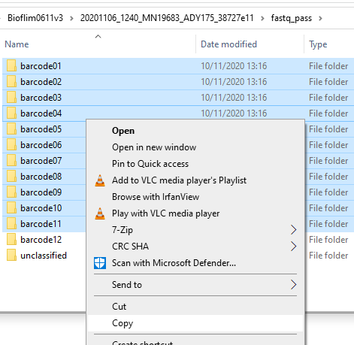
The sample name may look like this:
ADY175_pass_barcode01_f1db479d_0.fastq.gz

The first part (ADY175) is the Flow-cell-id.
The last part (f1db479d) is a unique generated code for the nanopore sequence run


2. Click on the Ubuntu icon in the Task-bar.

3. navigate to the folder with the fastq files:
cd /mnt/d/Nanopore_fastq_pass/EcoEvo2024/grond/fastq_pass

4. Make a directory:
mkdir compiled

5. Merge fastq files per barcode. Change the flongle ID!
for i in {01..12}; do cat barcode${i}/auc430*fastq.gz > compiled/barcode${i}.fastq.gz; done

  - Sequence data QC with NanoPlot
    - The data is now in folder: /fastq_pass/compiled
Go to the data folder:
cd /mnt/d/Nanopore_fastq_pass/EcoEvo2024/grond/fastq_pass/compiled

    - When starting nanoplot (or any other command) --> remember the capital N and P in NanoPlot!!!
    - Run NanoPlot:
NanoPlot -t 12 --fastq_rich barcode01.fastq.gz --N50 --verbose --raw -o /mnt/d/Nanopore_fastq_pass/EcoEvo2024/grond/nanoplotoutputbc01

NanoPlot works fast, in just a few seconds!
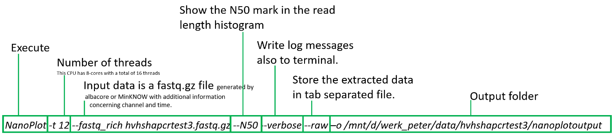
    - open nanoplot output (in windows 10) and check the data in NanoPlot-report.html 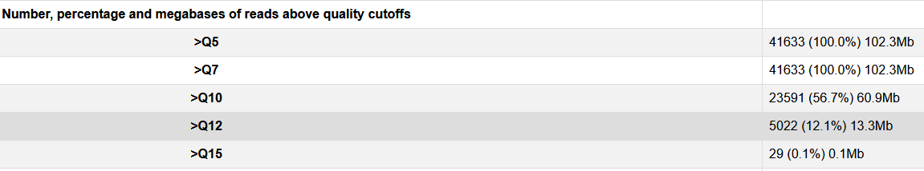
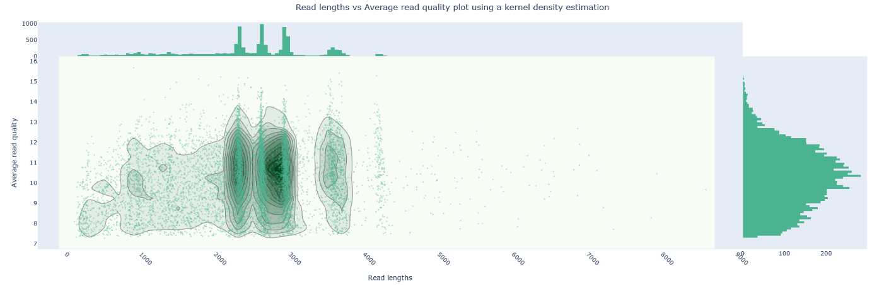
    - Determine the minimal and maximal read length. And the level of quality filtering!
For this data: Minlen 470 410 bp (470-60)
!Minlen size selection happens after--headcrop 30 --tailcrop 30

Maxlen 770 bp !size selection happens before --headcrop 30 --tailcrop 30
Quality 10 (or higher for more accurate reads)

  - NanoFilt
    - Clean up your data with NanoFilt (only a few seconds run time)
zcat barcode01.fastq.gz | NanoFilt -q 10 --length 410 --maxlength 770 --headcrop 30 --tailcrop 30 | gzip > HQbarcode01.fastq.gz

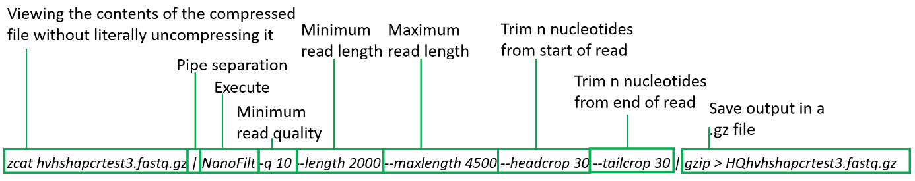

    - Check filtered data with NanoPlot:
NanoPlot -t 12 --fastq_rich HQbarcode01.fastq.gz --N50 --verbose --raw -o /mnt/d/Nanopore_fastq_pass/EcoEvo2024/grond/nanoplotoutputHQbc01

  - Start NGSpeciesID
    - Upon start/login to your server/computer you need to activate the conda environment "NGSpeciesID" to run NGSpeciesID as:
conda activate NGSpeciesID

    - You should now have 'NGSpeciesID' installed; try it:
NGSpeciesID --help

    - The data is still in folder: /fastq_pass/compiled
Go to the data folder:
cd /mnt/d/Nanopore_fastq_pass/EcoEvo2024/grond/fastq_pass/compiled

    - Unzip file
gunzip HQbarcode01.fastq.gz

    - Give command:
NGSpeciesID --t 12 --ont --consensus --racon --racon_iter 3 --sample_size 10000 --abundance_ratio 0.001 --fastq HQbarcode01.fastq --outfolder NGSIDHQbc01

    - To deactivate the environment use
conda deactivate

    - Collect data, go to NGSpeciesID output folder
cd NGSIDHQbc01

    - Concatenate (to merge .fasta together)
cat consensus_reference_*.fasta > NGSIDHQbc01.fasta

    - Open Word and use “replace” to make the fasta file Excel ready.
Replace:
_ for ^t (tab)
^p> for %
^p for ^t (tab)
% for ^p>

