|  |  |
| --- | --- |
| mycase.kiss  .start_kiss  .i 1  .o 1  .p 12  .s 6  .r a  0 a d 1  1 a c 1  0 b f 1  1 b d 0  0 c a 1  1 c c 1  0 d d 0  1 d b 1  0 e a 1  1 e b 1  0 f a 1  1 f f 1  .end_kiss | mycase.dot  digraph STG {  rankdir=LR;  INIT [shape=point];  a [label="a"];  b [label="b"];  c [label="c"];  d [label="d"];  e [label="e"];  f [label="f"];  INIT -> a;  a -> d [label="0/1"];  a -> c [label="1/1"];  b -> f [label="0/1"];  b -> d [label="1/0"];  c -> a [label="0/1"];  c -> c [label="1/1"];  d -> d [label="0/0"];  d -> b [label="1/1"];  e -> a [label="0/1"];  e -> b [label="1/1"];  f -> a [label="0/1"];  f -> f [label="1/1"];  } |

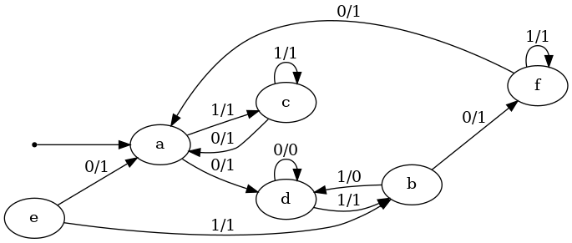

|  |  |
| --- | --- |
| myresult.kiss  .start_kiss  .i 1  .o 1  .p 10  .s 5  .r a  0 a d 1  1 a c 1  0 b c 1  1 b d 0  0 c a 1  1 c c 1  0 d d 0  1 d b 1  0 e a 1  1 e b 1  .end_kiss | myresult.dot  digraph STG {  rankdir=LR;  INIT [shape=point];  a [label="a"];  b [label="b"];  c [label="c"];  d [label="d"];  e [label="e"];  INIT -> a;  a -> d [label="0/1"];  a -> c [label="1/1"];  b -> c [label="0/1"];  b -> d [label="1/0"];  c -> a [label="0/1"];  c -> c [label="1/1"];  d -> d [label="0/0"];  d -> b [label="1/1"];  e -> a [label="0/1"];  e -> b [label="1/1"];  } |

