1. **(20%, Inserting into an Ordered Lists)** Write a program that inserts 10 random integers from 0 to 100 in order in a linked list. Write the following two functions to display the generated linked list.

**(a) (Display a list)** Write function displayList to display the content of a linked list. The function takes a pointer to the first node of a linked list as argument. The program should display the generated random number and the linked list when a number is inserted to the linked list.

**(b) (Recursively Print a List Backward)** Write a function printListBackward that recursively outputs the items in a list in reverse order. Your program has to use the function to show the generated linked list in reverse order after the 10 random integers are inserted to the list.

1. (20%) Write a program to generate two ordered linked lists of integers with random length (less than 10). Then implement the following functions. The program should display the original linked lists and the resulting linked lists. You can use the displayList function in Prob. 1.

**(a) (Concatenating Lists)** Write function concatenate that takes pointers to both the random generated lists as arguments and concatenates the second list to the first list. Display the resulting linked list.

**(b) (Merging Ordered Lists)** Write function merge that merges two ordered lists of integers into a single ordered list of integers. The function should receive pointers to the first node of each of the lists to be merged and return a pointer to the first node of the merged list. The program should display the two original linked lists and the merged one.

**(c) (Creating a Linked List, Then Reversing Its Elements)** Write function reverse that creates a copy of the merged list in (b) in reverse order. The program should display the reversed linked list.

1. (20%) Write and thoroughly test a program that creates a doubly linked list – a list in which each node contains two pointers, one to the node that follows the current node and one to the node that precedes the current one.

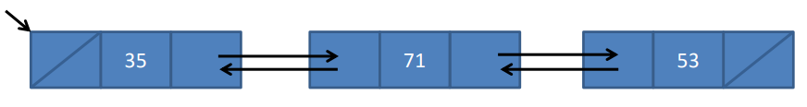Develop functions to insert a node at the beginning of the list, at the end, and in front of a node with a designated key. Also, write a function to delete a node with a designated key and functions to display the list from any point to the end and from any point backward to the beginning.

1. (20%) A palindrome consists of a word or deblanked, unpunctuated phrase that is spelled exactly the same when the letters are reversed. Write a recursive function that returns a value of 1 if its string argument is a palindrome. Notice that in palindromes such as level, deed, sees, and Madam I’m Adam (madamimadam), the first letter matches the last, the second matches the next-to-last, and so on.
2. (20%) Write a program that inputs a line of text and uses a stack to print the line reversed.

For example:

Input: Happy New Year

Ouput: raeY weN yppaH