1. **(10%, Triangle-Printing Program)** Write a program that prints the following patterns separately, one below the other. Use for loops to generate the patterns. All asterisks (*) should be printed by a single printf statement of the form printf(“%s”, “*”); (this cause the asterisk to print side by side). [Hint: The last two patterns require that each line begin with an appropriate number of blanks.]

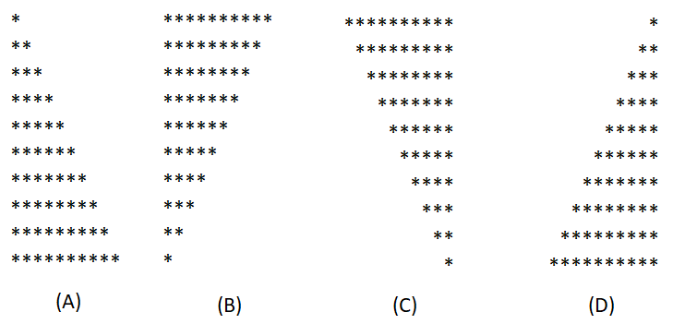

1. **(10%, Bar-Chart Printing Program)** One interesting application of computers is drawing graphs and bar charts. Write a program that reads five numbers (each between 1 and 30). For each number read, your program should print a line containing that number of adjacent asterisks. For example, if your program reads the number seven, it should print *******.
2. **(15%, Calculating Sales)** An online retailer sells five different products whose retail prices are shown in the following table:

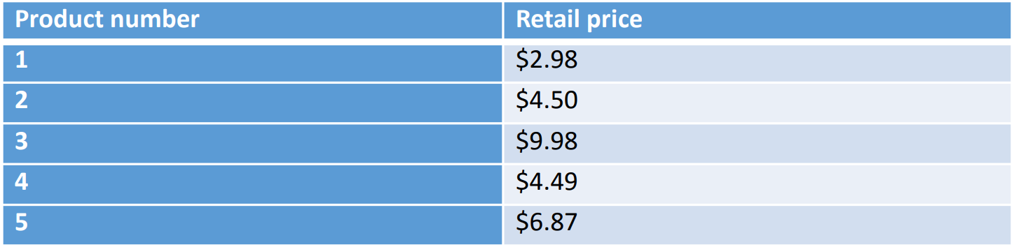

Write a program that reads a series of pairs of numbers as follows:

1. Product number
2. Quantity sold for one day

Your program should use a switch statement to help determine the retail price for each product. Your program should calculate and display the total retail value of all products sold last week.

1. **(15%, Calculating the Value of 𝝅)** Calculate the value of π from the infinite series

$$π=4-\frac{4}{3}+\frac{4}{5}-\frac{4}{7}+\frac{4}{9}-\frac{4}{11}+…+4×\frac{{-1}^{i+1}}{2i-1}$$

Write a program that displays the π for i=10000, 20000,…, and 100000.

1. **(10%, List each digits for a number)** Let n be a positive integer consisting of up to 10 digits, $d_{10}, d_{9}, …, d_{1}$. Write a program to list in one column each of the digits in the number n. The rightmost digit, 𝑑1, should be listed at the top of the column. [Hint: If n is 3,704, what is the value of the digit when computed by using digit = n % 10; ]
2. **(15%, Pythagorean Triples)** A right triangle can have sides that are all integers. The set of three integer values for the sides of a right triangle is called a Pythagorean triples. These three sides must satisfy the relationship that the sum of the squares of two of the sides is equal to the square of the hypotenuse. Find all Pythagorean triples for side1, side2, and the hypotenuse all no larger than 500.
3. **(10%, Prime Numbers)** Write a program to calculate and print a list of all prime numbers from 1 to 1000.
4. **(15%, Find the Two Largest Numbers)** Write a program that inputs a series of 10 non-negative numbers and determines the largest two numbers and then prints the result.