1. circuit analysis
2. L06:P16.sp
3. circuit diagram

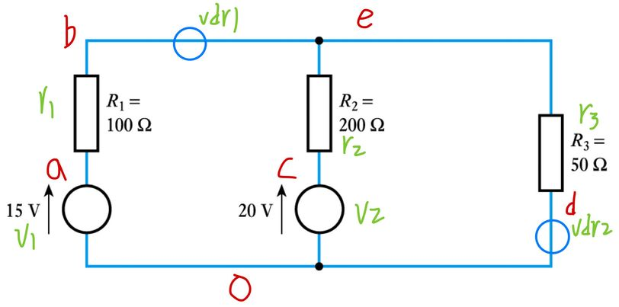

1. code

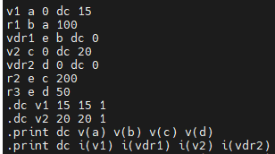

1. analysis results

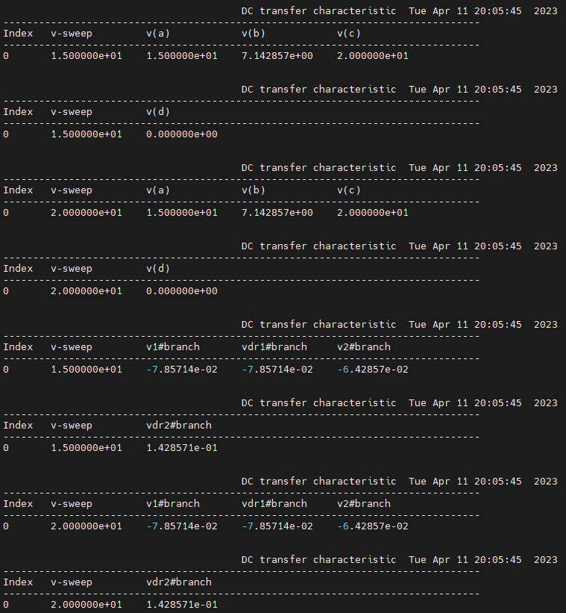

1. L06:P20.sp
2. circuit diagram

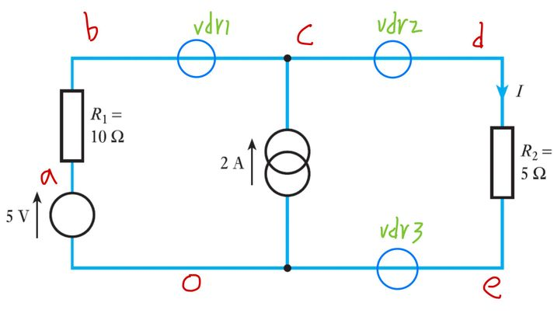

1. code

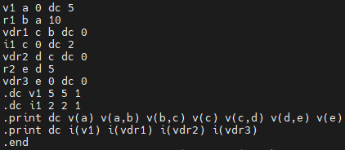

1. analysis results

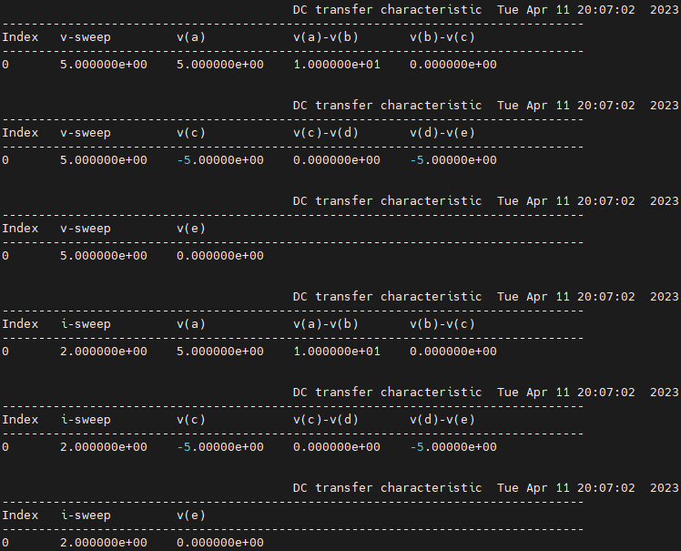

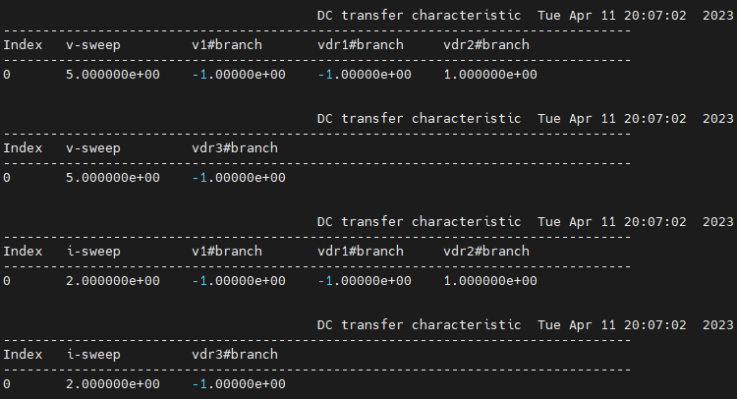

1. L06:P22.sp
2. circuit diagram

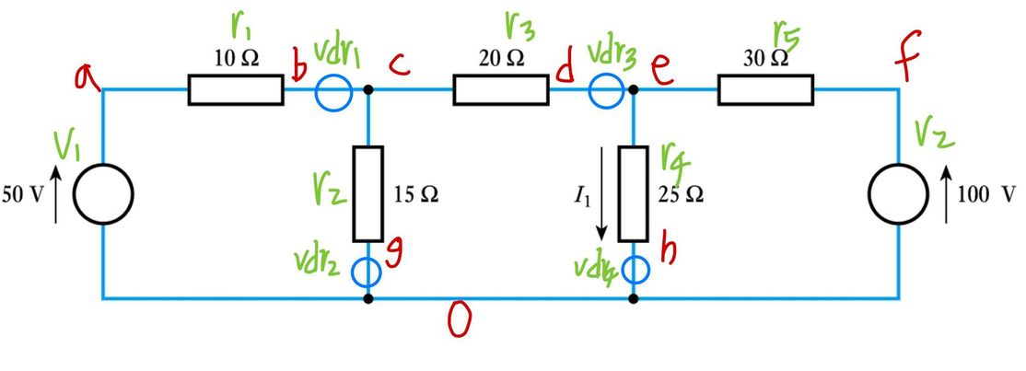

1. code

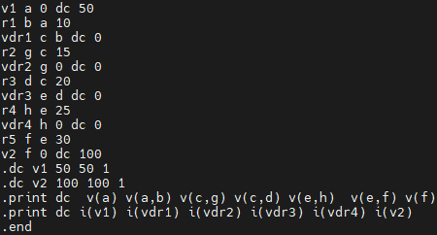

1. analysis results

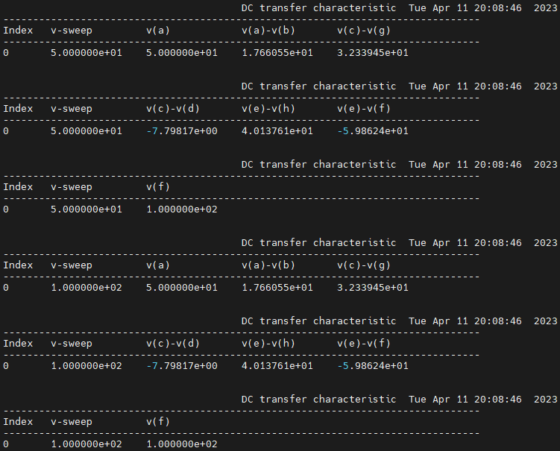

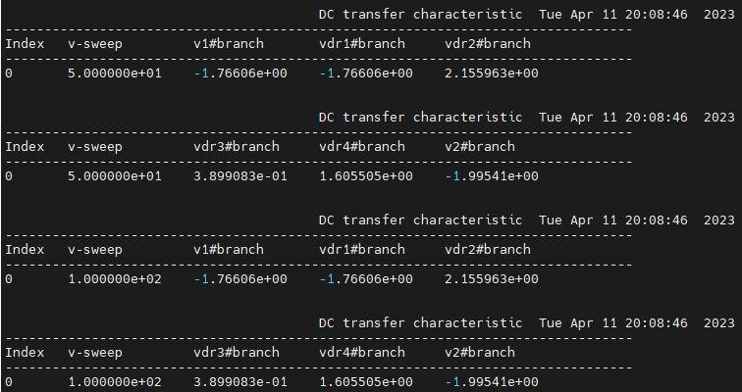

1. L06:P26.sp
2. circuit diagram

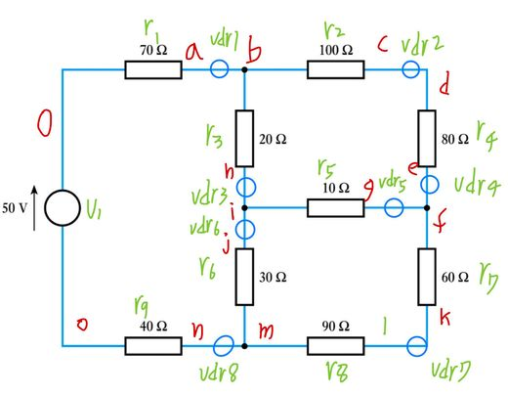

1. code

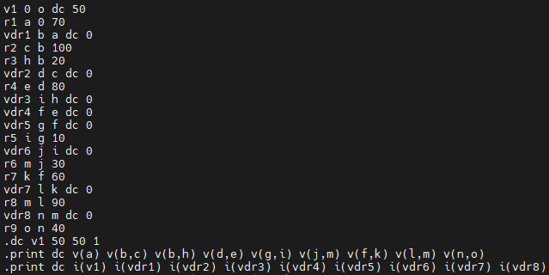

1. analysis results

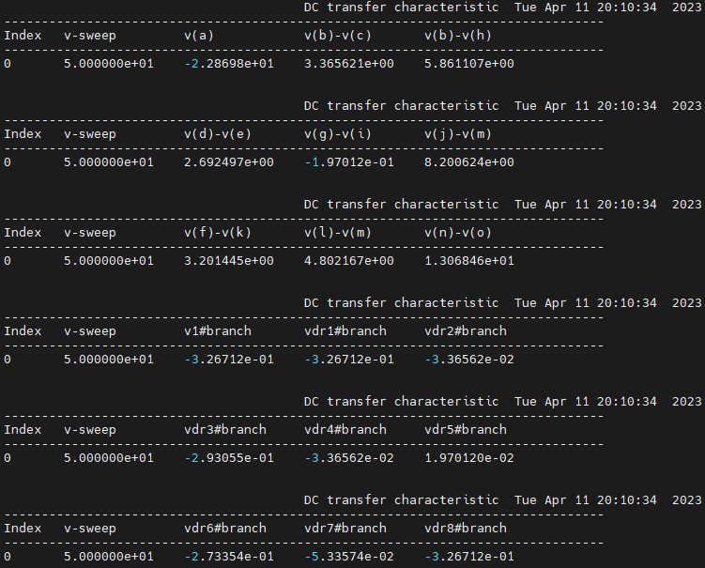

1. 心得

At the beginning, I used the code uploaded by the teacher to study a little bit, but when I typed it for the first time, I still forgot that the first line needs a space. After a long time, I asked Moodle for help. Although I knew the first line needs a space by watching video, I still made this initial mistake when I typed it for the first time.

Gradually, I programmed more fast. I can write the code in the shorter time. Before programming circuit diagram, I am used to marking every elements and every circuits int circuit diagram because it can clarify how to write and make it easier to program.

I become more proficient in programming the electric circuit. I will also have improvement in the future, too.