**The Supply and Demand of Fact v. Opinion**

**in Presidential Tweets**

Thad Kousser, UC San Diego

and

Stan Oklobdzija, UC San Diego

**Abstract**. Do presidential candidates, and now President Trump, use social media to lay out the factual basis for their positions, or do they primarily communicate their values and opinions?  We investigate this question by using human categorizations of over 8,000 tweets to train machine learning algorithms to code all of the tweets sent by all 23 candidates during and since the 2016 presidential election campaign.  We argue that politicians should supply more opinions than facts, in order to match voter demand for opinion over fact and increase audience engagement with their tweets.

In a descriptive analysis, we chart the flow of factual claims – many of which happen to be false, according to prominent fact-checking websites – versus opinion over the course of the campaign and across candidates.  Donald Trump leaned heavily toward opinion during the campaign, but so did Hillary Clinton and many of the most successful candidates. Turning to the demand for tweets, we analyze the rate at which a candidate’s tweet is liked or retweeted, relative to her number of followers.  We find that, for nearly every candidate, tweets that espouse an opinion generate significantly more engagement than factual claims. Negative opinions are especially engaging. These findings persist in multivariate models that hold constant the tone, subject matter, and ideology of the tweet, providing strong evidence that voters are more responsive to opinion than fact on social media.

           Among the many unprecedented features of the 2016 presidential election, two stand out: the ascendance of Twitter as a medium of direct communication between candidates and the public,[1] and a declining adherence to facts in elite political rhetoric.  How did these trends interact in the discourse of presidential candidates, and how did their audiences react? When presidential aspirants tweeted, did they seek to inform their followers by making factual statements or to persuade them by laying out their opinions?  Did those who read their tweets chose to spread facts across the Twittersphere by retweeting such statements, or was it opinion that was most likely to generate engagement on social media?

We answer both questions by analyzing the balance of fact versus opinion statements in the tweets of all major party presidential candidates throughout the course of the 2016 election. We separately analyze President Trump since then, because he is, in some sense, campaigning for reelection. We also look at audience engagement with each type of tweet in order to test how supply and demand interact. Our theoretical argument takes as its starting point two empirical findings in the prior literature; one showing how politicians use social media differently from other campaign media, clearly seeking to engage their audience and drawing benefits if they do (Grant et al. 2010, Lee and Shin 2012, Graham et al. 2013, 2016, Kreiss 2016a, 2016b, Lyons and Veenstra 2016), and the other demonstrating that their audiences are far from a random sample of the general public (Conover et al. 2011, Barthel and Shearern 2015, Pew Research Center 2017).

Our central contention is that candidates supply what members of their social media audience implicitly demand when they decide to follow a candidate on Twitter: the politician’s subjective take on the world. The very act of choosing to follow a candidate signals that a follower wants to hear from that candidate directly about her values, positions, preferences, and antagonisms, signing up to read her subjective views rather than using the nearly infinite informational resources of the internet to learn objective facts about her. The social media audience, then, should prefer opinions to factual claims. Candidates should shape the supply of their messages to match the demands of their audience, providing more opinion than fact in order to get their online followers to engage with their Twitter feeds. Finally, the immediate feedback mechanisms that Twitter provides – candidates can see how many “likes” and retweets any fact or opinion receives – should point them toward sending more of the types of messages that their followers find engaging. We expect to see the rate of opinion versus factual tweets grow over the course of the campaign, especially as candidates who undersupply opinion, relative to other competitors, adjust their strategies.

In order to test the hypotheses suggested by this argument, we construct an original dataset of 76,776 tweets sent by 23 major party candidates during the 2016 US presidential campaign and since then by President Trump. Taking a supervised learning approach to this large-scale text analysis (see Grimmer and Stewart 2013, Peterson and Spirling 2018), we present a novel measure categorizing tweets as either factual claims or opinions. Examples of fact-claiming tweets, which need not be in fact true, include John Kasich’s “A top ten state for job creation. Wages growing faster than the nation. Record number of businesses” or Carly Fiorina’s “In fact, single mothers earn $19,000 dollars less per year than married mothers. #empoweredwomen #ceidinner.” Opinions include Hillary Clinton’s “In America, we lift each other up. We build bridges, not walls. We stand together because we're stronger together” and Donald Trump’s “Hillary Clinton doesn't have the strength or the stamina to MAKE AMERICA GREAT AGAIN! #AmericaFirst.” Working with a team of ten research assistants who coded 8,363 tweets by hand, we demonstrate strong levels of intercoder reliability for this new measure. We then train machine learning algorithms to replicate these human coding decisions, accurately reproducing both our coding of fact versus opinion and measures of the sentiment, ideology, and subject matter of each tweet. After validating this approach, we classify all of these characteristics for the full corpus of tweets. We also gather data on the level of engagement with each tweet, either through audience likes or retweets, along with the size of each candidate’s Twitter following at the time the tweet was sent.

This approach allows us to chart the prevalence of fact versus opinion tweets throughout the 2016 election.  We find, consistent with our predictions, that it is opinion that a politician’s online audience finds most engaging, and that the 2016 presidential candidates supplied more of it, especially as the campaign wore on.  We calculate the rate of fact versus opinion tweeting for each candidate and chart it over time, showing that Donald Trump spearheaded but was not alone in using social media to set forth his views rather than to inform – every candidate in the race tweeted their opinions more often than facts. Leveraging a feature of Twitter that allows us to measure the instantaneous reaction of a political audience to elite messages, we examine the impact of fact versus opinion strategies on liking and retweeting rates. Opinions earn likes or go viral at far higher rates than facts for nearly every major candidate. In within-candidate models that control for the ideology, sentiment, and subject matter of a tweet, we show that followers engage with opinions much more often than they do with facts, a trend that held as strongly among Hillary Clinton, Bernie Sanders, and Ted Cruz’s followers as it did among Donald Trump’s audience. Opinions with a negative sentiment win more engagement than neutral or positive opinions, across all candidates. We also show that the demand for opinion over facts has remained steady over the course of the Trump presidency.

Twitter use by political leaders around the world has become an increasingly promising and vital arena to study (Golbeck et al 2010, Grant et al. 2010, Bruns and Highfield 2013, Graham et al. 2013, 2016, Himelboim et al. 2013, Mejova et al. 2013, Strauss et al. 2013, Evans, Cordova, and Sipole 2014, Kruikemeier 2014, Barbera 2015, Bhattacharya et al. 2015, Evans and Clark 2016, Kreiss 2016a, 2016b, McGregor et al. 2016, 2017, Meeks 2016, Metzger et al. 2016, Steinert-Threlkeld 2017). To this burgeoning literature, we contribute a new argument, a novel measure of the content of tweets, and a set of findings showing how supply and demand interact to bring more opinions than facts into America’s new digital civic discourse.

*I. Theory*

**I. A. Supply: How Do Candidates Use Fact and Opinion?**

Presidential candidates began using Twitter as a key part of their communications strategies in 2012 (Conway et al. 2013, Murthy 2015, Kreiss 2016a, 2016b). It took on heightened prominence in the 2016 campaign, especially through the unique candidacy of Donald Trump, who used his @realDonaldTrump handle to send 7,792 tweets from July 1, 2015 through Election Day in November 2016, and another 3,079 between the election and March 2, 2018. Yet Trump and his communications team were not alone in making Twitter a central part of their campaign. Hillary Clinton was the most prolific campaign tweeter, sending 8,937 tweets, Bernie Sanders sent 7,794, Ted Cruz sent 8,500, and John Kasich sent 4,384. With Twitter audiences that ranged from 14.4 million followers for Donald Trump to 10.3 million for Hillary Clinton and 3.9 million for Bernie Sanders by Election Day, this media provided an avenue for candidates (and their communications staffs, who often tweet on their behalf) to speak both to media and to a massive number of voters directly. While tweet volume certainly does not predict electoral success (Conway et al. 2013, McGregor et al. 2017), Trump’s rapid rise suggests that using this medium effectively can be part of a successful campaign strategy. Twitter has taken its place alongside the stump speech and the television commercial as a staple of presidential campaigning. Maintaining a vigorous social media presence is now a central aim of any campaign, with candidates devising intentional online strategies. What, then, do candidates set out to accomplish when they send a tweet?

One way to think about Twitter is that it simply provides an additional medium for candidates to get out their campaign message. If politicians’ tweets are nothing more than campaign broadcasts sent through another medium, they should invest in the same sort of rhetorical portfolio that they do on the stump and in their advertisements.  Presidential candidates will introduce their biographies, drive home the key message that motivates their candidacy, lay out their stances on major issues, and contrast themselves with their opponents. And, in the words of Mayhew (1974), they will claim credit and take positions. All of these can be accomplished either through factual claims or by statements of opinion.

For instance, Republican candidate Gov. Chris Christie of New Jersey tweeted “I fight for what I believe in and make sure that government works for the people...” in January 2016 in the weeks leading up to the Iowa Caucuses. Contrast that with the more concretely factual credit claim by fellow GOP candidate and former Governor of Arkansas Mike Huckabee who tweeted in November 2015, “As Governor, I passed first broad-based tax cut in the history of the state #GOPDebate #ImWithHuck.” Similarly, politicians can also take positions with an opinion, such as Hillary Clinton’s statement that “Your loved ones deserve the best care without you having to worry about your paycheck.” In an example of factual position taking, Clinton tweeted that she “...has only received one F in her life and she's proud of it: from the NRA. #DemDebate.”

Yet a more sophisticated view of how to use Twitter in politics highlights its comparative advantages relative to other media: Twitter allows candidates to send direct and personal messages that invite their audiences to engage, either through “liking” or retweeting a tweet.[2] Candidates can tweet straight from their phones to the devices of their followers, who then can immediately like or retweet what they read. This prospect for engagement is critical. Studies of politicians’ tweets in the UK and in the Netherlands (Graham et al. 2013, 2016) show that many leaders use this new medium to interact with individual Twitter followers or to invite broad engagement. Our argument is that when candidates use Twitter, they should, more than in their other forms of campaign communication, speak in the style most likely to elicit engagement.[3] The payoffs to engagement are clear: both experimental (Lee and Shin 2012, Lyons and Veenstra 2016) and observational (Grant et al. 2010) evidence shows that politicians are evaluated more favorably by voters when they post interactive tweets.[4] And because candidates get real-time feedback on how engaging their messages are, the savviest candidates will supply the types of messages that their audience demands.

Our contention is that politicians will supply the types of messages – either factual claims or opinions – that their Twitter followers demand. In the next theoretical section, we make a substantive argument that the social media audience should exhibit a stronger demand for subjective opinions than for opinions than for objective facts. Our data on audience engagement – measured via likes and retweets – is strongly consistent with this prediction. Consequently, because we expect strategic politicians to anticipate the demands of their audience, presidential candidates should tweet more opinions than factual claims.

*Hypothesis 1: Presidential candidates, seeking to tweet out what is most engaging to their audience, will*

*supply more opinion than fact on Twitter.*

**I. B. Demand: Twitter Followers Seek Opinions**

What are people looking for when they choose to follow a politician on Twitter? We contend that this decision is driven by their desire to hear directly from a candidate. When they follow a politician, they may or may not support her, but they are interested in hearing what she has to say, rather than simply reading objective information about her from outside sources. What these followers demand, then, is her personal perspective; the very act of choosing to follow a candidate is akin to signing up to read her subjective views rather than using the nearly infinite informational resources of the internet to learn objective facts about her. Selecting into a candidate’s Twitter following signals, we argue, that audience members want to find out whether they are a subjective fit with the candidate. Because of this, they should demand more statements of opinions than factual claims, because it gives them the information that they want and that they can get most directly from the candidate’s own feed.

This argument is based on our recognition that a politician’s social media audience is by no means a random or representative sample of the general public. While the overall Twitter audience is quite broad, with 22 percent of U.S. adults using Twitter (Pew Research Center 2019), it is not perfectly reflective of the electorate, and the audience grows narrower and less representative when one focuses on those who follow politics and then those who choose to follow particular politicians. According to the 2019 Pew Research Center study, Twitter users are younger and more likely to be college graduates than the general population.  An earlier study found that there are also racial and ethnic differences, with African-Americans more likely to be on Twitter than white Americans (Pew Research Center 2017). Even among Twitter users, those who follow politicians are a subsample: in Barthel and Shearer’s (2015) study, 12 percent of Twitter users followed civic or political leaders (compared to the 35 percent who followed entertainment or sports figures). The subsets of Twitter users who follow candidates with particular ideological stripes are smaller and likely to be even more distinct in their characteristics.  While we have not seen direct studies of the ideology of these followers, Barbera (2015) argues convincingly that they share an ideological affinity with the leaders whom they follow, and works by Conover et al. (2011) and Bakshy et al. (2015) show that social media audiences are politically polarized.[5]

There is a strong selection process, then, that constructs a politician’s Twitter audience. These are people who have chosen to join Twitter, to use it to learn about politics, and then to follow a specific politician. These decisions, we argue, tells us something about them that is the key to predicting how they will react to different messages. If they wanted to get just the facts about a candidate, they could Google her or use the plethora of internet resources such as votesmart.org to read about her biography, positions, and interest group ratings. For encyclopedic information like this, they can turn to reliable third-party sources, or at least the media that they trust. They can even get factual information on Twitter. Rosenstiel et al. (2015) show that 86% of Twitter users use it to read news, with 73% following individual journalists online. There are many online avenues through which to gather factual information about candidates.

Why might they turn directly to a candidate by following her on Twitter?  They would do so, we argue, because they want to get her take on the world, to hear about how she views events in the news or in politics. The act of choosing to follow a politician reveals that they are interested in her subjective view of the world, rather than simply objective facts about her.  They want to hear what she stands for, and learn whether her view of the world meshes with their own. Because of what they are searching for, they should be more likely to engage with a politician when she provides them with what they want: her opinions about the world. This logic that the Twitter audience self-selects forms the primary basis for our prediction here. The comparative advantage that a follower gets from subscribing to a candidate’s personal Twitter feed is that the candidate can provide her direct, unvarnished, and immediate opinions. Those who decide to follow a candidate, then, should be more receptive to opinions than to facts.

*Hypothesis 2: Twitter users who choose to follow politicians should be more likely to engage with an opinion tweet than a factual tweet.  This should be true for both retweets and likes.*

**I. C. What types of opinions should lead to the most engagement?**

Opinions can be expressed in qualitatively different ways, and it is quite possible that some forms of opinion are more engaging to Twitter followers than others. A rhetorical characteristic that could be especially important in political discourse is the sentiment of an opinion. Using the same strategy of having human judgments on thousands of tweets guide machine learning algorithms to categorize tens of thousands, we identify whether the sentiment of a tweet is positive, negative, or neutral as we judge whether it is fact or opinion. For instance, tweets that express positive opinions include Donald Trump’s “Our biggest problems are solved by growth. We need a President who is a job creator. Let’s Make America Great Again!” and Hillary Clinton’s “Hillary has spent decades fighting for veterans, members of the military, and their families.” Negative opinion tweets include Bernie Sanders’ “What would a Donald Trump presidency mean for the people of this country? I think it would be an absolute disaster, beyond a disaster,” and John Kasich’s “How can @realDonaldTrump’s insults & anger make him worthy of the same job as Washington, Lincoln and Reagan?” A tweet with a neutral opinion is Hillary Clinton’s “As flotus said the choice in this election is about who will have the power to shape our children for the next four years of their lives.”

Which type of opinion should be most engaging? Since our theory of supply and demand provides no clear guidance here, we are agnostic, but lay out three possibilities suggested by different strands of the existing literature. One possibility is that an opinion should be most engaging when there is any clear unneutral sentiment contained in it.  Neutral opinions do not tell us what a candidate stands for or stands against, and thus should not resonate. Stefan and Dang-Xuan (2012) find that, for politically relevant tweets, a tweet is more likely to be retweeted when it contains more words with an affective dimension, whether that sentiment is positive or negative.

*Hypothesis 3a. An opinion tweet will be more engaging when it expresses any type of sentiment, relative to a neutral sentiment.*

Another possibility is positive opinions may be particularly appealing and engaging because followers could be drawn to politicians more because of what they stand for rather than stand against.  One can support Donald Trump because of his views on immigration and taxes, even if one does not hate the NY Times. We lay out another possible expectation based on the logic that what members of a political constituency have in common is what they agree on rather than we they oppose.

*Hypothesis 3b. An opinion tweet will be more engaging when it expresses a positive sentiment, relative to a neutral or negative sentiment.*

A contrasting theory borrows from the logic of work by Abramowitz and Webster (2016) on “negative partisanship,” which shows that partisans in American politics have increasing negative views of their political opponents. In this line of thinking, people form political views based on what they oppose, and look to find commonality in what politicians or position they detest. This evokes the way politicians use Twitter in other countries: Van Kessel and Castelein’s (2016, 594) study of tweets by political groups in the Netherlands shows that both right and left-wing populist parties use tweets primarily as an oppositional tool “to give form to their adversarial rhetoric” against mainstream parties.

*Hypothesis 3c. An opinion tweet will be more engaging when it expresses a negative sentiment, relative to a neutral or positive sentiment.*

**I. D. Does Demand Reshape Supply?**

Finally, we lay out one clear implication of the logic in our argument, that politicians supply more opinion on Twitter because it is the type of rhetoric that their audience demands. If this mechanism is at work, we should see some evidence of a feedback loop through which candidates learn from and respond to their audience’s preferences over the course of a campaign. Of course, the savviest politicians might anticipate audience demand, providing more opinion than fact from the start. If they perform well, their competitors may learn from them and emulate their patterns of tweeting (Kreiss 2016a shows that Republicans began to emulate Barack Obama’s social media strategies after their demonstrated success in 2012). Or a more direct feedback mechanism can be at work. Candidates who do not give their audience enough of what they want will be able to learn from the likes and retweets of their tweets about what works and what does not work, shifting their balance of tweets away from factual claims and toward more opinion as the campaign progresses.

*Hypothesis 4: Learning from feedback of Twitter engagement, candidates will supply more of what their audience demands, shifting from factual claims toward opinion tweets over the course of a campaign.*

*II. Method: Measuring Fact vs. Opinion in Tweets*

To test these hypotheses, we need to categorize each of the tens of thousands of tweets from 2016 presidential candidates as a “factual claim” or an “opinion.” We also need to make other judgments about tweets – measuring the ideological positions that they convey, the sentiments that they connote, the policy areas that they address, and what they ask their audience to do – to hold constant these characteristics of communication and thus isolate the impact of fact vs. opinion on engagement. Prior works generally take one of two approaches to coding the content of tweets.

Some scholars use their expertise or research assistants to hand code tweets (Golbeck et al 2010, Graham et al. 2013, 2016, Himelboim et al. 2013, Mejova et al. 2013, Evans and Clark 2016, Meeks 2016), while others substitute artificial intelligence for human judgment to categorize the characteristics of massive numbers of tweets (Grant et al. 2010, Bruns and Highfield 2013, Kruikemeier 2014, Bhattacharya et al. 2015, Murthy 2015, Obschonka 2017) or use the social networks of Twitter followers to infer the ideology of politicians (Barbera 2015, Barbera et al. 2015, King, Orlando, and Sparks 2015). Because we needed to measure the complex concept of fact versus opinion, and to do so for a large volume of tweets, we leveraged the strengths of both approaches through “supervised learning”: we worked with a team of research assistants over 15 months to hand-code 8,363 tweets, then used these categorizations to train machine learning algorithms to classify the full set of about 207,000 tweets sent before and during the campaign by all candidates, and, after the election, by President Trump. In this section, we detail our approach and present validity checks for our measurement strategy.

The key idea behind a supervised learning approach, which McGregor et al. (2016) also apply to political tweets, is to begin with a small sample from the full set of texts being studied, reading and coding them intensively by hand. The final step is training and testing machine learning algorithms on this small dataset before using the algorithms to classify the entire corpus. Starting in October 2015, we used Twitter’s public API to download tweets from each major party candidate’s account. We also created scripts that automatically downloaded all tweets from these 23 accounts from that point onward, creating a complete dataset of tweets running through July 2018. Beginning in June 2016 and continuing through August 2017,[6] we worked with a team of eight graduate and undergraduate research assistants to categorize these tweets. Our coders read only the text of the tweet, receiving no information about who sent it. We created a codebook outlining operational definitions of the concepts that we sought to measure as well as the types of tweets that would fit into each category. We met twice weekly to discuss the concepts and to debate how tweets should be categorized, updating our codebook, contained in Appendix 1, with these difficult cases. This iterative approach follows the best practice recommended by Grimmer and Stewart (2013, 277).

Our primary task was to separate fact from opinion. Scholars have long drawn this distinction, with Shell (1967, 5) characterizing it this way: “facts are existing bits of known and verifiable information while opinions, even though based on facts, transcend the absolute certainty of facts and incorporate varying degrees of speculation, confidence, and judgment.” Our codebook defines “opinions” as statements of values, speculations about futures events, or judgments, and “factual claims” as assertions that could be verified as true or false. Importantly, they do not need to be true; factual claims are statements that can be fact-checked, not necessarily ones that survive fact-checking. When a tweet contained at least one clear opinion, even if combined with a factual claim, we categorized that tweet as an opinion.

In Table 1, we provide examples tweets that we categorized as fact or opinion, along with examples of two of our other key measures, “ideology” and “sentiment.” Another set of that we coded variables put each tweet into one of the ten subject areas, using the topic list created and applied to democracies around the world by the Policy Agendas Project (2017).[7] We also gather additional variables to serve as controls in our multivariate models, to isolate the impact of opinions.

How often did coders agree on their categorization when members of our research team independently coded the same tweets? In Table 2, we report measures of intercoder reliability for all of our variables, demonstrating generally strong levels of agreement. This reliability analysis is based on a set of 3,634 tweets, which we assigned to overlapping pairs of coders so that each researcher was paired with all others. We report the rate of agreement between coders and then the Cohen’s

kappa and Krippendorff’s alpha, measures of how much more likely the researchers are to agree

**Table 1. Examples of Variables and Tweets in Each Category**

|  |  |  |  |
| --- | --- | --- | --- |
| Is the Tweet a Factual Claim or an Opinion? | | | |
| Factual Claim | | Opinion | |
| A top ten state for job creation. Wages growing faster than the nation. Record number of businesses. | | In America, we lift each other up. We build bridges, not walls. We stand together because we're stronger together. | |
| In fact, single mothers earn $19,000 dollars less per year than married mothers. #empoweredwomen #ceidinner | | Hillary Clinton doesn't have the strength or the stamina to MAKE AMERICA GREAT AGAIN! #AmericaFirst | |
| Hundreds turned out this morning in Fairfax to hear Gov. Kasich's message of strength and optimism. | | I am the only one who stood up to 100K protesters, stood up to the big union bosses. I'll stand up to Washington. | |
| Ideology | | | |
| Liberal | Neutral | | Conservative |
| New docs show Bush/Cheney ignored 4th Amend. &amp; Justice Dept on wiretapping. Probably still think they're right. | Wonderful meeting with many prominent leaders of the Asian American and Pacific Islander community in Illinois. | | RT @FoxNews: .@RealBenCarson on ISIS: "We need to recognize that it is really an existential threat to our nation...the war is against all |
| “Four boys shot my son dead on Christmas Eve.” A moment backstage with a mom who lost her son to gun violence. | ICYMI: Today I appeared on The Real Story with @GretchenCarlson | | My conservative alternative to Obamacare focuses on restoring power to patients doctors: |
| Sentiment | | | |
| Negative | Neutral | | Positive |
| The sheer size and remoteness of the federal bureaucracy has caused the American people to lose trust in government. | This account will be run by campaign staff from now on but you’ll still see tweets from Hillary. They’ll be signed -H. | | Looking forward to joining @jaketapper and @TheLeadCNN today at 4:30pm ET. Tune to hear about our plan to help hardworking families! |
| There are some things in Washington we need to burn down. Read more here | For those with a question as to "secret service" protection, neither my team nor I are in the habit of commenting on security. | | RT @KevinBingle: BREAKING: The @BostonGlobe @GlobeOpinion endorses Gov. @JohnKasich for President! |

than we would expect by pure chance. Our rates of agreement range from 72% on our three-category sentiment measure to near perfect agreement on our policy areas, with the Cohen’s kappa measures ranging from “fair” to “almost perfect” agreement levels for all but one of our variables.[8]

Our final step to creating our dataset was to use all of the 8,363 tweets that humans coded by hand to train machine learning algorithms. We began by holding out 725 of these as a final testing set, providing the check on the performance of these algorithms that we report in Table 3.

We then “pre-processed” all of our tweets using standard methods for text analysis.[9] We trained algorithms[10] on 80% of the tweets, allowing them to learn what words and phrases in a tweet corresponded to human categorizations of it as “fact” or “opinion,” etc. We then tested the algorithms on the remaining 20% of the tweets, asking how often they could replicate the coding decisions made by humans. We selected the best performing algorithms for each variable, trained them on all tweets in our training and testing set, and then performed the final tests on the 725 out-of-sample tweets that we report in Table 3. We then used these algorithms to classify our entire set of about 207,000 tweets.

**Table 2. Measures of Intercoder Reliability: Humans Agreeing with Humans**

|  |  |  |  |
| --- | --- | --- | --- |
|  | Agreement Rate | Cohen’s kappa | Krippendorff’s alpha |
| Is the Tweet a Factual Claim or an Opinion? | 0.75 | 0.49 | 0.49 |
| Ideology (Liberal, Neutral, or Conservative) | 0.78 | 0.65 | 0.76 |
| Sentiment (Negative, Neutral, or Positive) | 0.72 | 0.57 | 0.71 |
| Is the Tweet Political or Personal? | 0.90 | 0.51 | 0.51 |
| Topic: Immigration | 0.99 | 0.78 | 0.78 |
| Topic: Macroeconomics | 0.97 | 0.72 | 0.72 |
| Topic: Defense | 0.96 | 0.74 | 0.74 |
| Topic: Law and Crime | 0.99 | 0.75 | 0.75 |
| Topic: Civil Rights | 0.98 | 0.67 | 0.67 |
| Topic: Environment | 0.996 | 0.80 | 0.80 |
| Topic: Education | 0.995 | 0.72 | 0.72 |
| Topic: Health | 0.99 | 0.77 | 0.77 |
| Topic: Government Operations | 0.98 | 0.27 | 0.27 |
| Topic: No Policy Content | 0.88 | 0.72 | 0.72 |
| Asks for a Donation? | 0.99 | 0.62 | 0.62 |
| Asks to Watch, Share, Or Follow? | 0.88 | 0.41 | 0.38 |
| Asks for Miscellaneous Action? | 0.83 | 0.24 | 0.24 |

*Note: Based on an analysis of 3,634 tweets coded by rotating pairs of research assistants.*

Table 3 shows how reliably, or unreliably for a few cases, the algorithms performed. The first column reports F1 scores, which averages the recall and precision of the categorizations. The second column reports the Cohen’s kappa. For fact versus opinion, the best performing algorithm (as judged by initial testing accuracy) replicated the human coding 75% of the time. Our accuracy was slightly lower for the ideology and sentiment of tweets, but that is often the case when variables can take on three values, and the Cohen’s kappa figures show that the algorithms did much better than we would expect by chance alone. Our final testing accuracy ranged from 83% to 99% for our other variables, although policy areas, Education and Government Operations, the Cohen’s kappa was low enough that we do not consider these sufficiently reliable variables to use in our analyses.

In order to analyze the impact of a tweet’s content on audience engagement, we collected data on the number of “likes” (referred to as “favorites” before November 2015) and the number or retweets for each tweet, with our data on engagement beginning in November 2015. In order to make this a rate of engagement that accounts for size of each candidate’s Twitter following, we used archival internet sources to record the number of followers for each candidate during the week that each tweet was created. [11] By Election Day, Twitter audiences ranged from over 13 million for Donald Trump, over 10 million for Hillary Clinton, and nearly four million for Bernie Sanders to approximately half a million for John Kasich and Mike Huckabee and 138,999 for Martin O’Malley.

**Table 3. Measures of Classification Accuracy: Computers Replicating Humans**

|  |  |  |
| --- | --- | --- |
|  | F1 Score | Cohen's Kappa |
| Is the Tweet an Opinion vs. a Factual Claim? | 0.75 | 0.40 |
| Ideology (Liberal, Neutral, or Conservative) | 0.67 | 0.48 |
| Sentiment (Negative, Neutral, or Positive) | 0.66 | 0.42 |
| Is the Tweet Political or Personal? | 0.90 | 0.24 |
| Topic: Immigration | 0.99 | 0.58 |
| Topic: Macroeconomics | 0.93 | 0.38 |
| Topic: Defense | 0.92 | 0.33 |
| Topic: Law and Crime | 0.98 | 0.37 |
| Topic: Civil Rights | 0.97 | 0.26 |
| Topic: Environment | 0.99 | 0.40 |
| Topic: Education | 0.99 | 0.00 |
| Topic: Health | 0.99 | 0.57 |
| Topic: Government Operations | 0.97 | 0.08 |
| Topic: No Policy Content | 0.83 | 0.59 |
| Asks for a Donation? | 0.99 | 0.44 |
| Asks to Watch, Share, Or Follow? | 0.97 | 0.66 |
| Asks for Miscellaneous Action? | 0.94 | 0.37 |

*Note: Based on an analysis of a final testing set of 725 tweets after training on 7,638 tweets.*

*II. Results: Fact, Opinion, and Online Engagement*

Our first analysis describes the overall balance of opinions versus factual claims tweeted during the 2016 presidential campaign, exploring the prediction of Hypothesis 1 that candidates will supply more fact than opinion. Descriptive statistics for all of the variables that we analyze in this section are available in Appendix 2. First, in Figure 1, we combine the tweets of all 23 major party candidates and track the proportion that are opinions, week-by-week, over the course of the campaign.[12] Next, in Figure 2, we report the proportion of opinions, rather than factual claims, in the Twitter feeds of each candidate who won convention delegates. Both approaches reveal the same strong and strikingly clear trend: Opinion far outpaces fact in presidential campaign tweets. Figure 1 shows that in every single week of the campaign, candidates tweets more opinions than factual claims. Of the 74,011 tweets during the campaign, 67.3% were opinions, a proportion that is significantly higher than the 32.7% rate of factual claims at the 99% confidence level. This rate rose early in the primary season and then again in the month before Donald Trump and Hillary Clinton captured their party’s nominations, time trends that we explore in greater depth below.

**Figure 1. Opinion vs. Fact over Time in the 2016 Presidential Campaign**

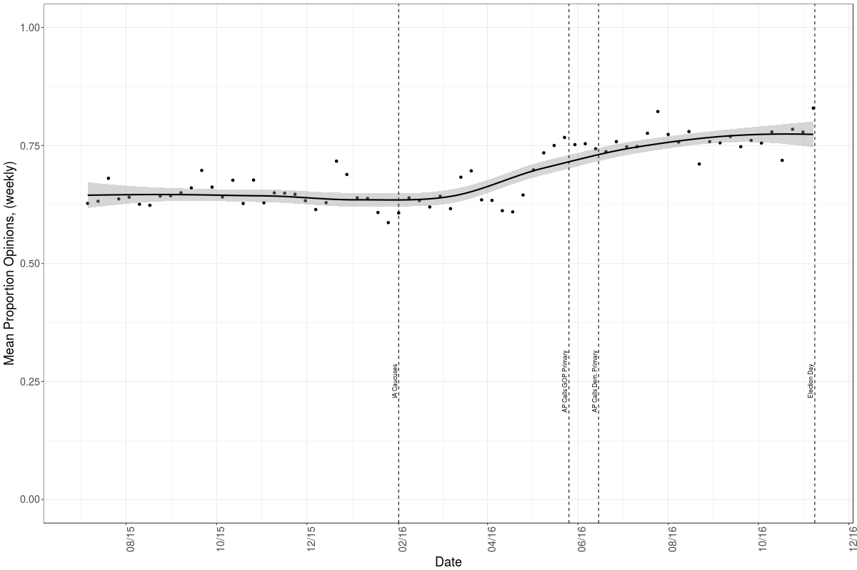

Note: This figure is based on classifications of 74,011 tweets from all major party candidates from July 1, 2015 through November 8, 2016. The gray bar indicates the 95% confidence interval around our estimate mean weekly rate of opinion versus fact tweeting.

The candidate-by-candidate opinion rates displayed in Figure 2 show that, while there are intriguing variations in the communication styles of different candidates, every one of them[13] tweeted more opinions than factual claims over the course of the campaign. It may come as little surprise that when Donald Trump was a candidate, 77% of his tweets set forth his opinions, with this rate falling only slightly to 72% as president. Yet Hillary Clinton slightly surpassed these rates, with 78% of her campaign tweets containing her opinions rather than factual claims. Jeb Bush, **Figure 2. Opinion vs. Fact across Candidates in the 2016 Presidential Campaign**

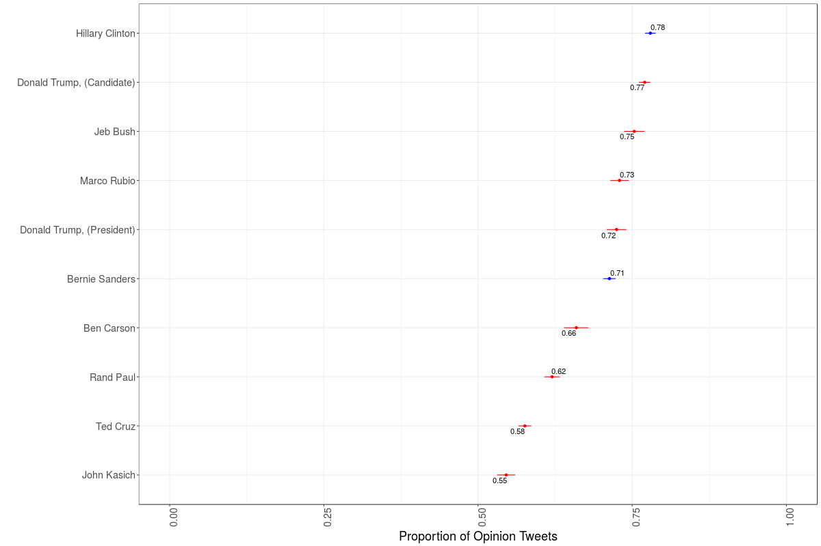

Note: This figure is based on classifications of 74,011 tweets from all major party candidates from July 1, 2015 through November 8, 2016, and on 2,765 tweets from President Trump from November 9, 2016 through March, 2018. The bars around each point represent the 95% confidence interval around our estimated rate of opinion versus fact tweeting for each candidate.

Marco Rubio, and Bernie Sanders all exceeded 70% opinions, and only John Kasich (56%) and Ted Cruz (58%) approached an even split of fact versus opinion. The descriptive analyses presented in Figures 1 and 2 provide clear and consistent evidence in favor of Hypothesis 1. Throughout the election season, in both parties, and for every candidate, those running for president in 2016 used Twitter to supply more opinions than facts, a trend that continues through the Trump presidency.

To explore how their social media audiences responded, we have a research design better equipped for causal inference. We can analyze how audience engagement varies for fact vs. opinion tweets within each candidate, holding constant the sentiment, ideology, and subject matter of each tweet and taking into account the different sizes of each candidate’s Twitter following. To test Hypothesis 2’s prediction that opinion will drive more engagement than factual claims, we look at the number of likes and retweets that each tweet garnered per thousand followers, measuring the audience size during the week each tweet was sent. Figure 3 compares the mean number of likes per thousand followers for opinion tweets (in blue) versus fact tweets (in red), for every delegate-winning candidate, without any statistical controls. In Tables 4 and 5, we report the results of full multivariate models to isolate the impact of opinions on engagement, all else equal.

Each approach tells the same story: Opinion tweets generate significantly more engagement than factual claims, revealing a stronger audience demand for subjective views than for objective facts. For all of our engagement analyses, we remove any tweet in which a candidate retweeted something from another account, because the retweet and likes figures for such messages reflect the engagement with the original tweets rather than the retweet sent by the candidate. Our data on engagement also begins just one year before the election, in November 2015, because this is what was available at the time we began this portion of the research. These constraints leave us with 33,829 campaign tweets and 2,765 presidential tweets with engagement data.

Even so, the differences in mean levels of engagement for fact and opinion tweets are significant at the 95% confidence level for six of the nine leading candidates. Bernie Sanders, the candidate who generated the most audience interaction, saw an average of 2.58 likes per thousand followers when he tweeted an opinion versus 1.90 when he tweeted a fact. For Donald Trump, the difference was 1.79 versus 1.32 likes per thousand followers. Ben Carson, John Kasich, Ted Cruz, and Rand Paul also saw significantly more engagement with their opinions. While this bivariate difference in means was not significant for Hillary Clinton, our multivariate models show that her opinions drove more engagement when we introduce a full set of controls. The substantive and human scale of these effects is substantial. Averaged across all candidates and all tweets, opinions get a boost of 0.328 likes per thousand followers. Based on the sizes of their audiences on Election Day, this would bring an expected increase of 4,270 likes for Donald Trump and 3,367 more likes for a Hillary Clinton tweet.

Table 4 presents the most rigorous test of Hypothesis 2 by presenting the results of a multivariate model with candidate fixed effects, estimating the impact of opinion versus fact while controlling for a tweet’s sentiment (positive or negative versus neutral), its implied ideology (liberal or conservative versus neutral), the policy area that it addresses, and what it asks the follower to do. Our standard errors are clustered by candidate to account for candidate-specific tweet patterns, and our dependent variable is the natural log of likes or retweets per thousand followers, to dampen the impact of outliers. Whether we look at likes or retweets, the verdict is the same. Opinions drive more engagement than facts, with this effect significant at the 99% confidence level. There are other consistent trends in what sorts of political tweets generate audience engagement. Negative tweets get more engagement than neutral ones, and positive tweets even less than that. Twitter followers find macroeconomics less stimulating than other policy area, responding most to tweets about civil rights or law and crime, and engage less with tweets that ask them to donate, to watch or

**Table 4: The Impact of Opinion on Engagement, all candidates**

|  |  |  |
| --- | --- | --- |
|  | Likes  (per 1,000 followers) | Retweets  (per 1,000 followers) |
| Is the Tweet an Opinion? | 0.17*** | 0.10*** |
|  | (0.02) | (0.03) |
| Sentiment is Positive | -0.07** | -0.12*** |
|  | (0.03) | (0.03) |
| Sentiment is Negative | 0.20*** | 0.23*** |
|  | (0.03) | (0.04) |
| Ideology is Liberal | 0.1 | 0.13 |
|  | (0.08) | (0.09) |
| Ideology is Conservative | -0.02 | 0.03 |
|  | (0.04) | (0.04) |
| Is the Tweet Political or Personal? | 0.09 | 0.21*** |
|  | (0.06) | (0.06) |
| Topic: Immigration | 0.02 | 0.04 |
|  | (0.04) | (0.04) |
| Topic: Macroeconomics | -0.13*** | -0.12*** |
|  | (0.03) | (0.04) |
| Topic: Defense | 0.07 | 0.11* |
|  | (0.06) | (0.05) |
| Topic: Law and Crime | 0.13** | 0.08* |
|  | (0.05) | (0.04) |
| Topic: Civil Rights | 0.26*** | 0.25*** |
|  | (0.05) | (0.06) |
| Topic: Environment | -0.02 | -0.04 |
|  | (0.07) | (0.06) |
| Topic: No Policy Content | 0.03 | -0.04 |
|  | (0.03) | (0.04) |
| Asks for a Donation? | -0.41*** | -0.28*** |
|  | (0.07) | (0.06) |
| Asks to Watch, Share, Or Follow? | -0.35*** | -0.26*** |
|  | (0.04) | (0.04) |
| Asks for Miscellaneous Action? | -0.19*** | -0.07** |
|  | (0.03) | (0.03) |
| Constant | -0.49*** | -1.10*** |
|  | (0.06) | (0.06) |
| Candidate Fixed Effects | *included* | *included* |
| Observations | 33,829 | 33,829 |
| R-squared | 0.06 | 0.07 |

*Notes: Table entries are linear regression coefficients, with robust standard errors clustered by candidate in parentheses. Dependent variable is logged.* *** p<0.01, ** p<0.05, * p<0.10.

**Table 5: The Impact of Opinion on Engagement, candidate by candidate**

|  |  |  |  |  |  |
| --- | --- | --- | --- | --- | --- |
|  | Donald Trump (Candidate) | Donald Trump (President) | Hillary Clinton | Bernie Sanders | Ted Cruz |
| Is the Tweet an Opinion? | 0.25*** | 0.06*** | 0.13*** | 0.19*** | 0.17*** |
|  | (0.02) | (0.02) | (0.02) | (0.04) | (0.04) |
| Sentiment is Positive | -0.06 | -0.07* | 0.04 | -0.05 | 0.06 |
|  | (0.05) | (0.03) | (0.03) | (0.04) | (0.06) |
| Sentiment is Negative | 0.08 | 0.09** | 0.15*** | 0.09** | 0.20*** |
|  | (0.05) | (0.04) | (0.03) | (0.04) | (0.07) |
| Ideology is Liberal | 0.20*** | -0.09* | -0.13*** | 0.01 | 0.07 |
|  | (0.04) | (0.05) | (0.02) | (0.03) | (0.07) |
| Ideology is Conservative | 0.05** | -0.05*** | -0.08** | -0.01 | -0.06 |
|  | (0.02) | (0.02) | (0.03) | (0.05) | (0.04) |
| Is the Tweet Political? | -0.05 | -0.01 | -0.35*** | -0.20 | 0.19*** |
|  | (0.05) | (0.04) | (0.05) | (0.13) | (0.07) |
| Topic: Immigration | -0.10 | 0.21*** | 0.06 | 0.03 | 0.26* |
|  | (0.08) | (0.06) | (0.07) | (0.10) | (0.13) |
| Topic: Macroeconomics | 0.03 | -0.01 | -0.09** | -0.12*** | 0.22*** |
|  | (0.06) | (0.03) | (0.04) | (0.04) | (0.08) |
| Topic: Defense | 0.17*** | 0.13*** | 0.04 | 0.42*** | -0.06 |
|  | (0.05) | (0.04) | (0.05) | (0.08) | (0.07) |
| Topic: Law and Crime | 0.28*** | 0.17* | 0.10* | 0.16 | 0.41** |
|  | (0.10) | (0.09) | (0.06) | (0.11) | (0.16) |
| Topic: Civil Rights | 0.02 | 0.38** | 0.30*** | 0.26*** | 0.04 |
|  | (0.14) | (0.19) | (0.05) | (0.09) | (0.14) |
| Topic: Environment | -0.84 | 0.10 | -0.09 | 0.02 |  |
|  | (0.60) | (0.16) | (0.10) | (0.08) |  |
| Topic: No Policy Content | -0.10*** | 0.06** | 0.14*** | 0.11*** | 0.21*** |
|  | (0.03) | (0.02) | (0.02) | (0.04) | (0.04) |
| Asks for a Donation? | 0.27 |  | -0.28*** | -0.44** | -0.19 |
|  | (0.60) |  | (0.09) | (0.22) | (0.23) |
| Asks to Watch, Share, etc.? | -0.21*** | -0.42*** | -0.26*** | -0.73*** | -0.28*** |
|  | (0.04) | (0.06) | (0.05) | (0.09) | (0.06) |
| Asks for Miscellaneous? | -0.15*** | -0.13* | -0.17*** | -0.33*** | -0.24*** |
|  | (0.04) | (0.07) | (0.04) | (0.05) | (0.05) |
| Constant | 0.28*** | 0.88*** | -0.32*** | 0.63*** | -0.60*** |
|  | (0.07) | (0.05) | (0.07) | (0.14) | (0.10) |
| Observations | 4,141 | 2,765 | 5,043 | 2,966 | 1,411 |
| R-squared | 0.08 | 0.06 | 0.07 | 0.07 | 0.08 |

*Notes: Table entries are linear regression coefficients, with standard errors in parentheses. Dependent variable is logged.* *** p<0.01, ** p<0.05, * p<0.10.

**Figure 3. Engagement with Fact vs. Opinion Tweets**

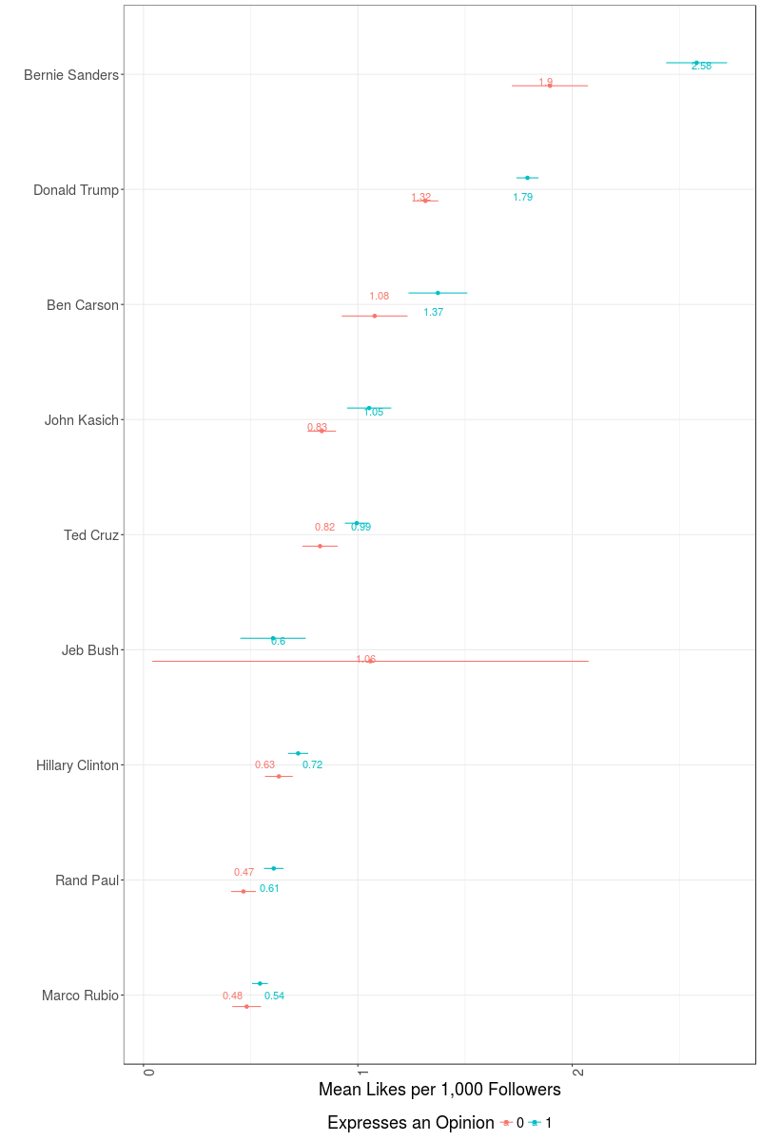

share a video, or to undertake some other action. Each of these is an intuitive finding, giving us greater confidence that our model reveals sensible systematic trends, but our top-line finding is strong support of Hypothesis 2’s prediction that opinion leads to engagement.

The candidate-by-candidate models presented in Table 5 show that this finding holds for Donald Trump, Hillary Clinton, Bernie Sanders, and Ted Cruz, the top competitors in the campaign, and continues to hold for Donald Trump as president. Opinions lead to more likes per thousand

followers for each of them, at the 99% confidence level. Some of the other tweet characteristics have consistent effects – negative tweets generate more engagement for nearly everyone, and no candidate’s audience likes to be asked to do anything – while other effects vary across candidates.

President Trump’s audience responds more to tweets about immigration, just as Ted Cruz’s followers did in the campaign, while Hillary Clinton and Bernie Sanders saw lots of engagement when they tweeted about civil rights but little when they addressed the economy. The impact of a tweet’s ideological content varies across candidates, unsurprisingly. Overall the clearest finding across all candidates is that opinion tweets consistently engage audiences better than factual claims.

Table 6 shows that opinions that contain negative sentiment are most engaging. The multivariate models of likes and retweets per thousand followers here are estimated in the same way as those reported in Table 4, except that its observations are only *opinion* tweets. This allows us to explore Hypothesis 3, which asks what types of opinions are most engaging to those who follow politicians on Twitter. All else equal, negative opinions drive more engagement than neutral ones, at the 99% confidence level. Positive opinions are less likely to be retweeted than neutral ones (at the 99% confidence level) and less likely to be liked (at the 90% level). This provides support for the logic, drawn from Abramowitz and Webster’s (2016) work on negative partisanship, that Americans increasingly define their politics by what they oppose. The raw data presented in Figure 4 shows that this preference for negative opinions holds for the audiences of every delegate-winning candidate. The red bars show mean likes per thousand followers for negative opinions, green bars display engagement with neutral opinions, and the blue bars are average likes for positive opinions. While the impacts in these smaller samples are not always statistically significant, engagement with negative opinions outpaces engagement with neutral or positive tweets for every candidate.

**Table 6: The Impact of Sentiment on Engagement, for opinion tweets**

|  |  |  |
| --- | --- | --- |
|  | Likes  (per 1,000 followers) | Retweets  (per 1,000 followers) |
| Sentiment is Positive | -0.08* | -0.12*** |
|  | (0.04) | (0.04) |
| Sentiment is Negative | 0.18*** | 0.21*** |
|  | (0.03) | (0.03) |
| Ideology is Liberal | 0.09 | 0.13 |
|  | (0.08) | (0.09) |
| Ideology is Conservative | -0.01 | 0.03 |
|  | (0.05) | (0.04) |
| Is the Tweet Political or Personal? | 0.10 | 0.22*** |
|  | (0.06) | (0.06) |
| Topic: Immigration | 0.04 | 0.04 |
|  | (0.04) | (0.05) |
| Topic: Macroeconomics | -0.16*** | -0.16*** |
|  | (0.03) | (0.04) |
| Topic: Defense | 0.08 | 0.10* |
|  | (0.06) | (0.06) |
| Topic: Law and Crime | 0.10* | 0.05 |
|  | (0.05) | (0.04) |
| Topic: Civil Rights | 0.27*** | 0.25*** |
|  | (0.06) | (0.07) |
| Topic: Environment | -0.02 | -0.04 |
|  | (0.06) | (0.06) |
| Topic: No Policy Content | 0.02 | -0.04 |
|  | (0.04) | (0.04) |
| Asks for a Donation? | -0.40*** | -0.28*** |
|  | (0.08) | (0.06) |
| Asks to Watch, Share, Or Follow? | -0.33*** | -0.22*** |
|  | (0.04) | (0.04) |
| Asks for Miscellaneous Action? | -0.18*** | -0.07** |
|  | (0.04) | (0.03) |
| Candidate Fixed Effects | *included* | *included* |
| Observations | 25,576 | 25,576 |
| R-squared | 0.05 | 0.06 |

*Notes: Table entries are linear regression coefficients, with robust standard errors clustered by candidate in parentheses. Dependent variable is logged.* *** p<0.01, ** p<0.05, * p<0.10.

**Figure 4. Engagement with Positive, Neutral, and Negative Opinion Tweets**

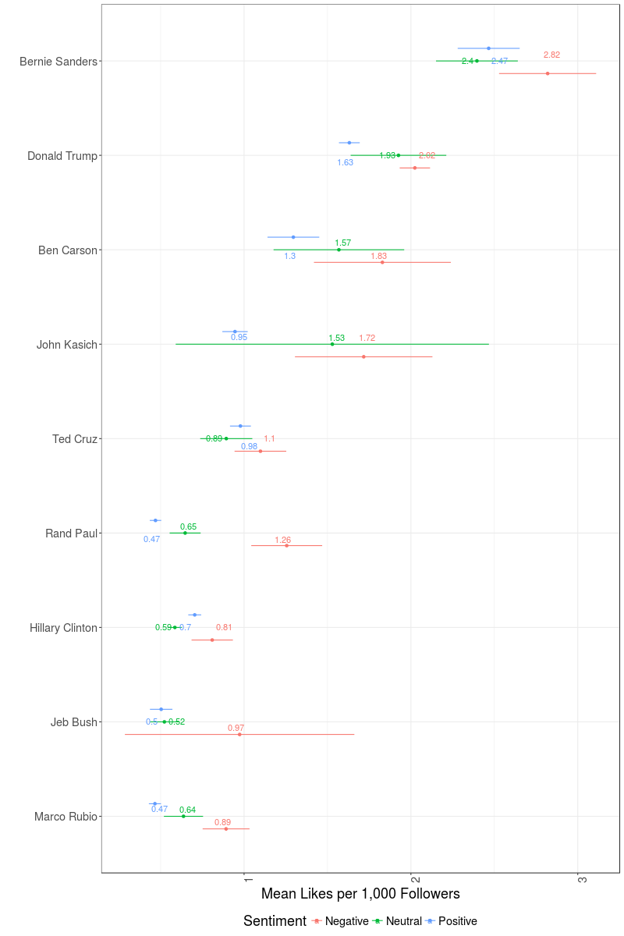

Finally, we investigate the feedback mechanism postulated in Hypothesis 4, the idea that candidates learn about audience demand for opinion over fact, either from reactions to their own tweets or from the examples of successful candidates. If this learning takes place, candidates should shift toward a greater share of opinion tweets over the course of a campaign. The plots in Figure 5

report the percentage of tweets that are opinions, rather than facts, at three distinct stages of the campaign: a. from the beginning our dataset on July 1, 2015 through to the day of the Iowa caucuses, February 1, 2016, b. during the primary season from Iowa through to the last major contests on June 7, 2016, and c. during the general election period, ending on November 8, 2016. We track Clinton and Trump’s tweets through all three periods, and other delegate winners from the pre-Iowa period into the primary season.

If Hypothesis 4’s feedback mechanism is at work, we would expect to see candidates increasingly tweet opinions in order to engage their social media audience. This test is not strongly identified for causal inference; candidates might change their communication strategies for other reasons over time, seeking to speak in different ways when their online audience expands or as the campaign progresses. For instance, Kreiss et al. (2018) find that candidates shift their messaging strategies and platform usage as Election Day approaches, which could account for the shifts in the rate of opinion that we observe. Still, we can look for evidence that is consistent with the pattern predicted by Hypothesis 4 to see whether or not we can rule out this mechanism.

The patterns displayed in Figure 5 are generally consistent with the idea that presidential candidates in 2016 learned that tweeting opinions was a more effective communication strategy. The first two plots show that Hillary Clinton and Donald Trump moved together in lockstep through the early campaign season, the primary, and the general election. Three quarters of their tweets were opinions in the early going, and then each increased that share to over 78% during the primaries (with each increase being statistically significant at the 99% confidence level). In the

**Figure 5. Shifts in the Opinion vs. Fact Balance over Time**

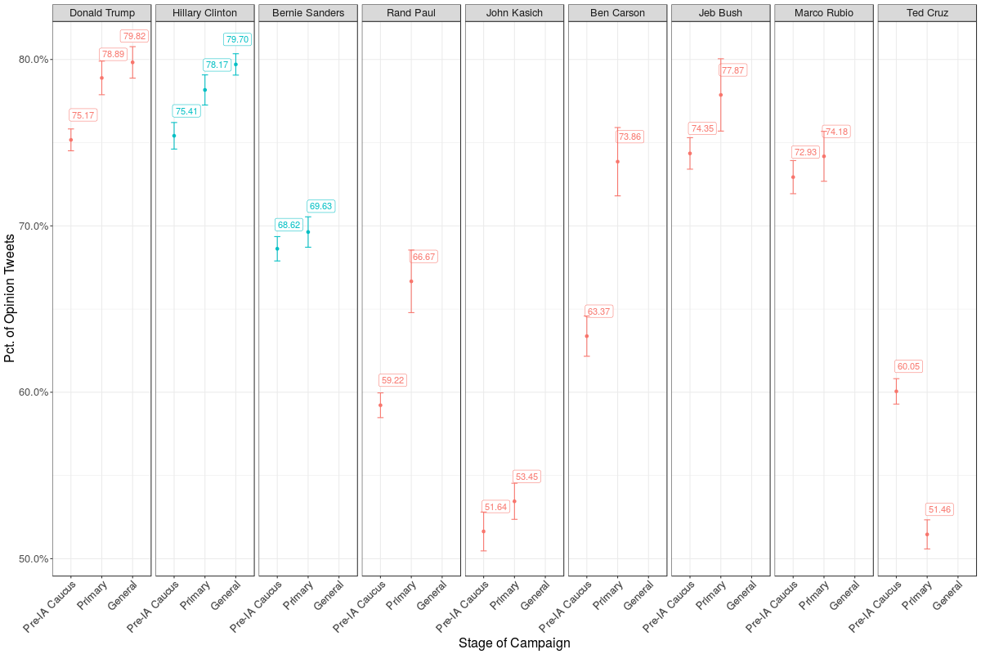

general election, Clinton and Trump further increased the percentage of opinion tweets by another percentage point, although these rises were not significant. It is also important to note that, in each period, the two eventual nominees led the field in the share of opinions that they tweeted, perhaps setting an example for trailing candidates to follow. All but one of these other contenders increased the share of his tweets that were opinions over the course of the campaign. From the pre-Iowa period to the primary season, Bernie Sanders, Rand Paul, John Kasich, Marco Rubio, Jeb Bush, and Ben Carson each increased his opinion tweeting rates, with Paul’s and Carson’s increases being significant at the 99% confidence level. Only Ted Cruz moved toward more facts. Overall, including Clinton and Trump, eight out of nine candidates shifted toward more opinions over the course of the campaign, with four of these eight shifts being statistically significant. This pattern is consistent with the idea that today’s politicians are learning, either from their followers or from their competitors, that using Twitter to convey their subjective worldviews rather than to lay out objective facts better meets the demands of their online audience.

*IV. Conclusion*

Our study finds that politicians, especially the most successful ones, primarily provide opinions. These are more likely than factual claims to engage the political audience and more likely to spread virally through retweeting. Candidates from both parties supply more opinions than facts, and online audiences on both sides of the aisle reveal their preference for opinion through their engagement. Negative opinions garner the most retweets and likes, while positive opinions earn the least. The feedback loop between candidate and their audiences suggest that, for better or worse, those who follow politicians on Twitter are getting what they demand: opinions.

We do not claim that our findings generalize to all campaign communications by candidates, or to the reactions of all voters. In fact, Bode et al.’s (2016) comparison between Twitter communications and campaign television advertisements shows they differ in their tone and content. The style of rhetoric that politicians deploy on social media may well be distinct from what they use in stump speeches and in television ads, and the people who chose to follow them online are likely looking to hear different things than the general public. Indeed, our theory is grounded in the idea that political discourse on Twitter is distinct from traditional civic discourse, driven by different incentives and desires. But its rising prominence in elections around the world and especially in the current American presidency (Conway et al. 2013, Stromer-Galley 2014, Kreiss 2016a, 2016b) makes it vital to understand how politicians use it, how their audience responds, and how this supply and demand interact to shape an increasingly prominent form of civic discourse.

Does the prevalence of opinion in campaign tweets raise or lower the level of this discourse? There are varying normative perspectives on this question. According to Arendt’s (2006, p. 239) work on the role of factual truth and opinion in politics, those who use opinions have an inherent advantage over those who use facts.  “[F]actual truth is no more self-evident than opinion,” and, what’s more, “the teller of factual truth is worse off than Plato’s philosopher – that his truth has no transcendent origin and possesses not even the relatively transcendent qualities of such political principles as freedom, justice, honor, and courage, all of which may inspire, and then become manifest in, human action.”

Opinion may inspire more human action, as our findings on audience engagement indicate. Yet the fact that opinions generate more engagement than factual claims does not guarantee that they improve the quality of politics. Stromer-Galley (2014, p. 2) argues that campaign use digital communication to interact with citizens only as means to serve their strategic ends, and that “presidential campaigns aim typically to circumvent interaction when it gives supports greater genuine participatory voice.”

An objection to the prevalence of opinion over factual claims in the digital political discourse is that it can deny citizens important information about facts and policies. In her book *Using Technology, Building Democracy: Digital Campaigning and the Construction of Citizenship*, Baldwin-Phillippi (2015, p. 102) has noted a “move away from policy,” in campaigns’ use of social media, where “messaging has moved away from providing information.” Importantly, even the factual claims that candidates make on Twitter are not necessarily true. We reviewed two prominent fact-checking sources, Politifact.com and the *Washington Post’s* fact-checking website, finding that a majority of the fact-checked tweets from both Donald Trump and Hillary Clinton were more misleading than true.[14]

While the Twitter feeds of presidential candidates are clearly not the place to turn for reliable factual information, this is unlikely to be the reason why their audience chooses to follow them. It is a taste for subjective worldviews, we argue, that drives people to follow politicians, and their patterns of engagement explored here bear that out. The public demands opinions more than facts on Twitter, which candidates are perfectly willing to supply.

**References**

Arendt, Hannah. 2006. Between Past and Future: Eight Exercises in Political Thought. Penguin.

Bakshy, Eytan, Solomon Messing, and Lada Adamic. “Exposure to ideologically diverse news and opinion on Facebook”. *Sciencexpress* (2015): 1-5.

Barbera, Pablo, John T. Jost, Jonathan Nagler, Joshua A. Tucker, and Richard Bonneau. 2015 "Tweeting from Left to Right: Is Online Political Communication More Than an Echo Chamber?" *Psychological Science* 25(10):1531-1542.

Barbera, Pablo. 2015. “Birds of the same feather tweet together: Bayesian ideal point estimation using twitter data.” *Political Analysis* 23(1): 76–91.

Baldwin-Phillippi, Jessica. 2015. *Using Technology, Building Democracy: Digital Campaigning and the Construction of Citizenship*. New York: Oxford University Press.

Barthel, Michael, and Elisa Shearer. "How do Americans use Twitter for news." *Fact Tank* 19 (2015).

Bhattacharya, Sanmitra, Yang Chao, Padmini Shrinivasan and Bob Boynton. 2015. “Perceptions of Presidential Candidates’ Personality in Twitter.” *Journal of the Association for Information Science and Technology*.

Bode, Leticia, David S. Lassen, Young Mie Kim, Dhavan V. Shah, Erika Franklin Fowler, Travis Ridout, and Michael Franz. 2016. “Coherent Campaigns? Campaign Broadcast and Social Messaging. *Online Information Review*, 40(5), 580-594.

Broersma, Marcel, Erik Tjong Kim Sang, Marc Esteve Del Valle, and Herbert Kruitbosch. 2017. “Active Learning for Classifying Political Tweets.” *Proceedings of the International Conference on Natural Language, Signal and Speech Processing* 110-114.

Bruns, Axel and Tim Highfield. 2013. “Political Networks on Twitter.” *Information, Communication and Society* 16(5):667-691.

Cohen, Jacob. 1960. “A Coefficient of Agreement for Nominal Scales,” *Educational and Psychological Measurement* 20(1):37–46.

Conover, M.D., J. Ratkiewicz, M. Francisco, B. Goncalves, A. Flammini, and F. Menczer. “Political Polarization on Twitter”. *Center for Complex Networks and Systems Research*., (2011): 89-96.

Conway, Bethany Anne, Kate Kenski, and Di Wang. 2013. "Twitter Use by Presidential Primary Candidates During the 2012 Campaign." *American Behavioral Scientist*57(11): 1596-610.

Cortes and Vapnik, [Cortes, C.](https://en.wikipedia.org/wiki/Corinna_Cortes); Vapnik, V. (1995). "Support-vector networks". [*Machine Learning*](https://en.wikipedia.org/wiki/Machine_Learning_(journal)) 20 (3): 273. [doi](https://en.wikipedia.org/wiki/Digital_object_identifier):[10.1007/BF00994018](https://dx.doi.org/10.1007%2FBF00994018)

Evans, Heather K. and Jennifer Hayes Clark. 2016. “‘You Tweet Like a Girl!’: How Female Candidates Campaign on Twitter.” *American Politics Research* 44(2): 326-352.

Evans, Heather K., Victoria Cordova, and Savannah Sipole. (2014) “Twitter-Style: An Analysis of How House Candidates Used Twitter in their 2012 Campaigns” *PS: Political Science and Politics* 47(2): 454-462.

Golbeck, Jennifer; Grimes, Justin M.; Rogers, Anthony. 2010. “Twitter Use by the U.S. Congress.” *Journal of the American Society for Information Science and Technology*, 61(8): 1612-1621.

Graham, Todd, Marcel Broersma, Karin Hazelhoff, and Guido van't Haar. 2013. "Between Broadcasting Political Messages and Interacting with Voters: The Use of Twitter During the 2010 UK General Election Campaign." *Information, Communication & Society*16(5): 692-716.

Graham, Todd, Dan Jackson, and Marcel Broersma. 2016. “New Platform, Old Habits? Candidates' Use of Twitter During the 2010 British and Dutch General Election Campaigns.” *New Media and Society* 18(5):765-783.

Grant, Will J, Brenda Moon, and Janie Busby Grant. 2010. "Digital Dialogue? Australian Politicians' Use of the Social Network Tool Twitter." *Australian Journal of Political Science* 45(4): 579-604.

Grimmer, Justin, and Brandon M. Stewart. 2013. “Text as Data: The Promise and Pitfalls of Automatic Content Analysis Methods for Political Texts.” *Political Analysis* 21(3):267-297.

Hallgren Kevin. A. 2012. “Computing Inter-Rater Reliability for Observational Data: An Overview and Tutorial.” *Tutorials in Quantitative Methods for Psychology*, *8*(1): 23–34.

Hand, David J. 2006. “Classifier Technology and the Illusion of Progress.” *Statistical Science* 21(1):1-15.

Hemsley, Jeff and Sam Jackson. 2018. “Political Issues that Spread: Understanding Retweet Behavior During the 2016 U.S. Presidential Election.” Proceedings of the 9th International Conference on Social Media and Society305-309.

Himelboim, Itai; McCreery, Stephen; Smith, Marc. 2013. “Birds of a Feather Tweet Together: Integrating Network and Content Analyses to Examine Cross-Ideology Exposure on Twitter”. Journal of Computer-Mediated Communication, January 2013, Vol. 18 (2):40-60.

Jerome Friedman, Trevor Hastie, Robert Tibshirani (2010). Regularization Paths for Generalized Linear Models via Coordinate Descent. Journal of Statistical Software, 33(1), 1-22.

King, Aaron S., Frank J. Orlando, and David B. Sparks. 2015. “Ideological Extremity and Success in Primary Elections: Drawing Inferences From the Twitter Network.” *Social Science Computer Review*.

Kreiss, Daniel. 2016a. *Prototype Politics: Technology-Intensive Campaigning and the Data of Democracy.* New York: Oxford University Press.

Kreiss, Daniel. 2016b. “Seizing the Moment: The Presidential Campaigns’ Use of Twitter During the 2012 Electoral Cycle.” *New Media and Society* 18(8):1472-1490.

Kreiss, Daniel, Regina G. Lawrence, and Shannon C. McGregor. 2018. “In Their Own Words: Political Practitioner Accounts of Candidates, Audiences, Affordances, Genres, and Timing in Strategic Social Media Use.” *Political Communication* 35(1): 8-31.

Kruikemeier, Sanne. 2014. “How Political Candidates Use Twitter and the Impact on Votes.” *Computers in Human Behavior* 34:131-139.

Landis, J. Richard and Koch, Gary G. 1977. “The Measurement of Observer Agreement for Categorical Data.” *Biometrics* 33:159-174.

Lee, Eun-Ju, and Soo Yun Shin. 2012."Are They Talking to Me? Cognitive and Affective Effects of Interactivity in Politicians' Twitter Communication." *Cyberpsychology, Behavior, and Social Networking*15(10): 515-20.

Lyons, Benjamin A, and Aaron S Veenstra. 2016."How (Not) to Talk on Twitter: Effects of Politicians' Tweets on Perceptions of the Twitter Environment."*Cyberpsychology, Behavior, and Social Networking*19(1): 8-15.

Mayhew, David R. 1974. *Congress: The Electoral Connection*. New Haven: Yale University Press.

Mcauliffe, Jon D., and David M. Blei. 2008. "Supervised Topic Models." In *Advances in Neural Information Processing Systems*, pp. 121-128.

McGregor, Shannon C, Regina G. Lawrence, and Arielle Cardona. 2016 “Personalization, Gender, and Social Media: Gubernatorial Candidates' Social Media Strategies.” *Information, Communication and Society* 20(2):264-283.

McGregor, Shannon C, Rachel R Mourão, and Logan Molyneux. 2017. "Twitter as a Tool for and Object of Political and Electoral Activity: Considering Electoral Context and Variance among Actors." *Journal of Information Technology & Politics* 14(2): 154–67.

Meeks, Lindsey. 2016. “Gendered Styles, Gendered Differences: Candidates' Use of Personalization and Interactivity on Twitter.” *Journal of Information Technology and Politics* 13(4):295-310.

Mejova, Yelena, Padmini Srinivasan, G. R. Boynton. 2013. “GOP Primary Season on Twitter: “Popular” Political Sentiment in Social Media. WSDM 2013 Proceedings, pp. 517-526.

[Metzger, Megan MacDuffee, Richard Bonneau, Jonatha Nagler, and Joshua A. Tucker. 2016. “Tweeting Identity? Ukrainian, Russian and #EuroMaidan.” *Journal of Comparative Economics*, 44(1): 16-40.](http://dx.doi.org/10.1016/j.jce.2015.12.004)

Murthy, Dhiraj. 2015. "Twitter and Elections: Are Tweets, Predictive, Reactive, or a Form of Buzz?". *Information, Communication & Society* 18(7): 816-31.

Obschonka, Martin, Christian Fisch, Ryan Boyd. 2017. “Using Digital Footprints in Entrepreneurship Research: A Twitter-Based Personality Analysis of Superstar Entrepreneurs and Managers.” *Journal of Business Venturing Insights* 8:13-23.

Peterson, Andrew, and Arthur Spirling. 2018. “Classification Accuracy as a Substantive Quantity of Interest: Measuring Polarization in Westminster Systems.” *Political Analysis* 26(1):120-128.

Pew Research Center. 2017. “Who Uses Facebook, Instagram, LinkedIn and Twitter?” January 11, 2017. Accessed at <http://www.pewinternet.org/chart/who-uses-facebook-instagram-linkedin-and-twitter/>.

Pew Research Center. 2019. “Sizing Up Twitter Users.” April 24, 2019. Accessed at https://www.pewinternet.org/2019/04/24/sizing-up-twitter-users/.

Poole, Keith T. 1998. "Changing Minds? Not in Congress!" In *Working Paper #1997-22*: Carnegie-Mellon University.

Rosenstiel, Tom, Jeff Sondermon, Kevin Locker, Maria Ivancin and Nina Kjarval. 2015. “Twitter and the News: How People Use the Social Network to Learn About the World.”  American Press Institute.

Schell, Leo M. “Distinguishing Fact from Opinion”. *Journal of Reading* 11, no.1 (1967): 5-9.

Stefanski, Leonard A. 2000. “Measurement Error Models.” *Journal of the American Statistical Association* *95*(452):1353-1358.

Steinert-Threlkeld, Zachary C. 2017. “Spontaneous Collective Action: Peripheral Mobilization During the Arab Spring.” *American Political Science Review* 111 (2), 379-403.

Stieglitz, Stefan, and Linh Dang-Xuan. 2012."Political Communication and Influence through Microblogging – An Empirical Analysis of Sentiment in Twitter Messages and Retweet Behavior." Paper presented at the 45th Hawaii International Conference on System Sciences.

Straus, Jacob R., Matthew Eric Glassman, Colleen J. Shogan, and Susan Navarro Smelcer. 2013. “Communicating in 140 Characters or Less: Congressional Adoption of Twitter in the 111th Congress.” *PS: Political Science & Politics,* 46 (1): 60-66.

## The Policy Agendas Project at the University of Texas at Austin. 2017. “The Comparative Agendas Project Master Codebook.” [www.comparativeagendas.net](https://mail.ucsd.edu/owa/redir.aspx?C=IFXaFwjAXo0tmL9MKoez2tmOQlqgLEJ3WugkhfyTSKY5lRD2xRHVCA..&URL=http%3A%2F%2Fwww.comparativeagendas.net). Accessed October, 2017.

Van Kessel, Stijn, and Remco Castelein. 2016. "Shifting the Blame. Populist Politicians’ Use of Twitter as a Tool of Opposition." *Journal of Contemporary European Research* 12(2): 594-614.

**Appendix 1. Codebook for Categorizing Tweets**

**GENERAL RULES**

Do not code according to the link

RT (retweet):

* Consider the strategy of the retweet, i.e., *why* was it retweeted?

*Logic: e.g., retweeted because the news/statement is in favor of the tweeter or helps attack a candidate*

* Code according to the person being quoted

*Logic: e.g., the news source is carrying out his/her speech*

“RT @kktv11news: @RandPaul on debt ceiling: I'm worried about bankrupting the America. Balance keeping government open and borrowing million” - *code as Rand Paul’s opinion*

Click through the accounts if you do not know/recognize them

Leave non-English tweets or tweets without any content as “NA” (all fields)

*E.g., RT @Karee_news: @ReigniteAmerica @CNM_Michael @tedcruz45 @WakeUpAmerica @bringUSback* <https://t.co/JQVxOUlX5y> - Leave all fields as “NA”

* Consider the news source, e.g., Huffington Post or Breitbart

**SENTIMENT (-1 Negative; 0 Neutral; 1 Positive)**

*Neutral is not “don’t know”

Hint: Imagine what the emotional state of the reader would be after reading the tweet.

“-1” Negative if:

* Sarcasm or mocking tone
* Pointing out someone is not doing something
* Defining oneself by putting specifically someone else down

“0” Neutral if:

* Saying someone attacked another person without expressing dis/approval
* Statements like: “We should/must [do something]...” without mentioning specific politicians or issues with a partisan divide

“1” Positive if:

* Asking for donations or asking you to “join the team” without referring to another politician or issue.
* “I’m about to [do this],” “I’m going to [do this]”
  + Only in regards to campaign events. E.g., show appearances.
* Candidate/PAC asking you to watch something/read something/check something out without any other reference to something else.
  + Does this w/o making negative reference to another candidate or topic.

**POLITICAL/NOT POLITICAL (0 Not Political; 1 Political)**

“0” Not political if:

* Mentions one’s own personal characteristic but does not relate to political values or policy preference

E.g., “I have a nice dog,” “I love it here in Iowa,” “I’m stuck in traffic.”

* Mentions another politician’s personal characteristics in a positive light. Normally, this is a candidate RT’ing another talking about his/her personal traits.
  + These are devoid of policy content.

“1” Political if:

* If the tweet associates a candidate with a politician
* If there is a slogan associated with a candidate (e.g., “feel the bern”)
* Mentions personal characteristic of a candidate that relates to political values or policy preference
* Referring to nondescript statements from a political reporter

**IDEOLOGY (-1 Liberal; 0 Neutral; 1 Conservative)**

*A liberal/conservative politician’s name mentioned does not make it liberal/conservative, it’s the totality of the message and the position taken

*If hanging out with a politician, the tweet is the ideology of the politician with whom hanging out with

* + Imagine a friend posted this on Facebook, what would you think his/her ideology is?

*“#GOPDebate” does not itself make the tweet conservative

“-1” Liberal if:

* Path to citizenship, immigration reform, community organizers, undocumented, assault weapon
* If it attacks GOP as a whole

“0” Neutral if:

* Apple pie issues
* Anyone (liberal/conservative) could have said it (e.g., anyone could be attacking Donald Trump)
* Cheering for things that everyone cheers for and attacking things that everyone dislikes
* Expansion of social security that only mentions disabled veterans but not seniors

“1” Conservative if:

* Amnesty, illegal, tax reform

**POLICY/TOPIC**

*One category per tweet ONLY

1. Immigration
2. National Security

Veterans, military, foreign terrorism, NSA/spying, non-trade foreign policy, refugee crisis

1. Macroeconomics

Taxes, spending, Wall Street, jobs, infrastructure (e.g., Flint), social security, labor unions, trade

1. Crime and Law Enforcement

Police, guns, 2nd amendment

1. Education
2. Civil Rights

Race, LGBT, abortion, gender

1. Healthcare

ACA, drug prices, Medicare/aid, state mandate

1. Environment

Energy resources, global warming, fracking, agriculture

1. Governance

Money in politics, term limits, redistricting and apportionment (not race-related), corruption

1. No Policy Content

Hillary’s email

If a tweet mentions 2+ topics:

1. Find what the majority of the tweet is discussing and code it as such

*E.g., “We don’t get strong national security by going deeper into debt” -* [Macroeconomics]

1. If it just mentions 2+ topics, (“Talking about immigration and ISIS on Bill O’Reilly”), flip a coin or use some kind of random assignment

**ASK (“1” if the condition applies, leave as “NA” otherwise)**

*The ask should be explicit

1. Asking for donation

* To give money or buy something to support the campaign

1. Asking you to watch/share/read/listen/follow to something

* Key words: tune in, check it out, watch, share, read, look, learn
* What does NOT count: “I will be on…,” “Now on CNN...” etc.

1. Miscellaneous ask

* Key words: Click, vote, submit (your question), join (Cruz Crew), sign up (for the newsletter), RT
* An ask within the hashtag counts, e.g., “#VoteTrumpNV”

**FACTUAL CLAIM OR OPINION**

*The two categories must be mutually exclusive, i.e., a tweet must fall into one or the other

*A factual claim could be false (but that does not make it an opinion)

*All questions should be coded as opinions.

1. Factual Claim

* The tweet makes some verifiable statement, it doesn’t necessarily have to be true, but some assertion of a fact must be made
* The claim can be verified as true or false
* The content is mostly verifiable, even if it has a non-factual description

Examples:

“Illegal immigrants cost our country millions each year.”

“Our healthcare system leaves too many Americans behind.”

“at capacity”

1. Opinion

* Cannot be verified as true or false, often times too abstract
* If it is mainly an ask for you to do something (e.g., “Watch…”)
* Contains value judgement (e.g., good, bad)
* Speculation about future events without clear reference to identifiable scientific source
* States a factual claim then comment on it
  + E.g., RT @cvpayne: .@tedcruz apologizes to @RealBenCarson<https://t.co/yBz0kV6jrp>

I think Ben will accept it...would you?

* Key words: good, bad, fun, dupe, strong

Examples:

“Obamacare has been a disaster.” (*Note, there is no specific claim, just an appraisal…*)

“Wonderful turnout today in NH!”

“Together we can make America great again!”

“Packed House”

**Appendix 2. Descriptive Statistics of Variables**

|  |  |  |  |
| --- | --- | --- | --- |
| **Variable** | **N** | **Mean** | **St.Dev.** |
| Is this Tweet an Opinion? | 106,850 | 0.640 | 0.480 |
| Sentiment is Positive | 106,850 | 0.655 | 0.475 |
| Sentiment is Negative | 106,850 | 0.242 | 0.428 |
| Ideology is Liberal | 106,850 | 0.249 | 0.432 |
| Ideology is Conservative | 106,850 | 0.527 | 0.499 |
| Is the Tweet Political or Personal? | 106,850 | 0.966 | 0.182 |
| Topic: Immigration | 106,850 | 0.026 | 0.160 |
| Topic: Macroeconomics | 106,850 | 0.066 | 0.249 |
| Topic: Defense | 106,850 | 0.072 | 0.259 |
| Topic: Law and Crime | 106,850 | 0.013 | 0.114 |
| Topic: Civil Rights | 106,850 | 0.013 | 0.115 |
| Topic: Environment | 106,850 | 0.016 | 0.124 |
| Topic: No Policy Content | 106,850 | 0.694 | 0.461 |
| Asks for a Donation? | 106,850 | 0.006 | 0.076 |
| Asks to Watch, Share, Or Follow? | 106,850 | 0.084 | 0.277 |
| Asks for Miscellaneous Action? | 106,850 | 0.066 | 0.249 |

1. For evidence of the ascendance of Twitter, see Mike Isaac and Sydney Ember, “For Election Day Influence, Twitter Ruled Social Media,” *New York Times*, November 8, 2016 or the observations of Dan Pfeiffer, Barack Obama’s former communications director, paraphrased as “future White Houses will spend their time figuring out how to connect with voters on social media,” in Joe Garofoli, “After Trump, Politics is All About Social Media,” *San Francisco Chronicle*, July 31, 2018.
2. There are two ways that people can engage on Twitter. The first is “liking” a tweet, which audience members typically do only if they approve of it and do not mind having others who follow them on Twitter seeing the original tweet. Second, they can retweet it, either because they like it and want their own followers to see it or because they simply want to start a discussion about it. In this paper, we are theorizing about engagement broadly, so all of our hypotheses point toward doing more of both behaviors. The empirical correlation between likes and retweets is 0.91 in our dataset.
3. Of course, it is not a certainty that politicians will supply what their audience demands: Hemsley and Jackson’s (2018) correlational analysis of 4,754 tweets sent by candidates in the final three months of 2016 presidential election finds a mismatch between the topics that candidates tweeted about and the topics that their audiences retweeted most often.
4. Lyons and Veenstra (2016) provide experimental evidence showing that respondents evaluate politicians more favorably when politicians post interactive tweets than when they broadcast their positions through one-way communication. Lee and Shin (2012) show in an experiment that when politicians have highly interactive Twitter accounts, certain types of respondents have more positive evaluations of the politician and report a stronger intention to vote for him.  Grant et al (2010, 579) show that Australian politicians “are attempting to use Twitter for political engagement, though some are more successful in this than others” and that “Those who use Twitter to converse appear to gain more political benefit from the platform than others.”
5. Specifically, Conover et al. (2011) show that the social networks of Twitter users who tweet about politics are polarized; they retweet the posts of users whose ideologies they agree with, and Bakshy et al. (2015) show that Facebook users choose to consume News Feed articles that fit with their ideological leanings.
6. Because we began coding tweets before the campaign ended, after drawing a random sample from our full set of tweets generated by June 2016, we drew additional random samples of tweets from the summer and fall of 2016 and then through June of 2017 for President Trump so that the distribution across time of the tweets in our hand-coded sample reflected the timing of the full corpus of tweets.
7. Because several of the topic areas created by the Policy Agendas Project -- agriculture, labor, energy, transportation, social welfare, housing, domestic commerce, technology, foreign trade, international affairs, public lands, culture – feature zero or very few tweets, we consolidated this handful of tweets into related topic areas.
8. For our key measure of fact versus opinion, the coders agreed 75% of the time. While imperfect, this is a relatively high score for a new and inherently subjective concept to measure. The kappa of 0.49, indicates a “moderate” level of agreement, according to Landis and Koch (1977, p. 165). Is this strong enough? According to Hallgren (2012, p. 6), “acceptable IRR estimates will vary depending on the study methods and the research question.” Importantly, we use the factual claim versus opinion categorization as an independent variable in our analyses. Any random measurement error in it will lead to attenuation bias in our models (Stefanski 2000), understating the true impact of opinion. The imperfect measurement of this concept, then, should make us more confident in our later findings about its impact on engagement.
9. We stemmed words so that words like “tax” and “taxes” would be read interchangeably, we made all words into lower case, we removed URLs, and we deleted the Twitter handles of candidates from the text of tweets to concentrate our analysis on the content that the tweets contained. We turned each tweet into a “term frequency-inverse document frequency” vector to highlight words that are used often in one tweet but rarely in others (see Colleoni, Rozza, and Arvidsson 2014 for a similar application to Twitter), and allowed words and phrases to enter into our analysis as unigrams, bigrams, and trigrams (one-, two-, or three-word phrases).
10. We used a standard set of text analysis algorithms, including linear support vector machines (which performed best for whether a tweet made a factual claim and whether it was political or not), multinomial negative binomial (which performed best for classifying sentiment), and the bagging classifier (which performed best for the remaining 14 variables).
11. We compiled data on follower counts from Trackalytics.com, an online repository of social media data, and from the Internet Archive’s “Wayback Machine.” We gathered likes and retweet data from Twitter’s API once a week, and thus our engagement numbers reflect the number of likes or retweets a tweet had during the week after it was tweeted.
12. Our analysis begins on July 1, 2016, two weeks after Donald Trump entered the campaign and solidified the field, and continues through Election Day, November 8th, 2016.
13. Indeed, this is true not only for the delegate-winning candidates whose rates we report here but for all of the candidates. The candidate with the smallest percentage of opinions among those others was Jim Gilmore at 56%*.*
14. Using Politifact.com and washingtonpost.com/news/fact-checker/, we identified all the tweets in our dataset from either Donald Trump or Hillary Clinton that had been subjected to this scrutiny. Of the 52 tweets that Politifact.com checked, four were coded as “True,” five as “Mostly True,” seven as “Half True,” and the remainder as “Mostly False” (14 tweets), “False” (13 tweets), or “Pants on Fire” (nine tweets). The *Washington Post* investigated two of Clinton’s tweets and 223 tweets from Trump during the campaign and his presidency. Each had one tweet categorized as completely true, with the rest earning an average of 2.05 Pinnochio noses. (on a scientific scale of zero to four noses, with zero – designated by Geppetto – indicating a true statement). This exercise indicates that our reported rates of “factual claims” strongly overstates the number of facts that each presidential candidate injected into online discourse through Twitter.