Super PAC Insurance: How Market-Based Campaign Finance Reform Would Look.

Nick Warshaw[1]and Stan Oklobdzija[2]

**Abstract:**

Since the Citizens United decision in 2010, super PACs have grown to dominate the American campaign finance landscape. With the ability to raise unlimited amounts of money, a super PAC can quickly dominate the airwaves during an election—dramatically altering an election and raising serious concerns for effective representation. To counteract super PAC spending, we propose an old business model, insurance, for a new market vertical, super PACs. An insurance model can protect insured candidates from Super PAC expenditures, reduce the influence of money and politics and produce a return for its investors--all with no investment of public funds and without changing any existing campaign finance laws or regulations. Our paper demonstrates not only the financially viability of super PAC insurance, but outlines the legal viability of such a proposal as well.   To determine the price of candidate premiums, we use Federal Elections Commission (FEC) data to produce a count model that predicts the approximate dollar level of super PAC spending in a candidate race based on a series of factors. Further, we demonstrate the feasibility of effectively predicting super PAC spending using an ensemble learning method. Being able to forecast which raises a super PAC will enter and approximately how much they will spend allows for the creation of sound premiums to guard against a market collapse. The results of our study speak not just to the business model of super PAC insurance, but to a new strategy in combatting the effects of money-in-politics.

## Private Sector Campaign Finance Reform

For the last few decades in American politics, the volume of political spending has crept slowly upward each election cycle. However, the 2010 Supreme Court decision, *Citizens United v. Federal Elections Commission* (FEC),supercharged this trend. After *Citizens United* outside spending, political expenditures made by groups other than the candidate or the political parties, skyrocketed 662 percent in U.S. House Elections and 1338 percent in U.S. Senate Elections (Hasen 2013). The Supreme Court has effectively shut down those interested in reducing the influence of money in politics from reforming campaign finance through the judiciary. Moreover, current congressional leaders are avowedly against passing a bill to reform the current campaign finance regime legislatively (Greenberg and Carroll 2015). As such, those interested in changing this campaign finance system must turn to alternate means of reducing the influence of money in politics. The private sector can and should provide an alternate method to deter super PACs from spending in elections. In 2012 a private ordering model dramatically reduced super PAC spending in the U.S Senate race in Massachusetts (Sitaraman 2014). Senator Elizabeth Warren and former Senator Scott Brown signed “The People’s Pledge.” Both candidates agreed if a super PAC supported their candidacy they would donate, from their campaign funds, 50% of the amount any super PAC spent on their behalf to a charity of their opponent’s choice (ibid). The Pledge worked. In 2012 outside spending accounted for 9 percent of total political expenditures in the Massachusetts Senate race. By contrast, in the highly competitive 2012 U.S. Senate races in Virginia, Wisconsin, and Ohio, outside spending accounted for 62 percent, 64 percent, and 47 percent of total spending, respectively (Creighton 2013). Crucially, the Pledge largely deterred major third-party groups like the League of Conservation voters on the left and American Crossroads on the right from spending in the race (ibid). Before the Pledge these groups spent millions, but they curtailed their spending once the Pledge went into effect (Sitaraman 2014). As Ganesh Sitaraman, a Vanderbilt Law Professor and one of the authors of the terms of the Pledge, articulated the Pledge demonstrated “private ordering, rather than public action,” can reduce the influence of super PACs on our political system (ibid). Despite widespread media attention on the Pledge, very few other candidates adopted the terms of the Pledge in their elections (ibid). Ultimately, this agreement requires mutual consent between two rival candidates. Invariably, one candidate believes super PAC spending will benefit their candidacy more than their opponent, and therefore they do not sign the pledge. A private ordering model, which does not require agreement between rival candidates, should be better suited to reduce the influence of super PACs on the electoral process. This article argues the creation of a new form of insurance, super PAC insurance, should deter super PACs from making expenditures. Super PAC insurance will provide a private ordering non-governmental solution to campaign finance reform. Just like with traditional insurance, candidates will purchase insurance policies from an insurance carrier. If and when a super PAC spends against an insured candidate, that will be considered an insurable event. An insurable event will trigger a payout on the policy up to two times the amount the insurance carrier predicts super PACs to spend against the insured candidate. Investors in this business will make a profit if the amount of money collected on premiums is greater than the amount paid out on claims and administrative costs (A.M. Best Company 2014). This framework should disincentivize outside spending by applying the model of “mutually assured destruction.” If super PACs know spending against insured candidates will trigger a barrage of attacks against their preferred candidates, they will be less likely to make expenditures at all. If super PAC insurance becomes widely adopted, it will ameliorate the influence of super PACs on our democracy. For this unconventional proposal to be viable, the insurance company must confidently predict its expected loss per customer. In the super PAC insurance market vertical, expected loss is a function of the likelihood that a super PAC will attack an insured candidate and or support their opponent. This paper will proceed in two primary parts. The first will address the business and legality of super PAC Insurance[3] and the second will demonstrate that super PAC spending is a predictable phenomenon.

## The Business and Legality of Super PAC Insurance:

Super PAC insurance affords candidates the ability to protect themselves against super PAC spending. The business model for super PAC insurance should be viewed in five distinct parts:

1. The insurer must first raise underwriting capital.
2. As will be addressed more extensively below, the insurer must next determine premium pricing for candidates.
3. The insurer must then define insurable events.
4. Once premium prices are determined, and the policies are written the insurer can go to the market and begin selling policies to candidates.
5. Finally, if and when an insurable event occurs, the insurer will make payouts on candidate’s policies.

First, all insurers need sufficient underwriting capital to backstop their policies. Super PACs will be deterred from spending against insured candidates if insurers can credibly payout on their policies. Therefore, an insurer in the super PAC market must first fully underwrite the business. Super PAC insurance will likely attract investment from investors interested in reducing the influence of money in politics and making a return on their investment. By aligning themselves with super PAC Insurance, these investors will make a profound statement: they are interested in investing in a new private venture to reform democracy.

The super PAC market is clearly ready for this type of investment. Many millions of dollars are currently donated to political reform groups like Common Cause, Public Citizen, and the Brennan Center for Justice (Tau and Vogel 2014).In 2012, wealthy individuals like Peter Thiel and Reid Hoffman gave millions to MAYDAY PAC, a super PAC created to reform campaign finance (Schatz 2014). These efforts have unfortunately been largely unsuccessful at reducing the influence of super PACs. Moreover, these donations are not tax deductible nor will investors ever see a financial return on their investment.

By investing in super PAC Insurance, donors become investors in the same cause of campaign finance reform. These investors previously suffered a certain loss; with super PAC insurance they can change democracy and make a return on their investment.

Next, all insurers must predict how much they expect to lose per customer. In the super PAC market, a candidates’ risk is based on how likely it is a super PAC will spend money attacking their candidacy and or in support of their opponent. An insurer must predict how much money is likely to be spent against an insured candidate. Candidates who are more likely to have a larger amount of money spent against them will be charged proportionally larger premiums. Candidates wanting additional insurance coverage will also pay more in premium costs.

Our analysis assumes super PACs want to influence the electoral outcomes of the races they spend money in. Super PACs ability to raise money in the next election cycle is tied to their previous success or failure. As such, super PACs covet being the margin of victory in a given race. The model assumes super PACs will be less likely to spend money in races where they do not believe they can influence the outcome of the race.

As will be documented below, super PAC spending can be predicted. As a result, reasonable premiums can be calculated. Premiums can be calculated with the following formula adopted from Kunreuther et al. (2013, 47):

***Premium = Expected Loss/(1-Premium Loading Factor)***

The loading factor is comprised of administrative, marketing and sales costs, which typically ranges from 30-40%. Further, iterations of this paper will create individualized premium estimates for each member of Congress.

The insurer should collect premiums from all Republican or Democratic Congressional candidates who won their primary election. The insurer should remain strictly non-partisan. This is important both from a business model and branding perspective. A company offering super PAC insurance would create an open enrollment period for candidates to purchase their policies. Insurance companies often have open enrollment periods to control risk (Roumell 2014). Political candidates should have a set time frame to obtain coverage after which they will not be able to purchase a policy. This is to prevent the type of extreme adverse selection in which candidates being bombarded with super PAC advertising would select into the market while others in races which super PACs didn’t enter would stay out. A political expenditure will be considered an insurable event if 1) money is spent by a super PAC2) the FEC classifies the spending as an “independent expenditure” [4] or an “electioneering communication,”[5] and 3) the aggregated amount spent is reported to the FEC. Candidates should find the linkage between claims and FEC regulations attractive; there are clearly defined and verifiable standards for claims. Furthermore, tying insurable events to FEC spending that must be disclosed within 24-48 hours ensures the insurance entity can verify and payout on insurance claims quickly. The final requirements for insurable events are that the political expenditure is legally required to be reported to the FEC and the super PAC complied with regulations and disclosed the expenditure to the FEC. Political committees, including super PACs,that report independent expenditures or electioneering communications aggregating over $10,000 in a calendar year for a specific election must report these expenditures within 48-hours.[6] Within twenty days of a federal election, committees spending over $1,000 must disclose their expenditures within 24 hours to the FEC.[7] If the super PAC meets all of the aforementioned criteria and it complies with federal regulations by disclosing the expenditure to the FEC, the political expenditure will be considered an insurable event. When an insurable event occurs, the insurance carrier will remit a policy payout to the candidate. The amount that is paid out will be based on the policy the candidate purchased. A baseline policy will provide candidates with two times the amount of money the insurance carrier believed super PACs would spend against the insured candidate. If an insurer expects super PACs to spend $50,000 against a candidate, it will pay a candidate up to $100,000. This $2:00:1:00 payout ratio is based on the success of the People’s Pledge. The Pledge deterred the vast majority of super PAC spending in Massachusetts with a $.50: 1.00 ratio (Creighton 2013). If fifty cents on the dollar can deter super PAC spending a $2:00:1.00 ratio should be able to deter even more super PAC spending than the People’s Pledge. Crucially this $2:00:1:00 payout to a candidate is an even larger figure when viewed in super PAC dollars. Because of Federal Communications Commission (FCC) regulations, a dollar that is controlled by a candidate is more valuable than one controlled by a super PAC (Goldmacher 2015). The FCC mandates that candidates be afforded the “lowest unit charge” from television stations (ibid). Candidates are provided the same discount that television stations give to a commercial advertiser who purchases television advertising in bulk. In contrast, television stations have complete latitude to charge super PACs for advertising.[8] This discrepancy makes a material difference in money super PACs spend on advertising versus candidates per commercial (Yeagar 2015). Estimates of the average difference between the amounts of money spent range from 40% to 100% (see Moshary 2014; Yeagar 2015). The lowest unit charge mandate by the FCC makes super PAC insurance even more attractive to candidates. If an insured candidate is attacked by a super PAC, the insurer will payout up to $2.00:1:00. Because of the FCC mandate, this payout is effectively a $2.80-4.00:1.00 payout (Moshary 2014). This massive discrepancy of money spent by super PACs should discourage them from spending against insured candidates. The salient election law issue for super PAC insurance is whether the FEC considers this insurance payout a service or a contribution. The FEC draws a sharp distinction between contributions and services.[9] Corporations are banned from making contributions to federal candidates’ campaign committees. [10] The FEC would likely treat the payout on an insurance policy to be a permitted service, not an impermissible contribution. Candidates may expend campaign funds to procure services for their campaigns. Such services range from direct mail, political consulting, and liability insurance. The FEC defines contributions as “any direct or indirect payment, distribution, loan, advance, deposit, or gift of money, or any services, or anything of value.”[11] When the FEC previously provided guidance on the legality of new business models their answer was based on if the candidate paid the “usual and normal charge” for a service.[12] A charge is usual and normal if the cost is set “at a commercially reasonable rate.”[13] Previous FEC advisory opinions suggest super PAC insurance would be considered a permissible service. The FEC allowed the National Conservative Political Action Committee (NCPAC) to obtain a key person insurance policy[14] on their Chairman’s life. [15] If their Chairman died, NCPAC would receive payment from their insurance carrier.[16] The FEC concluded that such a payout “would not be viewed as a contribution to NCPAC from the insurer.” Moreover, the committee could use “proceeds from the policy… for any lawful purpose.”[17] The FEC stated such a policy is legal so long as the insurer provided the policy at a rate based on market factors.[18] Super PAC insurance would largely mimic the structure of the NCPAC policy. Premium pricing would be based on business factors, not political ones. The insurer would not favor one party or candidate over another. It would not provide discounts based on political preference. Furthermore, super PAC Insurance likely would be treated as a new form of insurance coverage that campaigns currently buy. Campaigns already purchase liability insurance.[19] As such, the FEC will likely treat a payout from a super PAC insurance carrier to a candidate as a legally permitted service and not a donation.

## Predicting super PAC spending in Congressional Races:

As previously discussed, of paramount importance to crafting an insurance market is the ability of insurers to reasonably forecast the risk a customer has of incurring a payable event. Knowing how likely a customer is to trigger a payout allows an insurer to not just to calculate a proper premium for coverage, but ensures the integrity of the market. Further complicating the insurance transaction is the problem of asymmetric information. That a purchaser of insurance inherently knows more about their likelihood of needing coverage and thus will strategically purchase when their risk-level is highest (see Akerlof 1970; Rothschild and Stiglitz 1976). Though several studies have come to differing empirical conclusions about the extents to which asymmetric information affects an insurance market (e.g. Chiappori and Salanie 2000; Cardon and Hendel 2001; Finkelstein and Poterba 2004), our insurance market may be one of the few where the insurer possesses better information about the risk of an insurable event than the customer. We begin with our model for super PAC spending in House and Senate elections. Like car accidents, home fires or residential burglaries, the entrance of a super PAC into a Congressional race is both a rare and costly event.

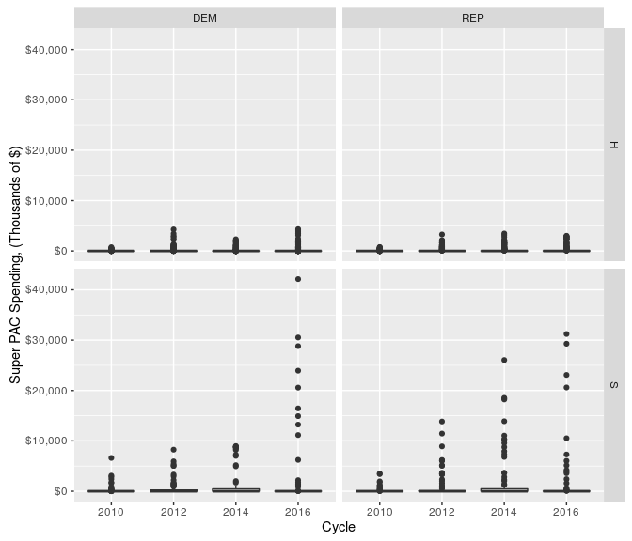

*Super PAC Spending in Congressional Races: 2010-2016 Source: Authors Calculations, Data from the FEC* Though a significant majority of Congressional elections had no super PAC spending at all, the immensity of their spending in certain races has pushed the average spend across all races up further and further since the inception of the super PAC following *Citizens United*. While the hypothetical average super PAC expenditure in 2010 House race stood at $26,891.92, by 2016 that number climbed to $172,165.1. As the amount of money injected into American politics by outside spending groups grows, the price of being caught unprepared has increased precipitously with every passing election. Predicting how much an unfriendly super PAC will spend either supporting one's opponent or attacking a Congressional candidate has largely been a matter of guesswork for campaigns. Campaign managers typically use past super PAC spending against a candidate or against similar candidates as a barometer for how much to can expect in adversarial super PAC spending. For instance, one former senior official in a targeted 2016 Senate race described the uncertainty involved in a campaign’s calculation of how much money to set aside to defend against the incursion of a super PAC into their race. “In my experience working on Congressional, Senatorial, and Presidential campaigns, anticipating Super PAC spending in any particular race is extremely difficult. Our assessments are based partly on historical precedent - looking at Super PAC spending in previous election cycles with similar race dynamics - but more than anything our decisions are made on gut feeling,” said Brad Elkins, former Deputy Campaign Manager for former Missouri Secretary of State and Candidate for U.S. Senate Jason Kander (Author interview). A high ranking Republican strategist concurred with this sentiment. “When you are in the heat of a campaign, Super PAC spending feels a bit like hurricane season in a coastal town. You know some big Super PACs are developing “out there” but you’re not sure if your campaign will be hit by one or how heavy the financial downpour will be or whether a gale force wind will knock you out, said Mike Shannon, strategist and director of media buying for President George W. Bush’s 2004 reelection campaign. This non-empirical ad-hoc method may overlook several important predictors that might more accurately forecast the magnitude of super PAC spending against a candidate. For our analysis, we employ a random forest regression technique to model adversarial super PAC spending. The random forest model has several advantages over more traditional count models. First, using a Poisson distribution to model campaign finance data does not allow for overdispersion (see Blackwell 2017 for an innovative solution to this challenge). Further, although both Poisson and negative binomial distributions censor values below zero, both count models also model a more or less even distribution of observations around some mean value (see King 1998). As the following figure suggests, this is not representative of the population distribution when trying to model super PAC spending. A full 67.11 percent of Congressional candidates between 2010 and 2016 had no super PAC spending against them with extremely large spends in some races pulling up the overall average.

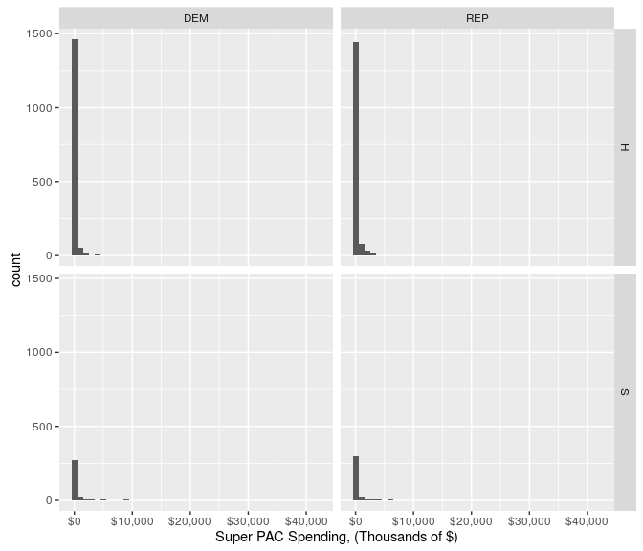

*Distribution of Super PAC Spending in Congressional Races: 2010-2016 Source: Authors Calculations, Data from the FEC*

Besides the extreme zero-inflation of our data, the random forest model is also advantaged over traditional MLE models in that more data can be added to the model to gain accuracy without subsequent penalties for overtraining (see Ho 1995). Building from the decision trees framework from which the model was developed, increasing the number of decision trees at each classification node leads to convergence while at the same time being "robust to outliers and noise" (Breiman 2001). Key for our purposes here is that random forests allow for non-linear relationships and complex interactions, a facet that has been exploited already in other areas of political science research such as civil conflict (see Hill and Jones 2014). First, we define "oppositional super PAC spending" as any super PAC expenditure that targets a Candidatex or supports that candidate's opponent in a given Racey. This data comes from the Federal Elections Commission data on Congressional elections. It's important to note that due to gaps in FEC regulations candidates may be attacked by advertisements that are not disclosed to the FEC. For example, this data doesn't contain communication that would otherwise be considered an Electioneering Communications but if it is made outside of the FEC's 60-day general election window or 30-day primary election window in which all expenditures must be reported to the federal oversight body. Thus, the portion of super PAC spending we study in this article is a fraction of the total spending in a given race. Though a complete dataset would be available from the Wesleyan Media Project[20], data from the 2016 election is embargoed until 2020. Future iterations of this study will replicate the full universe of super PAC spending. Using the randomForest package for the R statistical processing language (Liaw and Wiener 2002), we model oppositional super PAC spending at the candidate level as a function of the following variables:

1. A dummy variable indicating whether the candidate is a Republican.
2. A dummy variable indicating whether the candidate is running for the U.S. Senate.
3. A dummy variable indicating whether the candidate is an incumbent seeking reelection.
4. A dummy variable indicating whether the candidate is male.
5. The number of television households in the largest media market, (Nielsen DMA), in a candidate's district[21].
6. The percent of the vote-share won by Barack Obama in the previous presidential election in a given state/Congressional District.
7. The amount of oppositional super PAC spending against a candidate in their previous Congressional race.
8. The number of unique donors in the candidate's previous Congressional race.

For this model, we run the model with 500 trees, though the error rate stabilizes at about 200 trees. As the following figure indicates, removal of the dummy variable indicating Senate grew the mean-squared-error by over 15 percent, (as noted in the left plot.) Also important were the measurement of how many unique givers a candidate raised money from in a previous cycle, the percent of the vote obtained by Barack Obama in the previous election and the variable measuring the size of the largest media market. Interestingly the preferred model of campaigns currently, knowing how much opposition from super PACs a candidate faced in a previous election was not the best predictor of how much they would receive in the current one.

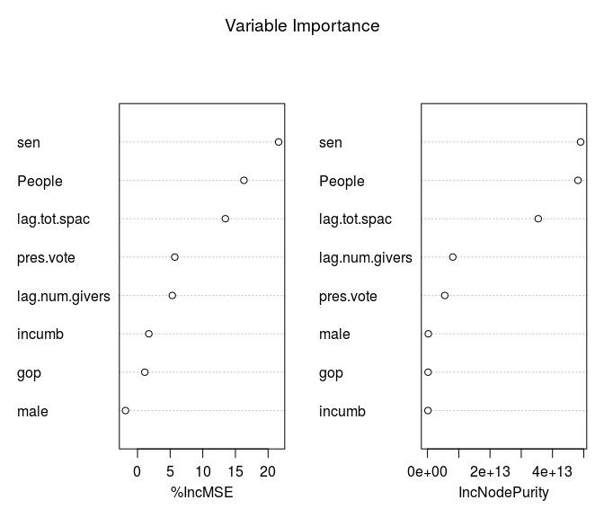

*Variable Importance Plots from Random Forest Model of super PAC spending* As the below figure demonstrates, the random forest model accurately predicted the vast majority of races having zero super PAC spending in them. However, the model misses several large outlier races in which super PAC spending totaled over $10 million. Overall, the mean difference from the prediction model's estimate of super PAC spending in a race vs. the actual amount of spending was a mere $1,547, though the maximum error was about $26.2 million. On aggregate, the difference in pay-outs vs. income from the insurance market was about $4.2 million.

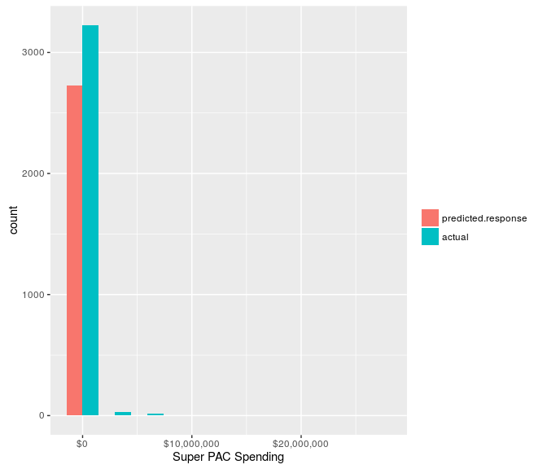.

*Predicted super PAC spending vs. Actual super PAC spending: 2010-2016*

Using two differing sets of training data, we can show both the efficacy of our prediction model and the inherent fallibility of attempting to model complex real-world phenomena with even the most sophisticated of algorithms. First, using data from 2010-2014, we attempt to predict super PAC spending in Congressional races during the 2016 election. This unsupervised learning method uses 94.24 percent of the data to predict the remaining 189 observations[22]. In this iteration of the random forest model, we remove the variable for a total number of unique givers in the past election due to missingness in the 2016 data.Using past cycle to predict the preliminary data from 2016, we find a mean error of about $436,000 which is again influenced by large outliers, (one of about $26 million in predicting the super PAC spending against Nev. Sen. Catherine Cortez Masto.) We suspect our results may improve upon release of the full dataset, though we remain agnostic at the moment. In total, this version of the model underpredicted super PAC spending by about $82 million. Subsetting based on a typical 80 percent training set to test against a 20 percent validation set yields more promising results. In this version of the model, though we have less training data, selecting across years gives us a mean error of just about $10,000 and a maximum error of about $16 million. This is to be expected as eliminating the heterogeneity across cycles allows for a more accurate prediction, even though the utility of such predictions for our purposes is somewhat less. However, due to the aberrant nature of the 2016 presidential race, super PAC behavior was markedly different in that cycle as opposed to previous cycles. Future cycles are likely to return to a similar pattern as those of 2012 and 2014. Using this approach, our model predicted super PAC spending much more accurately, with a combined error of just $ 6 million of predicted values under actual values.While this figure may seem daunting, there is a key advantage in insuring against super PAC spending that makes our insurance market less price sensitive than a traditional insurance market. As discussed previously, the ability of candidates to purchase airtime at a deep discount magnifies the purchasing power of their dollars versus those of a super PAC. So while the model may underpredict super PAC spending, the acceptable margin of error is much wider given that a candidate dollar buys twice as much airtime as that of a super PAC. Moreover, given the success of the Pledge we expect super PACs to be deterred from spending against an insured candidate. An insured candidate can signal to a super PAC that they have a mechanism to defend themselves against a Super PAC expenditure. This should deter super PACs from entering the race at all. Unlike most forms of insurance we expect the purchasing of insurance to change the number of insurable events.

**Conclusion:**  In the wake of the Watergate Scandal, Congress passed its first modern limits on the financing of campaigns. In the ensuing forty years the Supreme Court has repeatedly struck down Congresses’ repeated attempts to regulate money and politics (*Buckley v. Valeo, Citizens United v. FEC, McCutcheon v. FEC* ). The current Court’s broad interpretation of the First Amendment makes it extremely unlikely this trend will reverse anytime soon. Therefore those interested in reform must turn to alternate means of reducing the influence of money on campaigns. As previously demonstrated private ordering solutions successfully deterred super PACs from entering a pivotal Senate race in Massachusetts. This paper contends for private ordering solutions to become widespread a model must be produced which candidates can unilaterally elect to invest in deterring super PAC spending. Super PAC insurance meets this need for a unilateral private ordering model. The insurance business model should attract private investment and effectively deter super PAC spending. For the super PAC insurance business model to be viable an insurance carrier must be able to predict its expected loss per candidate with confidence. The forecasting methodolofy described in this paper demonstrate that super PAC spending is a predictable phenomena. Our methodology significantly improves upon campaigns current ad-hoc guesswork methodology. The prediction of expected loss will be the basis for an insurance carrier to set its premiums for candidates. After studying super PAC behavior, we conclude that a super PAC insurance carrier could not only deter super PAC spending for its insured customers but also make a profit.

## References:

A.M. Best Company. 2014. “Understanding the Insurance Industry.”

Akerlof, George A. 1970. “The Market for‘ Lemons’: Quality Uncertainty and the Market Mechanism.” *The Quarterly Journal of Economics*. JSTOR, 488–500.

Blackwell, Matthew. 2017. “Game Changers: Detecting Shifts in Overdispersed Count Data.”

Breiman, Leo. 2001. “Random Forests.” *Machine Learning* 45 (1). Springer: 5–32.

Cardon, James H, and Igal Hendel. 2001. “Asymmetric Information in Health Insurance: Evidence from the National Medical Expenditure Survey.” *RAND Journal of Economics*. JSTOR, 408–27.

Chiappori, Pierre-André, and Bernard Salanie. 2000. “Testing for Asymmetric Information in Insurance Markets.” *Journal of Political Economy* 108 (1). The University of Chicago Press: 56–78.

Creighton, Tyler. 2013. “Common Cause Ma., A Plea for a Pledge 4”, http://www.commoncause.org/research-reports/MA_050113_Report_Plea_for_a_Pledge.pdf.

Finkelstein, Amy, and James Poterba. 2004. “Adverse Selection in Insurance Markets: Policyholder Evidence from the UK Annuity Market.” *Journal of Political Economy* 112 (1). The University of Chicago Press: 183–208.

Goldmacher, Shane. *Jeb Bush loses TV ad edge to Marco Rubio,* Politico (Nov. 17, 2015), <http://www.politico.com/story/2015/11/marco-rubio-jeb-bush-super-pac-215962>

Greenberg, John, and Lauren Carroll. 2015. "Fact-checking John Boehner's Claim That Americans Spend More on Antacids than Politics." Tampa Bay Times. May 3, 2015. Accessed May 9, 2015. http://www.tampabay.com/news/politics/fact-checking-john-boehners-claim-that-americans-spend-more-on-antacids/2228124.

Hasen, Richard. 2013. "Three Wrong Progressive Approaches (And One Right One) to Campaign Finance Reform." Harvard Law and Policy Review 8, no. 1. http://papers.ssrn.com/sol3/papers.cfm?abstract_id=2293979.

Hill, Daniel W, and Zachary M Jones. 2014. “An Empirical Evaluation of Explanations for State Repression.” *American Political Science Review* 108 (03). Cambridge Univ Press: 661–87.

Ho, Tin Kam. 1995. “Random Decision Forests.” In *Document Analysis and Recognition, 1995., Proceedings of the Third International Conference on*, 1:278–82. IEEE.

Jefferson, Scott. 2014. *Six Reasons Every Political Campaign Should Have Insurance*, Clarke Sampson Blog. <http://www.clarkeandsampson.com/blog/six-reasons-every-political-campaign-should-have-insurance>;

King, Gary. 1998. *Unifying Political Methodology: The Likelihood Theory of Statistical Inference*. University of Michigan Press.

Kunreuther, H.C., Pauly, M.V. and McMorrow, S., 2013. *Insurance and behavioral economics: improving decisions in the most misunderstood industry*. Cambridge University Press.

Liaw, Andy, and Matthew Wiener. 2002. “Classification and Regression by RandomForest.” *R News* 2 (3): 18–22.

Moshary, S., 2014. Price discrimination across pacs and the consequences of political advertising regulation. *mimeographed, MIT*.

Rothschild, Michael, and Joseph Stiglitz. 1976. “Equilibrium in Competitive Insurance Markets: An Essay on the Economics of Imperfect Information.” *The Quarterly Journal of Economics*. JSTOR, 629–49.

Roumell, Nina. 2014. *Why There’s an Open Enrollment Period for Health Insurance?,* Colorado Consumer Health Initiative,

<http://cohealthinitiative.org/blog/2014-04-16/why-theres-open-enrollment-period-health-insurance>.

Schatz, Amy. 2014. *Techie-Funded Mayday super PAC Releases Donor Information*,re/code <http://recode.net/2014/08/06/techie-funded-mayday-super-PAC-releases-donor-information>.

Sitaraman, Ganesh. 2014 *Contracting Around* Citizens United, 114 Colum. L. Rev. 755, 763 n.38.

Tau, Byron and Vogel, Kenneth P. 2014. *How to Waste $10 Million*,Politico. http://www.politico.com/story/2014/11/2014-elections-mayday-PAC -larry-lessig-112617.html

Yeager, Melissa. 2015. *The High Cost of Television Ads for super PACs,* Sunlight Foundation, https://sunlightfoundation.com/blog/2015/12/22/the-high-cost-of-television-ads-for-super-pac/

1. Juris Doctor, UCLA School of Law. Email: warshaw2016@lawnet.ucla.edu
2. PhD Candidate, Department of Political Science. The University of California, San Diego. Email: [stano@ucsd.edu](mailto:stano@ucsd.edu)
3. For a more extensive discussion on the legality of Super PAC Insurance please see: Nick Warshaw, “Forget Congress: Reforming Campaign Finance Through Mutually Assured Destruction,” 63 UCLA L. Rev. 207, 262.
4. 11 C.F.R. § 100.16 (2015).
5. *Id.* § 100.29.
6. 11 C.F.R.§§ 104.4(b)(2),104.4(f) (2015).
7. *Id.* § 104.20(b).
8. *http://www.broadcastlawblog.com/2012/09/articles/political-broadcasting-reminder-part-1-the-basics-of-lowest-unit-charges/*
9. *Citizens Guide,* Fed. Election Comm’n, http://www.fec.gov/pages/brochures/citizens.shtml
10. [Citizens united[
11. 52 U.S.C. §30118(b) (1976)
12. FEC, Advisory Op. 2014-09 (Aug. 14, 2014), http://saos.fec.gov/saos/searchao;jsessionid=4A902D46538FBA4D093564C501C0192D?SUBMIT=continue&PAGE_NO=0
13. 11 CFR 100.52(d)(2).
14. A key person insurance policy provides a company or entity with a cash benefit if a crucial member of their team dies. For more see: <https://www.nationwide.com/key-person-life-insurance.jsp>; https://www.entrepreneur.com/encyclopedia/key-person-insurance
15. FEC, Advisory Op. 1985-34 (Nov. 22, 1985) http://saos.fec.gov/saos/searchao?SUBMIT=continue&PAGE_NO=0
16. *Id.*
17. *Id.* 
18. *Id.*
19. *AIG Introduces Coverage for Political Campaign Committees,* Insurance Journal, (Sept. 26, 2007), http://www.insurancejournal.com/news/national/2007/09/26/83740.htm
20. <http://mediaproject.wesleyan.edu/dataaccess/>
21. Data on Nielsen DMAs obtained from the following site: <https://www.tvb.org/Portals/0/media/file/DMA/2015-2016-dma-ranks.pdf>
22. This analysis was performed on an initial release of Adam Bonica's Database on Ideology, Money in Politics, and Elections which was not complete at the time of this analysis. The data was obtained via special permission from the author for exploratory use and the full data-set is forthcoming via Bonica, Adam. n.d. Database on Ideology, Money in Politics, and Elections: Public version 2.0 [Computer file]. Stanford, CA: Stanford University Libraries. <http://data.stanford.edu/dime>