Shchukin Stanislav |  |  |  | 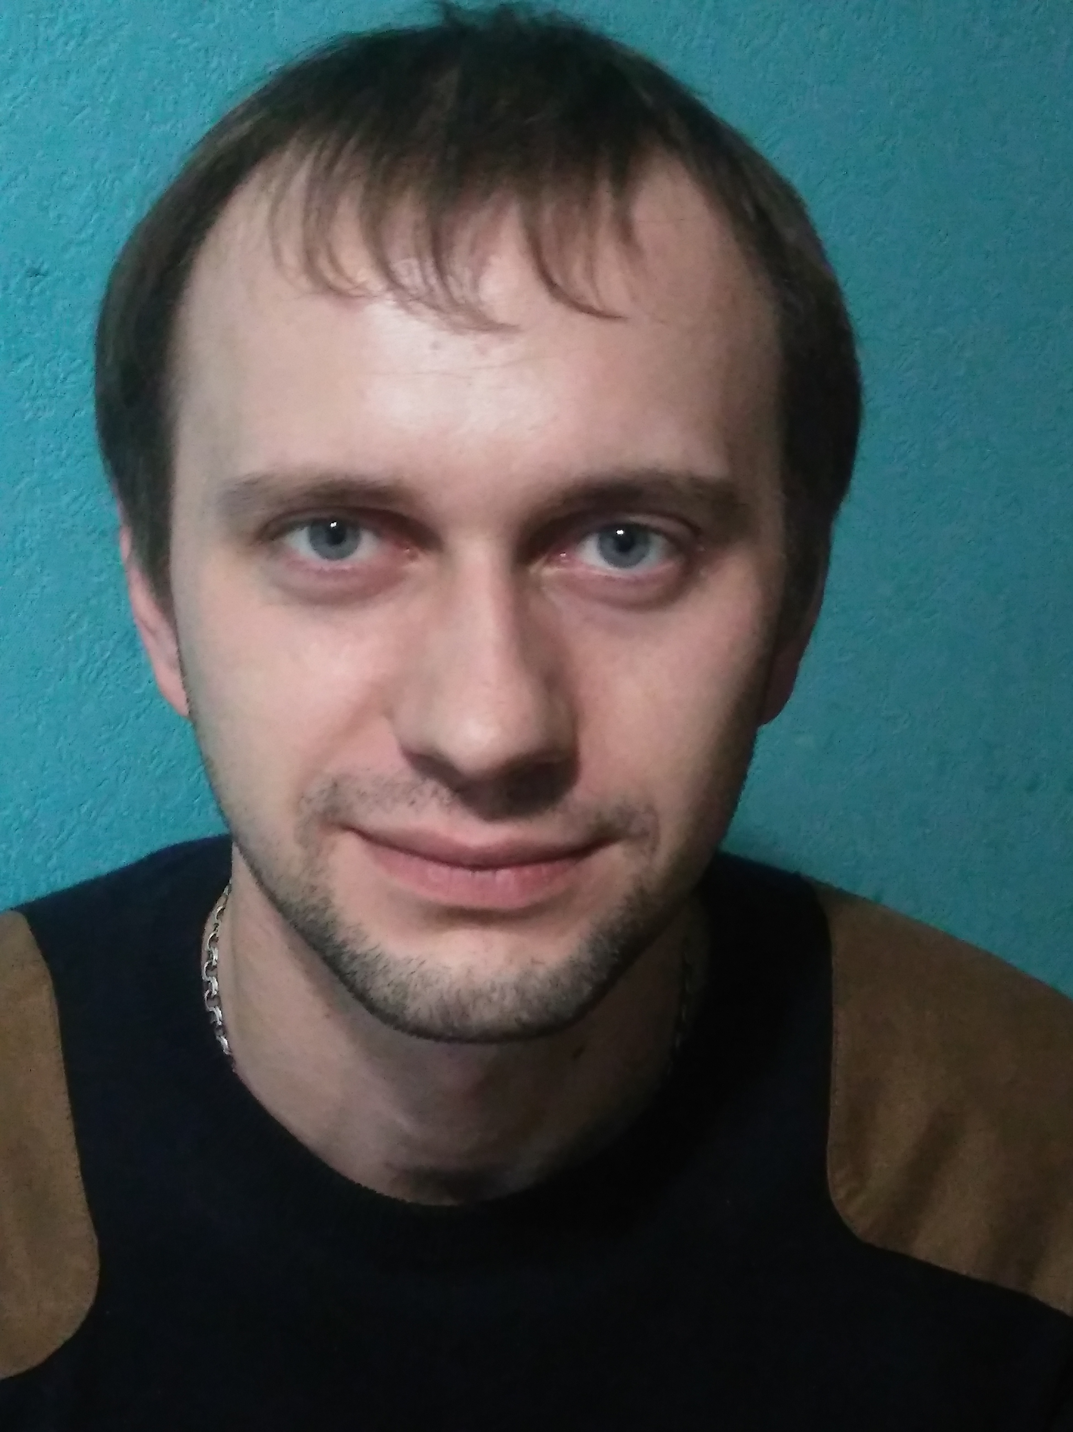
Szczecin |  | 17.01.1986
 |  |  | +38(063)8720222
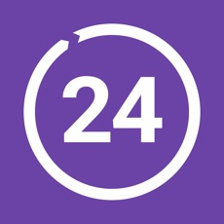 |  | +48792203102
 |  | stan.shchukin@gmail.com
 |  | Щукин Станислав
 |  | https://www.facebook.com/ShchukaStan
 |  | https://github.com/StanShchukin

Technical Skills

- PHP, HTML, CSS;
- prefer CMS Wordpress;
- have experience in configuring the working environment of Linux, Apache; MySQL;
- have an idea about Git ( at work was not required , sometimes I make commits for myself);
- have little experience in OpenCart and Laravel;
- I’m not writing large scripts, for specific tasks on JS/JQuery;

Work experience

Since May 2019 — I have been in Poland.

from the end of 2017- May 2019 (more than 1.5 years)
I worked in the company «DigitalDealerz» . I worked in a position «developer PHP» with CMS Wordpress.
My responsibilities include setting the template and editing CSS according to design.
Extending the functionality of the theme through the selection of ready-made plug-ins or creating your own.
I implemented a plugin for a construction company . In the admin panel, prices are indicated in currency, and are displayed on the site at the exchange rate. I used API MinFin Ukraine.
I worked with API Trello .Sending unique email to page visitors to Trello .
I worked with API YouTube. Play video based on page language.
I have experience in administration and configuration Ubuntu-server .Used ISPConfig and Webmin .

08.2014 - end of 2017 ( 3 years)
Work for myself. I organized a welding and metalwork shop in the garage, I carry out private orders on its basis.
I work as a driver in a taxi service.

07.10.2005 - 31.07.2014 (8 years)
LLC „MTD“. Worked on production. Responsibilities included the manufacture and installation of cabinet furniture.
Since 2009, the workshop was reorganized into the manufacture of metal furniture. We have become a branch of the Czech company «KOVONA», I mastered the profession of a welder (I have the 3rd rank). I have experience working on CNC machines. I was the head of the workshop. I quit due to the move of the enterprise to another district of the city.

13.04.2007-26.04.2006
Served in the army. Military service. I served an electro-diesel generator.

Education

2012
National Aerospace University -'Kharkiv Aviation Institute'​
Bachelor in Software Engineering.

Courses

2017
Spalah IT School. „PHP primary level“.

Personal qualities skills

Strong analytical mind, responsibility, pedantry, ability to lead a group.

Languages

English — reading documentation and chatting on the forum.
Russian— native speaker.

Family status

I'm married, I have 2 sons (8 and 5 years old).

Hobby

Since childhood, I have been interested in moto-auto equipment and its maintenance. I like to come up with useful or multifunctional pieces (devices) for technology or for a comfortable stay and translate them into real wood and metal.
I am a member of the popularization of the scooter movement in Kharkov. From 2008-2013 I was in the scooter club of KhNSK.
Hiking and motor tourism.

