Ask! Forum

Software Design Document

Name: Stanciu Alin Marian

Date: 03/31/2020

**TABLE OF CONTENTS**

1. INTRODUCTION 1

1.1 Purpose 1

1.2 Scope 2

1.3 Overview 2

1.4 Reference Material 2

2. SYSTEM OVERVIEW 3

3. SYSTEM ARCHITECTURE 4

3.1 Architectural Design 4

3.2 Decomposition Description 4

4. DATA DESIGN 5

4.1 Data Description 5

5. HUMAN INTERFACE DESIGN 6

5.1 Overview of User Interface 6

5.2 Screen Images 6

# INTRODUCTION

## Purpose

The purpose of the Software Design Document is to provide a description of the design of a system fully enough to allow for software development to proceed with an understanding of what is to be built and how it is expected to built. The Software Design Document provides information necessary to provide description of the details for the software and system to be built.

This document describes the architecture and system design of an IT system that helps people in different topics like software development, languages, science, etc. It will explain the purpose, features and the interfaces of the software, it’s role and the constraints under which it must operate.

## Scope

The application has a forum structure and is intended to be a website with the purpose of helping users doing activities of searching and solve their problems in an easy manner such as:

* An user has an account to acces the forum.
* There are 2 types of users: normal user and admin user.
* An admin user can perform important actions during web-site lifetime.
* Whenever a question is posted, a new topic starts.
* Asks something, wait to be answered by others experienced users.
* Every question or article can be commented by an user.
* An article can have comments with up or down votes.
* Every account has a rating level which can increase proportionally with number of up votes for an answer.
* If an user has a question or article with negatively rating, the overall account rating down.
* An user can give up or down votes for a question, article or comment posted.
* An user can receive up or down votes for question, article or comment posted.

There are two types of users that interact with system: normal users and admins. Each of these two types of users has different use of the system so each of them has their own requirements.

**Normal users** can use the website to post questions about anything. For his questions, the user can receive upvotes or downvotes if the other users which view the question consider a good one or irrelevat. For one question can be more answers. Like a question, every answer (response of that) can have upvotes and downvotes but these have not influence the total rating of users.  
The upvotes and downvotes received for a question increase/decrease the total rating of user which post. A normal user can post articles and other users can appreciate them. Monthly, it is made a rank with all users by total rating.

**The admins** also only interact with the web forum. They are managing the overall system so there

is no incorrect information within it. The administrator can manage the information for each topic, can mark an answer as the best, can remove a topic if consider irrelevant and even remove an user which not follow terms and conditions of the forum.

## Overview

This document is written according to the standards for Software Design Documentation explained in “IEEE Recommended Practice for Software Design Documentation”. Sections 3 – 4 contain discussions of the designs for the project with diagrams, section 5 shows samples of UI from the system.

## Reference Material

The user of this SDD may need the following documents for reference: IEEE Standard 1016-1998, IEEE Recommended Practice for Software Requirements Specifications, IEEE Computer Society, 1998.

# SYSTEM OVERVIEW

The current solution was built by me, Stanciu Alin Marian, for an assignment at Web Application Design lab.

Source code is available using standard open source management tools such as Git. All source code is stored in a Github repository which is private.

The Ask! Forum utilizes an open-source web server, IIS. IIS is focused on high performance, high concurrency and low memory usage. Additional features on top of the web server functionality, like load balancing, caching, access and bandwidth control, and the ability to integrate efficiently with a variety of applications, have helped to make IIS a good choice for modern website architectures.

Ask!’s development language is C# in ASP .Net Framework and database is SQL Server. Github provides version control and source code management for my web application. Github is the largest host of soure code in the world.

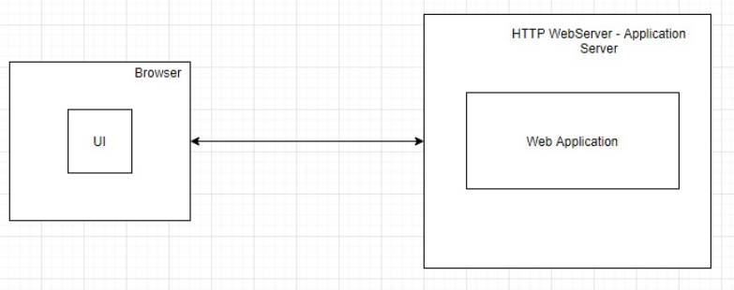

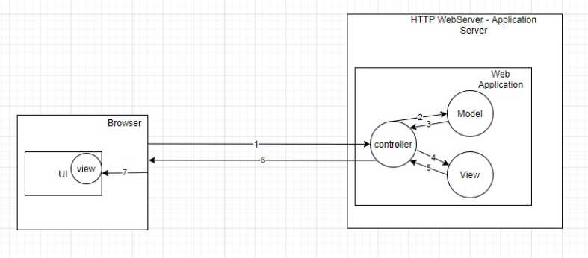

# SYSTEM ARCHITECTURE

## Architectural Design

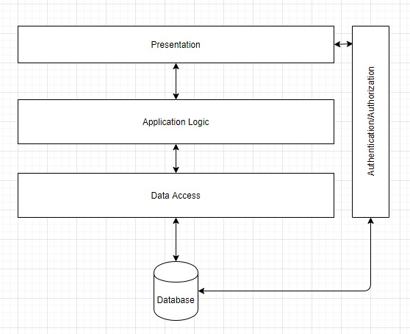

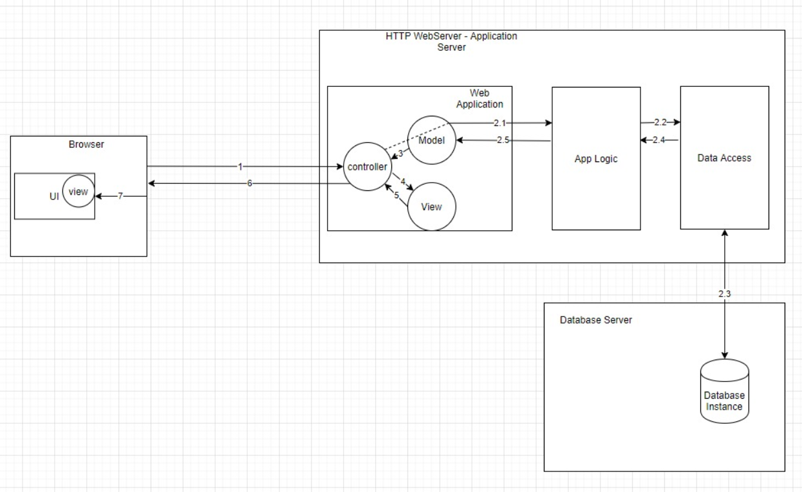

## Decomposition Description

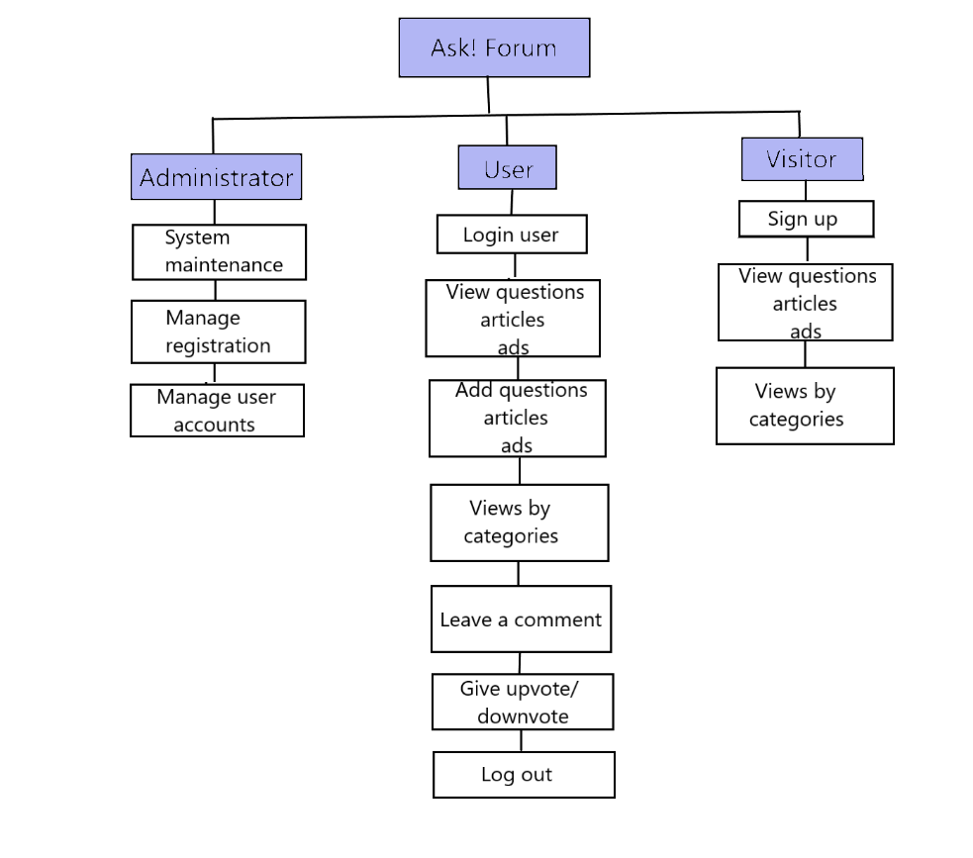

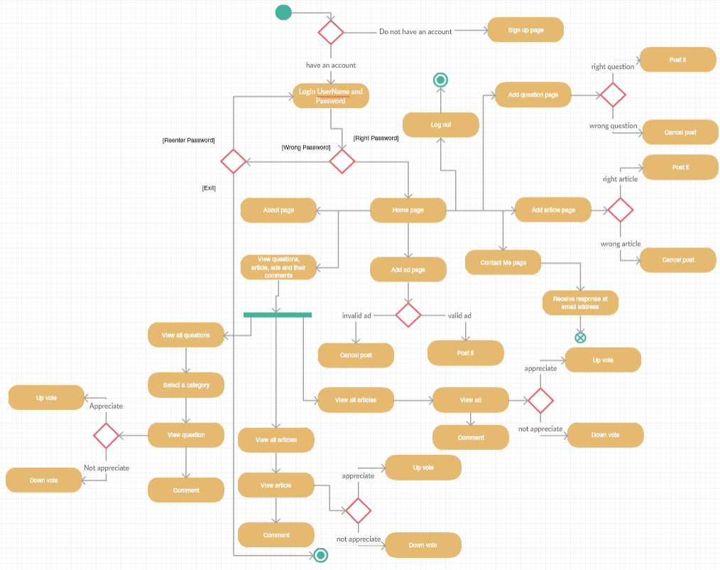

Activity diagram for Ask! Forum

# DATA DESIGN

## Data Description

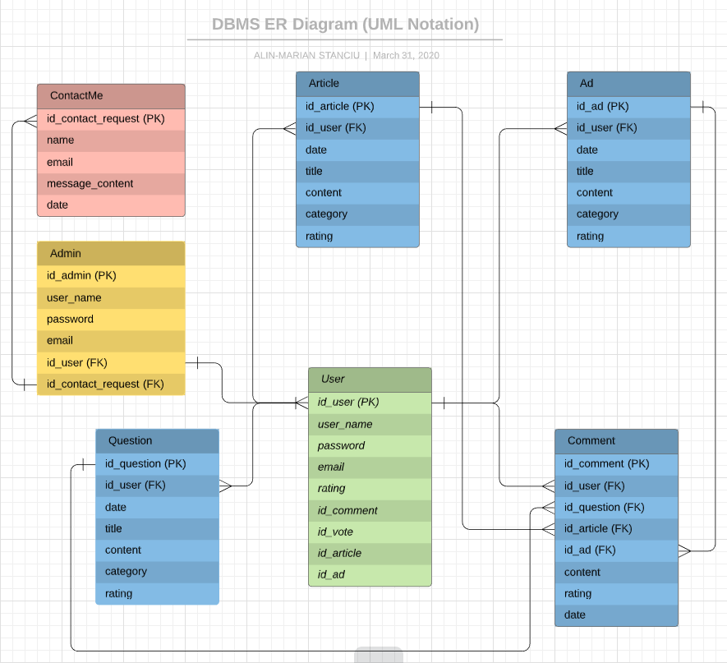

# HUMAN INTERFACE DESIGN

## Overview of User Interface

**Normal user** can use the website to post questions about anything. For his questions, the user can receive upvotes or downvotes if the other users which view the question consider a good one or irrelevat. For one question can be more answers. Like a question, every answer (response of that) can have upvotes and downvotes but these have not influence the total rating of users.  
 The upvotes and downvotes received for a question increase/decrease the total rating of user which post. A normal user can post articles and other users can appreciate them. Monthly, it is made a rank with all users by total rating.

## Screen Images

