Baby Care – Stand By Baby  
Don’t cry

*Choi Junho 2018007810*  
College of engineering,  
Hanyang University  
Dept. of Information systemSeoul, Korea  
chlwnsgh1004@naver.com

*Yoon Jongwoo 2018007629*  
College of engineering,  
Hanyang University  
Dept. of Information systemSeoul, Korea  
4813_y00n@naver.com

*Kim Taehwan 2018007492*   
College of engineering,  
Hanyang University  
Dept. of Information systemSeoul, Korea  
crow4240@naver.com

*Kim Jaebean 2018007429*  
College of engineering,  
Hanyang University  
Dept. of Information systemSeoul, Korea  
cant_sleep@naver.com

*Kim Taeyun 2018007483*  
College of engineering,  
Hanyang University  
Dept. of Information systemSeoul, Korea  
kty19999@naver.com

*Abstract*— Our team is trying to create a function that helps parenting through stand by me and NUGU speakers. Double-income families are under stress over childcare. Among them, the hardest thing to feel is a child who cries day and night. Children have an irregular sleep cycle because their nervous system is less developed. Since day and night cannot be distinguished immediately after birth, parents should create an appropriate sleep environment at a set time. It is very important to sleep well during newborn or early childhood. This is because growth hormones are actively secreted, which determines the child's growth. Through functions that help raise children, we will help children sleep comfortably and give parents and children great happiness and satisfaction.

Role Assignments

|  |  |  |
| --- | --- | --- |
| Roles | Name | Task description and ete. |
| User | Choi Junho | Parents who want to raise healthy children comfortably without stress are selected as their main customers. Use the questionnaire to collect customer needs for development. He needs to choose some of the most necessary answers. He also thinks of ways to test and improve applications and points out flaws. Provide feedback accordingly and check continuously. |
| Customer | Kim Taewhan | A baby crying day and night is selected as an application user. He needs to get a good grasp of the characteristics of the child and melt them into our development. He should investigate their cries and what music and sounds they can react to stop crying. He is also responsible for continuously observing our development and evaluating the capabilities implemented. |
| Software developer | Kim Taeyun | He should review the software that can implement this development and analyze and classify the appropriate software. He identifies what development tools we should use. It is also responsible for assigning tasks and organizing tasks that need to be performed in order. |
| Development manager | Kim Jaebin,  Yoon Jongwoo | They should implement the software function and make sure that the user's needs are well integrated into the software. When there are deficiencies or more necessary functions, it plays a role in supplementing the functions. |

# Introduction

Motivation

Our team focused on making appliances that help newlyweds raise their children. Many newlyweds have lovely babies and gain great happiness. However, it is also true that couples are under a lot of parenting stress to take care of their lovely children. There are several types of parenting stress, such as a war of nerves with a child, a child's bad eating habits, and a solitary parenting.

Our team thought about what was the biggest parenting stress for newlyweds who take care of their babies. We thought that the most difficult thing about taking care of the baby was not being able to sleep well because of the baby. Babies in newborns and infants have irregular sleep cycles because their nervous systems are less developed.

During this period, the baby does not sleep at night, or can't sleep deeply and is unable to sleep deeply. Whenever that happens, the baby cries or shouts, and every time that happens, the parents also wake up and try to put the baby to sleep. We think this situation is a natural parent's love for the baby and is an essential parenting behavior. But parents are human, too. If these days continue every day, mental and physical stress builds up, which I think will be bad for the baby because parents cannot take care of the baby in full health.

So we thought it would be nice to have an application that helps the baby sleep and care. First of all, We thought about <What helps a baby sleep?>. Our team searched for various data, and was able to found one research. According to a published study, babies affected by white noise fell asleep faster. At that time, the research team conducted a survey of 40 newborns and confirmed that 80% of the babies in the subjects fell asleep in five minutes in a white noise environment. It is said that the baby can have a significant effect because it is already exposed to sounds similar to white noise from the mother's womb.

So the application we're designing plays white noise or music that helps the baby sleep when it recognizes the baby's crying at a certain time(ex 12a.m to 5a.m). In addition, there are functions that can be useful in the usual childcare environment. For example, when a baby cries or shouts in a situation where parents receive a phone call or go out urgently, the application can detect the baby's voice and add favorite music and videos to reduce the baby's anxiety.

This application that we're designing will help create a healthy sleep environment for baby. We think parents will be a reliable helper in taking care of the baby.

## Problem statemnet(client’s needs)

- In 2021, 52% of newlyweds have dual-income families. This is a 2.4 percent increase from last year and is expected to increase more and more.

- Childcare is the most troublesome problem if you work together. It is also the biggest reason for giving up giving birth.

- Not only are there couples who cannot use parental leave, but they cannot use it for a long time. There is also a limit to taking care of children or grandparents being able to take care of children.

- In addition, the most difficult situation for parents is when their child does not sleep or wakes up at dawn.

- Therefore, it is necessary to create a bed environment for children to sleep well so that parents and children can have regular sleep patterns.

*Research on any related software*

## A. Kakaotalk

Kakao Talk is a mobile messenger application launched in March 2010, with a 94.4% share of mobile messengers in Korea as of 2018. This means that this application is used by almost all Koreans. Our application has a function to notify parents' Kakao Talk when Standby Me detects a child's crying. We are going to add this function using Kakao Talk api.

*B. Youtube*

YouTube is Google's content hosting website and the world's largest video platform that allows users to freely upload or watch videos. We aim to display the videos we need on the standby me screen through this YouTube. The videos we need are videos that babies will like, such as cute fairy tale characters or cartoon characters. There are also many videos on YouTube that include various melodies that help babies sleep. We plan to refer to these videos.

*C. NUGU AI*

<NUGU> is the first artificial intelligence service in Korea that applies advanced voice recognition technology and artificial intelligence engines to identify and perform what customers want when they talk to their dedicated devices. For example, in this application, when a user issues a voice command ("Play me music", "Who is the singer who sang this song?"), NUGU has the ability to execute these commands. We thought that NUGU needed to develop voice command capabilities in conjunction with our applications

*D. Rumi by Deeplyfin:*

This application is an artificial intelligence parenting helper application. and is equipped with several functions, and the main function is to record baby crying between three and six months, separate the general noise from the baby's voice, and analyze baby crying with deep learning-based artificial intelligence technology. Through the analysis, the expression of the baby's intention is classified into six categories: hunger, sleepiness, discomfort, burping, pain, and temperature and humidity problems. Rumi' consists of devices and smartphone apps. The device works by detecting the baby's voice among various sounds mixed in daily life and sending it to the cloud server. We think that Rumi's ability to detect baby cries is similar to the ability to add to our application.

*E. CCTV app - <Baby monitor Saby 3G Baby Monitor>*

Through this application, many parents can see very simply what their baby is doing. You can simply watch videos and receive notifications when your baby is sleeping or playing through two smartphones. The main function is to recognize the baby as artificial intelligence when it wakes up and automatically identify when the baby wakes up. Our application will also have a function to check the baby's movement or fever through a camera and send notifications to parents, and I think there are many similarities.

*F*. *LG ThinQ app:*

Babies love white noise, a kind similar to the sound they've heard in their mother's womb for nine months. In fact, studies have shown that white noise is effective in putting babies to sleep because it calms them down and reduces their stress. We are inspired by the ability of this application to provide white noise and will add these capabilities.

*G. Application: Sleeping Baby - White Noise*

Through this application, many parents can see very simply what their baby is doing. You can simply watch videos and receive notifications when your baby is sleeping or playing through two smartphones. The main function is to recognize the baby as artificial intelligence when it wakes up and automatically identify when the baby wakes up. Our application will also have a function to check the baby's movement or fever through a camera and send notifications to parents, and I think there are many similarities.

# Requirement Analysis

## A. Running Mode

Say 'Baby Sleep Mode' to the nugu speaker and run it. On this screen, the user can touch a button that allows the mode to run immediately, and if it was first executed or not set, guide them to Requirement B(setting). Once set, enter the Requirement E("Baby Sleep Mode").

## B. Setting

This feature requires selecting the video to be played, setting the appropriate body temperature, and setting the mobile phone to be notified. You can enter the menu by touching the button with the setting phrase or by saying 'Set Baby Sleep Mode' on the nugu speaker.

a. Video Setting - You must set up a specific video file that the baby likes, or a video file with parents. If you don't have such a video file , it is also possible to set the YouTube video that the baby likes If you don't have a video to set, you can recommend and set a YouTube video that many other babies like.

b. Set proper body temperature - You may have a baby who has a lot of heat on his body even in normal times, so you need to set the appropriate body temperature separately. You can set the temperature step by step (ex. Step 1: 37 degrees, Step 2: 37.5 degrees, Step 3: 38 degrees).

c. Set up mobile notifications - to receive notifications if your child wakes up or has a temperature problem. To do this, you must set up your phone. You can also set the level of notification, and set the notification differently for each step of body temperature, so that parents can receive a bigger notification when the step is higher.

d. Alarm Settings - In case your child does not wake up for a long time, you should set the time to run the alarm to wake up. You must set the video or song to be played at this time, and you can also use the image set in Requirement B-a

e. CCTV Settings - Allows you to send url of the web to view CCTV, and allows you to choose whether to store several days of CCTV file on the server. The longer the period, the lower the quality of the stored image quality.

f. All sleep Settings - You should pre-set the appliances to shut down so that they do not disturb your baby's sleep. At this time, the appliances should be linked to LG ThinQ.

## C. Baby Sleep Cycle

## It is important to check your baby's sleep pattern. It's because we need to check when the baby slept recently and how long he slept. To do this, stand by me's front camera checks when the baby fell asleep, when he woke up, and the total sleep time and saves it on the server. It also shows a table or graph by organizing them.

## D. Exit Mode

You can exit the mode by saying 'End Baby Sleep Mode' to the nugu speaker. To prevent malfunction, a screen will appear to confirm once more, and the data must be stored safely so that the setting value is not lost.

## E. Baby Sleep Mode

## When enabled, CCTV is activated through the front camera of the stand by me to detect movement or measure body temperature while the baby is sleeping and recognize the baby's wake-up and crying through the NuGu speaker. If the child does not cry, the screen on Stand By Me shows the current room, the child's appearance and body temperature. If nugu recognizes that the baby is crying due to requirement G, the screen is switched to requirement H. Even in this case, CCTV and body temperature measurement do not stop.

*F. Baby temperature measurement*

## When both the baby and the parent sleep, a fever can cause dangerous situations. If the baby's body temperature rises above the proper temperature measured by the front camera of Standby Me, a notification is sent to the parents' cell phones.

*G. Crying sound detection*

To check the frequency spectrum when a sound is detected that goes over a certain decibel. At this time, ai, who knows information about a child's crying through learning, determines whether this sound is a baby's crying or a different sound, such as the sound of a vacuum cleaner.

*H. Play Videos*

Play videos or YouTube that you have pre-configured. At this time, if the child's crying does not stop until the video is over, ai will play the children's song video that the babies like. After a certain period of time (ex.5 minutes), the child stops crying and plays a sleep-inducing song to put the child to sleep.

*I. Alarms*

In the case of babies, it can also be a problem if they do not wake up for a long time. To prevent this case, play a video or song to wake the baby up when the set time has passed, or at a specific time. At this time, a Kakao Talk message is also sent to the parents' cell phones to tell them that they need to wake up the child.

*J. CCTV*

View real-time status where standby is located via the web. Parents can check if their child is sleeping well and what he is doing.

*K. Save to Server*

To save the video recorded via CCTV to the server. Hang up files by date, and be connected to the server in real time. If the save is successful or unsuccessful, a notification window must be displayed.

*L. Motion detection*

The camera detects large movements of the child. If the baby stands up and crosses the safety bar of the bed, it may shock the head, so it detects it and executes the requirement M.

*M. Notify parents*

If your child wakes up, shows abnormal body temperature, does not wake up for a long time, or detects large movements, send a Kakao Talk message to the parent's mobile phone you have set up. To this end, it works in real time by linking the Nugu speaker with Kakao Talk api.

*N. All sleep(Lg ThinQ)*

When entering Baby sleep mode, shut down other appliances (for example, robot vacuum cleaners, washing machines, etc.) that may cause noise to avoid disturbing the baby's sleep. For this purpose, the Lg Thin Q application is linked to use the Home Appliance Shutdown function. It is important to set and interlock appliances that may cause noise in advance.

# Development environment

A. Choice of software development platform

We will develop applications on Windows using a Linux-based platform with mac OS. Android is a set of software that includes the mobile operating system and middleware and critical applications of platforms such as smartphones produced by Google. Android is the world's most representative open source platform and has the largest number of users in the world. It will be used as a service using YouTube app to implement apps including video recommendations. It will also use the Web OS, a mobile operating system that runs on the Linux kernel. It can be used through a touch screen without using a virtual keyboard. The languages for development are Go (1.19.1), Enact (4.5.2), JavaScript(ECMAScript 2021).

|  |  |
| --- | --- |
| Tool and language | Reason |
| Enact | Enact builds atop the excellent React library, and provides a full framework to the developer. Beyond initial setup, Enact continues to provide benefits. It was built with performance in mind, and conscious decisions were made to ensure that applications remain performant as they grow in size and complexity. This ranges from the way components are rendered to how data flows through application. Enact was designed to produce native quality applications for a wide variety embedded web platforms. We do front work by implementing WebOS through this language. |
| JavaScript(ECMAScript 2021) | JavaScript is an object-based scripting programming language. This language is mainly used within a web browser and has the ability to access embedded objects from other applications. It is also used in server programming, such as runtime environments such as Node.js. Our development is mainly JavaScript. |
| Go (1.19.1) | Go is not a scripting language like Python, but a compilation language. The compiler's compilation speed is so fast that it can be written like an interpreter language. It is a great advantage to be able to write code concisely and easily implement powerful functions thanks to its rich library. Simply place the code in GitHub without registering the package in the registry to include it in the program. This enables decentralization and management. Concurrency control can be simplified using coroutines and channels. Configure the overall backend environment through the Go language. |

Cost estimation

|  |  |
| --- | --- |
| Device | Price(won) |
| Standy by me | 1,153,000 |

B. Software in use



*a.* *Visual studio code(1.72.2):* It is an integrated development environment, an integrated package, and a standard development tool distributed and sold by Microsoft. We can develop both desktop and web applications running on Windows. There is no need for a separate development tool when used in a single package form. Many of the existing programs were produced using visual studios. In addition, a number of development tools or SDKs are increasingly available in plug-in form based on visual studios. In react native development, VSCode is mainly used as a basic editor. It will increase productivity when creating Android apps with various development environment settings.



*b.* *GoLand:* It is a cross-platform IDE aimed at providing an environment for Go development. It supports real-time error inspection and correction suggestions, fast and safe refactoring and one-step cancellation, intelligent code completion, and unnecessary code inspection quickly and effectively. We will also use code navigation to perform efficiently by moving quickly to type-implemented interfaces, hidden methods, implementations, usage locations, and declarations.



*c.* *AWS:* Amazon Web Services provides online services for other websites or client-side applications. It is a PaaS that provides a platform that provides functions that other developers can use, not directly open to end users. Various services of Amazon Web Services can be accessed, used, and managed through the REST protocol and the SOAP protocol. This does not require pre-provisioning of resources to handle our activities.

*d.* *Web OS:* It is a Linux-based mobile operating system currently used by LG Electronics. It has many advantages, such as supporting a variety of app frameworks and having an efficient bus system (Luna-Bus). It is used in many places such as LG Electronics' smart TV, Signage, and Smart Watch. On Stand by me, Webos 6.0 is installed. IDE (Integrated Development Environment) is a software for building an application that combines common developer tools into one GUI (Graphical User Interface (GUI). Web OS also provides IDE to support the graphical development environment. Using terminals, we use the app and service package.



*e.* *Node.js:* Node.js is a software platform used to develop scalable network applications (especially server-side). It utilizes JavaScript as the writing language and has high processing performance through non-blocking I/O and single thread event loops. It includes a built-in HTTP server library, which allows the web server to operate without separate software such as Apache, allowing more control over the operation of the web server.

*f.* *GitHub:* GitHub is a web service that supports hosting Git Repository, a distributed version management tool. While the git is a text command input method, GitHub provides a graphical user interface (GUI). GitHub operates Gist and Wiki, which are similar services to pastebin, for each repository, and can be fixed through GitHub. Users can discuss, manage storage, submit contributions to other storage, and review changes to code. We will collaborate efficiently through this repository by using features such as merge and commit.

*g.* *Notion:* Notion is a comprehensive memo service that integrates memos, documents, knowledge organization, tasks, projects, and databases into one service. As soon as the text is modified to benefit from collaboration, it is synchronized in real time on other devices. The page may be generated as a sub-item with little limitation. The transfer operation can also be handled by dragging with the Drag-and-drop method. Since data is managed by a unit called a block, various formats may be used.

C. Task distrbution

|  |  |
| --- | --- |
| Name | Task |
| Choi Junho |  |
| Kim Taewhan |  |
| Kim Taeyun |  |
| Kim Jaebin |  |
| Yoon Jongwoo |  |

# Specifications

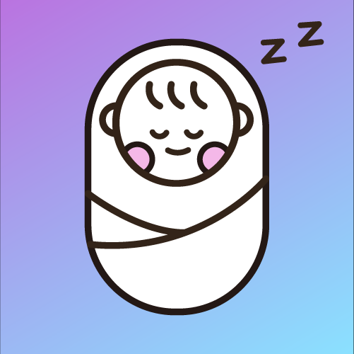

A. Login page

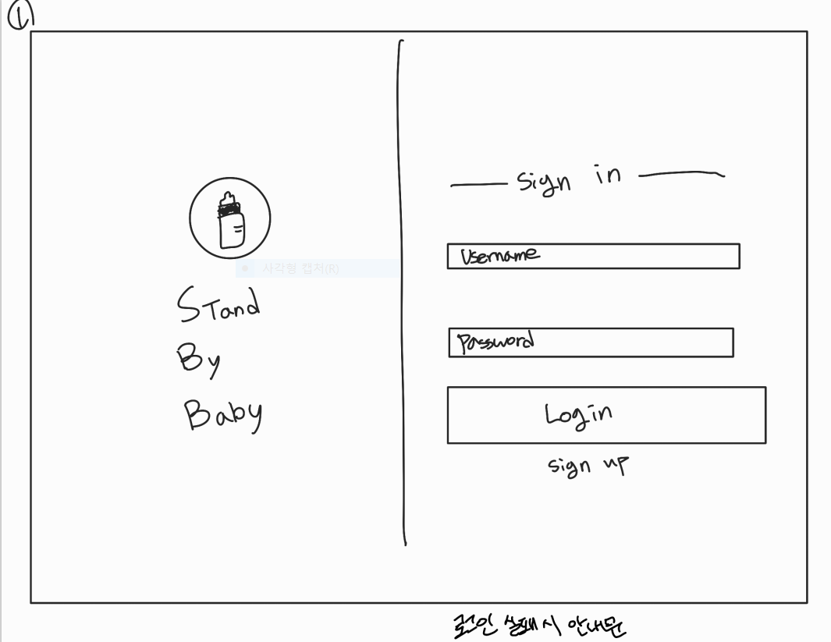

This picture is the login page. You can log in by entering your ID and password. If you don't have your ID, you can sign up by pressing the Sign up button. The ID is displayed as entered, and the password is displayed as asterisk.

a) Login Error

This picture shows the login failure window with the wrong ID or password. Displays the "ID or password is incorrect" information window.

B. Sign up Page

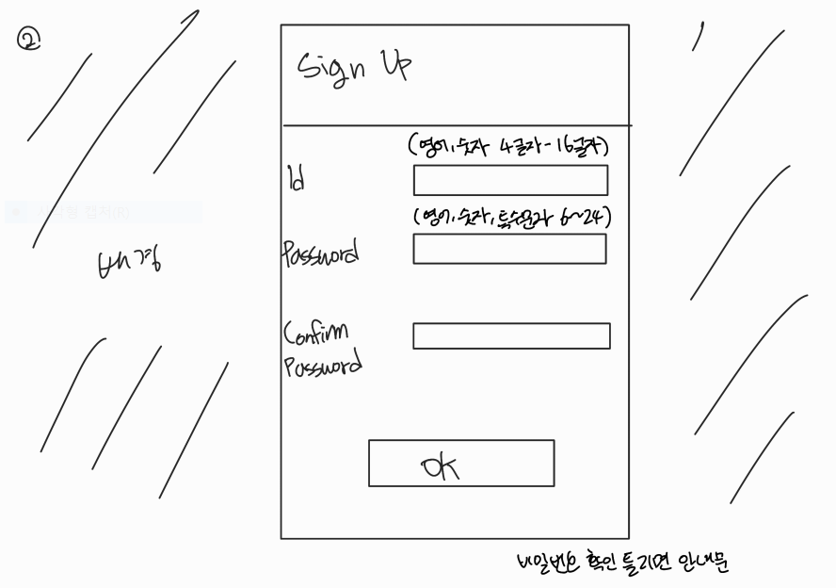

This picture is a Sign up page. You can enter your preferred ID and password. The ID must consist of 4 to 16 English characters or numbers. For passwords, you must have at least one English, number, and special character from 6 to 24 characters. In addition, there is a confirmation box where you need to write down your password once more to prevent incorrect password entry, and you can sign up only if the two spaces match. Also, mobile phone number authentication is required. If you press the transfer button after entering the number, the authentication number will be sent as a message, and you must enter the authentication number accurately in the certification box to register as a member

a) ID duplicate error

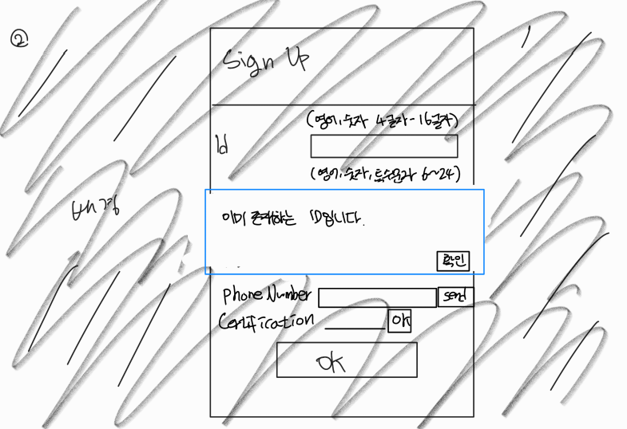

This picture is a sign up error window due to duplicate IDs. Displays the "ID already exists" information window. The ID must be different from the existing ID of another person's

b) ID Condition error

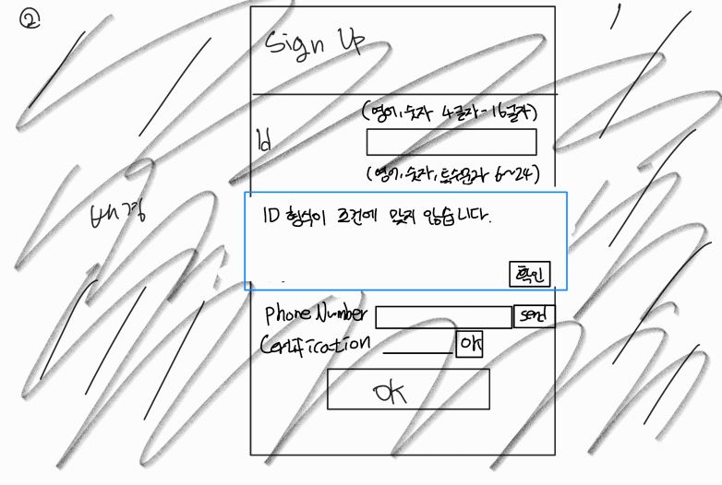

This picture is a sign up error window due to ID conditions. Displays the "ID format does not meet the criteria" information window. The ID must consist of a combination of 4 to 16 English characters or numbers.

c) Password condition error

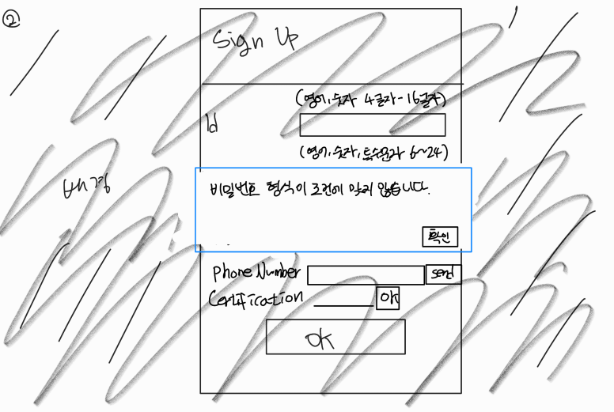

This picture is a sign up error window due to password conditions. Displays the "Password format does not meet the criteria" information window. Password must be between 6 and 24 characters long and must contain at least one English, number, and special character.

d) Password match error

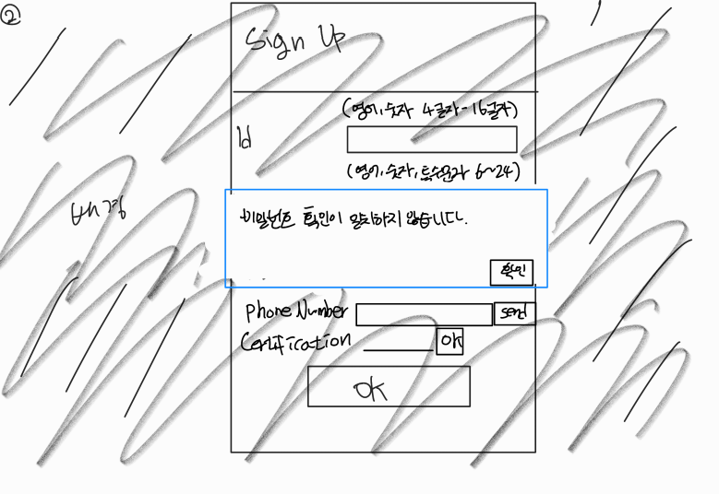

This is a window where the password verification section does not match the contents of the password section, resulting in an error in sign up. Displays the "Password Confirmation Mismatch" information window. Password and password verification must be the same.

e) Certification match error

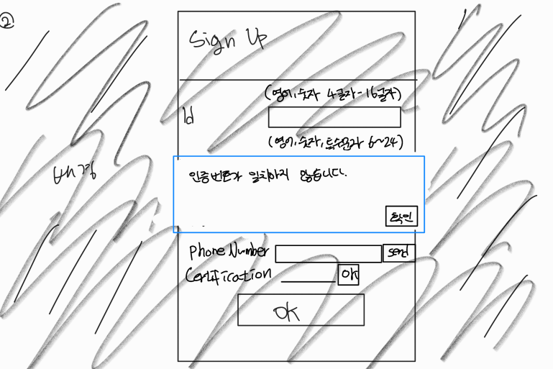

This picture shows an error in sign up because the authentication number does not match. Displays the "Certification Number Mismatch" information window. The authentication number you entered must match the authentication number sent by the server.

C. Main Page

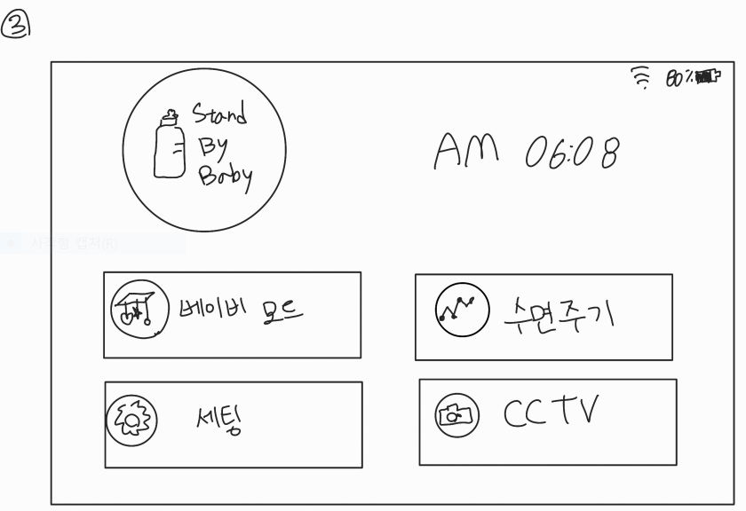

Our main page looks like (picture). This page is available after you complete your login and displays the time, date, and remaining battery capacity. There are also four buttons. It is a button that allows you to enter Baby sleep mode immediately, a setting button that allows you to set various settings, a button that checks the baby's sleep cycle, and a button that allows you to check stored CCTV videos. Since setting takes precedence, if you press baby sleep mode without setting, switch the screen to the setting page. Also, if you click the sleep cycle and CCTV video button when the mode has never been operated, the information window "empty" will be displayed. When all settings are finished and the mode is successfully entered, the button of baby sleep mode is lit.

D. Setting

This picture is the setting page. On this page, you have buttons that allow you to set up four items. You have to complete all four settings before you can enter baby sleep mode. If you try to enter the mode without completing it all, it will display a guide window telling you what settings you have not completed and prevent you from entering the next step. You can return to the main page by clicking the application icon at the top of all settings pages.

a) All sleep setting

This picture shows the ALL Sleep settings page. This page contains the Find button. Press the button to find the appliances associated with the LG ThinQ app. When home appliances are recognized, a check box is created. When you press the boxes, it stops working when Baby Sleep Mode is running.

b) Video setting

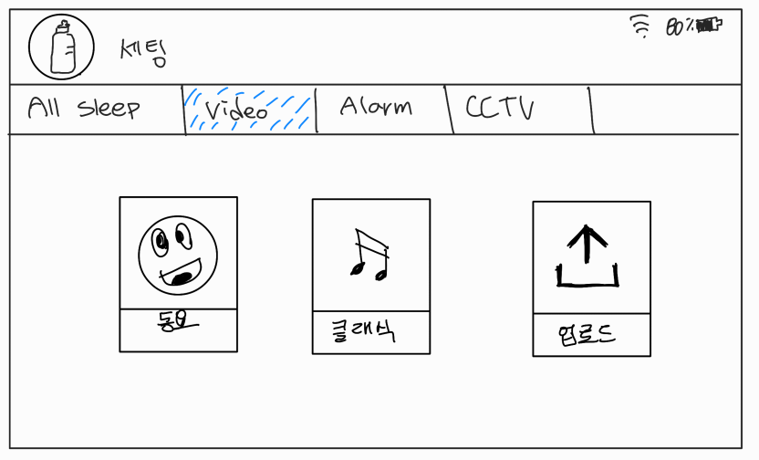

This picture is the video settings page. There are three buttons on this page. Each button is a children's song, a classic, and a video upload button. In Video Settings, set the image that will be played when the baby is put to sleep.

1) Children’s song button

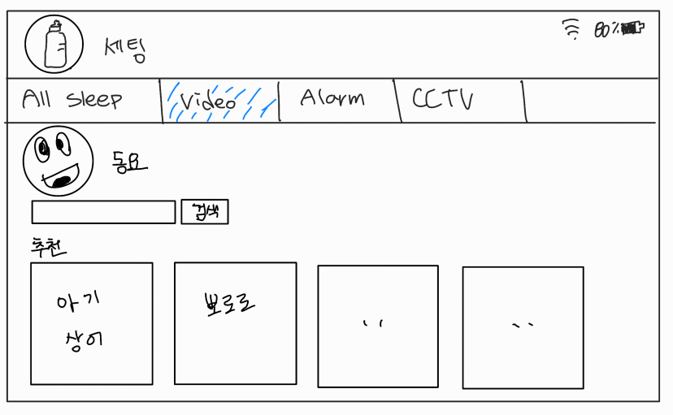

This picture is a children's song page. This page displays four recommended children's songs. If you don't like it, you can set other children's songs on YouTube through the search box

2) Classic button

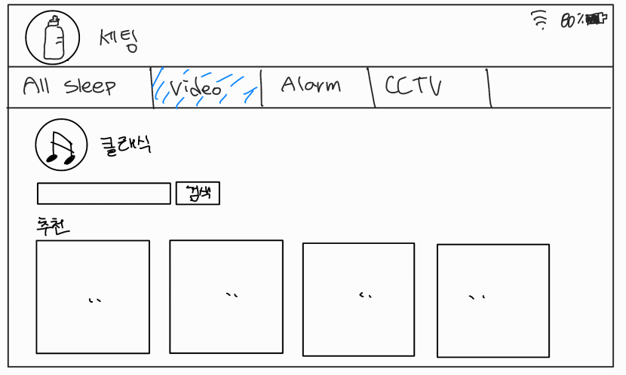

This picture is a classic page. This page displays four recommended classics. If you don't like it, you can set up other classic images on YouTube through the search box.

3) Upload button

This picture is an upload page and has an upload button. When you press the button, the screen switches to the gallery, and you can upload the video you have in your storage space and choose the video that will be played.

c) Alarm setting

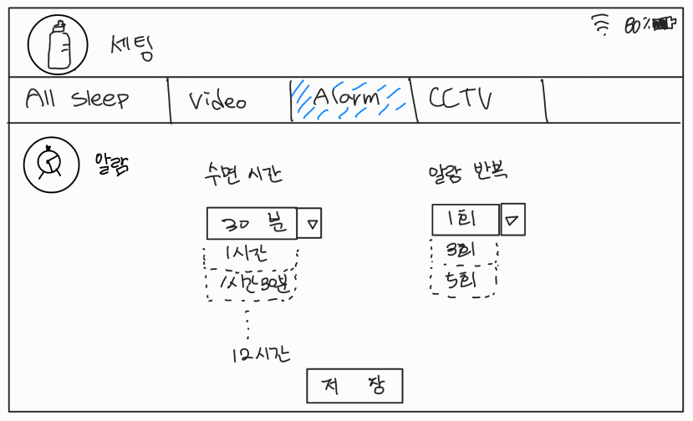

This picture is the alarm settings page. There is a select box that lets you set the time to wake your child up, and you can choose every 30 minutes from 00 hours 00 minutes to 12 hours 00 minutes. If you select 00 hours 00 minutes, the alarm function is disabled and the music to be played in the alarm is set to the default value.

d) CCTV setting

This picture is the CCTV settings page. There is a button that allows you to select the URL transmission and video storage period. When you press the URL transfer button, you send a URL that allows you to view CCTV in real time to the authenticated mobile phone number when you sign up. The video storage period is a selection box, and you can choose between the 3rd, 7th, and 14th days. The longer the duration, the lower the image quality. It is guided under the selection box with 720p on the 3rd, 480p on the 7th, and 360p on the 14th.

E. Baby sleep mode

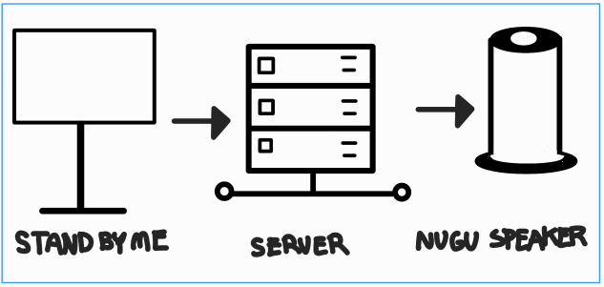

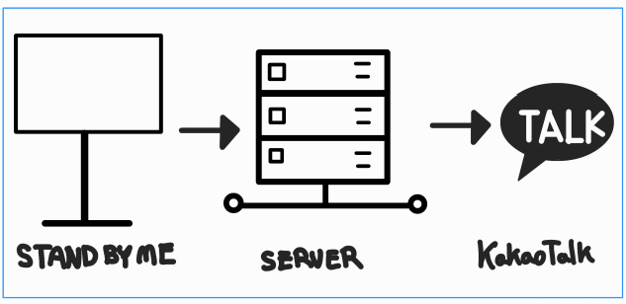

Baby sleep mode is the mode that oversees the functions of this application. Setting must be done first, and you cannot enter unless setting is done. After the setup is complete, you can press the Baby Sleep Mode button on the main page or issue the "Baby Sleep Mode" command to the NUGU AI speaker to run the mode. When the baby is in sleep mode, it is set up through the setup process to run the video, alarm, CCTV, and ALL Sleep functions. In addition, baby temperature measurement, baby crying detection, and motion detection are performed, which are functions that do not require setting. When parents need to be notified by baby body temperature measurement , baby crying detection function, and motion detection, Kakao Talk notification is sent to the phone number certified when signing up. You go through the same process as this picture. When external data is acquired by NUGU AI speaker or standby, the data is sent to the server, processed, and information is received from the server to the NUGU AI speaker and sent a Kakao Talk notification.

F. Sleep cycle

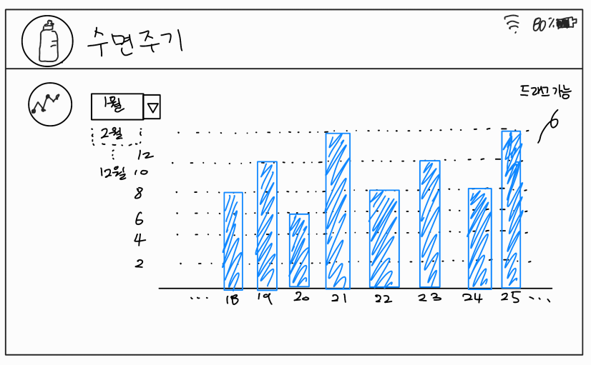

This is a sleep cycle page. You can choose the month you want to see between January and December through the select box at the top. Through the front camera of Standby Me, the child's sleep time is determined, stored on the server, and the figures are bar-graphed according to the date. The x-axis represents the date, 1 day to the last, the y-axis represents the time, and the reference point represents 2, 4, 6, 8, 10, and 12 hours. You can show 8 days' worth on one screen and drag it to both sides to see graphs of the front and back dates.

G. CCTV

This picture is a page where you can see the saved CCTV. You will get a list of videos as much as the date set by the CCTV settings. Next to each list are the View and Download buttons. Press the View button to view the CCTV footage of the day stored on the server on the standby me screen. Press the Download button to display the "Do you want to download?" information window. Pressing the Yes button will start the download, and pressing the No button will cause the information window to disappear.

a) CCTV View

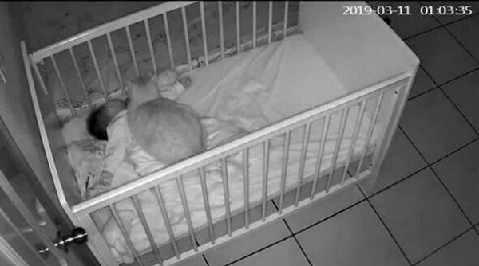

This is a CCTV view window (example). In the upper right corner, the year, date, time, minutes, and seconds appear. The criteria for this time apply the same as the time setting for StandbyMe. You can play the entire image or return to the previous screen via the Back button.

H. Motion detection

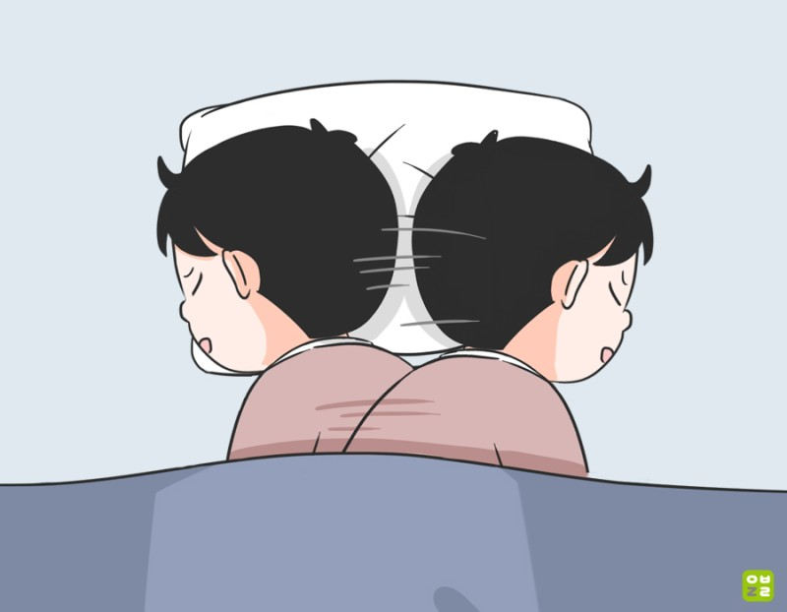

This function is operated by a motion detection sensor on the front camera of the standby. It always works when Baby sleep mode is executed, and when there is a risk that the child may move or roll out of bed, it sends a Kakao Talk notification to parents through the data processing process of Baby sleep mode.

I. Baby temperature

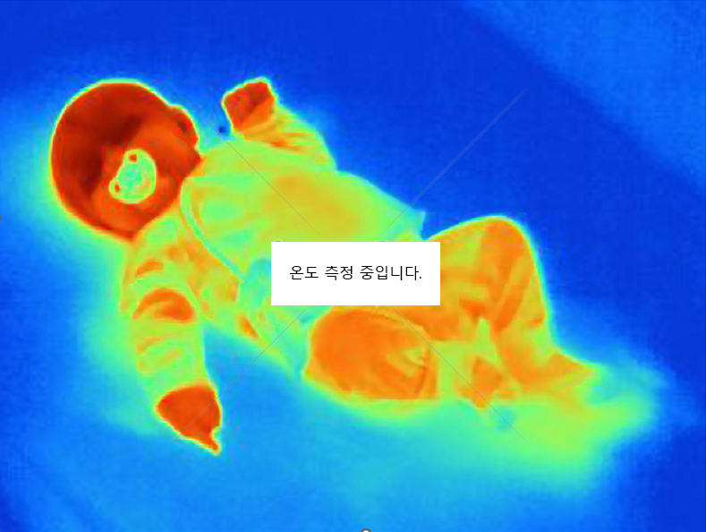

This feature is always enabled when baby sleep mode is running. The baby's body temperature is measured through the standby me's front camera (thermal imaging camera), and if there is a problem with the body temperature, a Kakao Talk notification is sent to the parents' mobile phones set through the data processing process of the baby's sleep mode. The measurement temperature is based on the Celsius temperature (℃), and the scale of the high temperature is 37.5℃ in level 1 and 38℃ in level 2. Sends three notifications every five minutes when measured in level 1, and five notifications every three minutes when measured in level 2.

J. Crying sound detection

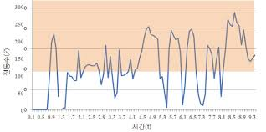

The waveform of the baby crying continuously input through the microphone repeats a pattern in which the frequency increases and then decreases rapidly. This is because the baby sniffles or catches his breath in the middle of crying. Therefore, the duration of the baby crying candidate region determined by frequency calculation is also considered. The cries of various babies appear more than three times (0.3 seconds) in a row. In addition, the baby does not continue for more than 3 seconds due to crying mid-sniffing or breathing. That is, it may be determined that the baby crying candidate area is a crying area only when 3 times (0.3 seconds) to 30 times (3.0 seconds) are continuously detected. If it is determined that the baby's crying is detected, notify the parents by Kakao Talk message with someone's speaker.