QA Test Plan - Customer Priority Feature (NANCY Only)
- Scope: NANCY only. Scheduler has a separate QA handoff and is intentionally out of scope in this document.
- Branches: GeoffERP-API feature/customer_priority @ 9ae4edf9; Geoff-ERP feature/customer_priority @ d1d468b9
- QA refresh date: 2026-04-22 (MDT)
- Status: AMBER - the NANCY admin/import path is working locally, but the current live 8-order BC proof still shows the release batch arriving in the reverse of the visible ordered payload.

In Plain English
Admins can upload a store-specific priority list. Existing Orders then highlights NEW customers in orange and priority customers in blue. When the sales team presses Process Orders, NANCY sends the selected jobs to the local Business Central mock so we can verify what order actually left NANCY.
This document is intentionally NANCY-only. The downstream Scheduler app has its own separate QA plan.

What Changed
Current local default settings are:
- Feature enabled (master) = ON
- Emit scheduler fields = ON
- New Customer Window (days) = 60
- Order Threshold = 7
The current demo state uses the real workbook import from Customer Tier-Priority Import Actual.xlsx: 169 imported, 24 skipped, and 14 duplicates removed. The top Denver rows include Premier Lofts = 1, Park 146 = 5, TAVA Waters = 16, and The Lookout at Broadmoor = 21.
Customer Priority now includes two NANCY-owned surfaces:
- Admin screen at /customer-priority with global settings plus per-store upload / view / Clear All.
- Existing Orders grid with a Priority column, orange NEW rows, and blue priority rows.
Observed row behavior in Existing Orders:
Rule | Visual
NEW customer | Orange row + NEW badge
Priority customer that is not NEW | Blue row + numeric priority
Insufficient material | Red text remains the pre-existing warning
Everyone else | No tint / blank priority
The current local Process Orders proof has two parts:
- Operator success proof: Premier Lofts job 1010659 flips from Processed = No to Processed = Yes in the Existing Orders UI.
- 8-order BC sequence proof: the local BC mock records the exact batch sequence NANCY sent for a clean Denver / TAVA Waters run.
Ordered payload sent into NANCY for the 8-order proof: 1010660, 1010638, 1010626, 1010537, 1010524, 1010498, 1010436, 1009866.
Observed at the BC mock: 1009866, 1010436, 1010498, 1010524, 1010537, 1010626, 1010638, 1010660.
Interpretation: NANCY definitely sent the batch and the local BC mock definitely recorded it, but the observed order is currently the reverse of the visible ordered payload.

How To Test
One-time setup: cd ~/NANCY/local-dev/docker && docker compose -p local-dev up -d
- Access URLs: https://dev.s10drd.com and https://dev.api.s10drd.com
- Login: robert@standardinteriors.com / LocalDev123!
T1. Admin menu exposes the screen - PASS: Customer Priority button is visible under Admin.
T2. Customer Priority page loads - PASS: page title, global settings, and imported Denver workbook priorities render in ascending priority order, starting with Premier Lofts = 1.
T3. CSV import happy path - PASS: import succeeds, store list is replaced, duplicates are deduplicated.
T4. Validation - no file - PASS: error toast / API error states No file uploaded.
T5. Validation - no store - PASS: error states storeId is required.
T6. Existing Orders - NEW customer - PASS: orange row with NEW badge.
T7. Existing Orders - priority customer - PASS: blue row with numeric priority value.
T8. Process Orders - single-row success - PASS: selected row flips to Processed = Yes.
T9. Process Orders - 8-order BC proof - PASS for proof capture means the BC mock recorded the exact sequence; current live result is the reverse of the visible ordered payload and should be filed as a defect/risk.
T10. Settings row loads from DB - PASS: UI and API both show ON / ON / 60 / 7 and Last changed is populated.

Current API Surface
Method | Path | Notes
GET | /User/api/CustomerPriority/GetList?storeId={id} | Store-scoped priority rows
POST | /User/api/CustomerPriority/Import | Multipart import with file, storeId, userId
DELETE | /User/api/CustomerPriority/Remove?storeId={id} | Clears a store list
GET | /User/api/CustomerPriority/GetSettings | DB-backed global settings
POST | /User/api/CustomerPriority/SaveSettings?userId={id} | Saves master / scheduler / window / threshold
GET | /Ordering/api/Order/GetAllOrderInstallationDetail | Existing Orders payload
POST | /Ordering/api/Order/SendBulkJobToD365BC | Process Orders release path

Known Limitations
- Local auth / authorization are still non-production. RoleAuthorizationFilter remains disabled locally and Startup.cs still uses the local HS256 JWT patch.
- Browser file-upload automation remains weaker than server-side import verification.
- The current live 8-order BC proof does not yet match the visible ordered payload. Treat that as the active NANCY-side risk.
- GetSettings / SaveSettings are not yet represented in current role metadata; this is masked locally because role filtering is disabled.
- Scheduler verification is intentionally out of scope here and has its own separate QA document.

Evidence Figures
Fig 1 - Admin page button
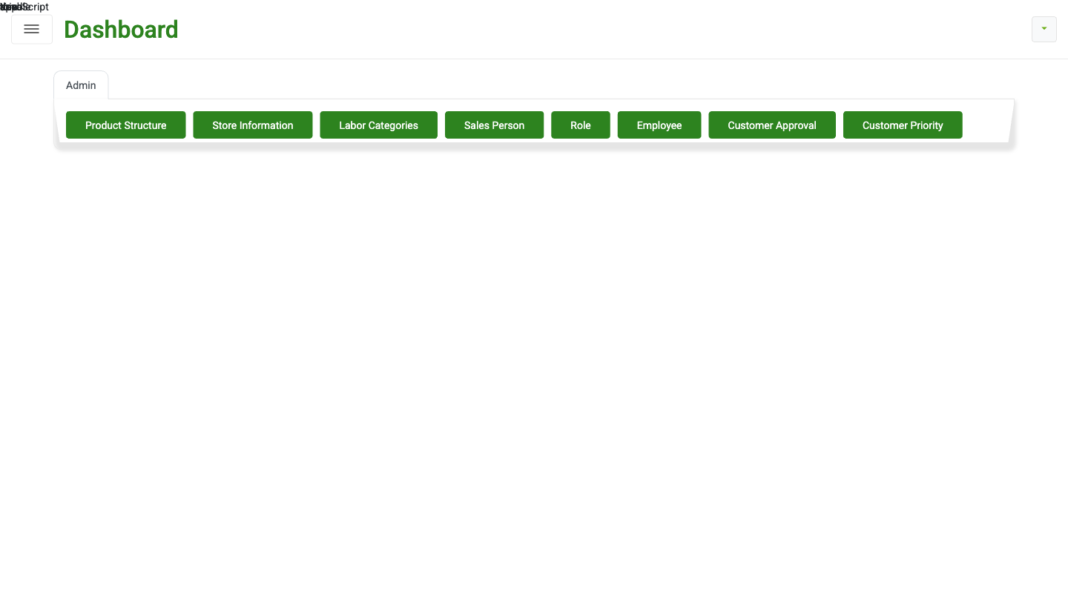
Fig 2 - Customer Priority page with imported workbook priorities
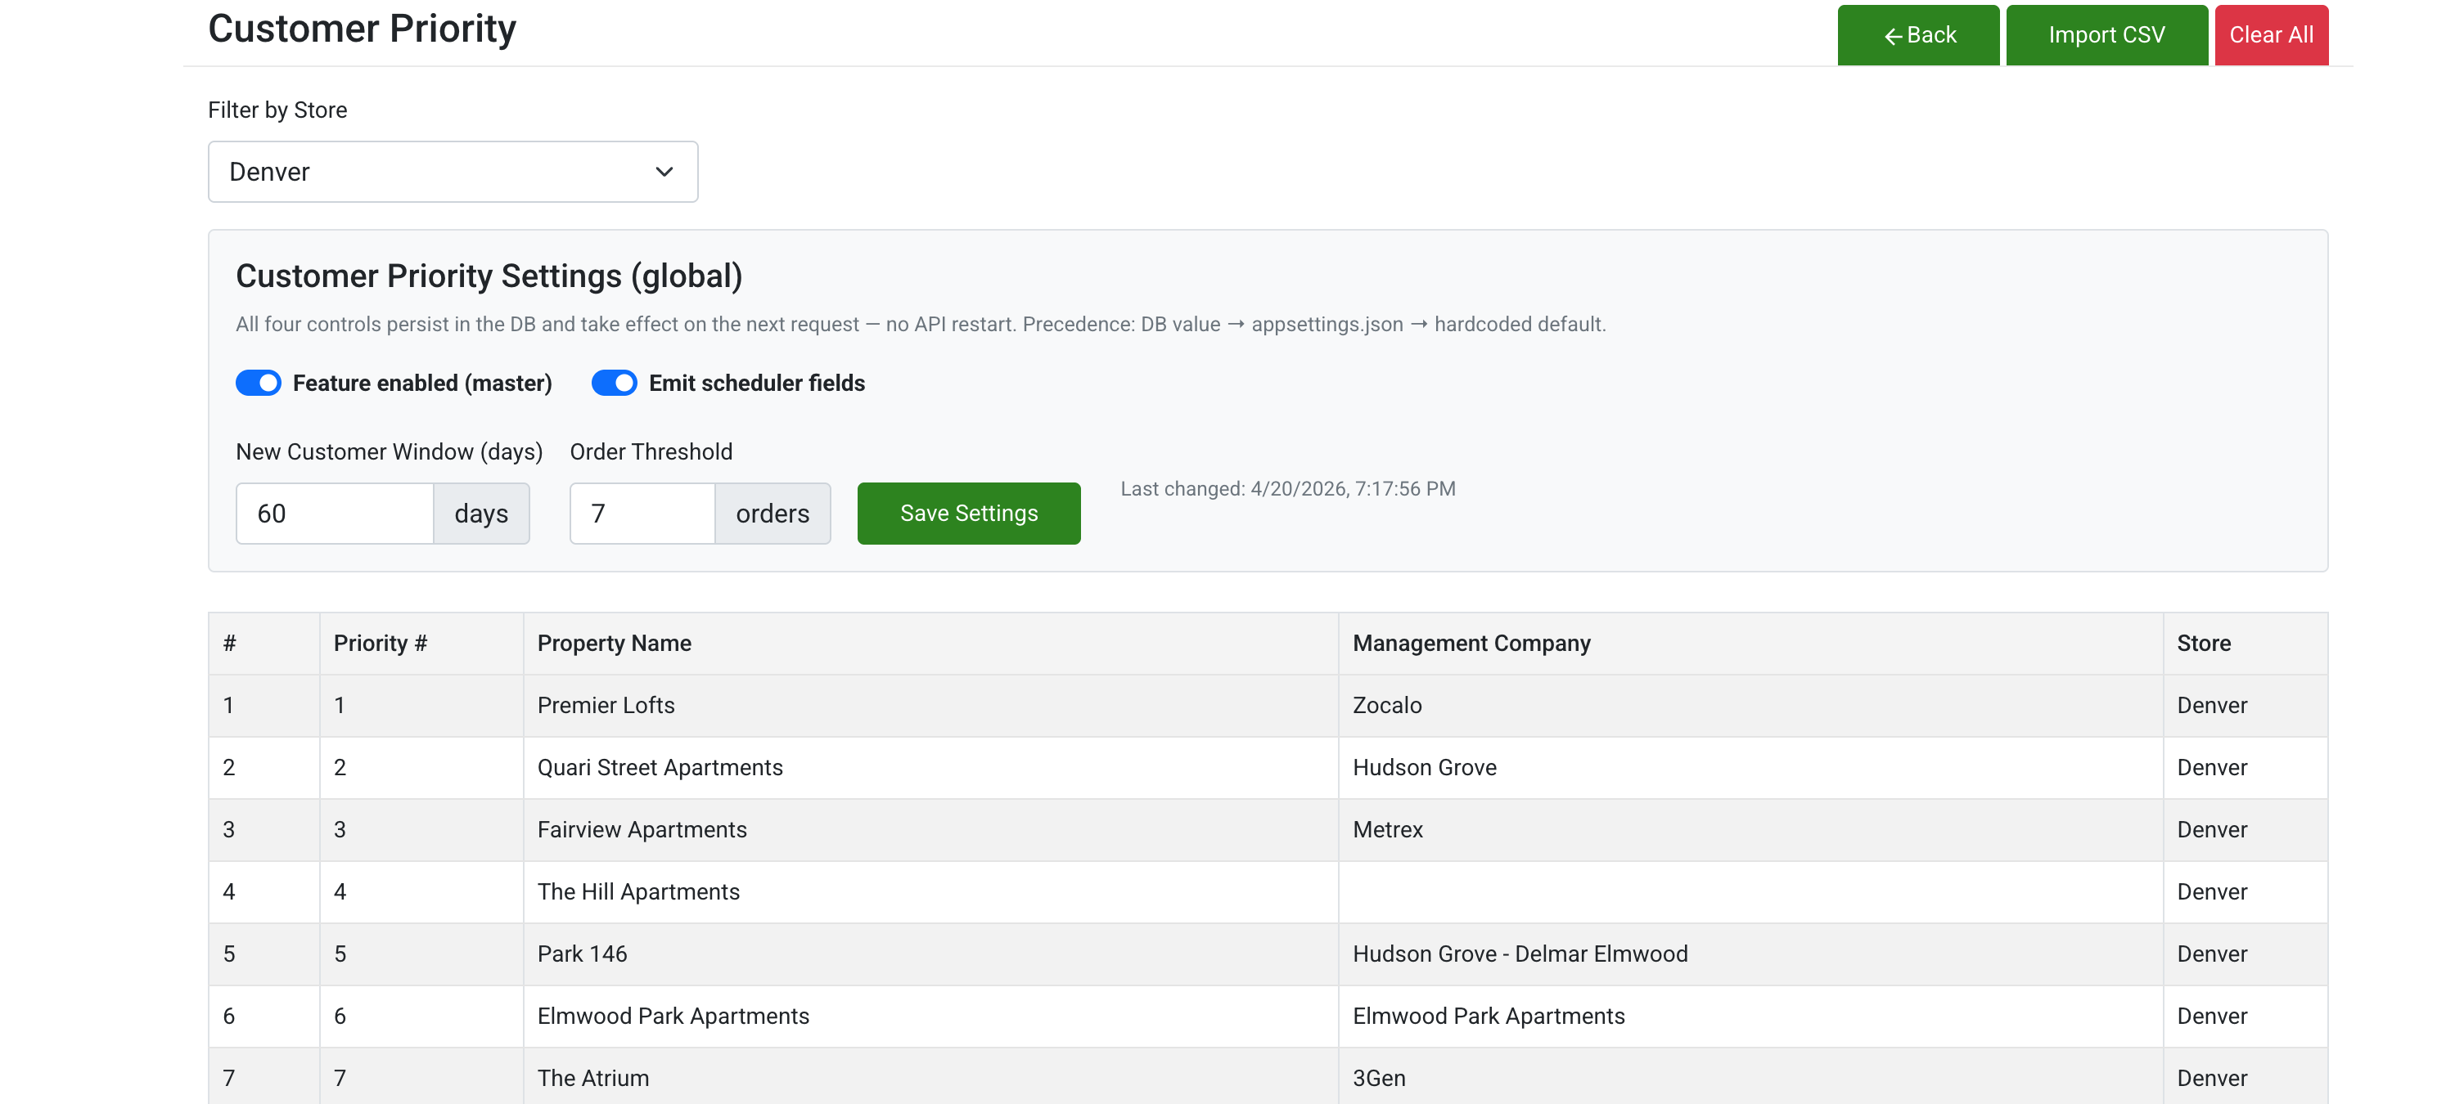
Fig 3 - Import modal (empty)
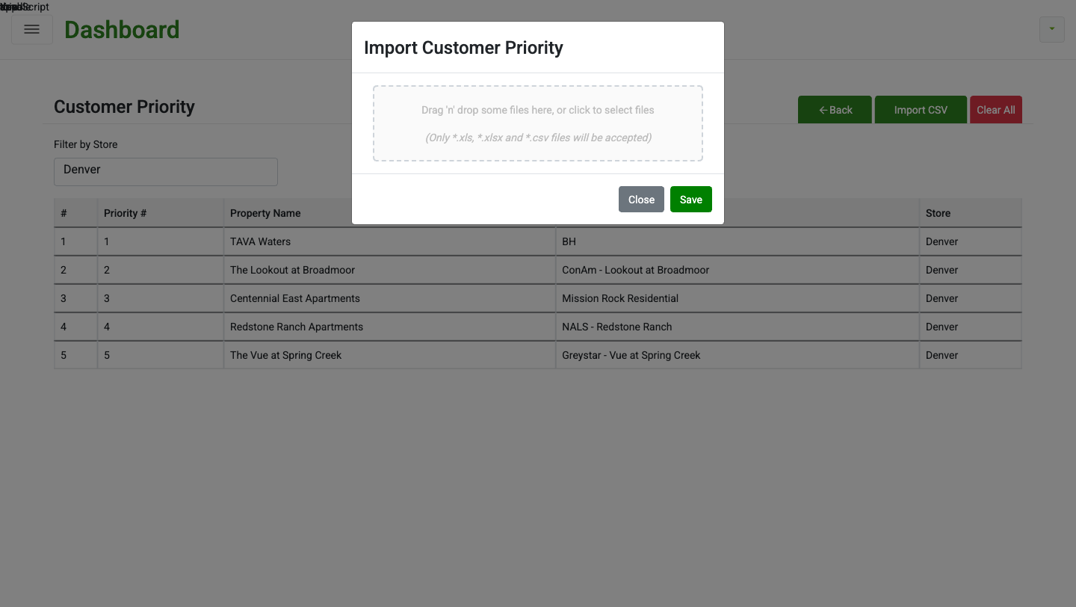
Fig 4 - Import modal with file attached
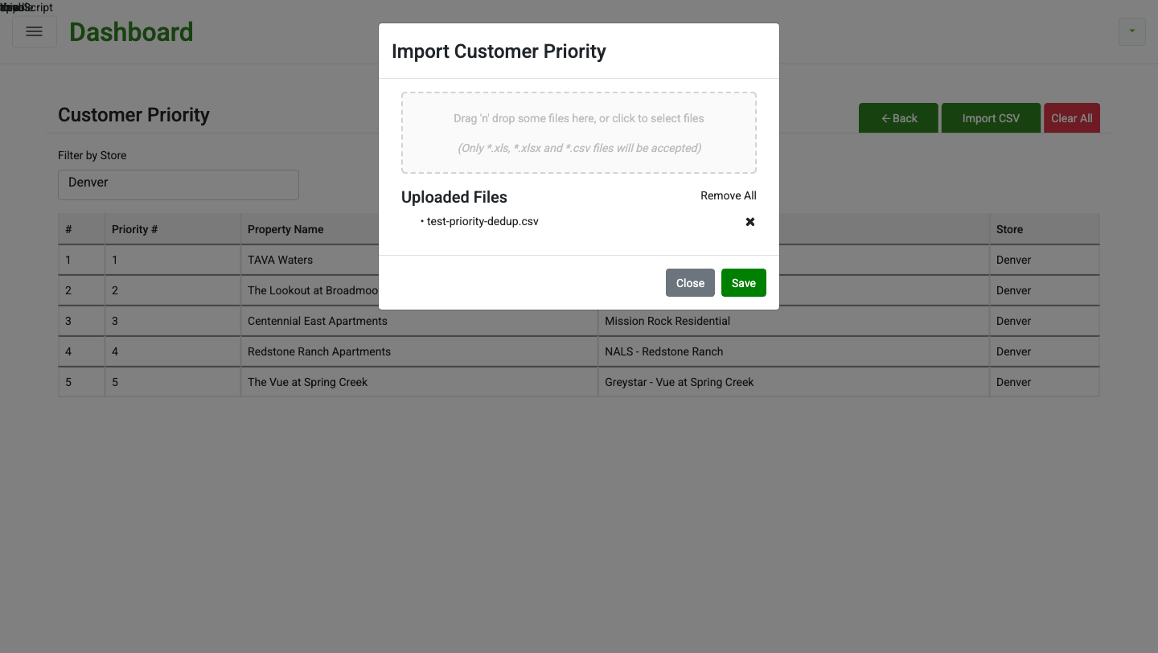
Fig 5 - Existing Orders orange NEW rows
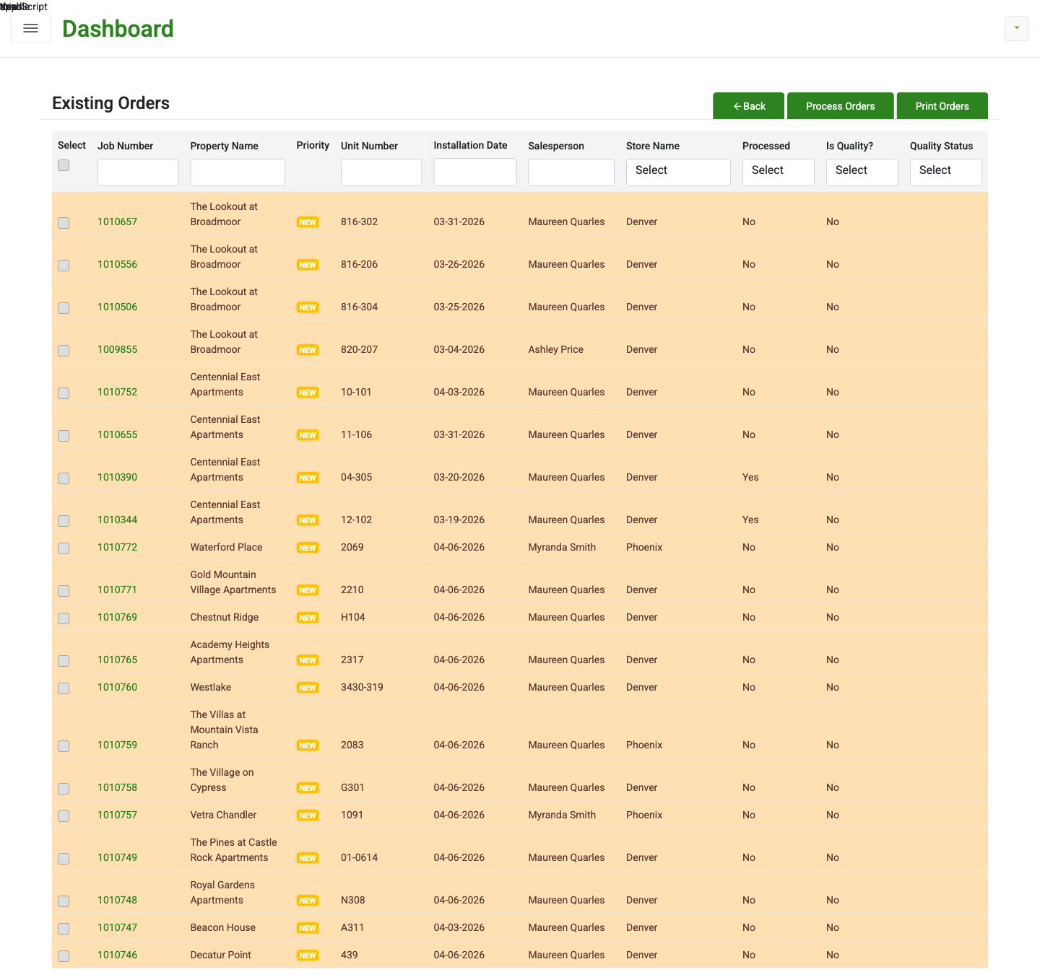
Fig 6 - Existing Orders blue priority rows
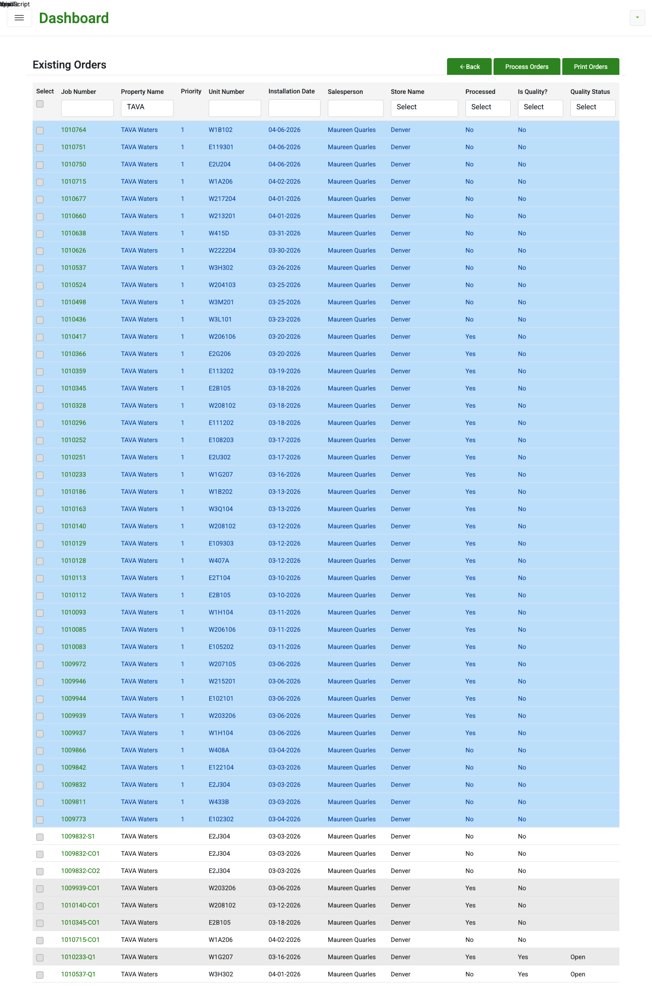
Fig 7 - Process Orders before and after for Premier Lofts
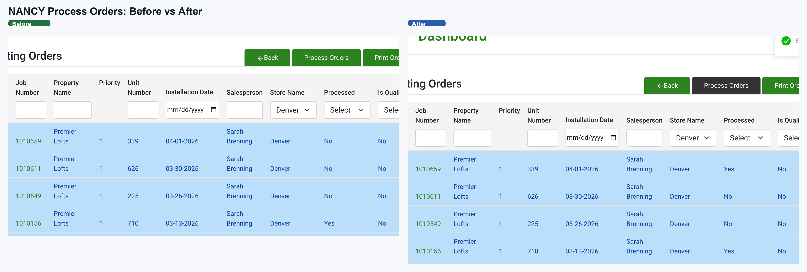
Fig 8 - 8-order BC release proof
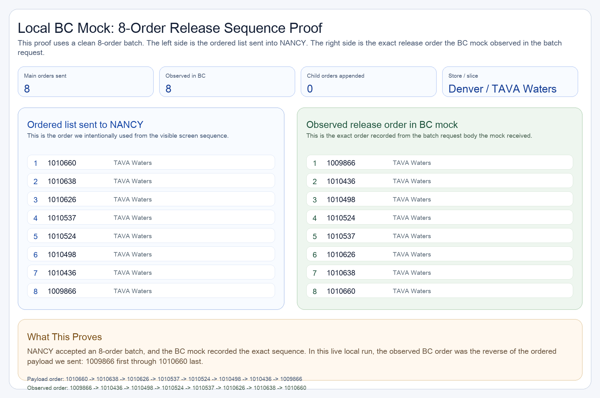

Sign-off Checklist
- Admin settings panel documented
- Imported workbook priority list documented
- Existing Orders orange and blue states documented
- Process Orders single-row success documented with screenshot
- 8-order BC proof documented
- NANCY-vs-Scheduler scope split made explicit
- Open issue remains: live BC order still needs to align with the visible ordered payload

