QA Test Plan — Customer Priority Feature (Scheduler Only)
- Scope: Scheduler only. NANCY admin/import/process-order behavior is documented separately.
- After-state workspace: /Users/william/csr-scheduler on feature/local-scheduler-bringup
- Clean comparison workspace: /Users/william/csr-scheduler-customer-priority on feature/scheduler-customer-priority
- Base revision: both workspaces started from 9b8aa4e
- QA refresh date: 2026-04-22 (MDT)
- Status: GREEN — the local Scheduler before/after proof is clear and the priority UI behavior is visible.

In Plain English
Scheduler is the downstream planning board. After this change, dispatch does not need to hunt for important jobs. NEW customers move to the top, priority properties move right after that, and the table tells the user exactly why a row is important.
This QA plan is intentionally local-only and uses no AWS services.

What Changed
- Scheduler stores priority_number.
- Scheduler stores is_new_customer.
- Scheduler sorts NEW rows first, then priority rows by ascending priority number, then regular jobs.
- The table shows a real Priority column with NEW CUSTOMER, PRIORITY N, or Standard.
- Rows use strong orange / blue treatment plus a thin pulsing edge so dispatch can spot them immediately.
- The older insufficient-material warning still survives as red key text.
Rule | Visual treatment
NEW customer | Orange row + NEW CUSTOMER label + pulsing edge
Priority customer | Blue row + PRIORITY N label + pulsing edge
Insufficient material | Red key text remains visible
Everyone else | Standard row

How To Test
- Before UI: http://localhost:3002
- After UI: http://localhost:3001
- Login: janedoe / secret
Test path 1 — Denver proof: use warehouse Denver and date 06 Apr on both sides. Before, ordinary jobs sit above TAVA Waters. After, TAVA Waters moves to the top and shows PRIORITY 1 in the Priority column.
Test path 2 — Phoenix proof: use warehouse Phoenix and date 06 Apr on both sides. Before, Waterford Place is still mixed into the regular list. After, Vetra Chandler and Waterford Place group at the top as NEW CUSTOMER.
Test path 3 — material warning proof: find a shortage-style material note in the after-state UI and confirm the row can still show priority styling while the key text stays red.

Observed Evidence
Denver after-state top rows: 1010750 TAVA Waters PRIORITY 1; 1010751 TAVA Waters PRIORITY 1; 1010764 TAVA Waters PRIORITY 1.
Phoenix after-state top rows: Vetra Chandler NEW CUSTOMER; Waterford Place NEW CUSTOMER.
The local Scheduler table now exposes priority as readable text, not just a color cue.
Verification for the preserved insufficient-material styling was completed in the focused local JobTable test pass.

Evidence Figures
Fig 1 — Denver before vs after
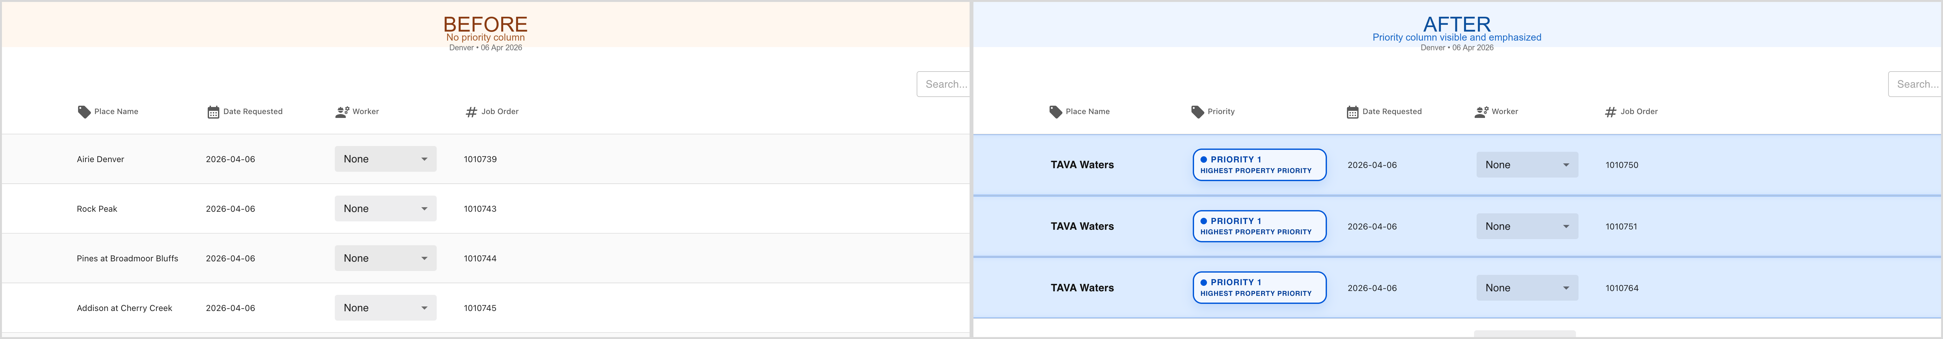
Fig 2 — Phoenix before vs after
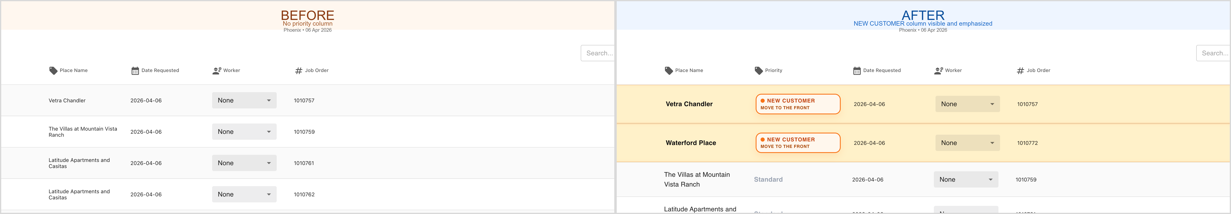

Known Limitations
- This report is local-only and proves Scheduler behavior against local NANCY, not staging or production.
- AWS-backed paths remain intentionally out of scope for this handoff.
- The comparison uses two local workspaces: a clean comparison app and the local testing app with bring-up changes needed for end-to-end local execution.
- This document does not re-test NANCY ownership such as CSV import, Existing Orders coloring, or BC release ordering.

Sign-off Checklist
- Scheduler scope separated cleanly from NANCY QA
- Denver before/after proof documented
- Phoenix before/after proof documented
- Priority column visibility documented
- Strong visual treatment documented
- Insufficient-material red styling explicitly preserved
- Local-only / no-AWS scope called out

