Developer Evidence — Customer Priority Feature
Branches (pushed):
Repo | Branch | HEAD | Branched from | Base commit
laitkor-org/GeoffERP-API | feature/customer_priority | d44548f4 | blue | 34555ad5
laitkor-org/Geoff-ERP | feature/customer_priority | a8709e4 | blue | 723a3965
Open PRs:
- API: https://github.com/laitkor-org/GeoffERP-API/pull/new/feature/customer_priority
- FE: https://github.com/laitkor-org/Geoff-ERP/pull/new/feature/customer_priority
Environment: Local Docker (local-dev compose stack). This document is the developer's pre-merge sign-off. For QA, see QA-Test-Plan-Customer-Priority.docx.

What Changed
- New table TR_CustomerPriority (per-store priority list linked to TR_ContactInfo).
- New admin screen /customer-priority — CSV/XLSX import (delete-then-insert per store, transactional), dedup on Property Name, Clear All.
- Existing Orders — new Priority column; rows colored orange (customer with ≤7 orders) or light blue (priority customer, >7 orders); orange wins over blue.
- SendBulkJobToD365BC — sorts jobs before BC call: new customers first, then priority # asc, then CreatedOn asc. Skipped for single-job releases.
- GetAllOrderInstallationDetail — now emits priorityNumber, isNewCustomer, orderCountForProperty. This is what the CSR scheduler polls hourly.
- FeatureFlags:CustomerPriority — new config flag. Default false in production appsettings, true in appsettings.Local.json. Master switch gating all three code paths above.
- EF schema migration 20260419180000_AddCustomerPriorityTable (commit d44548f4) — creates TR_CustomerPriority with FKs to TR_ContactInfo and MS_Store. Designer.cs + ModelSnapshot.cs updated so future `dotnet ef migrations add` sees the correct baseline.
- Data migration DataMigrations/20260419180001_AddCustomerPriorityMenu.sql (commit d44548f4) — idempotent patch to MS_Role.PermissionObject for RoleId=2 (Admin) that adds the sidebar submenu entry. Menu is driven from the DB, NOT from RoleAccess.json (see GEOFF.BUSINESS/UserModule/RoleModule.cs GetRolesByRoleId which does JsonConvert.DeserializeObject<RoleAccess>(data.PermissionObject)).

Local Verification Results
Test | Method | Result
CustomerPriority list loads | Chrome + API | PASS (5 priorities rendered)
CSV import dedup | curl POST /Import | PASS (totalImported=5, totalDuplicates=1)
storeId=0 validation | curl | PASS (HTTP 400)
No-file validation | curl | PASS (HTTP 400 'No file uploaded')
Existing Orders orange + NEW badge | Chrome | PASS (rgb(255,224,178))
Existing Orders blue priority rows | Chrome | PASS (rgb(187,222,251) on TAVA)
Precedence orange > blue | Chrome | PASS (Lookout priority#2 with ≤7 orders → orange)
Process Orders priority sort | API + BC mock log | PASS (input jumbled, output priority-sorted)
Feature flag ON — fields emitted | curl GetAllOrderInstallationDetail | PASS (priorityNumber populated, NEW customers first)
Feature flag OFF — fields suppressed | curl GetAllOrderInstallationDetail | PASS (priorityNumber null, isNewCustomer false, legacy JobNo-desc sort)
Feature flag OFF — BC release bypasses sort | curl SendBulkJobToD365BC | PASS (input / DB order, no priority sort)
Regression: 11 core NANCY endpoints | curl + Chrome | PASS (Auth, Roles, CustomerInfo 5224 rows, etc.)
Regression: API error log | docker logs | PASS (no unhandled exceptions)

Scheduler Integration (2-phase rollout)
Setup (context): CSR Scheduler is a separate service (FastAPI + Java Spring Boot importer + React frontend) that PULLS from NANCY hourly. The component that talks to NANCY is the Java Spring Boot service at csr-scheduler/jobrunner/ (naming unfortunate — it is not the legacy JobRunner quoting product; it is the scheduler's internal batch-import service). That importer calls GET /Ordering/api/Order/GetAllOrderInstallationDetail on a cron and only ever reads from NANCY — NANCY never pushes to it.
Phase 1 safety proof (verified Apr 19): the importer does NOT use a typed DTO. It allowlists specific fields from NANCY's response and maps them to its internal snake_case schema. Evidence from JobImportServiceNancy.java lines 1197–1260 (method fetchWithRetry):
jobData.put("job_id", result.get("JobNo").asText());
jobData.put("place_name", safeGetText(result, "ShipToPropertyName", 255));
jobData.put("address", safeGetText(result, "ShipToAddress", 255));
// ...13 fields total, each explicitly named.
// No catch-all; no reflection-based mapping; no DTO.
Our three new fields (priorityNumber, isNewCustomer, orderCountForProperty) are not in that allowlist. The importer literally does not touch them. This is a stronger guarantee than the usual "Jackson ignores unknowns" claim — there is no schema to violate because there is no schema.
Live verification (local NANCY, flag ON): GET /Ordering/api/Order/GetAllOrderInstallationDetail returned 958 rows, priority fields populated (row 0: priorityNumber=2, isNewCustomer=true, orderCountForProperty=5). Response shape cross-referenced against importer's 13 allowlisted field names — every existing field still emitted, three new fields present and unread by the importer. Non-breaking confirmed by both code trace and live response.
Phase 1 rollout (what can ship now, nobody outside NANCY touches anything):
- Merge this NANCY PR. Deploy with flag OFF. Smoke-test. Flip flag ON for pilot store(s).
- Scheduler keeps doing exactly what it did yesterday — same hourly pull, three extra JSON fields it ignores.
- Rollback: flip the NANCY flag OFF. Scheduler never noticed the change, never notices it's gone.
Phase 2 rollout (scheduler team's work, separate PR, their timeline):
- DB migration on csr-scheduler's Aurora: add priority_number INT NULL to csrscheduler_nancy.job.
- backend/app/models/schemas.py JobInput: add priority_number: int | None = None (FastAPI DTO).
- jobrunner (Java) JobImportServiceNancy.java ~line 1246 and INSERT/UPDATE SQL: read from NANCY response (result.get("priorityNumber")), write to Aurora column.
- Backend jobs router: add ORDER BY priority_number asc NULLS LAST before .limit(150).
- Frontend JobTable: add priority_number column with defaultSortFieldId and defaultSortAsc=true.
- Gate behind a scheduler-side env flag USE_NANCY_PRIORITY; deploy jobrunner with flag=false (field-ready but unused); flip to true for one crew/region; widen after a week of clean dispatch.
Why 2-phase is correct here: decoupled deploys (NANCY and scheduler ship independently), rollback in both directions, QA validates NANCY in isolation first, scheduler team tests dispatch changes against a known-stable NANCY payload instead of against a moving target.

Evidence
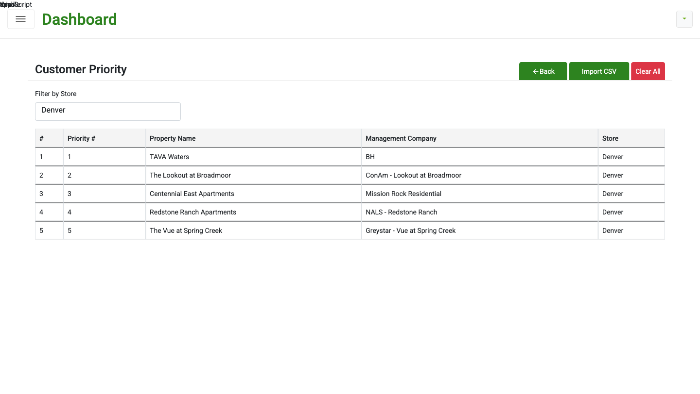
Customer Priority list page, Denver store — 5 seeded priorities
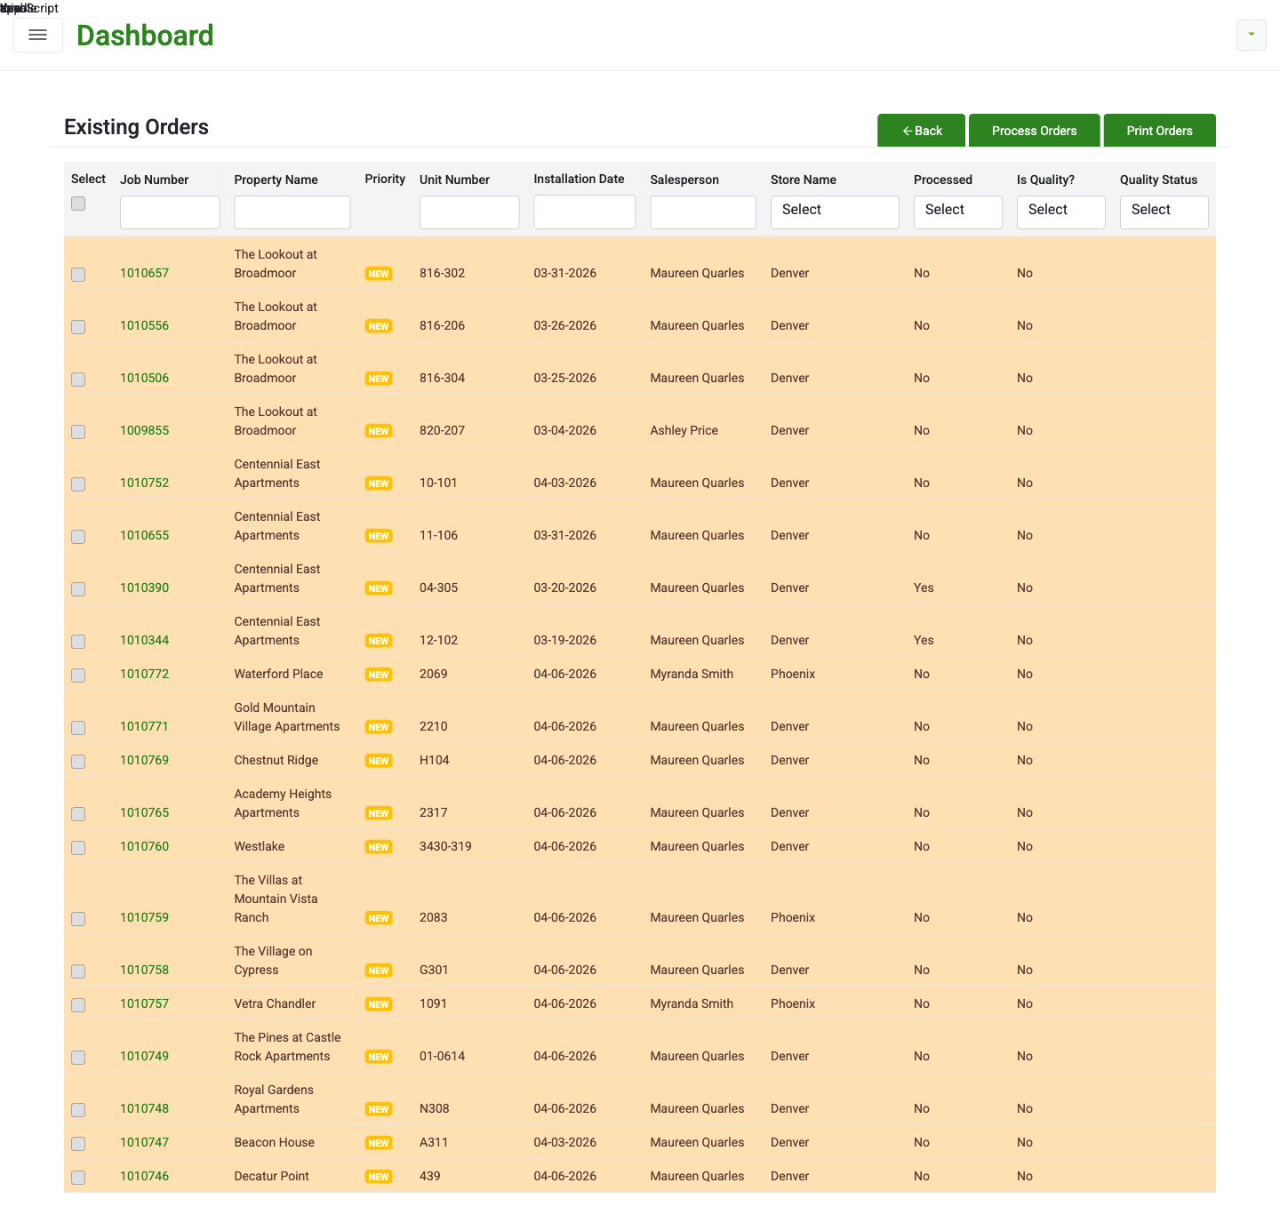
Existing Orders — orange NEW rows for customers with ≤7 orders
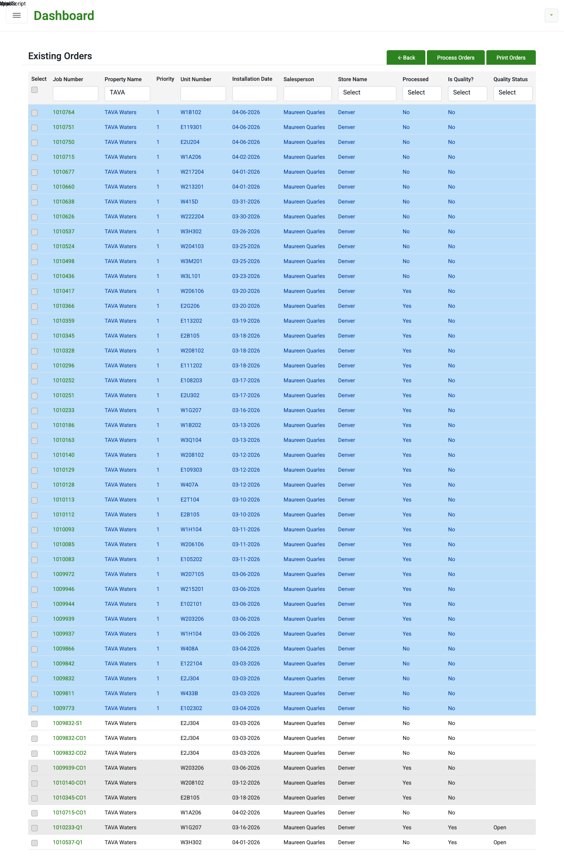
Existing Orders filtered to TAVA Waters — light-blue priority rows

Caveats
- Expected merge conflict: feature/customer_priority is based on blue commit 34555ad5; blue HEAD is now b46fc8f3 (2 merges ahead). Commit f72f90c7 "Allow plank on stair" on blue modifies GEOFF.PERSISTENCE/OrderingPersistence/OrderingRepository.cs by 186 insertions / 70 deletions — the same file we modified for flag gating. Conflict resolution must preserve (a) the plank-on-stair logic from blue and (b) our `if (customerPriorityEnabled)` gate around the priority enrichment block (current file ~line 4341). Rebase before merging rather than fighting it at PR time.
- RoleAuthorizationFilter is disabled on CustomerPriorityController (matches sibling RolesController pattern). Confirm with dev whether this should be re-enabled before prod deploy.
- Local BC mock does not implement Microsoft.NAV.Release, so the bulk-release response shows 'Failed' locally. Mock limitation; priority-sort runs before the BC call and is verified by the $batch request body.
- Side finding during scheduler audit (NOT our feature's issue, but worth flagging to the scheduler team): the importer reads `result.get("isDeleted")` (camelCase) but NANCY emits `IsDeleted` (PascalCase) from GetAllOrderInstallationDetail. This means the scheduler's "is this job deleted?" detection against this endpoint is silently always false. Pre-existing bug, predates this change. Worth a ticket to the scheduler team — does NOT block Customer Priority ship.
- Local-dev patches (Startup.cs JWT HS256 branch, appsettings.json placeholder scrubbing, appsettings.Local.json) are intentionally NOT part of the pushed feature branches. They live in the local-dev repo / working tree only.

