QA Test Plan — Customer Priority Feature
Branches (pushed):
Repo | Branch | HEAD | Branched from | Base commit
laitkor-org/GeoffERP-API | feature/customer_priority | d44548f4 | blue | 34555ad5
laitkor-org/Geoff-ERP | feature/customer_priority | a8709e4 | blue | 723a3965
Open PRs:
- API: https://github.com/laitkor-org/GeoffERP-API/pull/new/feature/customer_priority
- FE: https://github.com/laitkor-org/Geoff-ERP/pull/new/feature/customer_priority

Pre-flight Checklist (Dev / DevOps — before QA starts)
In plain English: before QA runs a single test, three things must be true on the staging server. If any of these is skipped, the very first test ("Customer Priority button on Admin menu") will fail — not because of a bug, but because the deploy is incomplete. Do not start testing until every box is checked.
Prereq | What / How | How to verify
Feature branches deployed | Deploy API branch feature/customer_priority at commit d44548f4 (feature code + EF migration + menu-patch SQL). Deploy FE branch feature/customer_priority at commit a8709e4. | Verification: `git log -1` on each deployed branch shows the matching commit hash.
EF schema migration applied | Run `dotnet ef database update` (or the team's equivalent deploy command) against the staging DB. This applies GEOFF.CORE/Migrations/20260419180000_AddCustomerPriorityTable — creates table TR_CustomerPriority with FKs to TR_ContactInfo and MS_Store, plus supporting indexes. | Verification: `SELECT COUNT(*) FROM TR_CustomerPriority` returns a number (0 or more) — not an error.
Menu-patch SQL applied | Run GEOFF.CORE/Migrations/DataMigrations/20260419180001_AddCustomerPriorityMenu.sql against staging DB. This adds the "Customer Priority" submenu to MS_Role.PermissionObject for RoleId=2 (Admin). Script is idempotent — safe to re-run. Note: the admin sidebar menu is driven from the DB, NOT from RoleAccess.json. | Verification: `SELECT PermissionObject FROM MS_Role WHERE RoleId=2` contains the string "Customer Priority". Users must REFRESH the browser (no re-login) to see the new menu button.
Feature flag set | Set FeatureFlags:CustomerPriority = true in staging appsettings.json (or Parameter Store / env var, per your deploy pipeline). Restart the API service. | Verification: GET /Ordering/api/Order/GetAllOrderInstallationDetail returns priorityNumber / isNewCustomer / orderCountForProperty with real values (not null/false/0).
Seed data available | At minimum: one Admin user credential for QA; at least one customer with ≤7 lifetime orders (for T9 orange-row test); at least one customer with >7 lifetime orders (for T10 blue-row test); one property to upload as a priority entry (for T3 CSV test). | QA supplies their own staging login.

Why this checklist exists: the EF migration creates the new TR_CustomerPriority table (without it, every API call to /User/api/CustomerPriority/* throws a SQL error). The menu-patch SQL adds the sidebar button (without it, the Admin page doesn't even show the Customer Priority entry — QA would fail T1 with nothing to click). Both live inside the feature branch (commit d44548f4), paths: GEOFF.CORE/Migrations/20260419180000_AddCustomerPriorityTable.cs and GEOFF.CORE/Migrations/DataMigrations/20260419180001_AddCustomerPriorityMenu.sql.

In Plain English
Before this change, NANCY handled orders first-come-first-served. That meant a brand-new tiny customer could get their material before one of our biggest accounts just because they placed their order a minute earlier. That's bad for business.
Robert wanted two kinds of customers to jump the line:
- BRAND-NEW customers (anyone with 7 or fewer orders ever). We want to wow them on their first jobs so they stick with us. Their rows show up ORANGE with a yellow NEW badge.
- VIP customers on a priority list that Admins upload (TAVA Waters, The Lookout, etc.). Their rows show up LIGHT BLUE with their priority number (1, 2, 3…).
If a customer is BOTH new AND on the VIP list, we treat them as new (orange wins over blue) — because keeping a new customer happy on their first few jobs is the most important thing.
When someone clicks "Process Orders" to send a batch to Business Central (our accounting software, think QuickBooks-for-enterprise), NANCY now sorts the batch so new customers go first, then VIPs, then everyone else. That way BC assigns material to the people who need it most, first.
There's also a Scheduler app (a separate system that assigns workers to jobs). It polls NANCY every hour to pull down the order list. NANCY now includes priority info on every order so the Scheduler can do the same kind of sorting on its side. (The Scheduler team will ship their side in a separate change — the NANCY change here is safe either way.)

What This Is (Technical)
A feature that lets Admins upload a per-store priority list of customer properties via CSV. When orders are released to Business Central, the system sends them in this order:
- New customers (≤ 7 lifetime orders) first
- Priority customers (> 7 orders), by priority number ascending
- Everyone else, by order creation date ascending
Two UI changes plus one downstream integration:
- New admin screen at /customer-priority — upload / view / Clear All, per store.
- Existing Orders list — new Priority column, rows colored orange (NEW customer) or light blue (priority customer, >7 orders). Precedence: orange wins over blue.
- GetAllOrderInstallationDetail response — now includes priorityNumber, isNewCustomer, orderCountForProperty fields. The CSR scheduler polls this endpoint hourly and will consume these fields (scheduler-side PR separate from this one).

Feature Flag
In plain English: a feature flag is an on/off switch in the settings file. If something goes wrong in production, dev can flip one setting to OFF, restart the API, and the whole feature instantly turns off — back to how NANCY worked before. No code changes, no emergency hotfix. This is our safety net.
Config key: FeatureFlags:CustomerPriority (bool, default false). Kill switch for the entire feature.
Behavior | Flag ON | Flag OFF
GetAllOrderInstallationDetail priority fields | priorityNumber / isNewCustomer / orderCountForProperty populated | Emitted as null / false / 0
Existing Orders default sort | NEW customers first, then priority # asc, then JobNo desc | Legacy JobNo desc only
Existing Orders row colors | orange NEW / light-blue priority | No coloring (all white)
SendBulkJobToD365BC release order | Priority-sorted before BC call | Input / DB order (legacy)
CSR scheduler ingest | Sees priority fields in payload | Sees the fields as null (safe, ignored)

Roll-out recommendation: deploy to staging with flag ON for feature testing. For production, deploy with flag OFF, verify no regressions, then flip to ON. If anything misbehaves, flip to OFF — the system immediately reverts to pre-feature behavior across UI, BC release, and scheduler ingest.

What the Feature Looks Like
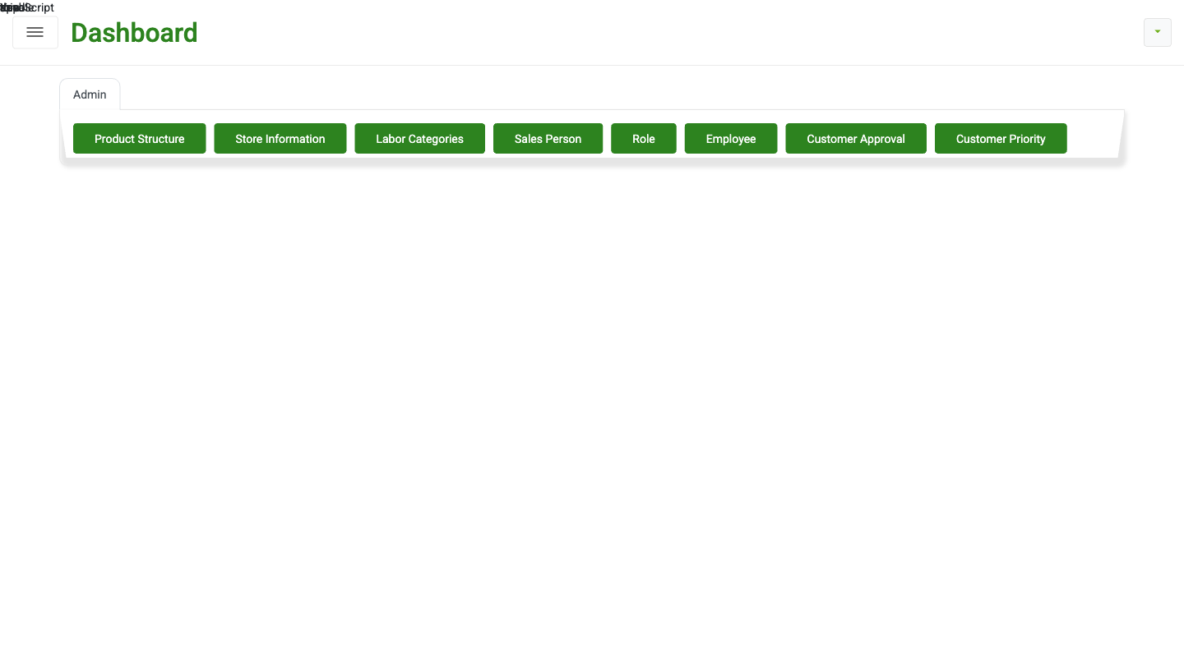
Fig 1 — Admin page: 'Customer Priority' button on the Admin menu strip
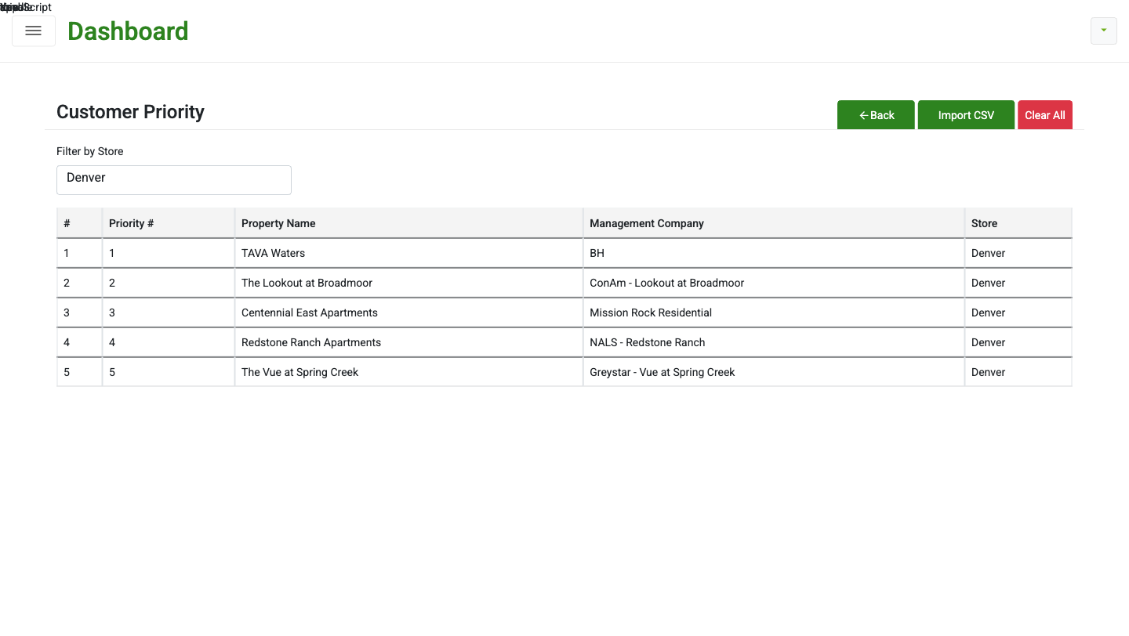
Fig 2 — /customer-priority: priority list for the selected store
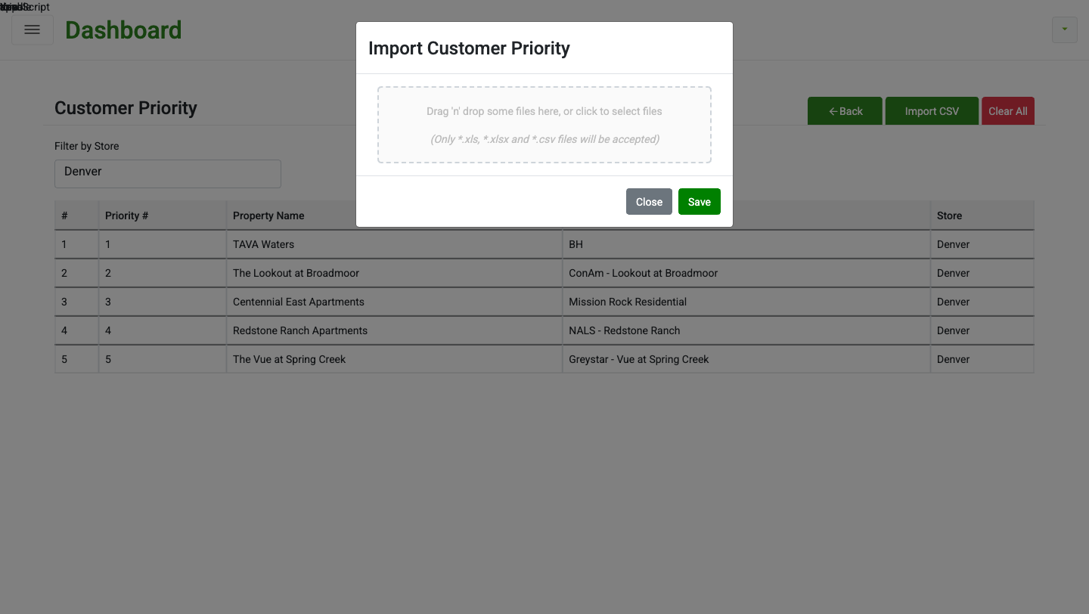
Fig 3 — Import CSV modal (empty state)
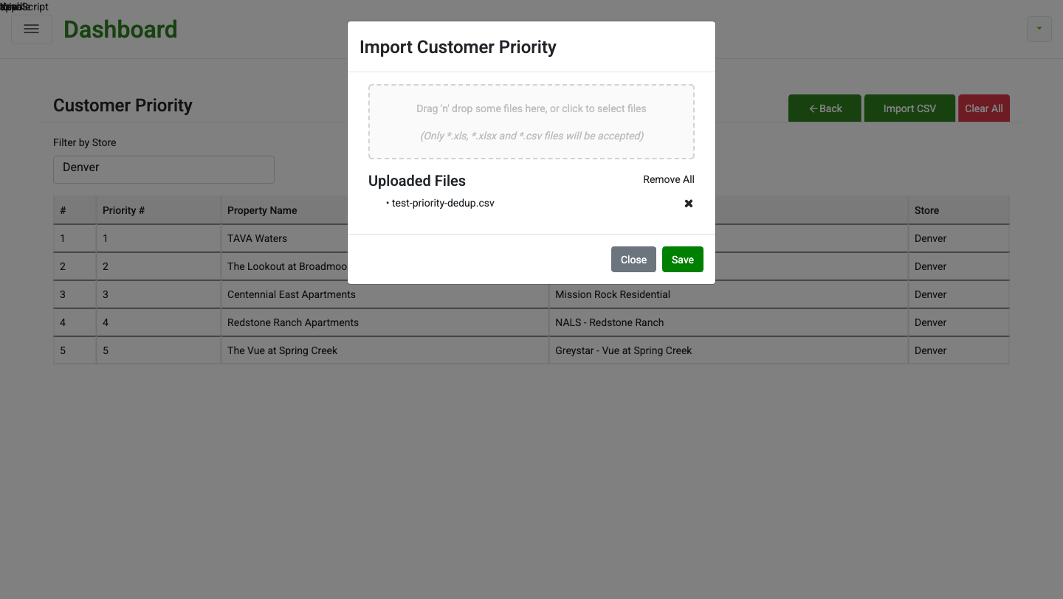
Fig 4 — Import CSV modal with file attached
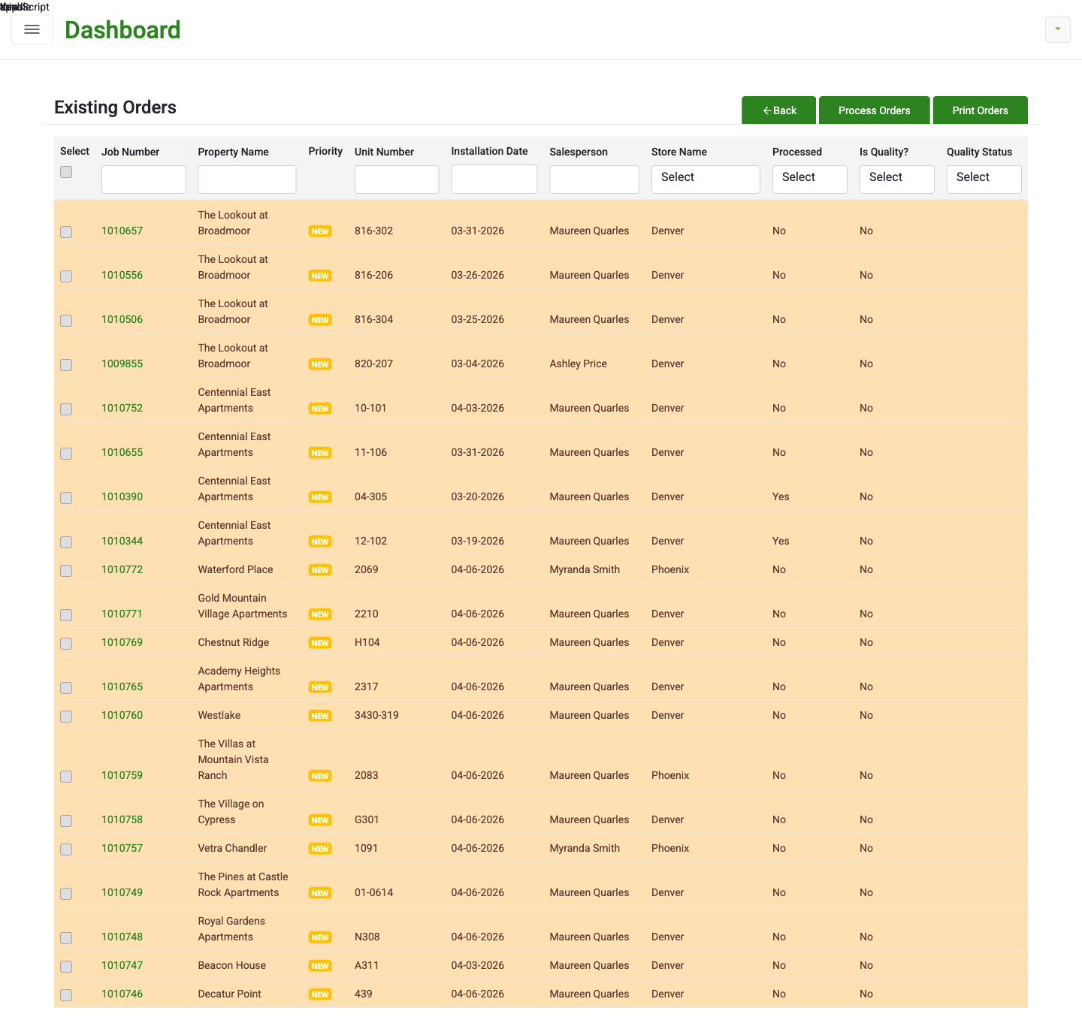
Fig 5 — Existing Orders: orange rows + NEW badge for customers with ≤7 orders
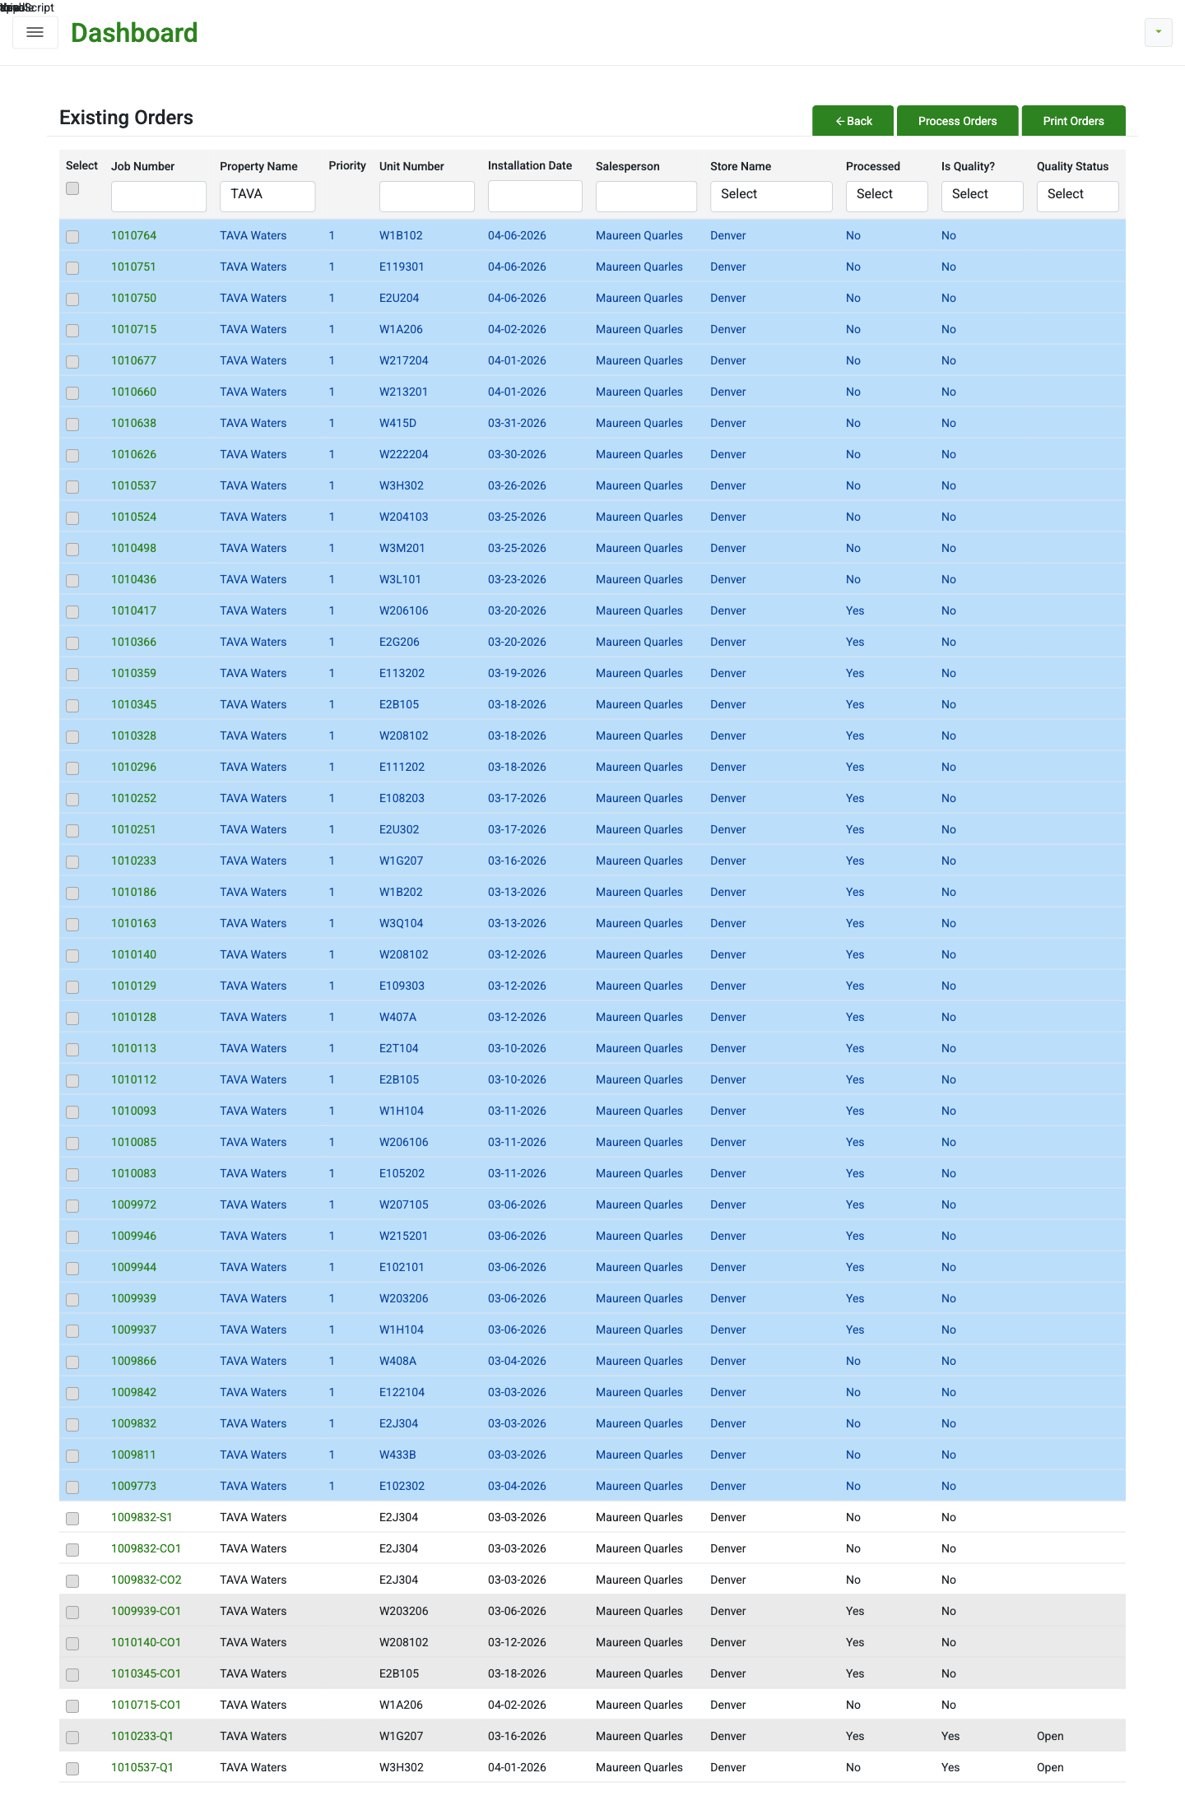
Fig 6 — Existing Orders: light-blue rows for priority customer (TAVA Waters) with >7 orders

How to Test — Feature (flag ON)
In plain English: run each test below, step-by-step. If the page behaves like the PASS line says, mark it PASS. If it behaves like the FAIL line says (or something weirder), mark it FAIL and file a bug with the test ID (e.g. "T4 FAIL"). Start at T1 and go down — later tests build on earlier ones (for example T9's colored rows need T3's CSV to have been uploaded).

T1. Admin menu exposes the new screen
Steps: Log in → Admin tab.
PASS: A green button labeled "Customer Priority" is visible on the Admin menu strip (Fig 1).
FAIL: Button missing, grayed out, or misspelled.

T2. Customer Priority list loads
Steps: Click Customer Priority → pick a store in the filter.
PASS: Page title "Customer Priority" shows. Table columns: #, Priority #, Property Name, Management Company, Store. Rows sorted by Priority # asc (Fig 2).
FAIL: Page errors, wrong columns, rows out of order.

T3. CSV import — happy path
Steps: Click Import CSV → attach a CSV with columns Property Name, Management Company, Priority Number → Save. Sample row: "TAVA Waters, BH, 1".
PASS: Toast shows "Imported: N, Skipped: S, Duplicates: D". Table refreshes. Previous rows for this store are replaced.
FAIL: Error, rows not replaced, or toast missing.

T4. CSV import — dedup
Steps: Upload a CSV with the same Property Name appearing twice (case differences and trailing whitespace should still count as duplicates).
PASS: Only one row kept per property. Toast shows Duplicates ≥ 1.
FAIL: Duplicates inserted into the list.

T5. Validation — no file
Steps: Open Import CSV → click Save without attaching a file.
PASS: Error toast "No file uploaded". No rows change.
FAIL: Silent behavior, or a success toast.

T6. Validation — no store
Steps: Open Import CSV with store filter empty. Try to save with a valid file.
PASS: Error mentions store is required.
FAIL: Upload succeeds with no store.

T7. Clear All
Steps: Click Clear All → confirm.
PASS: All priorities for the selected store are removed. Other stores unaffected.
FAIL: Nothing happens; error; or other stores' priorities removed.

T8. Per-store isolation
Steps: Upload priorities for Store A. Switch to Store B.
PASS: Store B shows only its own priorities (empty if none).
FAIL: Store B shows Store A's rows.

T9. Existing Orders — NEW customer (orange)
Steps: Existing Orders → find a customer with ≤ 7 lifetime orders.
PASS: Row has orange background. Priority column shows yellow "NEW" badge (Fig 5).
FAIL: No color or no badge.

T10. Existing Orders — priority customer (blue)
Steps: Find a customer on the priority list AND with > 7 lifetime orders. Example: TAVA Waters (Fig 6).
PASS: Row has light-blue background. Priority column shows the priority number.
FAIL: Wrong color or blank priority.

T11. Existing Orders — precedence
Steps: Find a customer on the priority list AND with ≤ 7 orders.
PASS: Row is orange + NEW badge (orange wins over blue).
FAIL: Row is blue, or has no highlight.

T12. Process Orders — priority sort
Steps: Select a mix of new customers, priority customers, and regulars. Click Process Orders.
PASS: Orders go to BC in this order: new customers first (priority # asc), then priority customers (priority # asc), then everyone else by creation date asc.
FAIL: Input order preserved or a different order observed.

How to Test — Feature Flag
Dev will flip the flag in the environment config and restart the API service. Run T9–T12 with flag ON, then with flag OFF.
F1. Flag ON — priority fields populated
Steps: Ask dev to set FeatureFlags:CustomerPriority=true and restart API. Run T9–T12.
PASS: All T9–T12 PASS as described.
FAIL: Any of T9–T12 FAIL.

F2. Flag OFF — feature reverts to legacy
Steps: Ask dev to set FeatureFlags:CustomerPriority=false and restart API. Then: (a) load Existing Orders, (b) upload CSV via /customer-priority then reload Existing Orders, (c) Process Orders on several jobs.
PASS: (a) NO orange or blue rows, no Priority column values. (b) Upload succeeds but coloring still does not appear. (c) Jobs are released in input / JobNo order, not priority order.
FAIL: Any row still colored; Priority column has values; Process Orders still priority-sorts; admin upload throws an error.

F3. Flag OFF — scheduler payload safe
Steps: Dev-verifiable only. Confirm GetAllOrderInstallationDetail emits priorityNumber: null, isNewCustomer: false, orderCountForProperty: 0 for every row.
PASS: API response JSON shows the three fields present but null/false/0.
FAIL: Fields populated when flag OFF, OR fields missing entirely.

F4. Toggle — no data loss
Steps: Flip flag OFF, upload a CSV of priorities, flip flag back ON.
PASS: Priorities uploaded while flag was OFF are visible once flag is back ON. No data loss; only runtime behavior changes.
FAIL: Priorities disappear, duplicate, or corrupt.

Edge Cases to Try
- Priority Number values: 0, negative, very large (99999), non-numeric, decimal, blank.
- Property Name with leading/trailing whitespace, mixed case, Unicode, very long (200+ chars).
- Property Name that does not match any existing customer — should be skipped with a clear message.
- Two customers sharing the same Priority Number — tie-break should be consistent (CreatedOn asc).
- Empty CSV, header-only CSV, wrong column names, extra columns, .xlsx with multiple sheets, 10 MB+ file.
- Re-upload same file twice — second should be a no-op replacement.
- Upload, then delete the customer from Customer Info — the row should disappear from Existing Orders color-coding.
- Process Orders with zero selected jobs, and with exactly one selected job (sort skipped for single-job release).
- Accessibility: NEW badge text must be legible for color-blind users (not color-only).

Regression — Existing Platform
In plain English: this section is making sure the new feature didn't accidentally break anything that was already working. Go through the list and quickly check each item. If Dashboard used to show widgets, it should still show widgets. If Place An Order used to work, it should still work. Anything that behaves different from before the feature was added = regression = bug.
Run after feature testing (with flag ON). All should behave as before.
- R1. Login, logout, password reset.
- R2. Dashboard widgets (Contacts / Proposals / Orders / Invoices A/R / Reports) load with correct counts.
- R3. Place an Order — end-to-end, saves and appears in Existing Orders.
- R4. Existing Orders filters (Job Number, Property Name, Unit Number, Salesperson, Store, Processed, Is Quality, Quality Status). Pagination and Print.
- R5. Deleted Orders — view, restore.
- R6. Sales Customer Info — list, search, edit.
- R7. Estimating Customer Info — list, create.
- R8. Pricing Contracts — view contracts, view products / labor per contract.
- R9. Product Catalog — list, edit, sync to BC.
- R10. Labor Catalog — list, edit, sync to BC.
- R11. Kits — list, create, edit.
- R12. Admin → Product Structure / Store Information / Labor Categories / Sales Person / Role / Employee / Customer Approval — each opens, lists, saves.
- R13. Orders previously released to BC still show Released status.
- R14. Seaming and ordering sub-apps open from their links.
- R15. Report exports (CSV / PDF) where available.
A regression is any existing behavior that changed, broke, or noticeably slowed.

Deploy & Rollout Plan
In plain English: once QA is happy on staging, here's how the feature gets out to real users. We deploy with the feature turned OFF first (safe — acts exactly like old NANCY). We confirm nothing broke. Then we flip the switch to ON and watch closely. If anything misbehaves, we flip back to OFF and the feature is gone — no rollback deploy, no emergency. This is why the feature flag exists.
Intended flow once QA signs off on staging:
- 1. Merge PR on GeoffERP-API (API branch feature/customer_priority, HEAD d44548f4) into the prod integration branch. Note: branch is 2 merges behind blue HEAD (b46fc8f3) and will conflict on OrderingRepository.cs — see the DEV evidence doc for resolution notes.
- 2. Merge PR on Geoff-ERP (frontend branch feature/customer_priority, HEAD a8709e4) into the prod integration branch.
- 3. Apply the EF schema migration to the prod DB (20260419180000_AddCustomerPriorityTable) — this creates TR_CustomerPriority. Then apply the data migration SQL (20260419180001_AddCustomerPriorityMenu.sql) — this adds the admin menu entry.
- 4. Deploy to production with FeatureFlags:CustomerPriority = FALSE in the production appsettings. This is the default in the committed config, so nothing extra is needed unless that value has already been changed.
- 5. Smoke-test prod: log in, open Existing Orders, confirm NO row coloring and NO Priority column values (flag is off). This confirms the deploy is safe and legacy behavior is intact.
- 6. Flip FeatureFlags:CustomerPriority to TRUE for the pilot store(s) first if environment-specific overrides are supported; otherwise flip globally. Restart the API service.
- 7. Watch for: (a) API error-log spikes, (b) Existing Orders loading time regression, (c) Process Orders → BC release errors.
- 8. If stable for 24–48 hours, declare full rollout complete.

Rollback plan: If anything misbehaves in prod, set FeatureFlags:CustomerPriority = FALSE and restart the API service. The system immediately reverts to pre-feature behavior end-to-end — UI coloring off, legacy sort, BC release in input order, scheduler payload emits the three fields as null. No data is lost; uploaded priority lists remain in the TR_CustomerPriority table and reappear when the flag is turned back on. Full git revert is only needed if there's a bug that persists with the flag off.

Sign-off checklist (QA completes before merging to prod):
- T1–T12 feature tests all PASS with flag ON.
- F1–F4 feature-flag tests all PASS.
- R1–R15 regression tests all PASS.
- Edge cases reviewed — any unexpected behavior filed as bugs or accepted with rationale.
- Security note for dev (below) has been addressed or acknowledged.

Security Note for Dev
RoleAuthorizationFilter is commented out on CustomerPriorityController (matches RolesController pattern). Any authenticated user can call these endpoints regardless of role. Confirm with dev that role-based restriction will be re-enabled before production.

Filing Bugs
For any FAIL: capture a screenshot, URL, UTC timestamp, and exact steps. Reference the test case ID (e.g. "T11 FAIL — row not orange" or "F2 FAIL — color stayed on with flag off"). Use the team's normal bug queue.

