**Vultures Rule the Roost (Title)**

**Resistance Art and Literature**

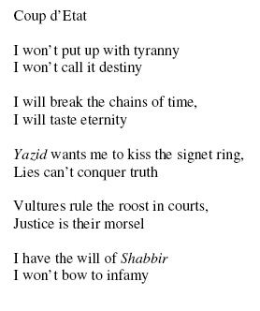

more

