${CLONEBLOCK}

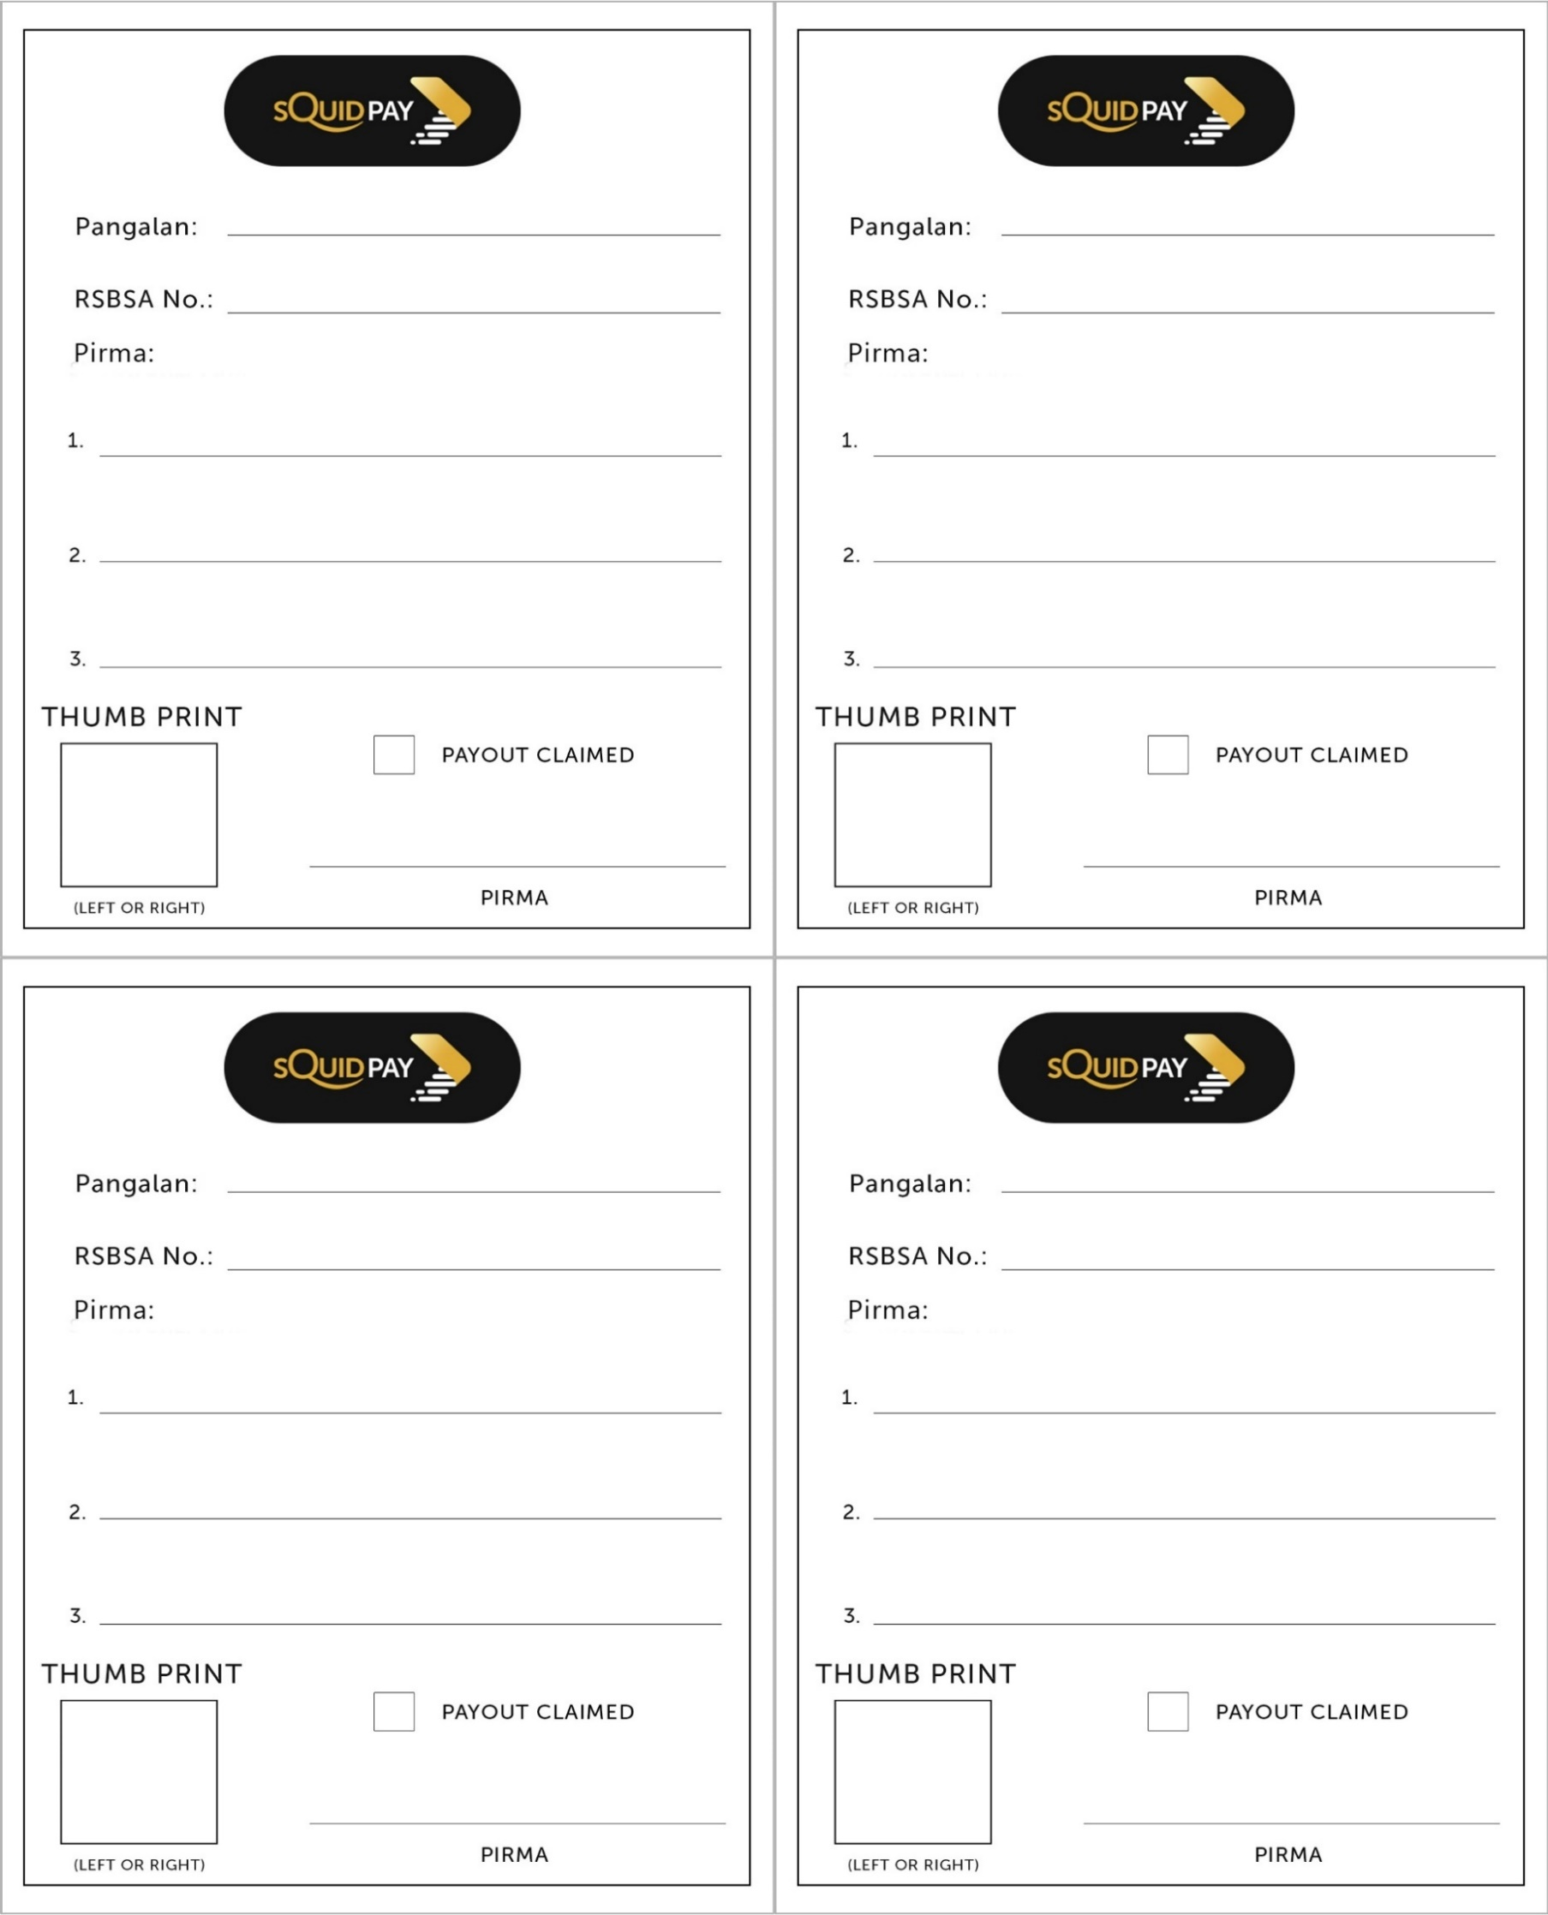

${rsbsa_no}

${dbp_batch_name}

${dbp_batch_name}

${dbp_batch_name}

${dbp_batch_name}

${rsbsa_no}

${full_name}

${full_name}

${rsbsa_no}

${full_name}

${full_name}

${rsbsa_no}

${dbp_batch_name}

${dbp_batch_name}

${/CLONEBLOCK}