Enable CORS to allow customized header for authorizer:

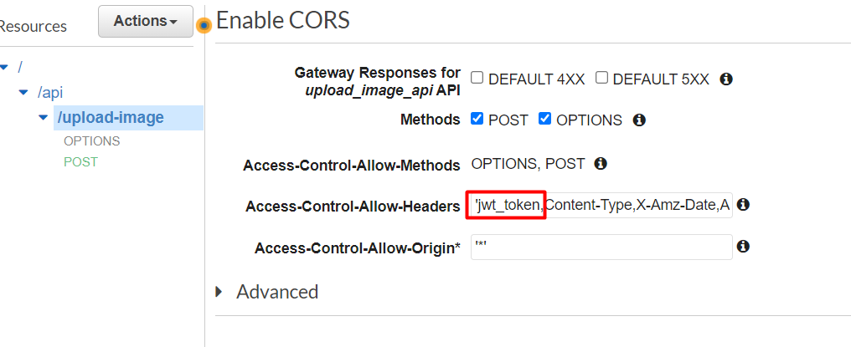

**References and Resources**

Image Upload Video: https://codepen.io/morten-olsen/pen/eNWyjj

Cognito Register Video: https://www.youtube.com/watch?v=pDMkL2cObC0

Cognito Login & Auth Video: https://www.youtube.com/watch?v=rOaUyCM-fcE